# Interview Participant Information

Easy English Version 2020

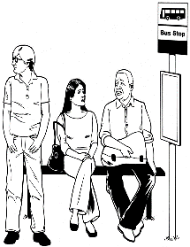

Information about **Public Transport** research.

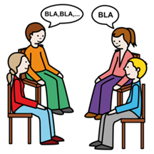

A **group** **interview** is a chat with a researcher.

A researcher learns information to help make things better for people.

The word **chat** will be used in this form.



The research is by Social Action and Research Centre for Anglicare Tasmania. Also called **SARC**.



The researcher is Dr **Lisa** Stafford.

Lisa also works with University of Tasmania. Also called **UTAS.**

Helping Lisa is Mary from SARC.

And three young people who are co-researchers with SARC.



The **research** wants to help make transport Inclusive for all people.

Like people with all disabilities, Autistic/neurodiverse people, people with mental illness and chronic illness.



TasmaniaPublic Transportis the **Bus**

Or



If no bus, you may useothertransport like

**Taxis, wheelchair taxi, uber, community transport.**

******Inclusive** is having the same choice to travel in your community like everyone else. Like

* Go to school or work
* Go to see friend,
* Go to parks or shops.



A group of people at **UTAS** check research so it is fair and helpful.

They are called human research ethics committee.



They said our research is okay.

The Research Ethics Approval Number is H0024779

## What will I be asked?

## A group interview will be other people and you being interviewed at the same time by Lisa the researcher.

We call group interview a **group chat**.

You will tell us what you think.

The questions are



1. What is good about the bus



1. What helps **you** use the Bus

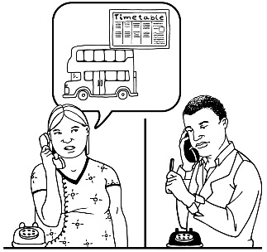

For example

help with timetable

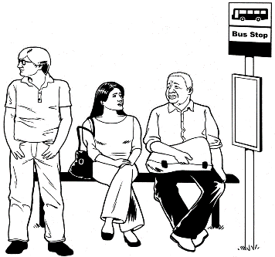

close bus stop

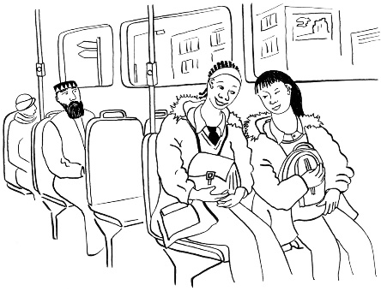easy to use

someone to travel with



1. What stops you using the Bus



1. Your ideas to make bus better



## When will we chat?





You need to choose a date for your location.



You do this online on a form called **consent form**

Using this link

<https://utaseducation.co1.qualtrics.com/jfe/form/SV_enVPuIzTuF81cDI>



Download Easy read consent form <https://www.anglicare-tas.org.au/trips-not-made/>

Or

Contact **Lisa**

Phone … 6226 2143



Email …. [lisa.stafford@utas.edu.au](mailto:lisa.stafford@utas.edu.au%20)



You will be asked

You want to chat with others.

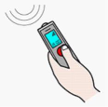

You okay that we record what you and others in the group tell us.

Only your voice will be recorded in a video call.



You can ask someone to help you.

* Like a friend or family member.



The community chats will be face to face.



But face-to-face may not be a choice with COVID-19.



So it may be a Video call.



+

## Who can be at a group chat?

You are 12 years and older



* People **under 18** need parent or guardian okay.

You must **live** in one of the community Locations in Tasmania

Like

* North West
* South East
* Outer Hobart

Any person in the community allowed.

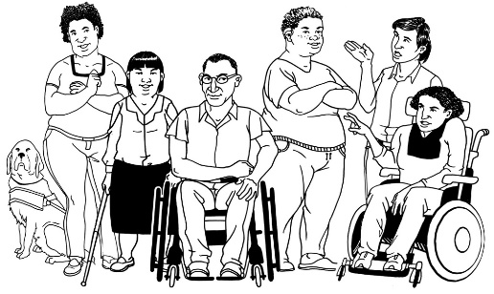

This includes people with disabilities, chronic illness, neurodiversity, Autism, mental illness.

## 

## Important information.



Your private information stays private.

We will keep information about you safe.

We may use the answers again in the future.

You can stop the chat at any time.



You can ask someone to help you.

* Like a friend or family member.

## What will you get from participating?

A report about the information you and others tell us.



We will give this to people and put it on the website.

Participation in this research project will **not** directly benefit you.



But may help make communities more inclusive in the future.

## Are there risks to me?

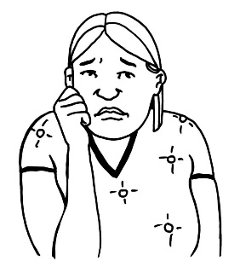

You may feel upset telling us about some things. Like what makes it difficult.



You do **not** have to tell us if you don’t want to.

You **choose** what to tell us.

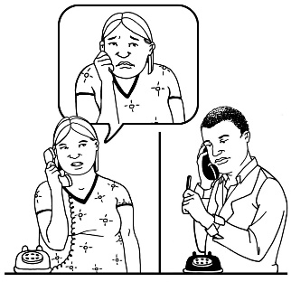

You can talk to a counsellor about things that made you really upset.

Call **Lifeline** on **13 11 14** for 24-hour telephone crisis support

Or

Call **Kids Helpline on 1800 551 800 for people age 5 to 25** years.



## For help or any questions contact

Ask Dr **Lisa** Stafford



Phone Lisa …6226 2143



Email …. [lisa.stafford@utas.edu.au](mailto:lisa.stafford@utas.edu.au%20)



**Not** happy with the research you can make a complaint to the **Executive Officer** of the HREC (Tasmania) Network

Say number H0024779.

Phone….03 6226 2975



Email……[human.ethics@utas.edu.au](mailto:human.ethics@utas.edu.au)



The project is funded by Anglicare Tasmania.



For more information visit [www.anglicare-tas.org.au/social-action-research-centre](http://www.anglicare-tas.org.au/social-action-research-centre)

**Images:** We used images from:

* Mayer-Johnson, Pictoselector
* Pixabay CC, Canva
* Pexels, The Change people <https://www.changepeople.org/gallery/media-gallery>
* Ted Grajeda, US, In the Australia Collection, <https://thenounproject.com/term/tasmania/410562/>

**Keep this information**