# Interview Participant Information

Easy English Version 2022

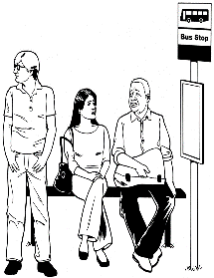

Information about **Public Transport** research.



**Interview** is a chat with a researcher

The word **chat** will be used in this form.



The research is by Social Actions Research Centre for Anglicare Tasmania. Also called **SARC**.



A researcher learns information to help make things better for people

The researcher is Dr **Lisa** Stafford

Lisa also works with University of Tasmania. Also called **UTAS**

Helping Lisa is Mary from SARC



The **research** wants to help make transport Inclusive for all people.

Like people with all disabilities, Autistic/neurodiverse people, people with mental illness and chronic illness



TasmanianPublic Transportis the **Bus**

Or



You may useothertransport like

**Taxis or wheelchair taxi, uber.**



**Inclusive** is having the same choice to travel in your community like everyone else.

Like

* Go to school or work
* Go to see friends
* Go to parks or shops



A group of people at **UTAS** check research so it is fair and helpful.

They are called human research ethics committee.



They said our research is okay.

The Research Ethics Approval Number is H0024779

We want to know



What is

* good about the bus
* bad about the bus



What helps you use the bus

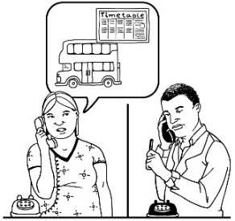

Like

* Help with timetable

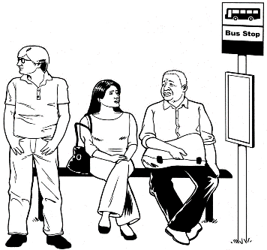

* close bus stop



* safe bus ride



We want to know

* What is hard about the bus
* What stops you using the bus



We want to know your ideas to make the bus better



**How do I get involved in a chat with Lisa?**

Contact **Lisa**

Phone … 6226 2143



Email …. [lisa.stafford@utas.edu.au](mailto:lisa.stafford@utas.edu.au%20)



Lisa will make a time to chat with you

## What will I be asked?

## In the chat

You will tell Lisa what you think.

## 

## Before you start the chat

## You need to agree to have the chat

## This is called consent.

Access consent form here

<https://www.anglicare-tas.org.au/trips-not-made/>



Complete it **and email it** .

Or



Download Easy read consent form <https://www.anglicare-tas.org.au/trips-not-made/>

Or

Contact **Lisa**

Phone … 6226 2143



Email …. [lisa.stafford@utas.edu.au](mailto:lisa.stafford@utas.edu.au%20)



You will be asked

You want to do the chat

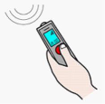

You okay that we record what you tell us.

Only your voice will be recorded in a video call.



You can ask someone to help you.

Like a friend or family member.



The chats will be on

a Video call like zoom



Or Phone.



## Who can do the chat?

You are young person or young adult



Between 12 to 30 years olds



* People **under 18** need parent or guardian okay.



You must **live** in one of the community Locations in Tasmania

Like

* North West
* South East
* 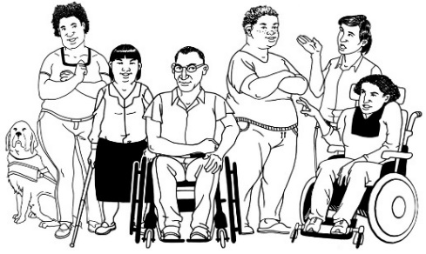Outer Hobart

You identify as a person with any disabilities, chronic illness, neurodiversity, mental illness.

## 

## Important information.



Your private information stays private.

We will keep information about you safe.

We may use the answers again in the future.

You can stop the chat at any time.



You can ask someone to help you. Like a friend or family member.

## What will you get from participating?

A report about the information you and others tell us.



We will give this to people and put it on the website

Participation in this research project will **not** directly benefit you.



But may help make communities more inclusive in the future.

## Parent Worried 2Are there risks to me?

You may feel upset telling us about some things. Like what makes it difficult.

You do **not** have to tell us if you don’t want to.

You **choose** what to tell us.

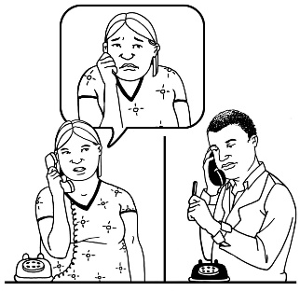

You can talk to a counsellor about things that made you really upset.

Call **Lifeline** on **13 11 14** for 24-hour telephone crisis support

Or

Call **Kids Helpline on 1800 551 800 for people age 5 to 25** years.



## For help or any questions contact

Ask Dr **Lisa** Stafford



Phone Lisa …6226 2143



Email …. [lisa.stafford@utas.edu.au](mailto:lisa.stafford@utas.edu.au%20)



**Not** happy with the research you can complain to the **Executive Officer** of the HREC (Tasmania) Network.

Say number H0024779.

Phone….03 6226 2975



Email……[human.ethics@utas.edu.au](mailto:human.ethics@utas.edu.au)



The project is funded by Anglicare Tasmania.



For more information visit [www.anglicare-tas.org.au/social-action-research-centre](http://www.anglicare-tas.org.au/social-action-research-centre)

**Images:** We used images from:

* Mayer-Johnson, Pictoselector
* Pixabay CC, Canva
* Pexels, The Change people <https://www.changepeople.org/gallery/media-gallery>
* Ted Grajeda, US, In the Australia Collection, <https://thenounproject.com/term/tasmania/410562/>

**Keep this information**