# Interview Participant Information

Easy English Version 2022

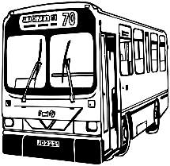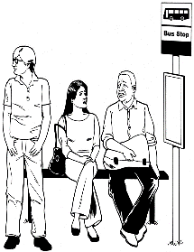

Information about **Public Transport** research.

**Activity interview** is a chat with a researcher

But before chatting you do an **activity**

The word **chat** will be used in this form.



The research is by Social Actions Research Centre for Anglicare Tasmania. Also called **SARC**.



A researcher learns information to help make things better for people

The researcher is Dr **Lisa** Stafford

Lisa also works with University of Tasmania. Also called **UTAS**

Helping Lisa is Mary from SARC

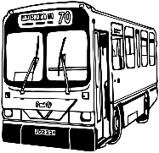

The **research** wants to help make transport Inclusive for all people.

Like people with all disabilities, Autistic/neurodiverse people, people with mental illness and chronic illness



TasmanianPublic Transportis the **Bus**

Or

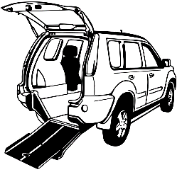

You may useothertransport like

**Taxis or wheelchair taxi, uber.**



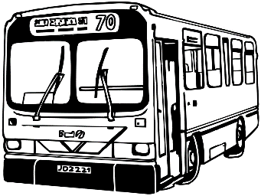**Inclusive** is having the same choice to travel in your community like everyone else.

Like

* Go to school or work
* Go to see friends
* Go to parks or shops



A group of people at **UTAS** check research so it is fair and helpful.

They are called human research ethics committee.



They said our research is okay.

The Research Ethics Approval Number is H0024779

**The Activity**

Complete **1** activity about using the bus

We want to know



What is

* good about the bus
* bad about the bus



What helps you use the bus

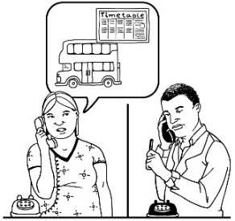

Like

* Help with timetable

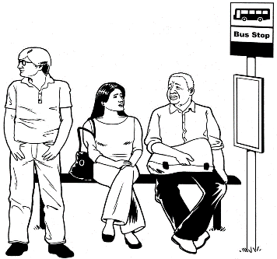

* close bus stop

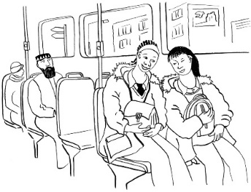

* safe bus ride

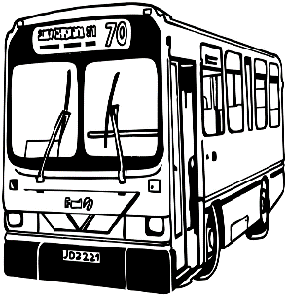

We want to know

* What is hard about the bus
* What stops you using the bus



We want to know your ideas to make the bus better



**First**

Choose activity

For 1 week



Make notes about using the bus

We call this e-travel diary

****OR

Take photos or make a video about using the bus

We call this **photo-video voice**



Both activities

Use **your** mobile phone



**No** data needed.



**When completed phone or email Lisa**



Lisa will then make a time to chat with you about what you have made

**E-diary Activity**

**What will I be asked to do?**



Use the notes app on your mobile phone.

This is available on android, i-phone, Samsung.

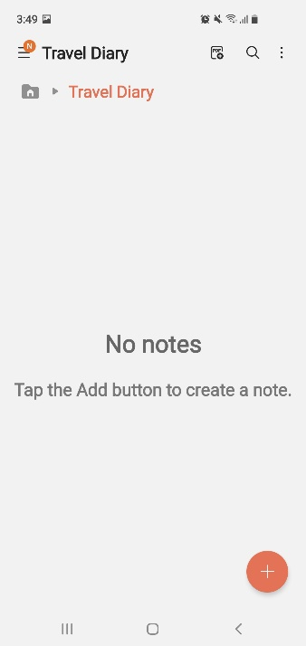

Create a new folder

Call it Travel Diary

For each day you travel

* Create a new note to folder
* Do this using the + button
* Add title and Day

Things to note:

Usual things you do

Like

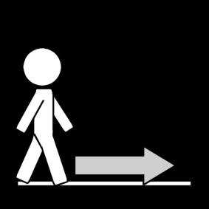

* Getting to the bus,



* What bus you took

How you felt

Like

* Good bus trip



Any problems

Like

* I missed the bus

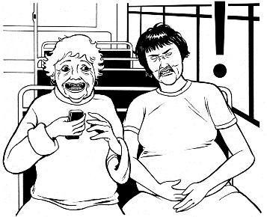

* Annoying passenger



**How to make a note**

* Type words
* Use Texting style. Not full words.



* Emojis



* Use talk to text



* Attach objects. Like photo of bus stop

Don’t have your phone

You can **just write you notes on paper**

**Photo/Video Activity - What will I be asked to do?**

In this activity you **show** us what using transport is like.

take photos

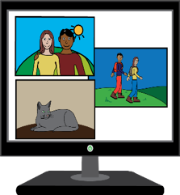Or

make a short video

**You are to do 2 things**



Take up to 6 photos

or

Make a short video up to 2 mins long

That shows us what helps you use the bus



Like

* Ease to read timetable

* close bus stop



* easy and safe

**Or**

**2.** Take up to 6 photos



or

Make a short video up to 2 mins long

About things that make it hard to use the bus

Like

• Bus information

• Access to bus stop

• No buses

**What to use to take photos?**

You can use your camera.



You can use your phone or tablet to take a picture or video.



You can use video camera to take video. Like a GoPro.

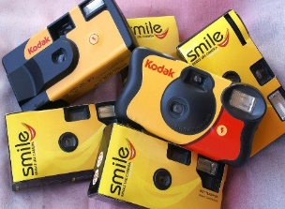

If you do not have a phone or camera contact us.

We can post you a disposal camera



Phone Lisa …6226 2143



Email …. [lisa.stafford@utas.edu.au](mailto:lisa.stafford@utas.edu.au%20)

**List to help take photos**



You can ask a family member or friend to help you.



Take photos of whole objects



Do **not** take picture of people’s faces



You can take photos of people’s back. Like from behind.

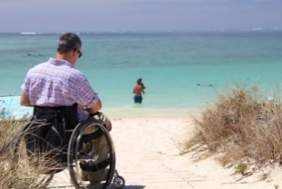

Take photos of person and background.



You can take a picture that reminds you of something.

Do **not** take photos straight into the sun.



Take photos with the sun behind you or in the shade.

Check your photo. Take another if unsure.





**What do I do after completing Activity**?

Contact **Lisa**

Phone … 6226 2143



Email …. [lisa.stafford@utas.edu.au](mailto:lisa.stafford@utas.edu.au%20)

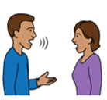

Lisa will make a time to chat with you about your activity e-diary or photo/videos.

## What will I be asked?

## In the chat

You will tell Lisa about your completed activity

You will tell us what you think.

## 

## Before you start the activity

## You need to agree to do the activity?

## This is called consent.

Access consent form here

<https://www.anglicare-tas.org.au/trips-not-made/>



Complete it **and email it** .

Or



Download Easy read consent form <https://www.anglicare-tas.org.au/trips-not-made/>

Or

Contact **Lisa**

Phone … 6226 2143



Email …. [lisa.stafford@utas.edu.au](mailto:lisa.stafford@utas.edu.au%20)



You will be asked

You want to do the activity plus chat

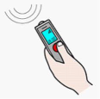

You okay that we record what you tell us.

Only your voice will be recorded in a video call.



You can ask someone to help you.

Like a friend or family member.



The chats will be on

a Video call like zoom



Or Phone.

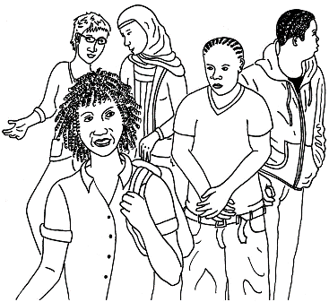

## Who can do activity chat?

You are young person or young adult



Between 12 to 30 years olds



* People **under 18** need parent or guardian okay.



You must **live** in one of the community Locations in Tasmania

Like

* North West
* South East
* 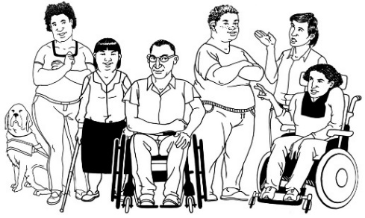Outer Hobart

You identify as a person with any disabilities, chronic illness, neurodiversity, mental illness.

## 

## Important information.



Your private information stays private.

We will keep information about you safe.

We may use the answers again in the future.

You can stop the chat at any time.



You can ask someone to help you. Like a friend or family member.

## What will you get from participating?

A report about the information you and others tell us.



We will give this to people and put it on the website

Participation in this research project will **not** directly benefit you.



But may help make communities more inclusive in the future.

## Parent Worried 2Are there risks to me?

You may feel upset telling us about some things. Like what makes it difficult.

You do **not** have to tell us if you don’t want to.

You **choose** what to tell us.

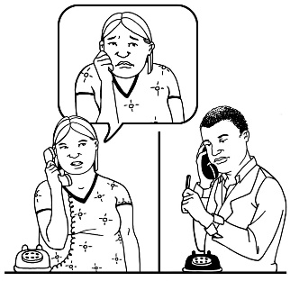

You can talk to a counsellor about things that made you really upset.

Call **Lifeline** on **13 11 14** for 24-hour telephone crisis support

Or

Call **Kids Helpline on 1800 551 800 for people age 5 to 25** years.



## For help or any questions contact

Ask Dr **Lisa** Stafford



Phone Lisa …6226 2143



Email …. [lisa.stafford@utas.edu.au](mailto:lisa.stafford@utas.edu.au%20)



**Not** happy with the research you can complain to the **Executive Officer** of the HREC (Tasmania) Network.

Say number H0024779.

Phone….03 6226 2975



Email……[human.ethics@utas.edu.au](mailto:human.ethics@utas.edu.au)



The project is funded by Anglicare Tasmania.



For more information visit [www.anglicare-tas.org.au/social-action-research-centre](http://www.anglicare-tas.org.au/social-action-research-centre)

**Images:** We used images from:

* Mayer-Johnson, Pictoselector
* Pixabay CC, Canva
* Pexels, The Change people <https://www.changepeople.org/gallery/media-gallery>
* Ted Grajeda, US, In the Australia Collection, <https://thenounproject.com/term/tasmania/410562/>

**Keep this information**