Tips for completing Transport Activity & Interview

We want to know your experiences of using transport in your community.

This includes good and bad in using the bus across the whole journey - access to information, from home to bus stop, to destination (school, work, shops) and return

This may include
- Ease of access to the timetable
- availability of the bus
- The bus stop
- easy and safety in using the bus

We also want to know what makes it difficult or stops you from using the bus.

Also keen to hear about your ideas and the priorities for making transport better for everyone in your community.

To Get Started:
First
Choose activity

Make notes about using transport for 1 week. Like using the bus.
We call this e-travel diary.

Or

Take photos /video about using transport. Like using the bus. We call this photo-video voice. You have a month to do this.

Both activities

Can be done on your mobile phone

No data needed.

When completed, contact the researcher Dr Lisa Stafford and she will make a time to chat with Lisa the researcher about what you have created.

What to do if doing the E-diary Activity
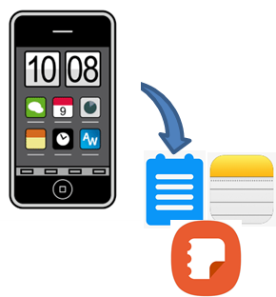
Use the notes app on your mobile phone.

This is available on android, i-phone, Samsung.

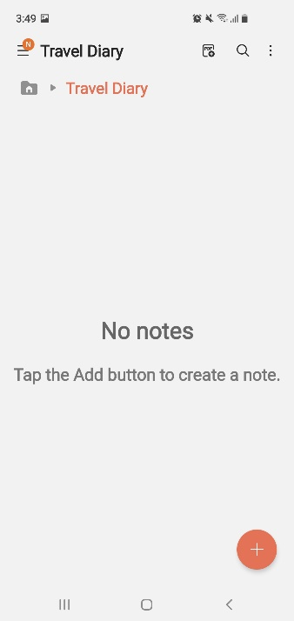
Create a new folder
Call it Travel Diary

For each day you travel
- Create a new note to folder.
- Do this using the + button
- Add title – Use the Date

Things to note:
Usual things you do
Like
- Getting to the bus,
- what bus you took

How you felt
Like
- ok bus trip, felt safe

Any problems
Like
- I missed the bus
- Annoying passenger

How to make a note entry
- Just type what comes to mind about your experience.
- That’s why doing it why you travel makes it easier.

You can use
- Texting style. Like LOL, OMG. You don’t have to use full words.
- Can use Emoji’s

- Can use talk to text
- Can attach objects. Like photo of bus stop. If you attach photos avoid any with other people’s faces.

If you don’t have your phone, just write notes on paper.

Remember to save.

When you catch up with Lisa for the interviews, Lisa will use her data (hotspot) and ask you to share your entries with her via her secure work laptop.

What to do if doing the Photo/Video Activity
In this activity you show us what using transport is like in your community.

Do this by take photos or make a short video

You are to do 2 things
- Take 1 to 6 photos or a short video that shows us what is good, or helps use public transport in your community?

If nothing this is okay, you can focus on just on what you want to change and fix.

2. Take 1 to 6 photos or a short video of things that make it hard or stops you using the Bus.
This can also include things you want to fix or change to make transport better.
This could include examples form elsewhere that you would like to have in your community to make public transport better for all.

What to use to take photos?
- You can use your camera.
- You can use your phone or tablet to take a picture or video.
- You can use video camera to take video. Like a GoPro.
If you do not have a phone or camera contact us.
We can post you a disposal camera
Phone Lisa….. 03 6226 2143
Or
Email….. lisa.stafford@uts.edu.au or sarc@anglicare-tas.org.au

List to help take photos
You can ask a family member or friend to help you.
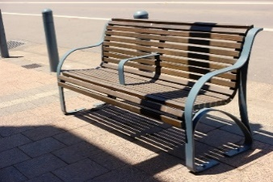

Take photos of whole objects

Do not take pictures of people’s faces.

You can take photos of people’s back. Like from behind.
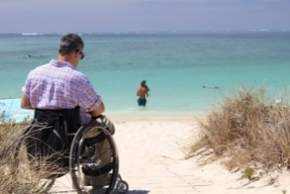
Take photos of person and background.

You can take a picture that reminds you of something.

Do not take photos straight into the sun.

Take photos with the sun behind you or in the shade.
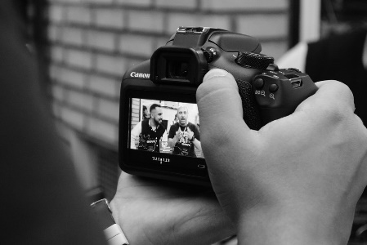

Check your photo. Take another if unsure.

Remember to save your photos.

What do I do after completing Activity?
Contact Lisa
Phone … 1800 243 232 ask for Lisa

Email …. sarc@anglicare-tas.org.au
Lisa will make a time to chat with you about your activity - e-diary or photo/videos.
When you catch up with Lisa for the interviews, Lisa will use her data (hotspot) and ask you to share your photos with her via her secure work laptop. Please do not upload photos and always respect other people’s privacy.

