
Rental Affordability

Snapshot

Tasmania 2023

Selina Claxton and Mary Bennett

WORKING FOR
A JUST TASMANIA

Contents

3 Anglicare’s experience in housing services and advocacy
4 Key findings
5 Availability
6 Affordability
8 Regional analysis
8 South
10 North
12 North West

14 Growth in weekly median rent is vastly outstripping income support
17 Older Tasmanians need their own homes in their own communities
20 Homelessness is putting the wellbeing of the next generation at risk
24 The private rental market is failing people living with disabilities
28 Recommendations
29 FAQ

Anglicare’s experience in housing services and advocacy

Anglicare Tasmania is a large community service organisation in Tasmania with offices in Hobart, Glenorchy, Launceston, St Helens, Devonport, Burnie, Sorell and Zeehan and a range of programs in rural areas. Anglicare’s services include crisis, short-term and long-term accommodation support; support services following a motor vehicle accident; aged and home care services; alcohol and other drug services; financial and gambling counselling; and child, youth and family support. In addition, Anglicare’s Social Action and Research Centre (SARC) conducts research, policy and advocacy with a focus on issues affecting Tasmanians on low incomes who are disadvantaged or vulnerable.
Anglicare Tasmania is committed to achieving social justice for all Tasmanians. It is our mission to speak out against poverty and injustice and offer decision-makers alternative solutions to help build a more just society. We provide opportunities for people in need to reach their full potential through our services, staff, research and advocacy.
Anglicare delivers a range of housing services including Housing Connect, housing support services, long-term communal or independent housing for people on a low income including some options for age-specific cohorts, and three youth to independence services with accommodation and crisis accommodation.
Every year since 2007, SARC has analysed the rental market across Tasmania for the Rental Affordability Snapshot. Our research projects have looked at the housing and accommodation needs of people experiencing mental health conditions, young people, unaccompanied homeless children, and families trying to reunite. Our research has also identified the need for safe and affordable housing to address other issues such as teen domestic violence and abuse.

Key findings
The Rental Affordability Snapshot has been published since 2007, when Anglicare Tasmania first tested whether it was possible for people on low incomes to afford to rent a home in the private rental market. It has since been taken up nationally by Anglicare Australia and runs annually in agencies around the country.
The Snapshot looks at all properties listed for rent on realeastate.com.au and gumtree.com.au on a weekend at the end of March every year. We then assess whether each property is affordable and appropriate for 14 types of households on low incomes, including young people, single parents, working families, older people and those dependent on Centrelink benefits. For more details on our methodology, please see the FAQ (p. 29).
The report also presents case studies that show the experiences of people on low incomes searching for housing in Tasmania’s private rental market today. They are all real people who are clients of Anglicare services. Names and some details have been changed to protect their privacy.
This year’s Snapshot also explores trends from our data over the past decade.
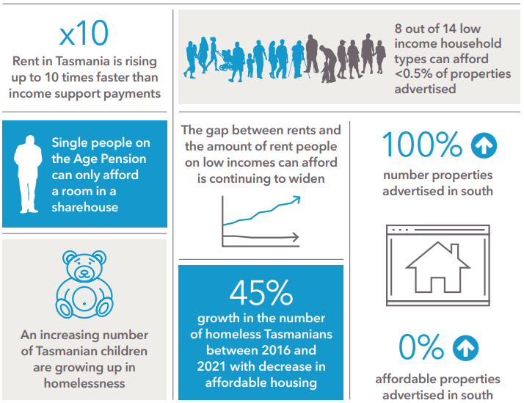

Availability
In 2023, there were 1037 properties listed for long-term residential lease across Tasmania on the Snapshot weekend. This is a 41% increase on the 737 properties found in 2022.
However, the increase in the number of properties advertised occurred only in the South of the state. Numbers in the North and North West have remained steady.

Number of properties advertised in Tasmania
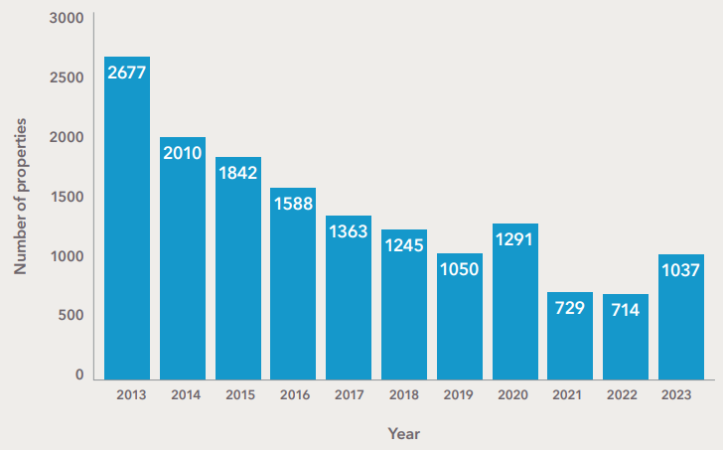

Figure 1. Number of private rental properties advertised in Tasmania on Snapshot weekend, 2013-2023.

.

Affordability
The increase in the number of properties has not translated into increased affordability for most low-income households. People on the lowest incomes, such as Youth Allowance and Jobseeker, will still find 0 properties in their price range. People on these payments urgently need a substantial increase to their income to raise them out of extreme rental stress.
By comparison, a single person on the minimum wage will be able to find 90 affordable properties in this year’s Snapshot, although many of these will be sharehouses. This is less than a quarter of the 384 properties that would have been available for them a decade ago in the 2013 Snapshot.
People receiving the Age Pension or Disability Support Pension, a higher rate of payment, will find 48 affordable sharehouses, but only 3 affordable units or houses. Although sharehouses are a positive experience for many people, they are often not practical for those with physical disabilities and may not be an option for those with mental health conditions. Older people, too, are unlikely to want to live in a sharehouse with strangers, and may have a lifetime of accumulated possessions that will not fit in a single room.
A couple on the Age Pension can combine their incomes to afford one of 15 small units and studios found this year.
Children whose parents receive government benefits as their main income are at risk of homelessness or poverty in today’s rental market. A single parent with one young child will find just 3 affordable two-bedroom properties advertised in Tasmania, and there are 4 three-bedrooms for a parent of two children. A couple on Jobseeker with two children will find 5 three-bedroom properties they can afford, and a single parent on Jobseeker with an older child will find nothing.
Children whose parents earn a full-time minimum wage are in a better position. There are 223 affordable properties for a working couple with two children, 21% of the total number advertised. This drops to 90 (9%) if only one parent works and the other receives Parenting Payment. Single-parent families are likely to experience rental stress. Even if they work full-time, a parent of two children, requiring a three-bedroom home, will find only 9 properties they can afford, and these are unlikely to be in major metropolitan areas close to work and school.

Data
Cohort | Household type | Income type | Max weekly rent | Number affordable and appropriate | Percentage affordable and appropriate | Number by region
Young people | Single  (18+) | Youth Allowance | $88 | 0 | 0% | South: 0  North: 0  North West: 0
Young people | Single  (in a share house) | Youth Allowance | $88 | 0 | 0% | South: 0  North: 0  North West: 0
Single adults | Single | Jobseeker Payment | $114 | 0 | 0% | South: 0  North: 0  North West: 0
Single adults | Single  (21+) | Disability Support Pension | $181 | 3 | 0% | South: 0  North: 0  North West: 3
Single adults | Single | Minimum wage | $212 | 90 | 9% | South: 55  North: 24  North West: 11
Older people | Single | Age Pension | $181 | 48 | 5% | South: 29  North: 10  North West: 9
Older people | Couple  (no children) | Age Pension | $260 | 15 | 2% | South: 1  North: 5  North West: 10
Single parents | Single, one child  (8+) | Jobseeker Payment | $178 | 0 | 0% | South: 0  North: 0  North West: 0
Single parents | Single, one child  (<5) | Parenting Payment Single | $225 | 3 | 0% | South: 0  North: 0  North West: 3
Single parents | Single, two children (one <5, one <10) | Parenting Payment Single | $255 | 4 | 0% | South: 0  North: 0  North West: 4
Single parents | Single, two children (one <5, one <10) | Minimum wage + FTB A and B | $329 | 9 | 1% | South: 0  North: 0  North West: 9
Couples with children | Couple, two children (one <5, one <10) | Jobseeker Payment (both adults) | $290 | 5 | 0% | South: 0  North: 0  North West: 5
Couples with children | Couple, two children (one <5, one <10) | Minimum wage + Parenting Payment (partnered) + FTB A and B | $386 | 51 | 5% | South: 5  North: 17  North West: 29
Couples with children | Couple, two children (one <5, one <10) | Minimum wage + Family Tax Benefit A | $491 | 223 | 21% | South: 60  North: 90  North West: 73

Regional analysis

South

Availability
The number of properties advertised in the South has almost doubled, from 323 in 2022 to 637 in 2023. The increase has been across different types of properties, from sharehouses (an 86% increase) to three-bedroom homes (a 95% increase).
This may be driven by an increase in the absolute number of properties available for long-term rental, an increase in lease turnover for existing rental properties, or a combination of both.

.

Number of properties advertised in the South
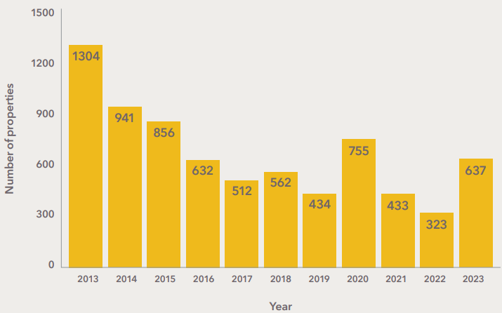

Figure 2. Number of private rental properties advertised in Southern Tasmania on Snapshot weekend, 2013-2023.

Affordability
The increase in the number of properties advertised has not resulted in increased affordability, with median weekly rent rising to $500 from $495 last year and little change for people on low incomes. Of the 14 types of low-income households, only five could afford any of the properties.
Families with both parents earning a fulltime minimum wage could afford 60 (9%) of appropriate properties in the market. However, if one of the two parents received Parenting Payment instead of wages, the family’s choice was limited to only 5 properties.
Single parent families, whether they are employed or not, and families receiving only government income support, could not afford any properties in the South.
An elderly couple receiving the Age Pension would find only one bedsit they could afford, a small rural studio in the Huon Valley.

For single adults, the only affordable properties in the South are sharehouses. There are 55 that are affordable for a person on a full-time equivalent minimum wage, and 29 affordable for a person on Age or Disability Support Pension. Living alone without flatmates is not possible in the South for people on low incomes unless they go into rental stress. Single people on Jobseeker or Youth Allowance cannot afford to rent any property in the South.

North

Availability
The number of properties advertised for rent in the North is unchanged from 2022 at 277.
Although the market has not further contracted, vacancy rates in Launceston have hovered around 1% since the end of COVID lockdowns in mid 2020. Launceston has not seen a healthy vacancy rate of 3% since 2014.

.

Number of properties advertised in the North

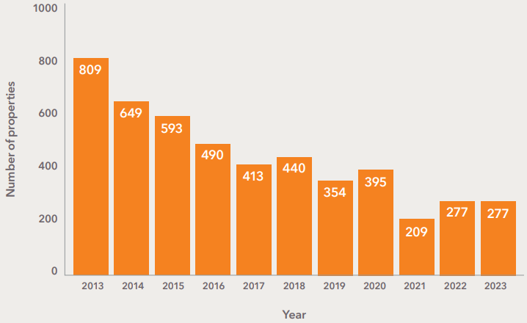

Figure 3. Number of private rental properties advertised in Northern Tasmania on Snapshot weekend, 2013-2023.

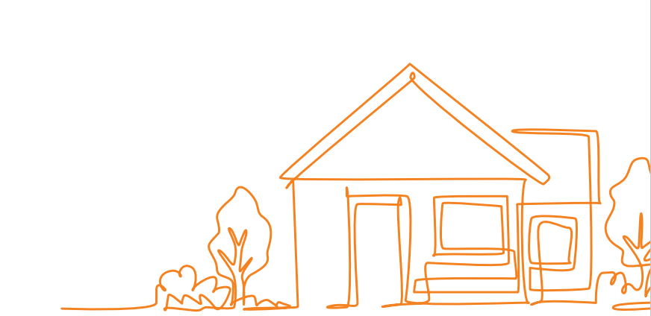

Affordability
Only 18 three-bedroom properties were advertised for under $400 per week in the North. All of these are out of reach for a working single parent, whose family would be in financial hardship.
The Snapshot found only one unshared unit in the North, located in George Town, that was affordable for a single working adult. As in the South, single people in Launceston could only afford sharehouses. Ten of these would also have been affordable for a person on Age or Disability Support Pension. While sharing may benefit some people, it is not appropriate for everyone and can be unsuitable for people with some mental health conditions.
There were five bedsits and small units affordable for a couple on the Age Pension.
All other household types studied in the Snapshot – single parents on income support, couples receiving Jobseeker with children, and single adults on Jobseeker or Youth Allowance – could not afford a private rental in the North.
One welcome change is an 83% increase in the number of mid-priced three-bedroom properties in the Snapshot that are affordable for a couple on the minimum wage (both adults working full time). Given that the total number of three-bedroom properties advertised has increased by only 22%, this represents a welcome improvement in affordability for this section of the market.

North West

Availability
There were 123 properties advertised on Snapshot weekend in the North West, almost the same as in 2022 (121 properties). The North West has been severely affected by lack of supply since the housing crisis began to bite in 2018.

.

Number of properties advertised in the North West

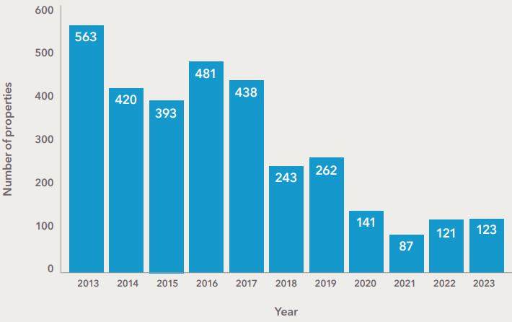

Figure 4. Number of private rental properties advertised in North Western Tasmania on Snapshot weekend, 2013-2023.

Affordability
The North West region includes the remote West Coast, where the cheapest rentals in Tasmania can be found. Therefore, the majority of affordable properties for very low-income household types in the North West are likely to be located in towns such as Queenstown and Zeehan, where jobs are scarce, public transport is extremely limited, and access to services such as medical specialists is difficult.
Median rent per week in the North West has increased by $50 over the last 12 months, from $330 to $380. This is still comfortably within the budget of a family on the minimum wage requiring a three-bedroom home, who will find 73 affordable properties if both parents work and 29 if one parent works and the other receives Parenting Payment. Even a working single parent, who will be in rental stress anywhere else in Tasmania, will find 9 affordable three-bedroom properties.
The 10 household types receiving only government income support cannot afford rent above $290 per week. There are only 9 properties in this range suitable for a family, half of them located in Queenstown. Some types of payments are even more limiting — single parents with children over 8 years are only eligible for Jobseeker, a very low rate of payment. These parents will not find an affordable two-bedroom home even in the remotest parts of Tasmania.
People on Age or Disability Support Pension will find 9 properties they can afford, 5 of which are rooms in sharehouses. Sharehouses account for only 7% of the advertised properties in the North West, reducing the options for single people. Even a person receiving a fulltime minimum wage will find only 11 affordable properties. A single person on Jobseeker or Youth Allowance cannot find affordable accommodation in the North West.



Growth in weekly median rent is vastly outstripping income support

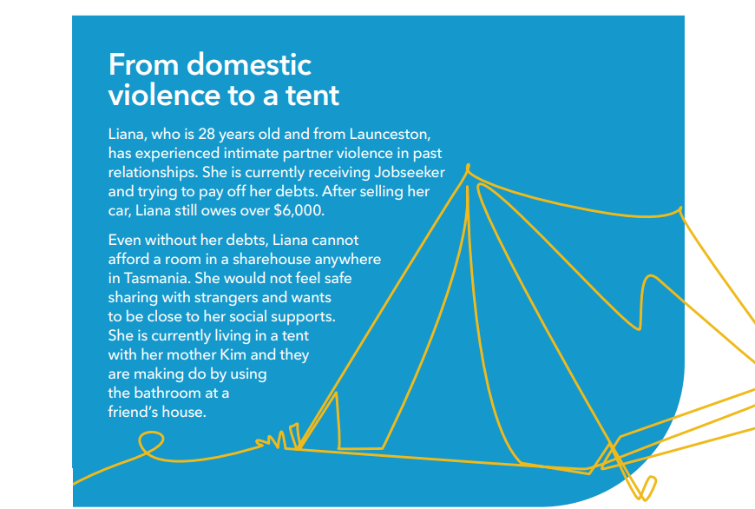

Trend data from the Snapshot shows that over the past decade median weekly rent in Tasmania has grown almost 8 times faster than the rent a person receiving Jobseeker can afford to pay (Figure 5). The cost of the cheapest room in a sharehouse has risen twice as fast as the rent they can afford. The situation for people subsisting on Youth Allowance was even more serious with median rents growing 10 times more than the amount they could afford to pay.
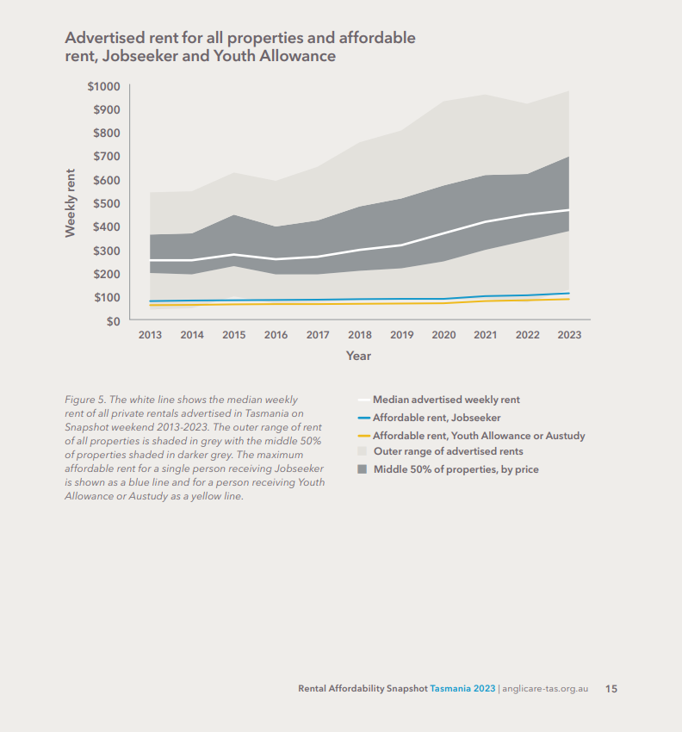

The 2023 Snapshot showed that people receiving Jobseeker or Youth Allowance cannot afford any private rental accommodation in Tasmania.
Lack of affordable housing for people like Liana can force them into situations with an increased risk of family violence and make it difficult to leave dangerous relationships. It is common for family violence to have significant financial impacts for victim-survivors, including debt.
Recently published SARC research revealed that for teens experiencing domestic violence, lack of affordable housing and insufficient income similarly trap teenagers in abusive intimate partner relationships. The very low rate of Youth Allowance reduces their options further.

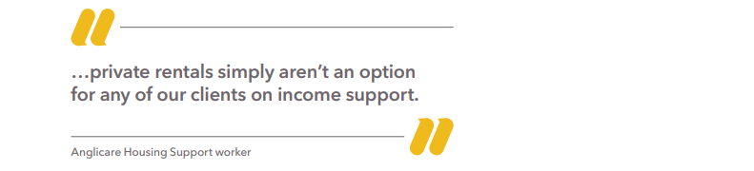



Older Tasmanians need their own homes in their own communities
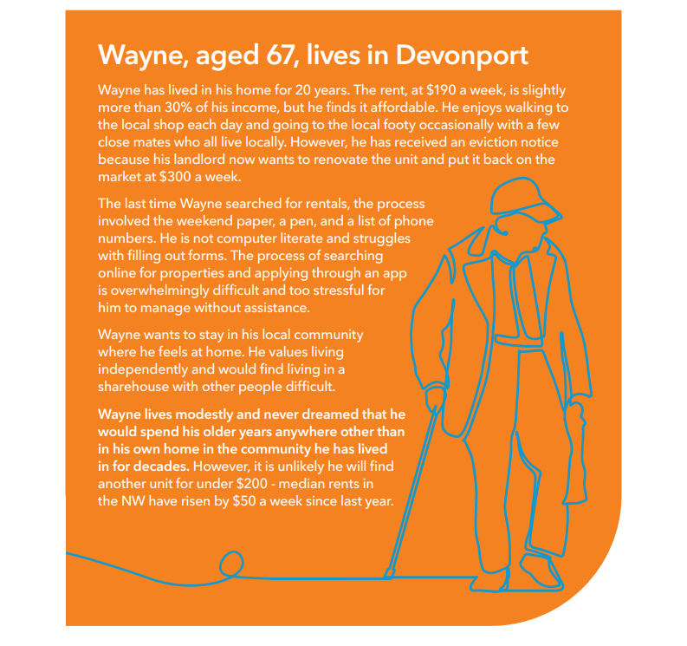
On Snapshot weekend, there were 48 private rentals advertised across Tasmania that, on paper, were affordable and appropriate for Wayne (see map in Figure 6). Forty-five of these rentals were single rooms in shared accommodation (shown in blue on map) – none were in Devonport (shown in orange on the map). The closest was 36km away in Sulphur Creek and the rest were 50km or more away.
The only 3 affordable properties not in shared accommodation were located over 180km away in Zeehan and Queenstown (shown in yellow).
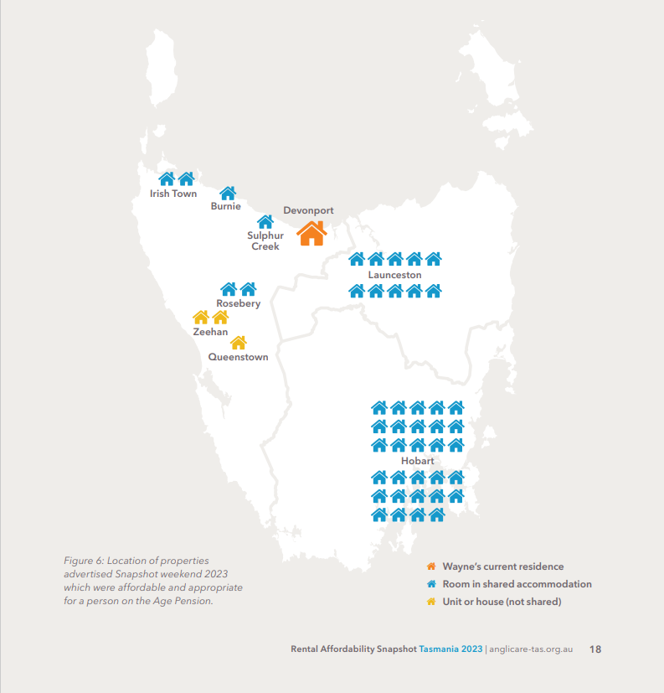

Snapshot trend data shows that since 2016, median weekly rent for one-bedroom self-contained properties in Tasmania has grown 7 times faster than the amount that a single person on an Age Pension can afford to pay (see Figure 7 below).
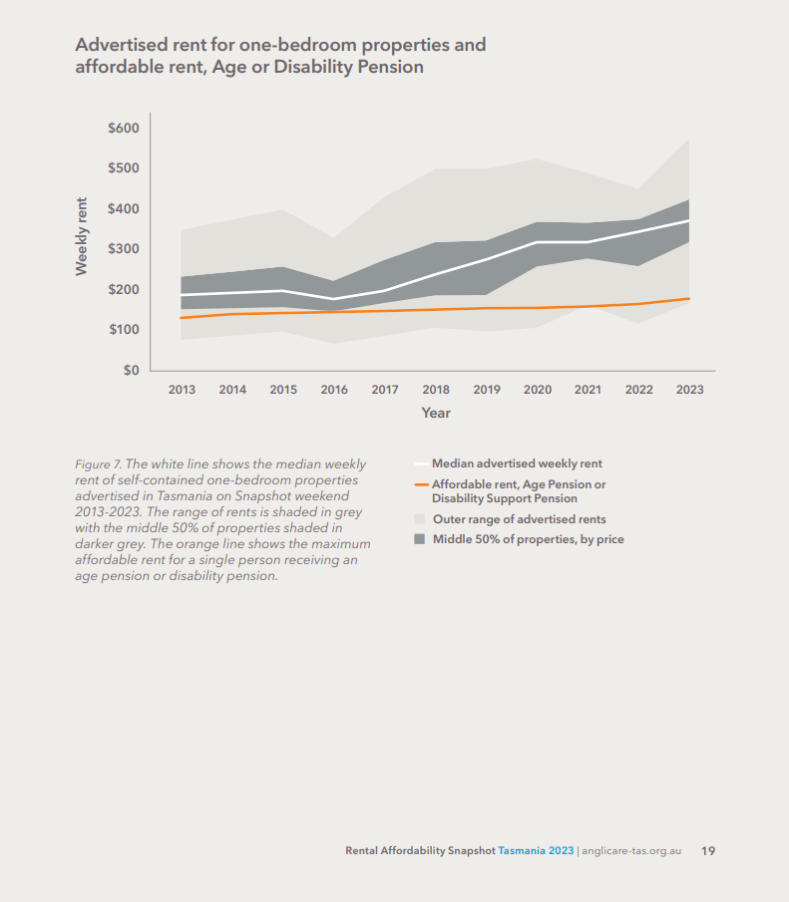

Homelessness is putting the wellbeing of the next generation at risk
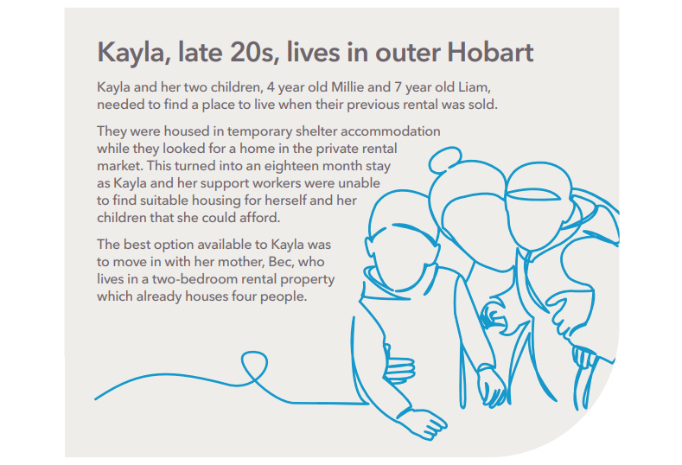

Kayla can afford $255 a week in rent and needs a three-bedroom rental property for her family. On Snapshot weekend, there were 4 suitable properties advertised. However, none was located in the south of the state. Located in Hillcrest, Zeehan and Queenstown, the closest private rental available is 260km away from Kayla’s community, her mother Bec and other social supports.

For single parents of 2 children on income support like Kayla, Snapshot trend data shows that median weekly rent has grown 6 times faster than the amount she can afford to pay in rent (see Figure 8). Private rentals in the south of the state are well beyond their means.
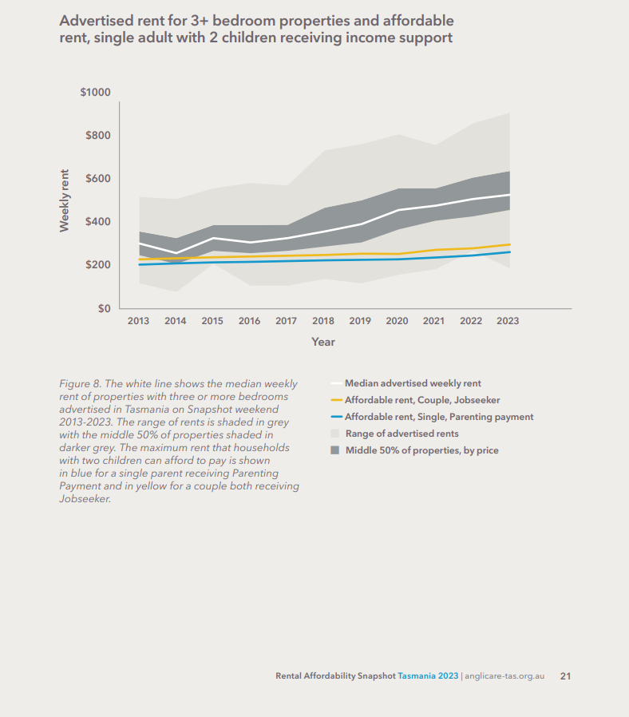

For single parents of one child receiving income support, there are no affordable private rentals anywhere in the state (see Figure 9).
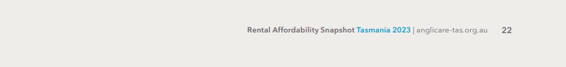
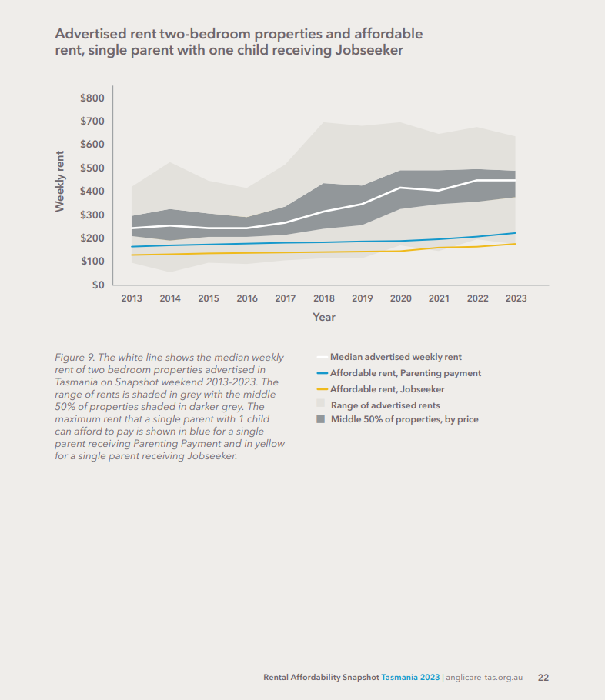
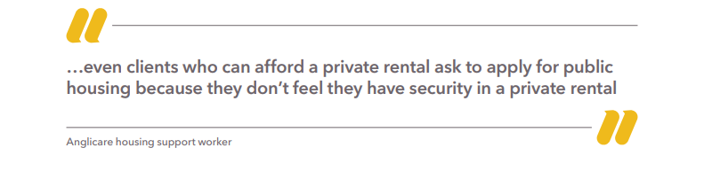
Kayla sees public housing as her family’s only option for a secure home.

With seven people now living in a two-bedroom rental property, Kayla’s children are growing up in a severely overcrowded home and are considered homeless by the Australian Bureau of Statistics.
Research shows that children like Millie and Liam living in severely overcrowded housing are at higher risk of emotional and behavioural problems and reduced school performance, partly due to lack of good quality sleep. Their mother Kayla is likely to experience distress due to her lack of control over her living conditions and there is greater risk of family conflict. Some overcrowded living arrangements may increase the risk of child abuse. Overcrowding can also contribute to child mental and physical health conditions, including anxiety, depression and asthma.
The failure of the private rental market to provide secure affordable housing for Tasmanian families has been reported in the Rental Affordability Snapshot by Anglicare since 2007. The current focus of the Federal and State Governments to address the current housing crisis is welcome. For Millie and Liam, it is unlikely that government action to provide housing will come soon enough to avoid the developmental impacts of homelessness and overcrowding.

The private rental market is failing people living with disabilities
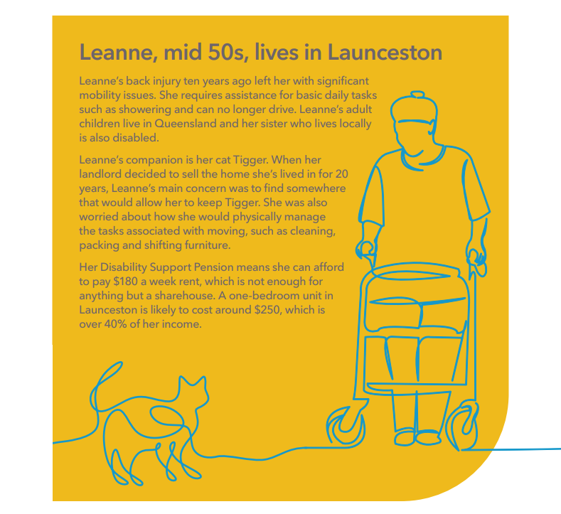

On Snapshot weekend, there were no affordable properties advertised in Launceston. Only three potentially appropriate properties in the state were affordable for Leanne, two in Zeehan and one in Queenstown. Even if the houses met Leanne’s physical requirements and allowed her to keep her cat, their remote location over 230km from Launceston and the support services she requires means that they are not an option.
A healthy private rental market with a vacancy rate in the range of 2-3% is still unlikely to meet the varied and specific needs of people living with disabilities without government intervention.
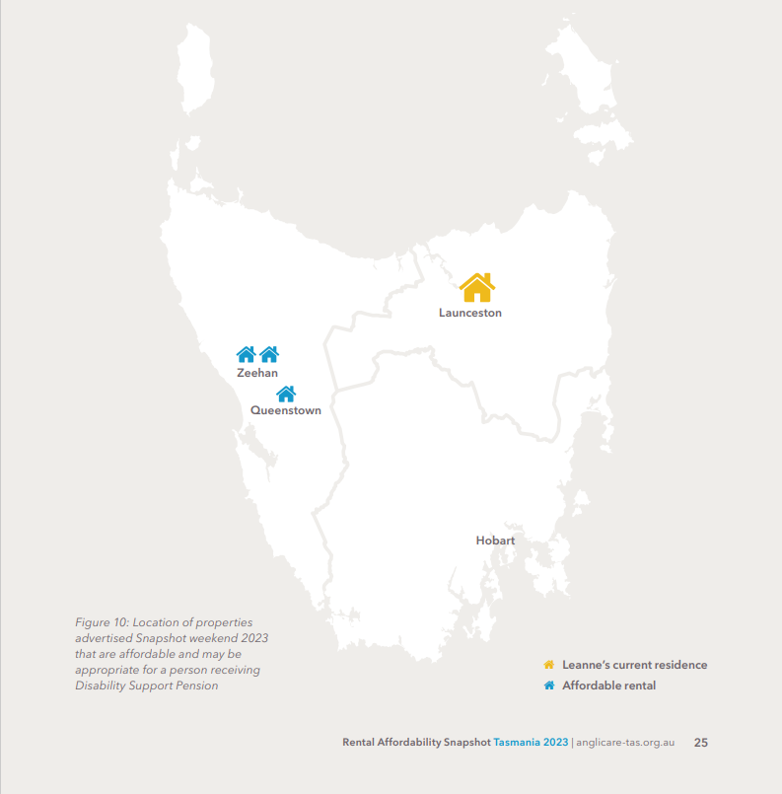

Discussion
Tasmania continues to have the least affordable rental market in the country. The ABS census found that Tasmania’s increase in homelessness between 2016 and 2021 was the highest of all the states at 45%. This is unsurprising in light of the trend data from the Rental Affordability Snapshot.
The 2023 Snapshot data shows that people on income support cannot afford to rent housing in the private rental market in Tasmania. Examination of Snapshot trend data shows that the problem continues to intensify as the gap is widening between private market rents and the amount that people on low incomes can afford to pay.
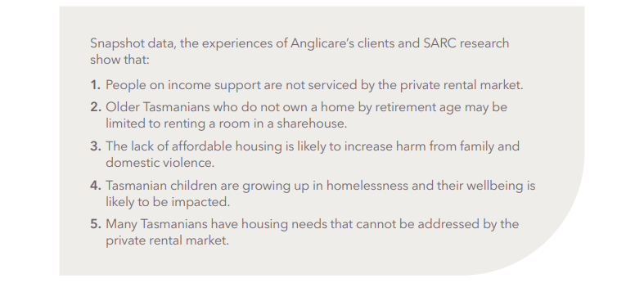

Anglicare Tasmania identified the lack of affordable housing provided by the private rental market at least seventeen years ago when it first published its rental market snapshot. We have previously recommended an increase in housing supply but it is not the complete answer.
The number of private rentals advertised in the South increased twofold in this year’s Snapshot. It is not clear to what extent the increase in the number of properties advertised in the South reflects an increase in the number of long-term rentals in the market. However, the Snapshot data shows that this increase in apparent availability has not been accompanied by an increase in affordability. Increased investment in the private rental market is clearly not addressing the urgent need for affordable housing.
Develop a framework with targets for maintaining a healthy housing market
We acknowledge that the Federal and state governments are working to address the housing crisis. However, it is difficult to address the lack of affordable housing now that it is a longstanding issue. Like inflation, it is better to act early to prevent a crisis.
Just as unemployment and inflation are monitored and targeted to maintain economic stability, the State Government should articulate a clear framework with targets that guides government investment and intervention to maintain a stable and healthy housing market and ensure that all Tasmanians have access to affordable and appropriate housing. For example, a target range for rental vacancy rates might be used to guide investment by government in local housing markets. This would benefit both investors and renters.
Invest to meet needs not addressed by the private rental market
Even an affordable private rental market will not meet the housing needs of many disadvantaged Tasmanians. Adequate investment in specialist accommodation and supporting services is required for Tasmanians whose needs go beyond simply providing a roof over their heads. This includes people who need assistance to maintain a tenancy, people living with disabilities and people who are unable to live independently.
Increase security of tenure in the private rental market
The lack of security of tenure for private tenants is resulting in people preferring to apply for public housing rather than live in a private rental accommodation. We know that community connection, continuity of schooling and social supports are important determinants of health and wellbeing. Increasing security of tenancy has significant public benefits and review of the Residential Tenancy Act to address this and other issues should be considered.

Recommendations

State Government
Anglicare Tasmania recommends that the State Government:
- Articulate a transparent framework with targets that guide government investment and actions to maintain a stable and healthy housing market and ensure that all Tasmanians have access to affordable and appropriate housing.
- Invest in affordable social housing, support services and supported accommodation to meet housing needs that cannot be met by the private rental market.
- Review and reform the Residential Tenancy Act to ensure
  - tenants are not evicted into homelessness
  - prospective tenants are not discriminated against on the basis of parenthood, unemployment or pet ownership
  - tenants have improved security of tenure.
- Review policy settings to ensure that they are likely to increase or have a neutral impact on the supply of affordable rental housing.

Federal Government
Anglicare Tasmania recommends that the Federal Government:
- Raise the rate of Centrelink benefits, especially Jobseeker Payment.
- Raise the rate of Commonwealth Rent Assistance to reflect current rental prices.
- Increase the supply of affordable and social housing, building on programs such as the National Rental Affordability Scheme.
- Review policy settings, including negative gearing and other taxation and investment incentives, to ensure they increase or have a neutral impact on the supply of affordable housing.
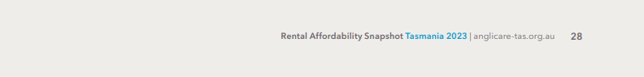

FAQ
What sort of properties are counted?
RAS counts houses, units, flats, bedsits and rooms in sharehouse that are advertised for long-term rental (at least 6 months). It does not count boarding houses, caravan parks, holiday accommodation, retirement villages, student accommodation run by UTAS or other educational institutions, or backpacker/fruitpicker accommodation. Sharehouses must offer private individual rooms, not just a bed in a shared room. Accommodation that asks for farm work, childcare etc., instead of or in addition to monetary rent is not counted.
Where are properties advertised?
We get our properties from two sources: realestate.com.au and gumtree.com.au. Care is taken to ensure properties are not counted twice due to being advertised on both platforms.
What does ‘affordable’ mean?
For lower-income people, a property is affordable if no more than 30% of income is spent on rent. This is a widely-recognised, internationally accepted standard that leaves sufficient income left over for a reasonable standard of living.
What does ‘appropriate’ mean?
An appropriate property is one that has enough bedrooms for the whole household (one bedroom for a single or couple, two bedrooms for a single or couple with one child, three bedrooms if there are two children). In addition, it is not considered appropriate for a person on DSP to live in a sharehouse, in recognition of the fact that some disabled people have special needs that cannot be easily accommodated in a sharehouse. We realise that this is not the case for all disabled people and that many would choose or prefer this style of living. (To see what is available when sharehouses are counted in, please refer to the ‘Single on Age Pension’ cohort, as the two have the same income.)
Why are sharehouses counted separately for people on Youth Allowance?
People on Youth Allowance receive a different amount of Commonwealth Rent Assistance depending on whether they live in a sharehouse.
Aren’t sharehouses just for students? Can anyone live in a sharehouse?
In response to Tasmania’s tight rental market, sharehouses have become increasingly common (9% of all listings in 2022). It is true, however, that many sharehouses are designed and set up for students. Others ask for specific genders, ethnicities or religions. Other requirements observed during RAS include non-smoking, vegetarian, animal lover, and marijuana-friendly. In general we have included all sharehouses unless they discriminate on the basis of gender or a similar characteristic.

SQM Research 2023, Residential vacancy rates: Launceston, viewed April 2023, https://sqmresearch.com.au/graph_vacancy.php?sfx=&region=tas%3A%3ALaunceston&t=1
Essential Services Commission 2019, Better practice in responding to family violence, viewed April 2023, https://www.esc.vic.gov.au/better-practice-responding-family-violence
Hobbs 2022, Young, in love and in danger, viewed April 2023, https://www.anglicare-tas.org.au/young-in-love-and-in-danger/
Australian Institute of Health and Welfare (AIHW) 2022, Australia’s children: Overcrowding, viewed April 2023, https://www.aihw.gov.au/reports/children-youth/australias-children/contents/housing/overcrowding
Australian Bureau of Statistics (ABS) 2023, Estimating homelessness: Census, viewed April 2023, https://www.abs.gov.au/statistics/people/housing/estimating-homelessness-census/2021

