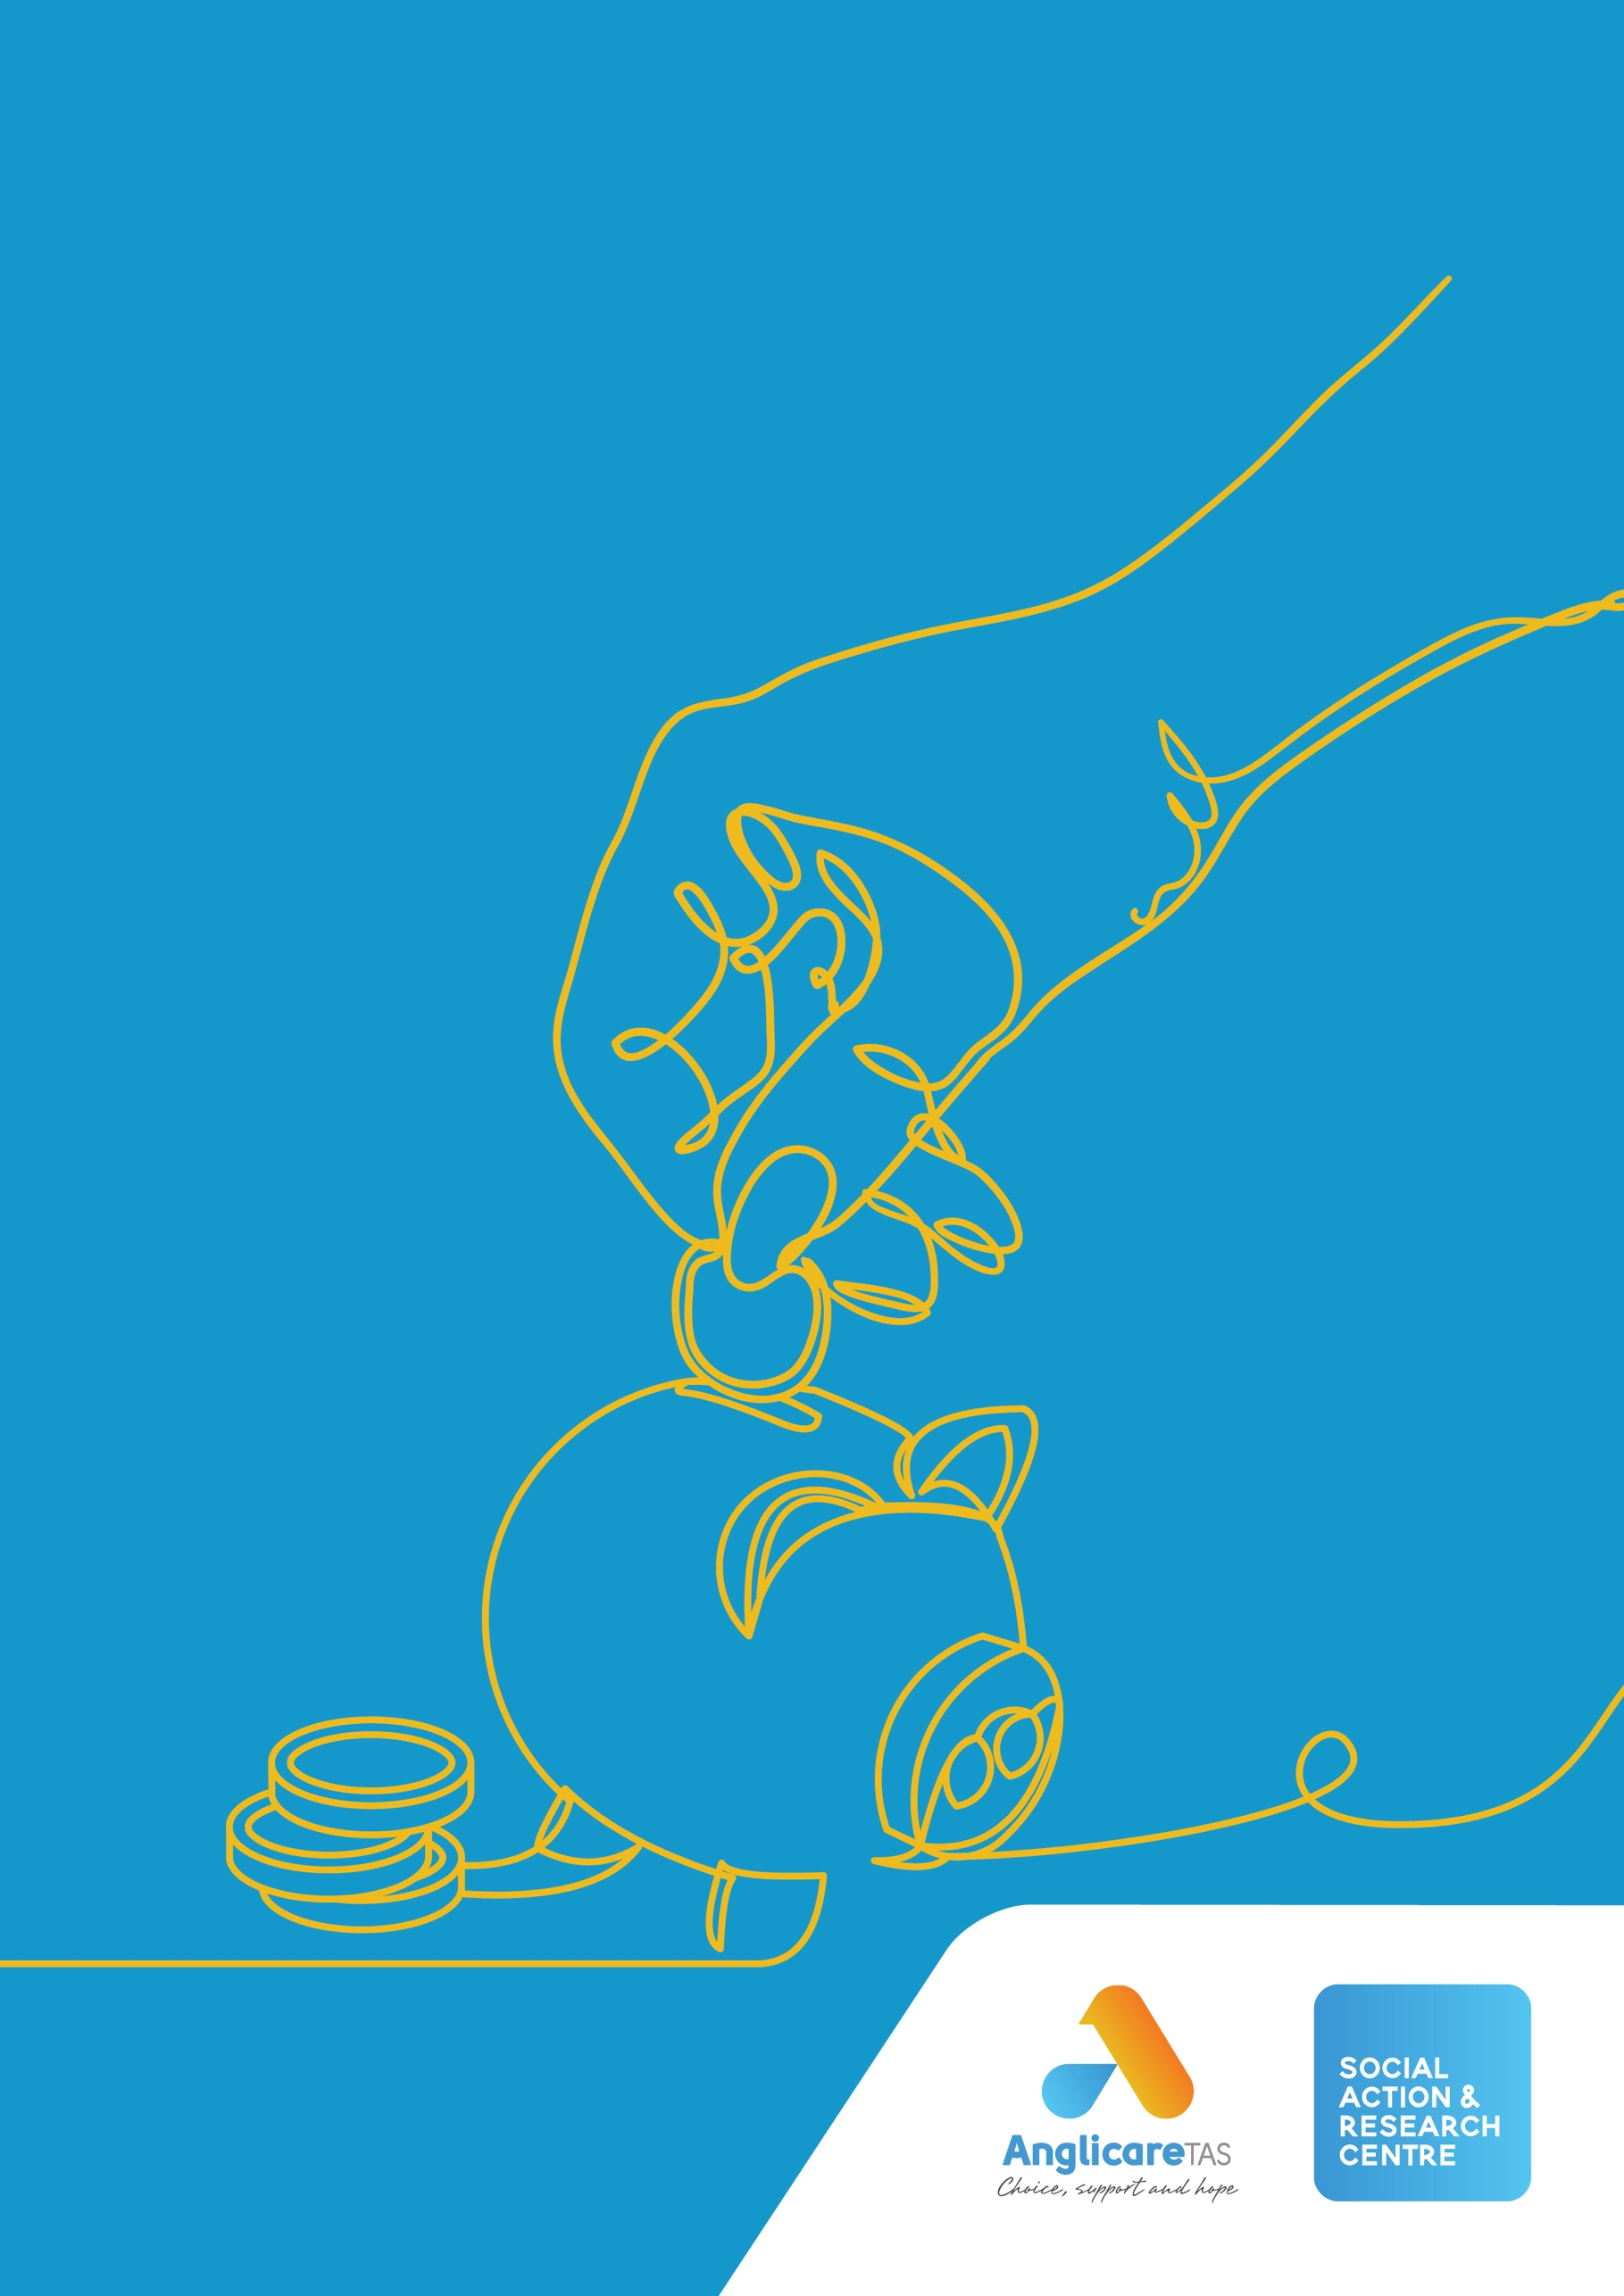
The poker machine card.

Simple as.

WORKING FOR
A JUST TASMANIA

Table of contents
Table of contents 2
Card-based gambling flips the script 4
Client story: David and Helen 5
What happened next 5
What might happen in future 5
How it works 6
Four critical features reduce harm 7
Why we need a poker machine card 8
Harm from poker machines in Tasmania is increasing 8
Poker machines are concentrated in disadvantaged communities 9
When people gamble more than they can afford, it harms everyone 11
It’s good for everyone 12
Users of poker machines 12
People at high risk of gambling harm 12
People harmed by someone else’s gambling 13
Venues 14
Other businesses 14
The Tasmanian community 14
Conclusion 15
References 16

Anglicare Tasmania acknowledges the Tasmanian Aboriginal community as the traditional and original owners and continuing custodians of this land lutruwita. We pay respect to Elders past and present.

Social Action and Research Centre
At the Social Action and Research Centre (SARC), we contribute to building a more just Tasmania.
This means we listen, collaborate, research, advocate and educate. We carry out research and work for changes that will reduce poverty and disadvantage. We listen to the views and experiences of people in local communities. We also hear from frontline workers. We share what we learn with others—including decision-makers in government.

Card-based gambling flips the script
The Tasmanian Government’s commitment to introduce a universal player card gambling system for poker machines by December 2024 is positive action that will reduce harm with minimal impact on people who engage in recreational gambling.[1]
It’s good policy. It’s a good idea. It’s simple as.

For many Tasmanians, gambling is recreational and enjoyable. However, gambling also causes harm and some forms of gambling are more harmful than others.

Gambling harm is not confined to the person who gambles. Research indicates that over 57,000 Tasmanians are directly impacted by someone else’s gambling and gambling indirectly impacts the whole Tasmanian community, including other businesses.[2]

The evidence is clear that right now, gambling on poker machines still results in more harm than any other form of gambling and that harm is increasing.[3] Poker machine gambling accounts for more than half of the money lost by Tasmanians to gambling and is the most common form of gambling amongst those who seek help.

Through its provision of the Gamblers Help and Financial Counselling Services, Anglicare Tasmania sees first-hand the harm experienced by people such as David, Helen and the communities in which they live (refer to case study).

When activities like gambling cause devastating harm to users and others in the community, an effective government takes action to reduce the harm. If there is a way to reduce the harm with minimal impact on non-harmful use, that is even better.

The card-based system is backed by evidence and will flip the script on stories like David and Helen’s. On the next page you can read about what happened to David and Helen (real people whose names have been changed to protect their privacy) and the better alternative offered by use of a card-based poker machine system.

At Anglicare, we know that people who are experiencing gambling harm from poker machines can’t wait for the introduction of the player card gambling system, because our clients are telling us exactly that.

Infographics:
$189.6 million – how much Tasmanians lost in poker machines in 2022-23
Tasmanians lose half a million dollars a day in poker machines
10% of Tasmanians report gambling on a poker machine in a 12-month period
Tasmanians who gamble on poker machines lose $3,350 a year each, on average

Client story: David and Helen
David retired from a career as a respected professional to enjoy a comfortable retirement on the superannuation earned during his working life. He was delighted to reconnect with Helen, whom he had known many years ago, and their relationship brightened his hopes for his later years.
David soon found out that Helen was gambling on poker machines regularly and he assisted her out of a tight spot financially. She said she’d sorted herself out and they continued to plan for a future together.
They moved to Tasmania and bought a house outright. With no mortgage, they settled down to enjoy a carefree retirement.
But Helen’s gambling addiction hadn’t gone away…

What happened next
At first, Helen funded her poker machine gambling with money intended for bills. Then she forged David’s signature to fraudulently mortgage their house. David didn’t become aware of the problem until bailiffs came to repossess their home. Although it should have been possible to establish that he was the victim of fraud, he had no money to pay a lawyer and Helen had disappeared.
David lost his home, his retirement savings, his dream of a life partner and his reputation in the community. He is now living off the age pension in rented accommodation and is painstakingly repaying the debts run up by Helen.
He is deeply distressed and anxious. The extreme stress he experienced is likely to impact his physical health and he is less able to afford quality health care. He has withdrawn from social involvement in his community and plans to move interstate once he has repaid Helen’s debts.

What might happen in future
Helen obtained the new cashless player card that enabled her to gamble on poker machines in Tasmania. The default limits on the card initially only allowed her to lose $100 a week and $500 a month, which she found helpful at first. However, Helen soon discovered that it was simple to increase these limits at the venue and she quickly gambled away $5,000.
When Helen hit the annual loss limit of $5,000, she was unable to gamble for the rest of the year. Raising the annual limit was not quite as straightforward as increasing her weekly and monthly limit and she could not produce the proof needed that she and David could afford to lose more money without going into debt.
The $5,000 loss came as a shock to David but it wasn’t too late for the couple to rescue their finances and their relationship. David supported Helen to seek help and they worked through the challenge together. Helen would always need to keep an eye on her gambling and the card helped her to do that.
David and Helen flourished in their retirement, enjoying life with their many friends in the local community.

How it works
The Tasmanian Government has committed that, from December 2024, you will need a registered player card to use poker machines in all hotels, clubs and casinos anywhere in Tasmania.[1] Some of the details will be finetuned over time but the card as announced will have the following features:
Simple as. | - Universal  You need a player card to gamble on a poker machine.
- One card per person
You register for a single card with a unique PIN. The card will have features to ensure only you can use it.
- Cashless
You load your card with funds using cash or a debit card via EFTPOS at a cashier desk at the venue.
- Poker machines
Using your card and PIN, you can gamble on a poker machine if there are funds on your card and you have not reached a preset loss limit or time limit.
- Information - Your card will message you about your gambling activity such as how much money you have lost or won and time spent gambling.
- Loss limits – When your loss limit is reached, your card will not allow gambling until the next [4]default period. Any increase in your loss limit takes effect after a cooling off period (see table).
- Time limits and breaks - The card will automatically become inactive for 10 minutes after two hours of continuous gambling.
Control how much you lose | Daily | Monthly | Yearly
The default settings on the card limit how much you lose. | $100 | $500 | $5,000
Can you set a lower limit yourself that takes effect immediately?
Can you increase the amount you can lose by completing a simple request at the venue? | Up to $500 | Up to $5,000 | No
You can apply for a higher loss limit but must show you can afford these losses without financial stress and can only apply once each default period. | If you want to lose more than  $500 a day | If you want to lose more than $5,000 a month | If you want to lose more than $5,000 a year
- Control and privacy – You can control how much you lose and how much time you spend gambling on poker machines. It’s easy to self-exclude by simply setting your limit to zero.

Four critical features reduce harm
Various forms of pre-commitment have been introduced in jurisdictions around Australia and internationally, providing evidence that a well-designed system can prevent and reduce harm from using poker machines. We have information about what works and what doesn’t. There are four critical features that must be part of a card system if it is to be effective in preventing and reducing gambling harm. [3, 4]
- Binding pre-commitment with default loss limits
This core feature means that the person using a poker machine must set a binding limit on the amount of money they are prepared and can afford to lose before they start gambling. Poker machines involve high intensity gambling which can be addictive. Research shows that people using poker machines often underestimate how much they have gambled and lose more than they intended. Setting a realistic loss limit before gambling and not being able to override that limit on impulse is an essential feature of an effective system to reduce gambling harm.
- It applies to all gamblers
A system that does not require all gamblers to use it is unlikely to be as effective at reducing gambling harm. Experiences interstate and overseas have shown that uptake of limit setting is low where pre-commitment is optional. It is not possible to predict who in the population will experience harm from gambling and so a population-wide approach will be most effective.
- A single system across all venues
Research shows that if the system applies to only some venues there is little reduction in gambling harm. This is because pre-commitment limits can be avoided by visiting a different venue. A single system is also simpler for users.
- A single card per person
For pre-commitment to be effective in limiting losses (and harm), it is important that each person is registered in the system only once so that the system has accurate information about their spending on all poker machines. The card should have adequate safeguards to protect personal information and prevent unauthorised use by a person other than the card holder.
Other important features that also reduce harm include:
- Providing the cardholder with account statements and tracking of their gambling activity empowers them to make informed decisions about their gambling.
- Ensuring that funds are loaded onto the card by the cardholder at a cashier desk, which enables venue staff to check that the use of the card is authorised.
- Enabling the cardholder to instantly decrease their loss limit, including reducing it to zero.
- A process for increasing loss limits that has a cooling off period before the increase takes effect. The process should also ensure that the increase will not harm you or others.
- Ensuring the card system is simple and easy for people to use.
- Enabling time limits to be set.
Binding, universal systems will provide the best protection from harm[3]

Why we need a poker machine card

Harm from poker machines in Tasmania is increasing
In 2022-23, Tasmanians lost $189.6 million gambling on poker machines, which was $11.5 million (6.4%) more than they lost the previous year.[5] Gambling harm from poker machines is also increasing. In 2022-23, the number of people who contacted Gamblers Help increased by 33%. Four in five people who actively engaged with Gamblers Help and nominated a primary gambling activity mainly used poker machines. Our current approach to reducing gambling harm is not working.
People from all age groups experience harm from poker machines (see chart below). In the past year, the number of people aged 18-24 who sought help due to poker machine harm doubled.
In the same period, Anglicare Tasmania saw a 48% increase in people aged 18 to 44 seeking help for gambling. This data suggests that online and sports betting is not displacing poker machine gambling but is simply increasing total gambling, particularly among young males.

Poker machines are concentrated in disadvantaged communities
In June 2023, there were 3,317 poker machines in 95 venues (including casinos) across Tasmania.[6] However, the charts below show that poker machines are concentrated in disadvantaged communities where per capita losses are also highest.
High poker machine concentrations are in disadvantaged Tasmanian communities[6, 7]

Poker machine losses are greatest in disadvantaged communities [7, 8]

In Tasmania, poker machines appear to be preferentially located in disadvantaged communities where losses per capita are likely to be highest and the harm from gambling is likely to be greatest.
West Coast, the most socioeconomically disadvantaged Local Government Area (LGA), has 141 poker machines per 10,000 people and average annual losses of $427 per capita.
By contrast, Hobart, the most socioeconomically advantaged LGA, has only 24 poker machines per 10,000 people and average annual losses of $64 per capita.
In fact, no relatively advantaged community (IRSDA >950) had more than 30 machines per 10,000 people. All communities with very high concentrations of poker machines (more than 60 poker machines per 10,000 people) were significantly disadvantaged communities (IRSDA <925).
There are 82% more poker machines per capita in north west Tasmania than in northern Tasmania and 178% more than in the south of the state.
A 2020 study showed that living close to a gambling venue increases the likelihood that people will gamble and experience gambling harm, mainly due to financial hardship. Importantly, the effects of living close to a gambling venue were largest for more vulnerable population subgroups, such as those with low income.[9]
Introducing the card-based system will reduce gambling harm, including in communities where poker machine concentrations are high.

Poker machine licences per capita by region, Tasmania[6]

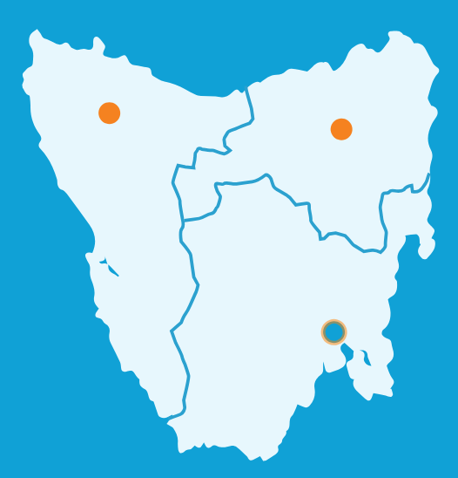

35
poker machines per 10,000 people
64
poker machines per 10,000 people

23
poker machines per 10,000 people

When people gamble more than they can afford, it harms everyone
Poker machines account for most gambling harm in Tasmania. The harm is so significant that it impacts everyone in the community, even though you may not be aware of it. You can read more about the harms from gambling, particularly in Tasmania, in the report What’s the real cost? [2]
This is why we need a public health approach to reduce gambling harm from poker machines. A public health approach means that we take action at the community level to prevent harm and protect all members of the community.
The types of harm you experience from poker machines will depend on whether you:
- use poker machines
- are directly harmed by someone else’s gambling
- live in a community with access to poker machine gambling
- are a victim of crime related to gambling
- own or work in a business
- own or work in a poker machine venue
- are a taxpayer paying for community supports for people experiencing harm.
The financial harms from gambling affect all Tasmanians. When the person using a poker machine gambles money they don’t have, the money has to come from somewhere. The diagram below shows how everyone pays.
The poker machine card is targeted at preventing people gambling more than they can afford.

It’s good for everyone

Users of poker machines
The card will give all poker machine users greater control by providing information, including account statements and tracking of their gambling activity. The poker machine industry currently has much more information than the poker machine user. The card will help level the playing field for poker machine users.
Users will be able set a limit on their gambling without having to completely self-exclude. This is a tool that is not currently available to poker machine users.
Apart from having to register for a card, this change will have little adverse impact on recreational poker machine users because the default limits are higher than the amount spent by most recreational poker machine users. These levels are based on data from Tasmanian poker machine users and will be monitored and refined as necessary.
For people who want to be able to lose more than the default limits and can afford it, this option is available.
The card will enable significant harm to be reduced with minimal impact on people who engage in low risk or ‘recreational’ gambling.
Poker machines can be highly addictive. To effectively reduce the harm to high risk users, there are few alternatives to a universal pre-commitment system other than removing poker machines from venues.
The benefits to poker machine users and the broader community outweigh the minor inconvenience of having to register for a card.

People at high risk of gambling harm
Frontline workers at Anglicare are hearing from numerous Gamblers Help clients that they are extremely eager to have the pre-commitment system introduced in Tasmania. One client described how it will be a relief to use the card instead of cash because it will allow them to set a boundary on how much they spend - to “budget it in” - and be able to stick to it.
The card will give people using poker machines an evidence-backed tool to help prevent losing more money than they intend or can afford. As the group experiencing the most direct harm from poker machines, they fully understand the magnitude of the benefits.
People experiencing harm often don’t seek help or self-exclusion because of the barrier of stigma. The card removes this barrier in two ways: (1) the card is required by all poker machine users and (2) the user can self-exclude or pre-commit to loss limits confidentially.
An important benefit of the card to gamblers experiencing harm is the recognition that industries that profit from products and services that cause harm have a responsibility to reduce the harm caused. This is particularly true of addictive products like poker machines.
The card will reduce the serious harms experienced by high risk gamblers.

What sort of harm is being prevented?
Research evidence shows that harms experienced by people as a result of using poker machines include:[2]
- Health
- Emotional distress associated with loss of control and powerlessness, loss of security and safety, shame and stigma, and fear of creditors
- Higher rates of suicide
- Higher levels of stress, anxiety and depression
- Higher rates of smoking, alcohol and substance abuse
- Higher prevalence of mood disorders, post-traumatic stress disorder, attention deficit and hyperactivity disorder, bipolar disorder and obsessive-compulsive disorder
- Direct and indirect impacts on physical health, including injuries from gambling-related violence
- Resources
- Reduced lifetime income
- Increased debt and difficulty paying household bills, which can result in selling assets, going without meals, being unable to heat their home, asking for a money from family and friends, and asking for help from welfare and community organisations
- Severe financial distress, bankruptcy, job loss, unemployment
- Criminal sanctions and legal costs if they commit gambling related crime
- Relationships
- Increased arguments and social conflict
- Damage to close relationships including relationship breakdown, separation or divorce
- Family dysfunction and damage to parent-child relationships
- Domestic violence as victim or perpetrator
- Social isolation and loss of community connections

People harmed by someone else’s gambling
On average, each ‘problem gambler’ directly affects six other people, each moderate risk gambler affects three other people and even low risk gamblers each affect one other person. Most people who gamble also underestimate how many other people are affected by their gambling.
Over 57,000 Tasmanians are harmed by someone else’s gambling, based on these findings. As most gambling harm in Tasmania is associated with poker machine use, the number of people directly benefitting from the introduction of the card is very high. This includes partners, children and parents of gamblers, friends and employers and victims of gambling-related crime.
For people in the poker machine user’s household, the card is likely to help reduce gambling-related stress in their relationships and improve the developmental environment for children. They will have more household income available to spend on essentials as well as education and leisure activities. There is also likely to be a decrease in harm from domestic and family violence and gambling-related crime.
Family and friends who previously assisted with financial bailouts will be better off, partly because they will be better off financially but also because damage to trust and relationships is reduced.

Venues
The card will make it easier for venues to comply with the existing mandatory code of conduct. The card will also reduce the time staff spend on compliance activities.
Venue staff are currently responsible for enforcing self-exclusions using a system that is cumbersome and not as effective as it could be. The card will significantly reduce the workload on staff associated with enforcement of self-exclusion and increase effectiveness.
Evidence from countries that have introduced universal pre-commitment shows that it does not result in people diverting their gambling activity to other forms of gambling. The main measurable impact is a reduction in revenue from poker machine users experiencing significant levels of harm.
The card will help prevent money laundering (disguising the origin of money made through illegal activities) through venues and so will assist them in meeting their duty of care around this.
Eight in 10 Tasmanians believe that gambling does more harm than good. Each year, the evidence of the harm from gambling becomes more irrefutable and the social licence to have poker machines is increasingly at risk. By reducing harm from poker machines, the card is likely to help address some of the risks to social licence for the gambling industry, including venues with poker machines.

Other businesses
Businesses experience a number of direct harms from poker machine use that are likely to be reduced with the introduction of the card. These include unpaid debts, fraud and other gambling-related crime.
Reducing harmful use of poker machines will also have a positive impact on the economy and increase spending in other businesses in the local community. Consumer spending is expected to increase due to a reduction in economic costs of gambling harm that are borne by the community (crime, health costs, community supports, lost productivity), increasing general economic activity. There is also a transfer of some spending in poker machines that is redirected to purchasing products and services from other businesses.
Addictive products also give venues with poker machines greater (and arguably unfair) market power which disadvantages businesses without poker machines. The card will go some way to levelling the playing field.
The net impact of the card on businesses and their employees is projected to be positive.

The Tasmanian community
The benefits of a poker machine card will extend to all members of the community. In addition to the benefits already mentioned, these include:
- reducing gambling related costs that are borne by the taxpayer (health costs, community supports, financial assistance, criminal justice system costs)
- reducing gambling-related crime and money laundering
- reducing gambling-related violence and domestic violence
- reducing the contribution of gambling harm to persistent disadvantage
- reducing adverse impacts on community relationships and improving community cohesion
- increasing participation in other community activities.
You can read more about the harms and costs of gambling in the report What’s the real cost?

Conclusion
The Tasmanian Government has committed to introduce a universal player card gambling system for poker machines by December 2024. This commitment, made in September 2022, delivers on recommendations made by the Tasmanian Liquor and Gaming Commission after extensive research and consultation.[10]
This will flip the script for many people experiencing harm from poker machines and offer them hope. Many of Anglicare’s Gamblers Help clients are looking forward to its introduction and see it as a practical tool that will be easy and effective to use. The card will also have benefits for people who use poker machines recreationally, giving them greater control and better information.
Evidence shows that there are four critical features needed for the card to be effective:
- binding pre-commitment with default loss limits
- applying to all people using poker machines
- a single system across all venues
- a single card per person.
Other important benefits include providing information to poker machine users about their gambling activity and helping them to take breaks from gambling.
The Government needs to deliver on this commitment because harm from poker machines in Tasmania is increasing, poker machines are concentrated in disadvantaged communities, and when people gamble more than they can afford, it harms everyone.
Whether you are a poker machine user, a person harmed by your own or someone else’s gambling, a venue or business owner, or a Tasmanian who doesn’t gamble, you will benefit from the introduction of the card.
The poker machine card will make life better for everyone in Tasmania.
Simple as.

References
1. Department of Treasury and Finance, Tasmanian Government response to the Tasmanian Liquor and Gaming Commission’s Report to the Treasurer on its Investigation of harm minimisation technologies: facial recognition and player card gaming. 2022, Tasmanian Government: Hobart.
2. Bennett, M., What's the real cost? 2022, Social Action and Research Centre: Hobart.
3. Rintoul, A. and A. Thomas, Pre‑commitment systems for electronic gambling machines: Preventing harm and improving consumer protection. 2017: Australian Institute of Family Studies, Melbourne.
4. Productivity Commission, Gambling, in Productivity Commission Inquiry Report. 2010: Canberra.
5. Department of Treasury and Finance. Gaming and Wagering Industry Data. 2023 29/08/2023 [cited 2023 06/09/2023]; Available from: https://www.treasury.tas.gov.au/liquor-and-gaming/publications-and-research/gambling-industry-data/gaming-and-wagering-industry-data
6. Department of Treasury and Finance. Venue licences and gambling activities data. Gambling Industry Data 2023 September 2023]; Available from: https://www.treasury.tas.gov.au/liquor-and-gaming/publications-and-research/gambling-industry-data.
7. Australian Bureau of Statistics. Socio-Economic Indexes for Areas (SEIFA), Australia. 2021 04/09/2023]; Available from: https://www.abs.gov.au/statistics/people/people-and-communities/socio-economic-indexes-areas-seifa-australia/latest-release.
8. Department of Treasury and Finance. Electronic Gaming Machine Expenditure by Municipality. Gambling Industry Data 2023 04/09/2023]; Available from: https://www.treasury.tas.gov.au/liquor-and-gaming/publications-and-research/gambling-industry-data/electronic-gaming-machine-expenditure-by-municipality.
9. Badji, S., N. Black, and D. Johnston, Proximity to gambling venues, gambling behaviours and related harms. 2020: Melbourne.
10. Tasmanian Liquor and Gaming Commission, Investigation of harm minimisation technologies: facial recognition and player card gaming - Report to the Treasurer. 2022, Tasmanian Liquor and Gaming Commission.

Author: Mary Bennett
Email: maryb@anglicare-tas.org.au
Website: www.anglicare-tas.org.au
© Anglicare Tasmania 2022
ISBN: XXX-X-XXXXXX-XX-X

