Policy Brief:

Housing Security for Older Tasmanians

Social Action and Research Centre

Anglicare Tasmania

Overview
Older Tasmanians are experiencing increasing housing insecurity and the underlying cause is a lack of affordable housing that is appropriate for older Tasmanians.
Urgent action is needed to enable older Tasmanians to ‘age in place’ in their local communities, to reduce their experience and risk of homelessness and housing insecurity, and to improve their physical and mental health and wellbeing.
We call on the Tasmanian and Australian Governments to accelerate and prioritise action to increase housing supply, including building more social and affordable housing, and to:
- ensure the state’s housing supply meets current and projected needs
- provide appropriate homes and supports for people to age in place in their communities, reducing the need for older people to move
- increase the housing security of older renters
- provide specific supports to assist older Tasmanians navigating the property market
- improve housing security and equity for groups of people at higher risk.

Why is this issue important now?
In February 2023, Anglicare frontline workers reported an increasing number of older people presenting in need of housing. In response, Anglicare’s The Right to Belong research project explored older Tasmanians’ experience of housing insecurity.
Tasmania is experiencing an unprecedented housing crisis in the context of a rapidly ageing population (see infographic The facts). The findings and recommendations of The Right to Belong form the basis of this brief and call for an urgent response.
The housing crisis has economy-wide impacts. The current shortfall in housing supply is entrenching socioeconomic disadvantage, undermining efforts to reduce domestic violence, constraining developmental and educational outcomes for young Tasmanians and increasing intergenerational disadvantage. It is driving up government spending in a range of areas including health, justice and community services, and also reducing the effectiveness of each dollar spent. It is wreaking havoc with the smooth operation of the labour market as workers struggle to find housing near available jobs.
Like unpaid debt, for every month that we have insufficient housing for every Tasmanian, the long-term impacts accumulate and further constrain the capacity of Tasmanians to flourish and the productivity of our economy.
The issue is not new. However, the catastrophic impacts of further delays in delivering an effective response to the housing crisis should make it an urgent priority for government.

Why focus on housing insecurity of older people?
More than one in three Tasmanians is aged 55 or over. This age group is expected to account for virtually all growth in the state’s population over the next decade and so their needs should shape investment in the new housing needed to address the crisis. However, the benefits of expanding housing supply will flow to Tasmanians of all ages. Improved housing affordability, previously one of Tasmania’s key drawcards, will deliver greater intergenerational equity and support state growth.

The facts

Affordability in the Tasmanian housing market has never been worse
- Tasmanian house prices and rents have risen sharply over the past decade to record levels
Tasmanian house price index
34%
since 2020
- Tasmania’s house price index has risen by 34% since 2020 and housing affordability is at a historic low [1]
- Hobart median rents have risen by 60% since 2016 and Hobart continues to have the (equal) lowest rental affordability in Australia [2]
- Since 2020, rental affordability in the rest of Tasmania has fallen by 17% to an all-time low [2]
Hobart rents
60%
since 2016
- New housing supply is inadequate and social housing has not kept pace with demand [1]

Home ownership among older Tasmanians is falling
7 in 20
Tasmanians are aged 55+
\
- Decreasing housing affordability is reducing home ownership rates among older Australians
- The proportion of older Australians renting has increased from 18% in 1996 to 21% in 2021 [3].
- From 2023 to 2030, it is estimated that the number of older Tasmanian renters will increase by 17% due to declining home ownership and population ageing [4].
Tasmanian renters aged 55+
17%
2023 - 2030

Older Tasmanians are a growing share of population
- 35% of Tasmanians are aged 55 years or older, compared to only 29% nationally [5]
Tasmanians aged 55+
12%
2024 - 2032
- Between 2024 and 2032, the number of Tasmanians aged 55 years and over is projected to increase by 23,800 (12%) to over 225,000 and account for 95% Tasmanian population growth [6]
- From the mid 2040s, it is projected that more than two in five Tasmanians will be aged 55 years and over, with this age group accounting for all growth in the state’s population

Figure 1: Cumulative change in the Tasmanian population by age group, 2023 - 2053

What older Tasmanians say about life[7]
- Half (54%) of older Tasmanians are pessimistic about the future with most citing the cost of living as a concern
- Satisfaction across most aspects of quality of life had fallen since 2018 and respondents were most dissatisfied with their:
- physical health
- financial situation
- connection to community
- The top concern about their home was their ability to adapt their home to make it accessible (17% rated as very poor), followed by energy efficiency
- Almost one in four (24%) rated access to public transport as very poor in their area, and this was the top concern respondents had about the area they live in
 | Since 2018
12% rate their quality of life as poor | 5%
49% rate their physical health as poor | 15%
46% rate their financial situation as poor | 10%
45% rate their connection to their community as poor | 12%
54% say things are getting worse for their generation | 16%
29% rate their level of difficulty accessing medical services as high | 12%
Source: COTA 2023

Causes of housing insecurity for older Tasmanians
Many older Tasmanians experience housing insecurity and either need to move out of a home they would like to stay in or are unable to afford or find a suitable place of their own at all. As shown in Figure 2, causes of housing insecurity for older Tasmanians include:
- lack of access to services and supports they need
- failure of housing to meet their mobility or health needs
- housing unaffordability
- the increase in the state’s older population outstripping supply of age-appropriate housing
- lack of security of tenure and affordability in the private rental market
- barriers to engaging with or exclusion from a digital property market
- fixed incomes relative to rising rents resulting in higher prevalence of rental stress (see Figure 3)
- income support being inadequate to meet housing costs if they do not own their own home, particularly if they are single.
Key groups at risk are older renters, Aboriginal Tasmanians, women, and people who have experienced relationship breakdown, have been widowed and/or are living alone. Childhood experiences and trauma also increase the risk of lifelong housing insecurity.

Effects of housing insecurity on older Tasmanians
Housing insecurity, including inappropriate housing, has a wide range of negative effects, some of which can have greater detrimental impacts on older people. These include:
- increased homelessness, including overcrowding, and housing stress which adversely affect health and longevity
- the detrimental impacts of moving, particularly if the move is not by choice
- health impacts if health and community services are not accessible
- risk of loneliness and social isolation when housing is not available near social supports
- impact on mental and physical health due to inability to engage in activities
- increased risks to health due to home being unsafe or not adaptable
- impacts on mental health due to lack of choice in housing and living arrangements
- increased anxiety about housing insecurity
- feeling less valued by the community.
Figure 2: Causes and effects of housing insecurity for older Tasmanians
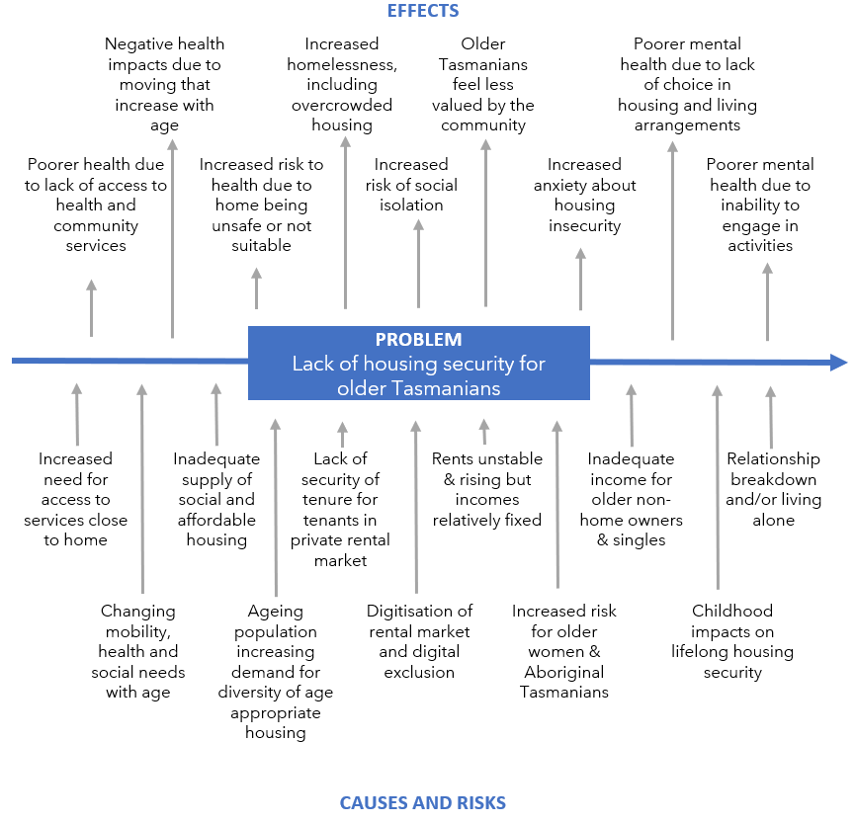

Client story — Colin

Colin is a single man in his 70s who lives next door to his landlord in a small town on the North West Coast. His landlord does not allow him to have guests at certain times of day and Colin feels overly monitored. He would like to move to a different property with greater privacy that feels more like a home of his own.
The problem is that private rental properties are only advertised online and real estate agents only accept online applications. Like many older people, Colin never learnt how to use email or the internet. He’s bought a smartphone and his son taught him how to text, but websites, online application forms and uploading documents are too complicated for him. He doesn’t know anyone with time to help him with every step of the process, so Colin feels as if he’s stuck where he is indefinitely.
Colin receives Age Pension and has a fortnightly income of $1100. He can afford $192 weekly rent. After his experiences with his current landlord, Colin is looking forward to living alone and is reluctant to consider a sharehouse. However, in most parts of Tasmania a one-bedroom unit costs at least $250, and more likely over $300.
On a weekend in March 2024, Colin would have found the following properties
Affordable and appropriate (unshared): 2 (Rosebery)
Affordable and appropriate (shared): 25 (statewide)
Cheapest appropriate: $290 (ground floor unit, Burnie)

Key issues and gaps
In April 2024, the National Housing Supply and Affordability Council (NHSAC) concluded that:
‘The housing system’s inability to supply sufficient housing that meets the population’s needs is the primary reason for worsening affordability’[1]
Increasing housing supply is necessary but not sufficient on its own to deliver housing security for older Tasmanians. This section identifies some key issues that need to be addressed in order to meet the housing needs of older Tasmanians.

Intergovernmental and interagency coordination
The response to Tasmania’s ageing population will be a dominating influence on government policy and outcomes for the foreseeable future. A successful response will require planning and coordination with federal and local governments as well as across state government agencies. A task of this magnitude justifies the appointment of a dedicated Minister to plan and deliver this response at the state level.

Innovation in housing models, construction and financing
The State of the Housing System 2024 refers to ‘retirement villages’ as a response to housing for older people.[1] It is important to recognise that a broad and diverse range of housing options is required to meet the need of older Tasmanians for their own space, access to services, and social connection, including alternatives such as cooperative housing, co-housing and co-ownership models.
The NHSAC report also points to the need for innovation in housing construction, design and financing models in order to produce homes faster, introduce innovations in housing design, make well-designed houses affordable, and increase the sustainability and energy efficiency of Tasmania’s housing stock.

Housing security for older Tasmanian renters
Compared to older Tasmanians living in a home they own, older renters struggle to pay their bills, meet their housing costs, and heat their home. They are less satisfied with their security and safety, and with their ability to adapt their home to make it accessible.
‘For pensioner couples and other low-income households, there are very few options … in the entire state. The Acceptable rents are only available … far from services and therefore likely to be an undesirable option for pension households.’ [2]
Compared to younger renters, older Tasmanians are more likely to live in poverty, with almost 4 in 10 (38%) older Tasmanian renters (aged 55 years or more) experiencing rental stress compared to 27% of renters aged under 55 [8] (see Figure 3).
Figure 3: Rental stress by age

Figure 4: Affordable rental properties
In March 2024, there were virtually no private rental properties advertised in Tasmania that were affordable for people relying on the age pension, let alone properties that meet accessibility needs and are located close to services. (see Figure 4).
Colin’s story illustrates the need for:
- better rights for renters in legislation
- affordable and appropriate properties near the services older Tasmanians need
- action to address digital barriers experienced some older Tasmanians when engaging with the property market that is now almost entirely online.

This participant in The Right to Belong highlights how Tasmania’s Residential Tenancy Act does not effectively prevent ‘no cause’ evictions, a significant cause of housing insecurity:
“You just feel powerless because, if I quibble it too much, they can just say, well, we won't renew the lease.”
In relation to housing security for older Tasmanian renters, The Right to Belong research found a need for rent stability, the ability to make minor modifications, greater security of tenure and creating an independent intermediary between landlords or their agents and tenants or potential tenants.

Moving has detrimental effects on older people
Moving house for older people is difficult and healthy ageing often requires that people have the option of ageing in place.
Moving for any reason has a significant negative impact on older people’s satisfaction with their home and their life overall that is not found in people under 55 (Figure 5). Being forced to move also has negative impacts on wellbeing, which affects people of all ages (Figure 6).
Moving can have additional difficulties for older people due to frailty, ill health and needing the assistance of others to pack up and relocate.
Figure 5. Impact of moving on life satisfaction of people aged 55+ years
Source: HILDA survey, wave 21
Figure 6. Impact of moving on life satisfaction when move is not by choice, all ages.
Source: HILDA survey, wave 21
This central consideration prioritises policies to reduce unnecessary moves and minimise harm from moving, including:
- facilitating modifications to existing homes to make them accessible
- increasing access to public transport and implementing actions under the eight domains of age-friendly communities (see box below)
- ensuring access to support services needed by older people, such as supports for people living with hoarding (see below)
- updating rental legislation to protect older renters and prevent unnecessary moves
- providing additional assistance to older people with moving.
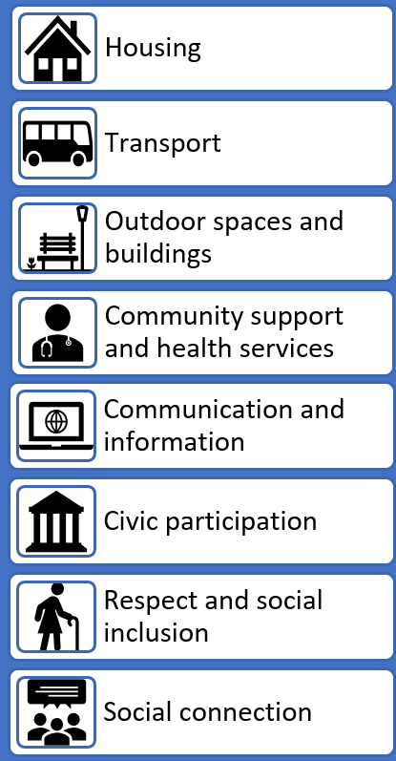
Age- friendly communities
Age-Friendly Cities and Communities is a global movement led by the World Health Organization (WHO) focused on creating communities for people of all ages.
Age-friendly communities design and adapt their environment, policies, and services for residents of all ages and different capacities so that they are able to live the lives they value.
In an age-friendly community, older people are valued, respected, and actively engaged.
Age-friendly communities are more liveable for everyone through action across eight domains: housing, transport, outdoor spaces and buildings, community support and health services, communication and information, civic participation, respect and social inclusion, and social connections

Support for people living with hoarding
The findings of Anglicare’s Treasured Lives research identified a significant service gap for older Tasmanians who are living with hoarding and struggling to maintain a healthy home. Currently there is very limited practical assistance available in Tasmania that is accessible to those on low incomes and most at risk of homelessness, and none that provides the coordinated care and clinical and psychosocial supports needed for long-term management.
[Name withheld] is a 75 year old man with severe hoarding both inside and outside … he was provided with referral codes in the past for hoarding, but no one has availability … He cannot shower at his property or cook and relies on doing this at other people’s houses within the community. I was reaching out to see if you knew of anything in the North that could help out, as this is impacting the way he lives and can receive services. (Non-Anglicare case worker, Northern Tasmania)
This service gap remains and is preventing older Tasmanians living with this disorder from receiving other services, placing them at increased risk of injury, causing bed-block in Tasmania’s hospitals, increasing fire risk and increasing their risk of eviction and homelessness.

Advocacy and protection to safeguard agency and prevent vulnerability
In contrast to other areas of life satisfaction, feelings of safety and security generally decline with age. Unfortunately, these anxieties are not unfounded and older Tasmanians who are renting, living alone, or dependent on carers can experience vulnerability. Housing security requires that older Tasmanians feel safe in their home and in dealings that affect their housing security. In particular, there is a need for:
- increased advocacy and legal support for renters and a more level playing field between renters and landlords
- a mandatory and coordinated response to reports of elder abuse that is appropriately resourced.

Action to provide housing security for older Tasmanians
The goals of this intervention are to:
- reduce the experience and risk of homelessness and housing insecurity by older Tasmanians
- enable older Tasmanians to ‘age in place’ in their local communities
- improve the physical and mental health and wellbeing of older Tasmanians.
Figure 7 identifies five areas for action to achieve these goals and how these actions will have impact.
Figure 8 provides an action plan to deliver housing security for older Tasmanians to address the issues and gaps identified in this brief. Implementing this plan requires actions across different levels of government which are detailed in the recommendations.
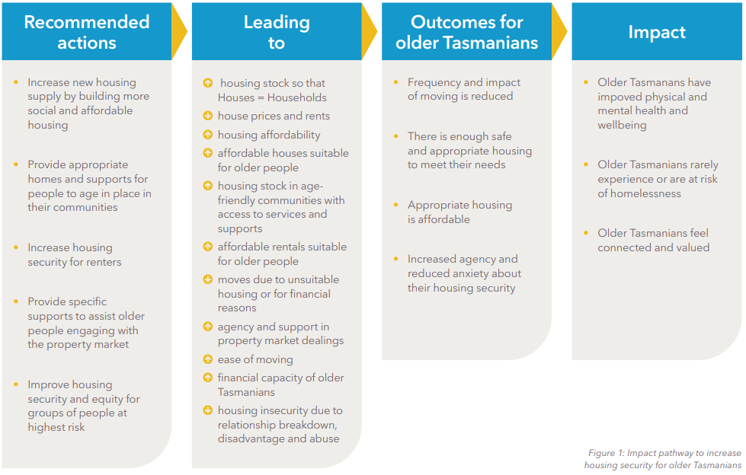
Figure 7. Impact pathway to increase housing security for older Tasmanians
Figure 8. Action plan to increase housing security for older Tasmanians

Recommendations

That the Tasmanian Government:
- Ensures that the supply of social and affordable housing for older Tasmanians meets demand based on current and projected population, home ownership rates and incomes of older Tasmanians.
- Brings forward review and reform of the Residential Tenancy Act to provide for minor modifications, rent stability, greater security of tenure and creating an independent intermediary between landlords or their agents and tenants or potential tenants.
- Releases and implements a Strategy for older Tasmanians that delivers outcomes across the eight domains of the WHO Age-friendly Cities and Communities Framework in partnership with local government.
- Increases the share of social housing allocated to Aboriginal Tasmanians to be at least equal to their representation in the community.
- Funds additional services provided by the Tenants’ Union in Northern Tasmania to provide legal and advocacy support proportionate to the number of people renting.
- Promotes and supports the development of innovative and alternative affordable housing models such as cooperative housing, co-housing and co-ownership models.
- Prioritises universal delivery of Respectful Relationships Education in Tasmanian schools.
- Formalises and resources effective responses to reports of elder abuse.

That the Tasmanian Government works with the Australian Government to:
- Ensure adequate funding of social and affordable housing construction.
- Provide support for modification of existing homes, including rental properties, to support ageing in place.
- Fund additional support for older Tasmanians to overcome digital barriers to engaging with the housing market and other services.
- Fund a pilot program to provide more effective support for Tasmanians living with hoarding.
- Provide specific supports to older women to ensure their independent housing security.

That the Australian government:
- Provides funding to NDIS and Aged Care Package recipients (or their spouse) to assist with moving residence.
- Adjusts the eligibility for the Age pension for Aboriginal and Torres Strait Islanders to align with the age of eligibility for Commonwealth-funded aged care.
- Implements recommendations to re-target superannuation tax concessions to ensure that they are more equitably distributed.
- Increases income support, including increasing Commonwealth Rental Assistance (CRA) for single people and for people receiving the Age Pension who do not own their own home, in addition to non-targeted indexation of CRA to median rents.
- Provides ongoing funding for Lawyer-assisted Family Law Property Mediation delivered through Tasmania Legal Aid.

Glossary
Accessible | An accessible home is designed to meet people’s needs in terms of access and mobility.
Affordable | For people with incomes in the lowest 40%, housing is ‘affordable’ if no more than 30% of income is spent on rent. This is a widely-recognised, internationally accepted standard that leaves sufficient income left over for a reasonable standard of living
Appropriate | Meeting the needs of the household, such as being the right size, with adequate heating and cooling, built and maintained to avoid causing health problems, and located within reach of services, employment, education and transport options.
Hoarding | Hoarding disorder is a psychiatric condition that involves challenges with acquiring, sorting and/or discarding items or animals. Those living with hoarding ascribe meaning or have emotional attachment to items others would see as not valuable. This attachment leads to significant emotional struggles in thinking about or actually discarding items.
Housing stress / rental stress | A person spending more than 30% of their income on housing costs is said to be in housing stress. If a person is renting, it can also be called rental stress.
Older people | Aboriginal people aged 45 and older, and non-Aboriginal  people age 55 and older

References

1. National Housing Supply and Affordability Council, State of the Housing System 2024, 2024. Canberra.
2. SGS Economics and Planning, Rental Affordability Index, 2023. SGS: Canberra.
3. Australian Institute of Health and Welfare, Home ownership and housing tenure, 2023. Viewed April 2024. Available from: https://www.aihw.gov.au/reports/australias-welfare/home-ownership-and-housing-tenure.
4. Claxton, S & Bennett, M, Rental Affordability Snapshot Tasmania, 2024. Anglicare Tasmania: Hobart.
5. Australian Bureau of Statistics, National, state and territory population, 2023. Viewed May 2024. Available from: https://www.abs.gov.au/statistics/people/population/national-state-and-territory-population/latest-release.
6. Tasmanian Government, TasPOPP 2024: Tasmanian and Local Government Area Population Projections 2023 to 2053, 2024. Department of Treasury and Finance: Hobart.
7. Polidoras, A, Toner, K, Banks, C, and Diseris, I, State of the Older Nation 2023, 2023. Council on the Ageing: Sydney.
8. Australian Bureau of Statistics, Census of population and housing, 2021. Viewed May 2024. Available from: https://www.abs.gov.au/census/find-census-data/census-data-topic.

Differences in life satisfaction shown in charts are significant with a 95% level of confidence.

