

# **2023-24 ANNUAL REPORT**



## **Improving Tasmanians’ quality of life**

# **Since 2021, Anglicare has been asking Tasmanians about their quality of life.**

## **We use specially designed survey tools to engage with people supported by our Aged and Home Care services and residents at some of our accommodation facilities.**

The results have shown that people’s care-related quality of life has improved. People gave high scores to domains like feeling ‘safe and secure’, ‘clean and comfortable’, and ‘having control over my daily life’. People said they felt they were ‘treated with dignity’.

‘Social participation and involvement’ is where people indicated they would like more than they have, and Anglicare is giving this focused attention. The World Health Organisation recognises social isolation as a priority public health issue across all age groups and regions of the world.

In this Annual Report, we share stories of how Anglicare supports people to re-connect with others and take part in their local community. It also highlights our efforts to reduce some of the practical barriers.

Hugh Mackay wrote in his book **The Way We Are** “a wounded society can only be healed when enough of us choose to live differently.” Kindness and connection begin “in our own life, our own household, our own workplace, our own street.”



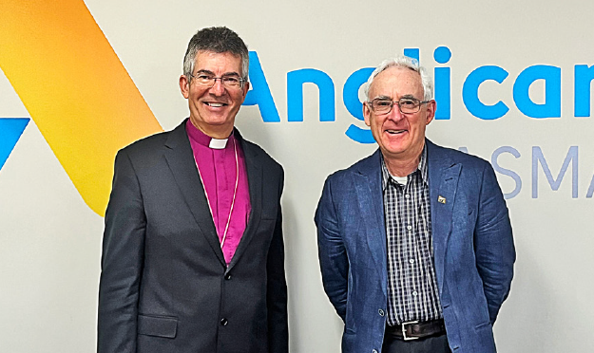

*Board Chair Mike Blake AM (right) and CEO Chris Jones*

# **Board Chair, Mike Blake AM**

## **Life “in all its fullness” is a core element of Anglicare Tasmania’s mission.**

Preparing for expanded responsibilities in housing and a new in-home aged care model have been focus areas for the Board this year.

I am grateful for the dedication shown by all Anglicare staff, and the stewardship of CEO Chris Jones and the leadership team.

Winning the tender for a statewide Housing Connect Front Door service was a testament to our team’s experience.

We held our position on essential poker machine reforms, and expanded the specialist skills of our Acquired Injury Support Services team.

Thank you to retiring Chair Stephen Carnaby for his contribution to Anglicare. Stephen was a Board member for nine years, the last two as Chair. We welcomed Scott Parnham and John McQuillan to the Board.

*\*Mr Blake was appointed Board Chair on 23 November 2023. He has been a Board member since March 2021.*

# **CEO, Chris Jones**

## **Anglicare cares about Tasmanians and their quality of life.**

To serve our community in challenging times, our organisation needs to be agile. We must also stay focused on our mission.

We have made improvements to our internal systems and built on our team’s skills and expertise.

I continue to be impressed by the dedication and responsiveness of our staff as they put Anglicare’s values into action every day.

A personal highlight was being given the opportunity to speak to the Commonwealth Grants Commission in March 2024. The Commission was interested to hear from Anglicare about the ‘big picture’ view of the needs of Tasmanians, particularly those who live in regional areas.

The data collected and reported by our frontline services was a crucial part of our presentation.

# **Our supporters**

## **Thank you to the many individuals, businesses, schools, parish partners and other organisations who donated time, money, food or other gifts this year.**

In 2023-24 Anglicare received funding and support from ABC Giving Tree, Allport Bequest, Attorney-General’s Department, Brotherhood of St Laurence, Colin Bisdee Trust, Burnet Institute, Catholic Care Tasmania, Colony 47, Department for Education, Children and Young People, Department of Health (Commonwealth), Department of Health (Tasmania), Department of Premier and Cabinet (Tasmania), Department of Social Services (Commonwealth), Department of Veterans’ Affairs (Commonwealth), Farrell Foundation, Homes Tasmania, icare, Launch Housing, Mental Health Council of Tasmania, Motor Accidents Insurance Board, National Disability Insurance Agency, National Injury Insurance Scheme Queensland, Playgroup Association of Tasmania, Primary Health Tasmania and The Salvation Army.

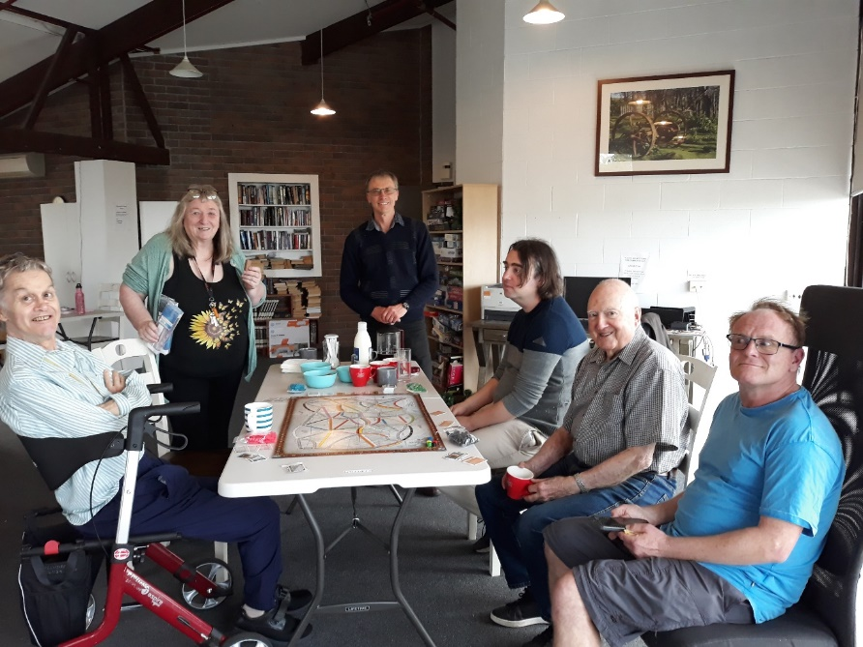

St Marks Church at Bellerive built on its partnership with nearby supported accommodation facility Bayview Lodge. Volunteers and residents came together to enjoy excursions, craft and cooking sessions and regular afternoon teas (pictured above).

Meanwhile, regular donations of pantry items by the parishioners at All Saints in South Hobart are improving food security for the people we support.

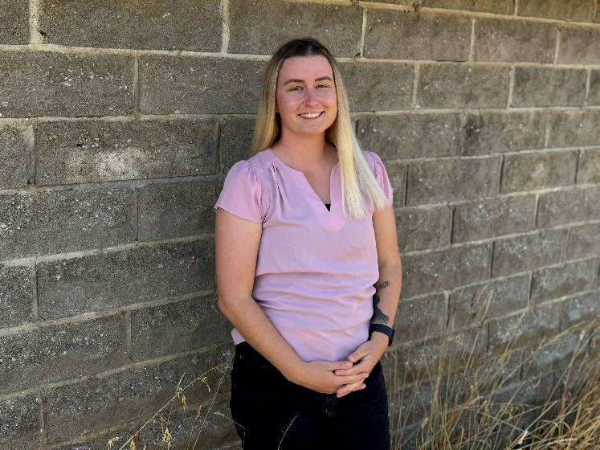

[We congratulated Georgie Jones when she was awarded the University of Tasmania’s Anglicare Scholarship in Social Work.](https://www.anglicare-tas.org.au/anglicare-scholarship-social-work-2024/)

# **Financial performance**

## **Anglicare is delivering quality services to the Tasmanian community at a time of high inflation and significant cost of living pressures.**

We used information from our frontline services to call on government to provide fair funding for the community services sector in our State.

Our team delivered close to $71.5 million of services to Tasmanians this year. Overall, Anglicare achieved a surplus of $3.0 million. We invested in our people, our systems, advocacy and service delivery models. We will continue to focus on workforce development and training next year.

Anglicare’s services boost the Tasmanian economy, including in regional and remote areas. We are one of the State’s largest employers, with 984 people on our payroll this year. We spent more than $50 million on wages and salaries and more than $20 million on locally-sourced goods and services.

[Read Anglicare’s full financial statements.](https://www.acnc.gov.au/charity/charities/080a5b6a-38af-e811-a963-000d3ad24077/documents/)

0.4% Bequests and donations
2.7% Interest and dividends
29.6% Tasmanian Government grants
13.9% Australian Government grants
5.1% Other grants
48.4% Fee for service/other revenue

1.0% Telephone and IT expenses
2.3% Vehicle and travel
4.6% Occupancy expenses
1.5% Depreciation and amortisation expenses
9.6% Disbursements to clients and partners
10.6% Other operational expenses
70.4% Staff - service provision and support

3.0% Financial counselling
12.1% Families, children and young people
15.2% Acquired Injury Support Services
18.6% Community aged care
24.7% Housing support
13.7% Health and wellbeing
12.6% Other

# **We are respectful**

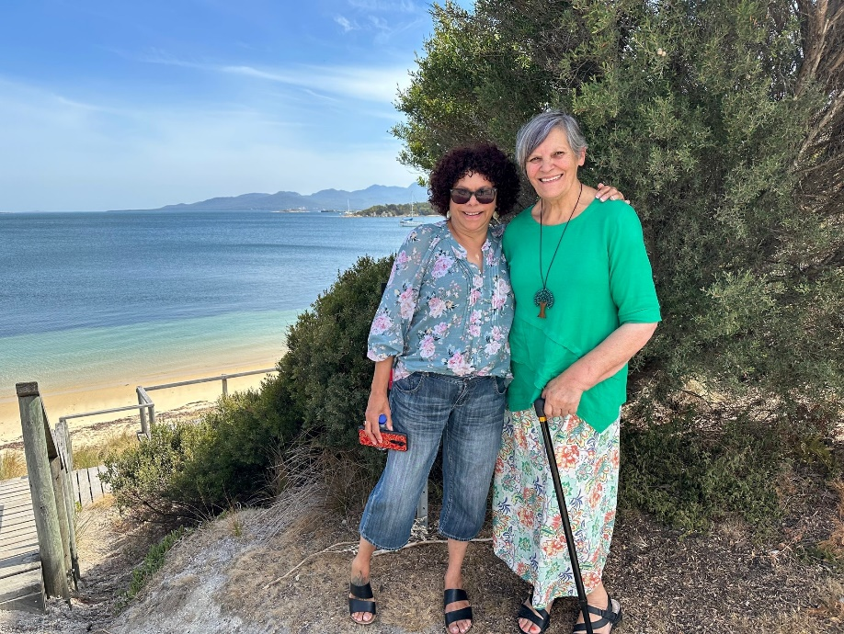

*yarnin up members Aunty Delia Summers (left) and Aunty Nola Hooper, pictured on Yellow Beach during a trip to Flinders Island and truwana/Cape Barren Island with CEO Chris Jones.*

## **Anglicare listens to, and learn from, the people we support. Responding to their insights is how we improve the services we offer.**

Anglicare is committed to developing and promoting good relationships, respect and opportunities with the Tasmanian Aboriginal Community.

Members of our Aboriginal advisory group, yarnin up, advise Anglicare on a range of matters including cultural protocols, employment, and service delivery that is culturally appropriate, accessible and effective for Tasmanian Aboriginal people.

Our Participant Advisory Council (PAC) comprises current and former clients and their family members. They meet regularly with our CEO and provide their views on a wide range of matters, from governance and child safety to very specific issues such as the quality of food offered at our accommodation facilities. [Retiring member Steven said serving on PAC gave him the opportunity to give back.](https://www.anglicare-tas.org.au/participant-advisory-group-an-opportunity-to-give-back/)

### **Active support**

Anglicare supports clients of its [Acquired Injury Support Services](https://www.anglicare-tas.org.au/acquired-injury-support-services/) in their own homes and in residential facilities. We are Tasmania’s most experienced provider of services funded by the Motor Accidents Insurance Board (MAIB).

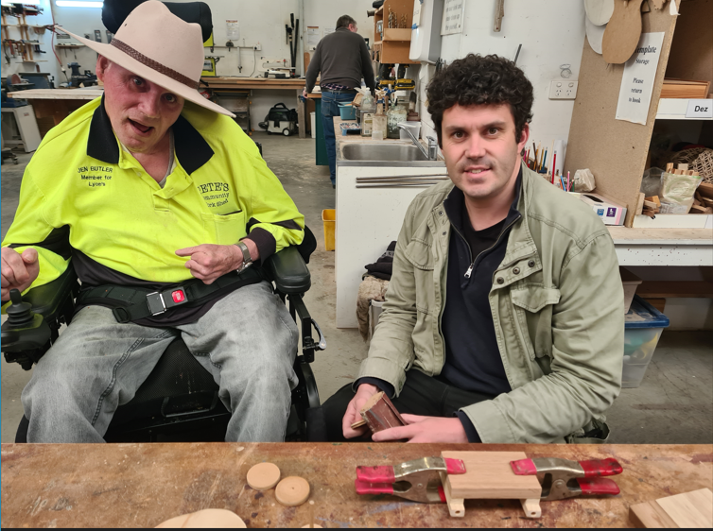

*Garry, pictured with support worker Alan, makes model trucks at his local Men’s Shed. Each week his calendar is filled with walks, swimming lessons, sailing and café visits.*

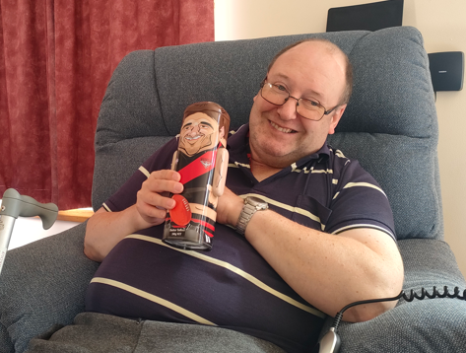

Michael has been a client for more than 20 years. This year he decided that he would like to live on his own. [Our team worked with him to find a stand-alone unit in the grounds of a residential facility we manage near Hobart](https://www.anglicare-tas.org.au/acquired-injury-support-services/), and this new independence sees him thriving. Michael enjoys chatting to the many people he knows on visits to his home town of New Norfolk.

# **We work for justice**



## **Our vision is for a fair society where no person is left behind.**

Anglicare’s [Social Action and Research Centre (SARC)](https://www.anglicare-tas.org.au/social-action-research-centre/)  highlights solutions to systemic problems affecting Tasmanians’ quality of life. We use information from our frontline services to engage with government about the needs of our community, and encourage decision-makers to make policy, system and service improvements.

A report called [Survival mode](https://www.anglicare-tas.org.au/survival-mode/), released in December 2023, explored the experiences of Tasmanians living on a low income in the midst of a cost of living crisis. We recommended that the Federal government raise the rate of JobSeeker and make healthcare more affordable.

Our [Rental Affordability Snapshot](https://www.anglicare-tas.org.au/rental-affordability-snapshot/), released in April 2024, showed that more renters are competing for fewer affordable properties. We supported reform of the Residential Tenancy Act and the building of more social housing.

In May 2024 we released the [Right to belong](https://www.anglicare-tas.org.au/research/the-right-to-belong/) report and a policy brief called [Housing security for older Tasmanians](https://www.anglicare-tas.org.au/research/policy-brief-housing-security-for-older-tasmanians/). They revealed the vulnerability of older renters in the volatile private rental market. They urged governments to take action to ensure housing supply meets the current and projected needs of our State’s ageing population.

We continued our advocacy on poker machine reform. The [Simple As report](https://www.anglicare-tas.org.au/the-poker-machine-card-simple-as/), released in September 2023 during Gamble Aware Week, outlined how a universal poker machine card system, as recommended by the Tasmanian Liquor and Gaming Commission, would benefit the entire Tasmanian community. It’s vital that this promised reform is delivered in full.

“The introduction of a universal poker machine card is a reasonable reform. It will save lives.”

*– Mary Bennett, Coordinator of Anglicare’s Social Action and Research Centre.*

“I think the system is designed to be punitive. It’s designed to make people give up.”

– Helena, interviewed for the **Survival mode** report about the challenges of living on a low income.



**Colin is a single man in his 70s who lives next door to his landlord. He wants to move to a new home that is more private, but applying for a new rental online is complex and he feels stuck. The Age Pension provides Colin with an income of $1,100 per fortnight. He can afford $192 in weekly rent, but the cheapest one-bedroom unit in his local community costs $290 a week.**

* ***From the Rental Affordability Snapshot 2024***

# **We are hopeful**



*Social connections protect and boost people’s sense of wellbeing. We support our Aged Care clients to access their community as much as they can.*

## **The right supports build on people’s strengths and improve their quality of life.**

This year our Aged Care Services continued to grow in response to increased demand. We supported more than 1800 older Tasmanians to live safely and independently in their homes.

We recruited close to 100 new team members and supported five home care cleaners to qualify for home care worker roles.

When our home care workers ask their clients “What’s for dinner today?” it paves the way for an important conversation about quality of life and healthy ageing. Training delivered by the Tasmanian Department of Health reinforced the importance of good nutrition, hydration and physical activity in preventing falls. Our clinical nursing team developed tailored meal plans for home care package clients. They also arranged referrals to allied health providers. One of our clients said Anglicare’s service provided her with “joyful company”.

### **On the housing frontline**

Anglicare provides a range of frontline housing services with the support of Homes Tasmania.

Our facilities provide wrap-around supports that suit people’s individual needs and life stages. We responded to more than 7,000 people and families in search of safe and secure housing. A major focus was preparing to run the statewide Housing Connect Front Door service from 1 July 2024.

The [Youth2Independence program](https://www.anglicare-tas.org.au/youth2independence/) supported 205 young people who had been homeless or at risk of homelessness. A new facility in the Hobart CBD opened in December 2023, providing a home and support for 26 young people. Anglicare joined the [National Foyer Community of Practice](https://foyer.org.au/national-foyer-community-of-practice/) in January 2024 when Trinity Hill, Thyne House and Eveline House were accredited by the Foyer Foundation.

Youth Development Coach Dani explains the Advantaged Thinking approach used by the Anglicare team: “We encourage the young people to try new things and to understand that making mistakes and learning from them is part of their journey. We encourage them to focus on possibilities rather than obstacles, and to open themselves up to opportunities.”



Mahalia was the first young person to move into the new facility in Campbell Street. It’s given her the security and stability she needs to balance study at the University of Tasmania’s School of Paramedicine with full-time work as a childhood educator. “The staff are interested in how I’m going and check in with me each day,” she said.

### **A love for learning**

The vision of Anglicare’s [Communities for Children kanamaluka (CfC) program](https://www.anglicare-tas.org.au/communities-for-children-cfc/) is that every child growing up in Launceston and the Tamar Valley is loved, safe, healthy, participating in learning and connected to culture and community. The program distributed close to $2 million in grants to local community organisations this year.

Based in the same region, the [Home Interaction Program for Parents and Youngsters (HIPPY)](https://www.anglicare-tas.org.au/home-interaction-program-for-parents-and-youngsters-hippy/) is a home-based, early learning program that gets children ready for school. It opens up opportunities for the whole family to connect with their local community.

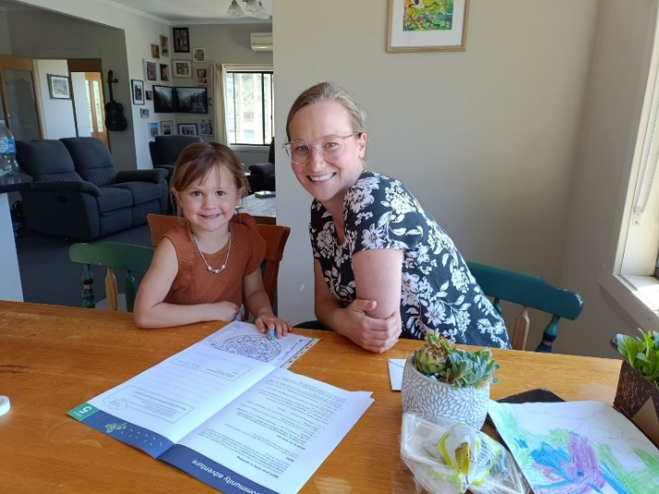

*Anglicare HIPPY tutor Yulanda, with enrolled student Sunny.*

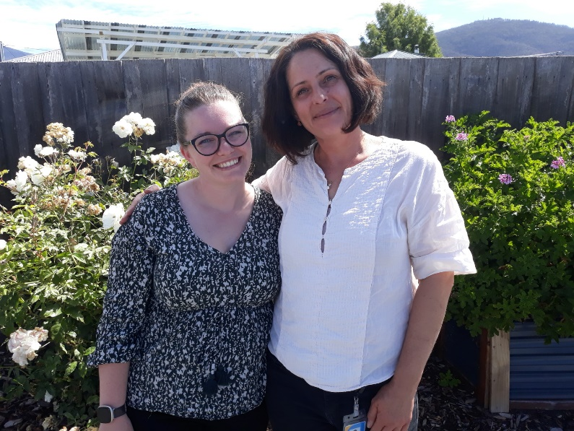

Anglicare hosted ten social work students from the University of Tasmania this year. Program Manager Brittany (left) said: “Fresh perspectives help remind us it is a privilege to support Tasmanians.” Ivana (right) described Anglicare as a gold-mine for learning. She is now working permanently with us in [The Way Back Support Service.](https://www.anglicare-tas.org.au/way-back-suicide-attempt/)

# **We are compassionate**

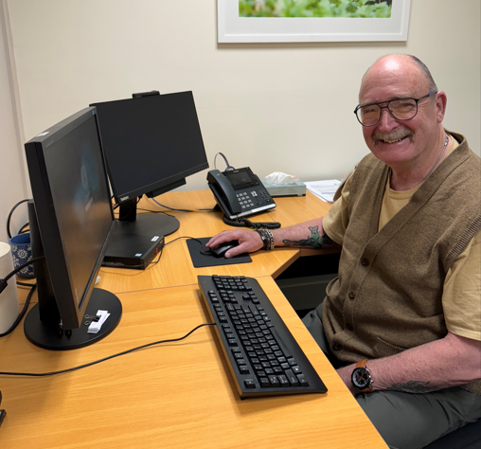

[*We welcomed Trevor Hurst into our financial counselling team*](https://www.anglicare-tas.org.au/anglicare-tasmania-partners-with-nils-tasmania/) *in Launceston. A volunteer with* [*the No Interest Loans Scheme (NILS)*](https://www.nilstasmania.org.au/)*, he helps people access safe credit for household essentials.*

## **Our services are professional, inclusive and kind.**

Our [Needle and Syringe Program](https://www.anglicare-tas.org.au/needle-and-syringe-program-nsp/) is a successful public health initiative that prevents harm and saves lives. Team members provide supplies of the overdose reversal drug naloxone and fentanyl testing strips to their clients. [Hobart-based NSP worker Jamila featured in the Work with Purpose campaign](https://workwithpurpose.au/jamila-nsp-harm-reduction-worker/) that encourages Tasmanians to choose a career in social services.

We marked [International Overdose Awareness Day](https://www.anglicare-tas.org.au/reducing-and-preventing-drug-overdose-tasmania/) in August 2023 with community gatherings for people with lived experience of loss due to overdose.

We supported a call by the Alcohol, Tobacco and other Drugs Council for [more investment in services for people with alcohol and other drug addictions, particularly early intervention services.](https://www.anglicare-tas.org.au/high-demand-for-alcohol-and-other-drug-services/)

### **Building resilience**

[Our qualified financial counsellors supported Tasmanians to weather the cost of living crisis.](https://www.anglicare-tas.org.au/financial-counselling-service-cost-of-living-crisis.) They saw a trend away from supporting people with debt-related issues towards assisting Tasmanians stressed about meeting regular, day-to-day expenses.

Team members attended training facilitated by Financial Counselling Australia about how best to [help individuals and communities recover from a natural disaster](https://www.anglicare-tas.org.au/financial-counselling-disaster-recovery/).

Anglicare’s [Gamblers Help](https://www.anglicare-tas.org.au/gamblers-help-services/) counsellors work with individuals and their families and friends to reduce the harms associated with gambling. Gamble Aware Month in September 2023 promoted conversations in order to reduce stigma. The [Get into the Game program](https://www.anglicare-tas.org.au/reducing-sports-betting-in-club-environments/) encouraged sporting clubs to help disrupt the normalisation of betting on sports and reduce the exposure of young people to gambling promotions.

[Anglicare receives funding to provide programs that protect and improve Tasmanians’ mental health.](https://www.anglicare-tas.org.au/mental-health-services/) They give people the skills to take charge of their recovery, and offer opportunities to make meaningful social connections.

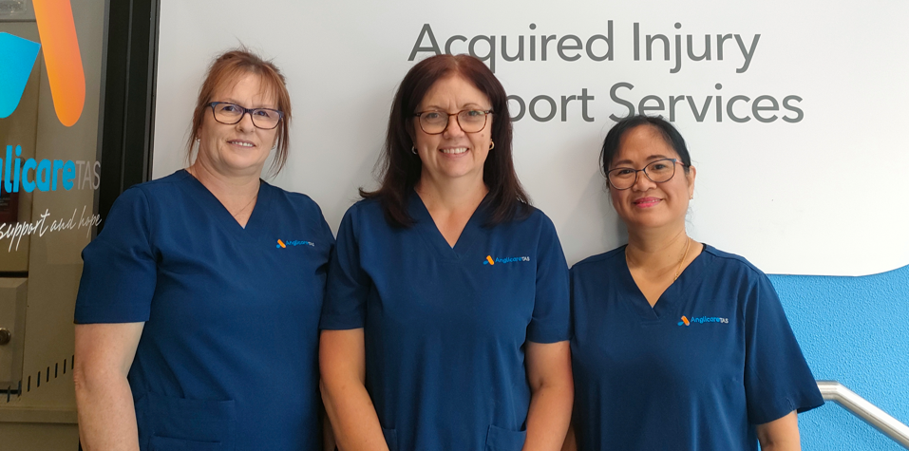

*“Our clients are very talented in many things and I feel so honoured that they share their knowledge with me. – Dina, Home Care Worker, Aged Care Services, pictured here on the right with colleagues Sharyn (left) and Cheryl.*

### **Anglicare’s Snapshot newsletter**

If you would like to read more about how Anglicare’s work improves the lives of Tasmanians, subscribe to Snapshot, our monthly newsletter that arrives by email.