Stretched Too Far:

Children and families surviving the cost of living crisis in Tasmania

Kristy Cope

October 2024

**Acknowledgement of Country**

**Anglicare Tasmania acknowledges and pays respect to the Tasmanian Aboriginal community as the traditional and original owners and continuing custodians of this land, lutruwita, on which this project has taken place. We acknowledge Elders past and present, and Aboriginal people who have participated in and are connected with this research.**

# Acknowledgements

Anglicare acknowledges the many people and organisations who contributed to this project.

Thank you to the Anglicare staff in the Hobart, Glenorchy, Sorell, Launceston, Devonport and Burnie offices who shared their insights about the harmful effects the cost of living crisis is having on Tasmanian families.

# About Anglicare Tasmania

Anglicare, in response to the Christian faith, strives to achieve social justice and to provide the opportunity for people in need to reach fullness of life.

Our values:

**Hope**: Confidently reaching for fullness of life.

**Compassion**: Showing empathy and care for those in need.

**Justice**: Promoting the fair distribution of resources and opportunities.

**Respect**: Recognising the inherent value and dignity of every person.

# Anglicare Tasmania’s Social Action and Research Centre

The Social Action and Research Centre investigates how and why Tasmanians are affected by poverty and inequality. We use what we learn to advocate for changes that improve people’s lives.

Our qualitative research centres on the lived experience of Tasmanians. It often features the voices of people who use Anglicare services and our frontline workers.

Our quantitative research uses data to demonstrate social trends.

We brief government and stakeholders on our research and create opportunities for networking and collaboration.

Contents

Acknowledgements 2

About Anglicare Tasmania 3

Anglicare Tasmania’s Social Action and Research Centre 3

Why do this research? 5

How did we do this research? 5

Quantitative and qualitative data 5

Literature review 5

Terminology 6

Executive summary 7

Findings 7

Recommendations 8

What do we mean by the cost of living crisis? 10

Why has the cost of living increased? 11

How the cost of living pressure impacts families 12

Who we spoke to and what we learnt 14

Families accessing Financial Counselling in July 2024 15

Findings 16

Families in financial stress 16

Domestic and family violence 17

Affording the basics 19

Suitable and secure housing 19

Adequate and nutritious food 25

Access to medical services 30

Conclusion and recommendations 35

# Why do this research?

Cost of living pressures faced by Australians continue to rise, and as a result there are Tasmanian families experiencing new or deepening financial hardship. With the cost of food, electricity and housing climbing faster than wages and income support payments, many are struggling to make ends meet.

# How did we do this research?

This research aimed to answer three questions.

1. What has changed for families as a result of the increasing costs of living?
2. How have families been managing cost of living pressures in 2024?
3. What impact are cost of living pressures having on children?

To answer these questions, the following research tasks were completed:

## Quantitative and qualitative data

* Trend analysis of service use data for Anglicare Financial Counselling from July 2022 – June 2024.
* Content analysis and thematic review of de-identified case notes from clients who attended Anglicare’s Financial Counselling in July 2024.
* Group discussion interviews conducted with Anglicare Child, Youth and Family Services staff to explore what impact the cost of living was having on the children and families they work with.
* Group discussion interviews conducted with Anglicare Financial Counselling staff to explore what can be done to ease the pressures of the cost of living crisis for families

## Literature review

* Review of relevant literature on the impact of financial stress on children and families, with a focus on effects on child development.

# Terminology

* **Financial stress** is any stress individuals feel as a result of a financial situation (Healthdirect 2023).
* **Financial vulnerability** occurs when individuals cannot or can just barely make ends meet (University of Melbourne 2020). It is important to remember that vulnerability may not be experienced all of the time, and that anyone can become vulnerable at any time (AFSA 2022).
* **Financial hardship** occurs when individuals have difficulty paying bills, repayments on loans or other debts on time (NDH n.d.).
* A broad definition of **family** is used in this report to reflect the many different experiences Australians have of family, and this includes those in caregiver relationships such as:
* parents and children
* grandparents and grandchildren
* chosen family, including close friends
* blended or step families
* foster families
* guardians or other important caretakers (Budinski and Gahan 2023).
* **Poverty** means that a household has inadequate income relative to their needs. In this report it is defined as households with income below the [Henderson poverty line](https://melbourneinstitute.unimelb.edu.au/publications/poverty-lines) (University of Melbourne 2024).
* In this report, **material basics** means the essential goods and services needed to live a full and dignified life across six domains as set out in The Nest, the wellbeing framework developed by the Australian Research Alliance for Children and Youth (ARACY):
* suitable and secure housing
* adequate and nutritious food
* appropriate clothing
* clean water and air
* access to transportation, services and nature
* access to tools and equipment needed for participation (ARACY 2024).
* **Family violence** refers to violence between family members, typically where the perpetrator exercises power and control over another person. The most common and pervasive instances occur in intimate (current or former) partner relationships and are usually referred to as **domestic violence** (AIHW 2018). To be all inclusive, this report uses the term **domestic and family violence**.
* We have used the term **victim-survivor** to refer to people who have experienced violence. It acknowledges the harm, pain and suffering of being a victim of crime, while also illustrating their strength and resilience (Women Against Abuse 2024).
* **Homelessness** is defined as when a person does not have a home or suitable accommodation that meets their needs. People are considered to be experiencing homelessness if their current living arrangement is in a dwelling that is inadequate; or has no tenure, or if their initial tenure is short and not extendable; or does not allow them to have control of and access to space for social relations. This definition includes people who are couch-surfing, living in overcrowded conditions and who don’t have appropriate agency where they live, as well as people who are sleeping rough (Shelter Tas 2021).

# Executive summary

Since 2022, the cost of living in Australia has been increasing faster than incomes, leading to what is often called a ‘cost of living crisis’.

Anglicare’s Social Action and Research Centre (SARC) has undertaken this research in response to reports from Anglicare’s Financial Counsellors that the impact of the crisis is deepening. As a result, an increasing number of dual-income households are experiencing financial hardship for the first time.

For families, a period of financial hardship is of concern as it can have lasting impacts on the development and life outcomes of children. Drawing on data from Anglicare’s Financial Counselling and Child, Youth and Family Support services, this research sought to understand the main drivers of financial hardship for families and identify where policy responses and targeted supports can have the greatest impact.

## Findings

**Housing** is the number one non‑discretionary item for households. Limited housing supply is driving a rental market that is unaffordable for low- and middle-income households, with rents equal to or higher than equivalent mortgage repayments.

For those who own their home, sharp increases in interest rates are leading to mortgage stress, with many Tasmanians facing the prospect of losing their home and being forced into a more expensive rental market.

**Food** insecurity is on the rise and as a result, families are turning to under-regulated and high-risk creditors such as Buy Now Pay Later lending to afford groceries.

**Medical care** is inaccessible for many families. With housing and food accounting for the majority of the household budget, parents and guardians are not able to afford private medical care. Parents and caregivers are struggling to provide their children with access to prompt care due to a limited supply of bulk-billed medical services and a growing gap fee for non-bulk-billed services.

## Recommendations

To address these major drivers, investment is needed in targeted support to ensure that in the face of increased costs of living, families can remain safe and stable and prevent avoidable adverse impacts on childhood development. This requires both short-term initiatives that address immediate needs and long-term reform to address underlying causes.

**Anglicare Tasmania recommends that:**

*To ensure all families receive enough income to cover the basic cost of living*

1. The Australian Government raises the rate of social support payments above the Henderson Poverty Line, and establishes an independent Income Support Payment Commission to set and maintain payment rates.
2. The Australian Government, in partnership with the Child Support Expert Panel, undertakes a review and reform of the child support system in Australia with a focus on embedding dedicated domestic and family violence protections.

*To ensure all families have suitable and secure housing*

1. The Tasmanian Government increases the supply of social and affordable housing for Tasmanian families to fully meet demand based on current and projected need, including the needs of families escaping domestic and family violence.
2. The Tasmanian Government amends the Residential Tenancy Act to provide for minor modifications, rent stability and greater security of tenure, including amendments to ban no-cause evictions and limit the frequency and amount by which rents can be increased.
3. The Australian Government works with the Australian Banking Association to offer expanded hardship options for families experiencing mortgage stress.
4. The Australian Government reviews the Rental Assistance Scheme in association with other income support payments, to ensure that households on low incomes pay no more than 30% of their household income on rent.

*To ensure access to affordable and nutritious food*

1. The Australian Government continues to strengthen regulations of the grocery sector to ensure fair prices for consumers, and takes targeted steps to ensure an affordable supply of fresh produce.
2. The Tasmanian Government delivers on the commitment to evaluate the *Food relief to food resilience: Action Plan 2023-25.* The evaluation should focus on understanding how successfully the plan has moved Tasmanian communities from emergency food relief towards a food resilient system. The learnings from the evaluation should be incorporated into the 2025 whole-of-government food resilience strategy.
3. The Tasmanian Government develops a safe credit product incorporating fintech to provide a convenient, cost-neutral alternative to Buy Now Pay Later that can be used for essentials such as groceries and fuel. This could be through the existing No Interest Loan Scheme (NILS) or a similar product.
4. The Australian Government undertakes a six-month review of Buy Now Pay Later regulations, including considering a ban on in-store advertisement for retailers of essential items, including petrol stations and grocery stores.

*To provide access to affordable and timely medical care for families*

1. The Australian Government reviews and reforms Medicare, with the aim of

* aligning the indexation of the Medicare rebate to the operational cost of providing medical care to reduce out-of-pocket costs paid by patients
* amending the payment process for medical appointments to eliminate the need for people to cover the full fee upfront before they can claim the Medicare benefit.

1. The Tasmanian Government increases access to bulk-billing GP services, including expanding the Mobile GP Practice to rural and regional town centres and embedding bulk-billing incentives into the GP Partnerships Grants Program.

# What do we mean by the cost of living crisis?

Every person spoken to while conducting this research understood what was meant by ‘the cost of living crisis’. As a population we are experiencing it together in real time.

Prices are rising faster than our incomes. As a result, essentials such as food and housing are taking a larger proportion of the household income. For some people, the higher costs are covered by reducing discretionary spending or even dipping into savings. However, for others it means making difficult choices about which essential item will be prioritised week to week, such as deciding if they can afford to see a doctor.

‘Low, middle or high income, it doesn’t matter – you get used to what you have’

— Financial Counsellor, Glenorchy

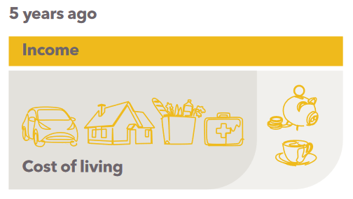

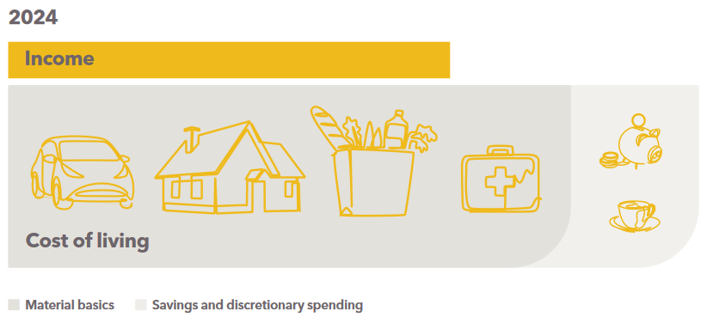

Financial Counsellors report that many Tasmanian families were stretched thin even before the cost of living started to increase. Wages are lower in Tasmania than the rest of the nation (ABS 2024a). For parents, childrearing responsibilities can limit their ability to undertake paid employment or increase their paid working hours (AIHW 2022a). Yet families need more income to cover costs compared to other household types (ABS 2017). Not only do they have higher grocery bills and housing costs, but families can have additional expenses that need covering such as child care and education costs.

Anglicare Financial Counsellors report that in previous years, families mainly sought assistance regarding high electricity bills related to winter heating. However, in 2024 most families sought assistance for mortgage stress, or for debts accumulated to cover essentials like food and fuel. Counsellors report seeing families seeking assistance for the first time who ‘previously have always been okay’, and an increase in dual-income households seeking budgeting advice, who ‘simply [do not have] enough income to cover the increased cost of living’. While the costs of material basics remain high, more families are expected to become financially vulnerable, or enter into financial hardship.

## Why has the cost of living increased?

In Australia, the Consumer Price Index (CPI) is the primary indicator of household inflation and the cost of living (ABS Jun-quarter-2024). To maintain price stability, the Reserve Bank of Australia (RBA) aims to keep growth in the CPI between two and three per cent (RBA 2024a).

|  |
| --- |
| **Box 1: Categories of CPI**  The **Consumer Price Index** (CPI) is the measure of how the price of goods and services changes over time (ABS Jun-quarter-2024). There are a number of categories of CPI including: |
| * Housing (including energy) * Food & non-alcoholic beverages * Recreation & culture * Furnishings, household equipment & services * Transport * Clothing & footwear * Insurance & financial services * Education * Alcohol & tobacco * Health * Communications |

**Figure 1**: Consumer Price Index (CPI), June 2014 – June 2024

Source: (ABS Jun-quarter-2024)

From mid-2022, global inflation pushed CPI growth above the target range. Between May 2022 and November 2023, the RBA increased the central bank cash rate from 0.1% to 4.35% in order to control inflation (RBA 2022). As a result, market home loan interest rates increased from around 3.65% to sit around 6.5% (RBA 2024b).

Inflation fell in 2023 after peaking at 7.8% pa in December 2022. However, the decline in inflation stalled in 2024, with the CPI fluctuating around 3.5 to 4.0% (ABS Jun-quarter-2024). Significant price increases are still being observed across essential categories of the CPI, with the cost of housing, food and non-alcoholic beverages of greatest concern.

## How the cost of living pressure impacts families

The impact pathway published by Monash University and VicHealth, shown in Figure 2, summarises how high inflation coupled with low wage growth can lead to material hardship and psychosocial and behavioural effects (Black et al. 2024). For parents it can impact their productivity and earnings, and can also affect their physical and mental health. This has spill-over effects for children. The effects of financial stress on children are discussed further on page 17 of the report.

Figure 2: Impact pathways between high inflation and health outcome for parents and children

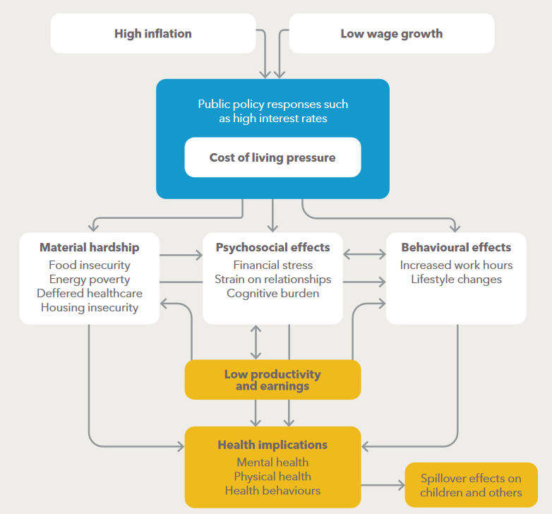

Source: (Black et al. 2024)

# Who we spoke to and what we learnt

The Social Action and Research Centre (SARC) spoke with frontline staff from Anglicare services that support children and families facing or at risk of financial stress or hardship.

The **Anglicare Tasmanian Financial Counselling Service** offers advice and assistance on a range of financial issues. This can include budgeting or managing debt and hardship arrangements. The Financial Counselling Service receives funding from both the Commonwealth Government and the Tasmanian Government, and is available to all Tasmanians, without any eligibility requirements. The data from the Financial Counselling Service can provide insights into the financial challenges Tasmanian families are experiencing.

**Anglicare Child, Youth and Family Services** include a range of programs aimed at supporting children and families through different stages of life. These programs receive funding from both the Commonwealth Government and the Tasmanian Government. Services are provided to children, young people, parents and families. The data from the Child, Youth and Family services can provide insights into the effects financial stress has on Tasmanian children and families.

The interviews with Anglicare staff provide useful information about how the rising cost of living impacts children and families in Tasmania. It also allows us to identify groups that are being disproportionally affected. The data shows that single female parent households are still bearing the brunt of financial hardship. However, there are many two-parent families struggling financially, even when both parents are working.

There is also significant concern for the high number of families reporting experiences of domestic and family violence, with one in five financial counselling clients disclosing domestic and family violence.

# Families accessing Financial Counselling in July 2024

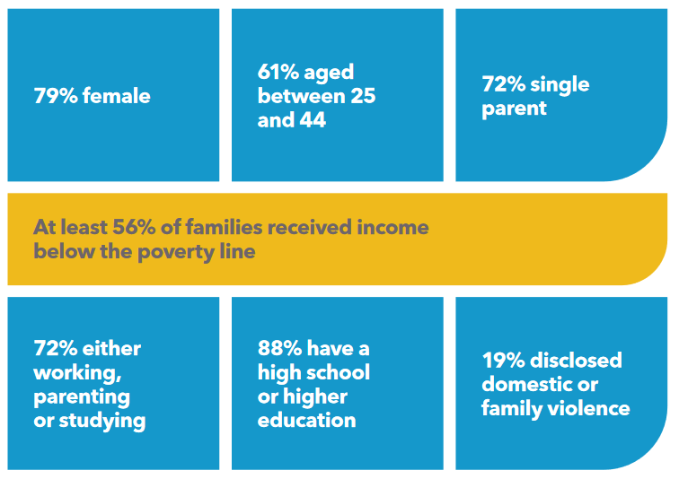

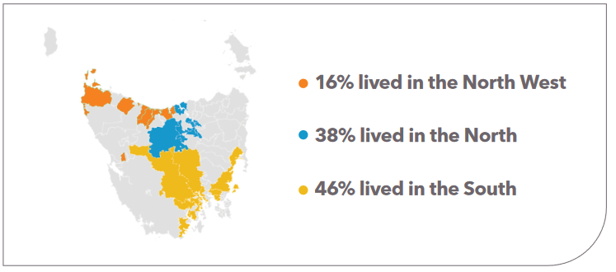

# Findings

## Families in financial stress

Many families in Tasmania are experiencing financial stress as a result of the increased cost of living, meaning that they do not have the financial resources to meet the material basics (Steen and MacKenzie 2013).

‘We are seeing people now that we just didn’t before. Dual-income families who used to always be fine are now only just getting by’

— Financial Counsellor, Hobart

‘Income just isn’t matching expenses’

— Financial Counsellor, Launceston

When families are struggling financially, parent and caregiver stress increase. This can lead to poor physical and mental health for parents and may decrease their parenting capacity (Neppl et al. 2016). Parents and carers can become easily frustrated, less patient or lack the emotional resources needed for supportive and nurturing parenting behaviours (NASEM 2016). As a result children’s emotional and physical needs may not be met, and the quality of their home environment may change (Neppl et al. 2016). All of these conditions are critical to healthy childhood development (NSCDC 2020).

‘What’s important is feeding your kids. It’s more important than seeing your psychiatrist so you just go without even though that impacts on how well you can parent’

— Child and Family Worker, Devonport

The Family Stress Model outlines how economic hardship can lead to compromised development in childhood (Figure 3).

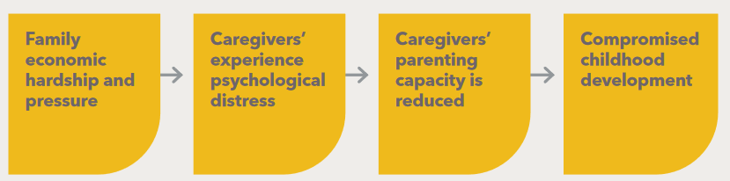

**Figure 3**: Family Stress Model (Neppl et al. 2016)

A child’s environment has a direct role in shaping the development of their brain and body (NSCDC 2020). Safe, stable environments foster healthy stress responses (NSCDC 2020). In contrast, constant stress can lead to overactive stress responses which can harm other physiological systems (Monks 2017).. The impacts include adverse effects on cardiovascular function, immune responsiveness and metabolic regulation, all of which are vital for lifelong health and wellbeing (NSCDC 2020)...

Beyond biological impacts, environmental stress can also result in poor socioemotional development. This can lead to poor mental health in childhood and adulthood, affecting educational engagement and, later, participation in society as an adult (Edwards et al. 2009; Coley et al. 2015).

Compromised childhood development has long-term social and economic costs for the individual and the broader community (AIHW 2022a). It is therefore important to respond to families’ experiences of financial stress as a public health issue. Providing early support to reduce the impact of financial hardship on families can improve children’s health, wellbeing, education and participation outcomes.

‘It starts with families being cold and hungry and they become more stressed and they can’t parent appropriately because they are just under so much stress, and then you start to see anger in the household and all this stress is handed down to the kids in one way or another’

— Child and Family Worker, Burnie

## Domestic and family violence

Tasmania, like the rest of the nation, has unacceptably high numbers of women and children experiencing violence every year. We heard from Anglicare staff that the increasing cost of living is impacting victim-survivors, heightening their risk of violence and strengthening the control perpetrators can gain through economic abuse. It is also increasing barriers to escaping violence (Tiyce 2024).

**Figure 4**: Incidents of domestic and family violence in Tasmania over an 8-year period

Source: (Tasmanian Government 2023a)

Domestic and family violence is complex. It can take many forms. One is **economic abuse** which involves a pattern of control, exploitation or sabotage of money, finances and economic resources. It can affect a person’s ability to obtain, use or maintain economic resources, threatening their economic security and potential for self-sufficiency and independence. Economic abuse is also known as financial abuse (DSS 2023).

**19%**

**of clients accessing financial counseling in July 2024**

**disclosed domestic or family violence**

Victim-survivors often experience ongoing impacts long after the economic abuse has occurred (ABA 2020). With inescapable debt and a poor credit history, victim-survivors may face long-term financial hardship (ABA 2020). Often this leads to being financially dependent on abusive partners (ANROWS 2020). As a result, economic abuse can leave victim-survivors trapped.

‘The cost of living is really impacting women and children experiencing DV – they have nowhere to go and they have no finances’

— Financial Counsellor, Burnie

Even when victim-survivors leave, economic abuse can still continue. Financial Counsellors shared that many victim-survivors do not claim child support from an abusive ex-partner due to fear for their own safety. Others are failing to receive adequate child support due to systemic issues within the Australian child support system (Cook et al. 2024). As a result, victim-survivors do not receive a fair income, worsening the effects of the increased cost of living. Their children are placed at risk of not receiving material basics, which increases the likelihood of child protection intervention and worsened trauma resulting from experiencing or witnessing violence.

‘We are seeing more mums who don’t get child support because they are too scared to ask for it, or for him to know where the kids live’

— Financial Counsellor, Hobart

Targeted supports addressing financial barriers for victim-survivors are needed to counteract the additional risks and impacts of domestic and family violence due to the increased cost of living. A dedicated focus on improving the Australian child support system is also needed to prevent additional abuse pathways.

# Affording the basics

Material basics are the essential items needed for every person to live a full and dignified life and are identified by the Australian Research Alliance for Children and Youth as:

1. suitable and secure housing
2. adequate and nutritious food
3. appropriate clothing
4. clean water and air
5. access to transportation, services and nature
6. access to tools and equipment needed for participation in society (ARACY 2024).

For children, sustained material deprivation increases the risk of poor physical and mental health development (NSCDC 2020). It can also affect their educational and social participation (Edwards et al. 2009).

Frontline workers with Anglicare’s Financial Counselling and Child, Youth and Family Services report families going without one or more of these basics on a weekly basis because they simply cannot afford them. This includes families prioritising fixed or unavoidable costs in their budget (rent, mortgage, bills, debts) over variable costs (food, clothing, fuel, medical care).

‘I have clients say … I can’t tell you how much I spend on food, whatever is left over is what I spend on food’

— Financial Counselor, Hobart

‘Kids can’t even get to school because the parents can’t afford the fuel’

— Child and Family Worker, Devonport

Assisting families to access housing, food and medical services is a priority and will increase their capacity to afford essentials in the other domains. The following sections of the report outline recommendations to ease the financial burden for families.

## Suitable and secure housing

### Why it is important

Secure and suitable housing is an essential need for healthy families (AIHW 2022b).

Secure housing promotes family stability and caregiving, and supports employment and children's education opportunities (Taylor and Edwards 2012). It also connects families to their community and the many natural supports that exist within it, including extended family. Disruptions to community for children can reduce their sense of safety and stability, and in turn negatively affect their socioemotional development (Livingstone 2018).

Unsuitable housing is any housing that is unsafe, of poor quality or overcrowded (AIHW 2023). The impacts of unsuitable housing on children can be diverse, ranging from poorer physical health to impaired socioemotional development (AHURI 2014). A child’s physical environment can directly impact their biological development. For example, a child in a poorly ventilated house may be exposed to high levels of mould, increasing the risk of developing a respiratory illness such as asthma (NSCDC 2020). Ensuring that children live in suitable and safe housing is essential to preventative health.

Anglicare’s Financial Counsellors observe that families usually prioritise secure housing over everything else, as far as they can.

‘Families are just trying to keep their homes right now, so many families won’t request maintenance so they don’t rock the boat and risk getting either a rental increase or being evicted’

— Child and Family Worker, Glenorchy

### More families are experiencing housing stress

Over the past decade, prices of Australian houses and rentals have increased at a greater rate than income. Between March 2023 and March 2024, median house prices in Australia increased by 7.7% and rental prices increased by 7.8% (KPMG 2024). Anglicare staff identified the increased cost of housing as a key driver of financial stress for families in two groups – renters and home owners with a mortgage.

Anglicare Financial Counsellors shared that:

**families in rentals**

have faced rental increases of over $100 a week.

**families in mortgaged properties**

have faced mortgage repayment increases of up to $250 a week.

Increasingly families are choosing between paying unaffordable mortgage or rental prices, or giving up their home and ‘trying their luck' in an equally unaffordable rental market.

Housing market conditions are also lowering the standard of housing that families are accepting. Staff shared examples of families who are not seeking reasonable maintenance or repairs on rentals because they fear eviction or further rent increases. For families buying their own home, increases in mortgage repayments and other costs of living are leading them to delay house maintenance. Instead, families are simply living with unsuitable conditions.

‘Rent and mortgage payments are an absolute non-discretionary – there is no way to reduce them – they are set by an external force and you have to comply or you lose your accommodation. Everything then has to come out of what is left once you have paid your rent or mortgage’

— Program Manager, Financial Counselling

### Families in the rental market

Staff reported numerous examples of families facing rent increases that placed them into rental stress and reduced their capacity to afford material basics.

**Figure 5:** Vacancy rates in Tasmania

Source: (SQM Research 2024)

The Tasmanian Housing Strategy recognises that a vacancy rate of around 3% indicates a healthy market in which demand for rental properties and the number of properties available (supply) are roughly in balance (Tasmanian Government 2023b). Vacancy rates in Tasmania remain well below 3%, maintaining upward pressure on rents (SQM Research 2024). In August 2024 vacancy rates tightened across much of the state and rental prices have continued to increase (SQM Research 2024).

Between 2020 and 2022, weekly rental rates in Tasmania grew 21.5% (SGS Economics & Planning 2023).

**Rental stress occurs when housing costs are greater than 30% of household income** (Anglicare Australia 2024)

|  |  |  |  |  |
| --- | --- | --- | --- | --- |
| **Median weekly rent in August 2024** | | |  |  |
| **Hobart** | **Launceston** | **Burnie** | | |
| $532.73  **5.5% higher**  **than in August 2023** | $497.52  **8% higher**  **than in August 2023** | $389.51  **9.3% higher**  **than in August 2023**  **(SQM Research 2024)** | | |

‘Increases in rent for pre-existing leases can push people over the edge’

— Financial Counsellor, Hobart

Under current regulations, renting families feel powerless to do anything other than to accept rent hikes. Frontline staff cited examples of families who, when attempting to negotiate on rent increases, were effectively evicted from their homes with no cause after which the property was re-advertised at an even higher rental price.

‘Families are being forced to move into places with higher rent that are known to be unaffordable, just to get accommodation’

— Financial Counsellor, Launceston

We urge the Tasmanian Government to improve security for renting families, including amending legislation to ban no cause evictions, and limit the frequency and amount by which rents can be increased.

### Families with a mortgage

Financial Counsellors are now reporting seeing more families in mortgage stress, and are expecting this to increase over the next year.

‘We always assume people with mortgages are financially okay – that isn’t the case anymore’

– Financial Counsellor, Sorell

**The fixed-term delay is important to understanding why some families are experiencing the full brunt of the cost of living crisis in 2024, rather than when interest rates began increasing in 2022.**

Between 2020 and 2022, most new home buyers took out loans with fixed rates of around 2% to 2.5%. Many households also refinanced their mortgages to take advantage of low interest rates. In 2022 almost 40% of all loan were on fixed term rates, as compared to around 20% in 2020 (RBA 2024b; Ung 2024).

These low-rate fixed term loans started to expire in 2024, and will continue expiring over the remainder of the year (Ung 2024). If these fixed term loans reprice at the current variable rate, the interest rate on the average rollover mortgage is expected to increase by around 4% pa (RBA 2024b).

Families in mortgage stress have little choice but to 'try to find the money' for repayments. The alternative is to enter the equally unaffordable rental market.

‘Previously we would have recommended selling and moving into a rental, but now that is as much as the mortgage if not more so – it’s not really an option anymore’

– Financial Counsellor, Hobart

|  |
| --- |
| **An example of the fixed term delay**  The mean price for a home in Tasmania in December 2021 was $649,200 (ABS 2021a).  If a family purchased their home with a 20% down payment totalling $129,840, they would have borrowed $519,360 from the bank.  A loan with a fixed rate of 2.5% pa would have a minimum monthly repayment of $2,053 for the period of the fixed rate contract.  If the term of the contract is 2 years, from December 2023 the interest on the loan would be charged at the variable rate of 6.5%.  This means the family’s minimum monthly repayment would increase to $3,126 per month.  This means every month the family must find **an extra $1,073** in their budget to cover the principal and interest on their mortgage.  These repayment estimates have been calculated using Finder.com.au mortgage repayment calculator (Whitten 2024) |

‘Looking at a family’s budget, they just don’t have the wiggle room – they can’t pay their mortgage but then they don’t have anywhere else to get that money from in the budget’

– Financial Counsellor, Hobart

### When there are no affordable houses

Families are struggling with rising living costs, including higher mortgage payments and rents. Demand for social housing in Tasmania is also increasing, with the number of applications on the social housing register increasing by 288 (6.4%) to 4792 over the two years to September 2024 (Homes Tasmania 2024).

In 2022-23, the proportion of Tasmanians accessing specialised homelessness services was higher than the national rate. 93% of specialised homelessness service clients needed accommodation, but only 40% of those already homeless found housing (AIHW 2024).

Families face a tough housing market with few affordable options. This means more children are exposed to the harsh realities of homelessness. In Tasmania in 2022-23, 816 children under 18 sought support from specialist homelessness services alongside their parents, and alarmingly, 413 children attended alone (Homelessness Australia 2024).

### The impacts of family homelessness

Anglicare Child, Youth and Family staff expressed deep concern that there is a growing social acceptance of family homelessness. Staff reported seeing more families surviving by couch surfing, living in overcrowded conditions or sleeping rough in campgrounds while they wait for affordable rentals or social housing to become available.

Staff reflected that previously, the statutory system protecting children would have activated a response when homelessness first occurred. With the current lack of alternative housing, interventions can be delayed. This means that children are experiencing greater depths and duration of homelessness.

Research shows that children who experience family homelessness are at greater risk of becoming homeless again, particularly in adulthood (AIHW 2021). We also know these experiences have lifelong impacts, and can increase children’s risk of exposure to violence, abuse or child exploitation (CCYP 2024). It is imperative that families experiencing homelessness get early and responsive support to protect children and reduce their likelihood of future episodes of homelessness.

‘When children are in unsafe and neglected spaces they are at increased vulnerability to exploitation’

– Program Manager, North West

Children are having to be adults before their time’

– Program Manager, Child and Family Services, North West

‘Children are having to make really hard decisions to survive’

– Child and Family Services, North West

## Adequate and nutritious food

### Why it is important

All children require adequate and nutritious food. Without it, children’s mental and physical development are at risk (RCH n. d.).

In July 2024, fruit and vegetable prices were 7.5% higher than in July the previous year (ABS 2024b). Anglicare staff reported that families are struggling to afford fresh produce and consequently often reach for low cost, high volume food which is low in nutritional value. There is significant concern that the foods containing nutrients essential for healthy child development are becoming the least affordable.

‘It is the fresh food that is missing … families have the pantry items like the creamed corn and the tinned beans but it’s the fresh stuff they really need’

– Financial Counsellor, Glenorchy

### Food insecurity on the rise

Many individuals across Australia are experiencing food insecurity. In 2024, Foodbank reported 3.4 million households (32%) faced moderate to severe food insecurity (Foodbank 2023). Many of those households were experiencing food insecurity for the first time (Foodbank 2023).

The Tasmania Project Food and Food Purchasing Survey found similar results, with one in four adults and children experienced some level of food insecurity between December 2023 and January 2024 (Kent et al. 2024)..

* **29%** of adults experienced food insecurity within past 30 days
  + 9% of adults were marginally food insecure
  + (anxious over food or a shortage of food)
  + 12% of adults were moderately food insecure
  + (reduced quality, variety or desirability of food eaten)
  + 9% of adults were severely food insecure
* **29%** of children experienced food insecurity within past 30 days
  + 16% of children were marginally food insecure
  + 13% of children were moderately food insecure (Kent et al. 2024).

Notably, survey results showed no Tasmanian children were severely food insecure. Anglicare staff suggest this is probably because parents prioritise their children’s needs over their own, noting that clients often report skipping meals to feed their children.

‘Parents simply don’t eat so that their kids can’

– Child and Family Program Manager, South

### Emergency relief

Food costs have risen significantly during the cost of living crisis and Anglicare staff have seen more families using emergency food relief. However, some families are hesitant to use emergency relief as they feel ashamed or think someone else needs it more. Shame and stigma often cause families to delay accessing food relief (see Figure 6). As a result, families may accumulate debt to pay for groceries or caregivers might skip meals so children can eat.

‘There is a lot of shame in using emergency relief’

– Financial Counsellor, Glenorchy

**Figure 6:** Barriers to food insecure individuals accessing food relief

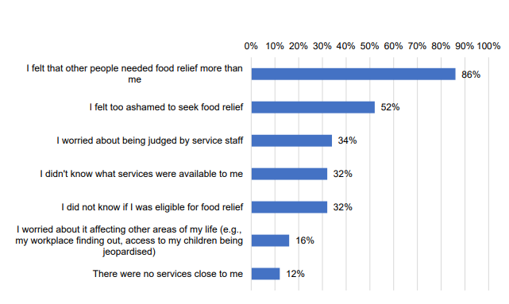Source: (Kent et al. 2024)

The shame of using emergency relief often means Anglicare staff have to work with families over several sessions before they will access food relief. This prolongs the time families go without enough food.

‘You hear from clients afterwards say “I wish I’d done that earlier”’

– Financial Counsellor, Glenorchy

Anglicare staff have also noticed changes in how families use emergency relief. Instead of using it briefly during unexpected crises, families are using it regularly to afford basic necessities. Without it, families have few options to access sufficient nutritious food.

‘Families are using emergency relief every fortnight or so. There are caps on how often you can go, but emergency relief services are working around guidelines just to make sure families have food but they shouldn’t be needing to use emergency relief that often’

– Child and Family Worker, Devonport

**Targeted support: Healthy School Lunches**

The Tasmanian Healthy School Lunch Project provides affordable, healthy lunches to all children at participating schools (Tasmanian Liberals n. d.). The program, which began as a trial in 15 schools in 2022, is now operating in 30 Tasmanian public primary and secondary schools (Jose et al. 2024).

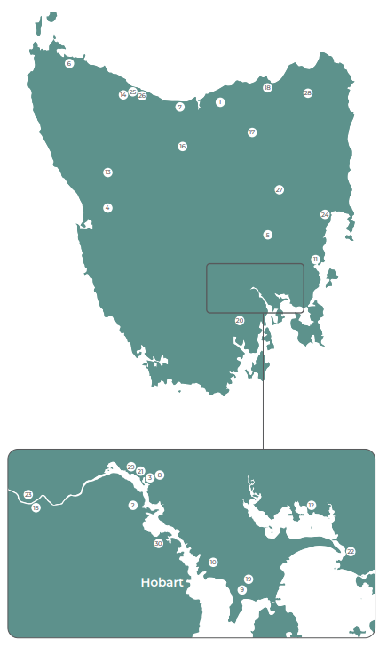 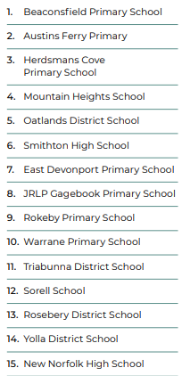 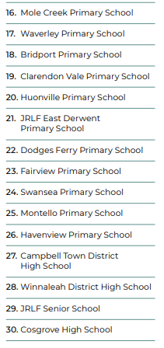Source: (Jose et al. 2024)

In a number of interviews, Anglicare staff commented on the positive impact of the program, which provides children with one or more highly nutritious meals per week. In addition to ensuring children’s nutritional needs are met, we heard that it is also reducing barriers to school attendance.

‘We know kids don’t go to school because they don’t have anything for lunch – that isn’t to say there isn’t anything in the cupboard at home but there isn’t anything to put in what is considered an appropriate meal to take to school’

– Financial Counselling Manager

Anglicare Tasmania encourages the Tasmanian Government to continue working to expand the project, with the aim of rolling it out to all public schools, prioritising schools in lower socioeconomic areas and those with lower school completion rates.

Buy essentials now, pay debt later

Anglicare staff are extremely concerned about families’ increasing reliance on Buy Now Pay Later (BNPL) products to pay for material basics.

From June 2024, BNPL lenders were classified as consumer credit providers under Australian law (Treasury 2024). The legislative amendments aimed at holding BNPL operators accountable for the credit they provide are welcomed. Yet Financial Counsellors report that easy and quick access to BNPL credit is still causing harm to individuals. They report that families often see BNPL products as a ‘lifeline’, despite it frequently leading to a spiral of debt.

‘BNPL are becoming a trap – [families] use them as a tool to get essentials but it just puts you further back later’

– Child and Family Service Worker, Glenorchy

‘We are seeing BNPL everywhere – it is being advertised on social media, in the shops – it is everywhere’

– Financial Counsellor, Launceston

The Anglicare Tasmania report [*Buy Now, Struggle Later*](https://www.anglicare-tas.org.au/research/buy-now-struggle-later/) provides more detail on the harms of BNPL lending. The report has a number of recommended actions, and we call attention to recommendation 3:

|  |
| --- |
| **Box 2 – Recommendation 3 from Buy Now Struggle Later**  For people facing financial stress or disadvantage, improve access to services such as the No Interest Loan Scheme which have promotion of the interests and wellbeing of the ‘borrower’ as their primary aim. This includes:  • exploring options to integrate features of fintech into such credit products  • expanding the funds available for the No Interest Loan Scheme (NILS)  • regulatory and funding support from public sector to support expanded access  • appropriate partnerships with commercial credit providers. |

The Tasmanian Government announcement of funding in the 2025 State Budget to expand NILS capacity with an additional 2000 loans is a welcome investment budget (Tasmanian Government 2024). Alongside continued funding, we urge the Government to work towards rapidly equipping NILS and similar safe credit products with fintech. This would offer a cost-free alternative to BNPL for families, allowing them to afford material basics without having to pay a lender premium.

## Access to medical services

**Why it is important**

For children, high quality healthcare early in life sets them up for healthy adulthood. Many chronic health problems, such as asthma, heart disease, diabetes and mental health conditions have origins in childhood (Department of Health 2019).

‘If the kids have health issues the family has to pay the medical bill but even for those on dual incomes it is difficult to afford’

– Financial Counsellor, Launceston

Poor medical care in childhood increases the chance of developing chronic health problems which, in turn, can reduce participation in society as an adult (NSCDC 2020) (Neppl et al. 2016).

‘Clients are choosing between paying for their home or their medication’

– Financial Counsellor, Launceston

### The cost of medical care in Tasmania

Anglicare staff described families delaying, rationing or going without medical care because they could not afford it.

In the latest Tasmanian Community Sentiment Survey, one in ten Tasmanians reported going without medical care between June and December 2023 due to cost concerns (Moloney 2024). This is supported by data showing that Tasmania has the lowest bulk-billing rate in the country, with only 0.9% of clinics bulk-billing compared to the national rate of 24.2% (Gillespie 2024).

‘Bulk-billing – it just doesn’t exist up here’

– Financial Counsellor, Launceston

‘Families can’t afford fees for [medical] appointments’

— Child and Family Service Worker, Glenorchy

With bulk billed medical services in short supply, we heard that Tasmanians who are unwell and struggling with the cost of living have to choose between:

* sourcing the funds to cover the cost of the appointment at a private clinic
* joining the waitlist for a bulk-billing clinic, which will be weeks or months long
* forgoing medical care, self-treating illnesses or accessing emergency medical care at a public hospital when their medical condition worsens.

‘Some can’t afford [medical care] because their rent is just too high’

– Child and Family Worker, Devonport

In a comparison of the gap fee paid in capital cities around Australia in 2022-23, Hobart is the least affordable after income is taken into account. Hobart, which has the lowest median weekly household income, has the second highest out-of-pocket fees for GP appointments, second only to Canberra, the city with the highest weekly household income. The average out-of-pocket cost for all of Tasmania has grown 8.5% over the last year, more than 2.5 times the national average of 3.1%.

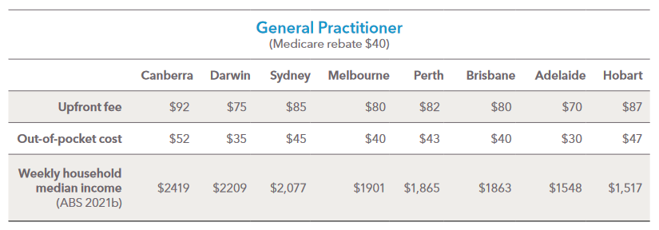

Source: (DHAC n. d.)

‘Medicare rebate gives some back but not all – AND you need the money up front’

– Child and Family Worker, Devonport

### Playing catch-up – indexation of Medicare

Over the past two decades the out-of-pocket cost of medical and mental health care has been increasing. It is now more expensive to visit a private practice because the share paid by the government, the Medicare rebate, has not kept pace with the rising cost of medical services.

On 1 July 2024, the Department of Health and Aged Care increased the indexation of Medicare rebates by 3.5% (DHAC 2024a). While this is welcome news, the rebate is still substantially below the cost of accessing health services.

Anglicare recommends action to reduce the out-of-pocket costs of accessing quality medical care, including reviewing the indexation of the Medicare Rebate Schedule (AMA 2022; RACGP 2024).

### Access to bulk-billing GPs in Tasmania

In 2022-23, the number of bulk-billed appointments in Tasmania decreased by 8.1%. This is the greatest annual decline in Tasmanian bulk-billing rates in over a decade (Productivity Commission 2024). Over the same period of time, 10.5% of Tasmanians delayed or did not see a GP due to costs, a 1.6% increase on previous financial year (Productivity Commission 2024). This means that more than 9,000 Tasmanians did not receive health care due to cost.

Through early and regular GP visits, preventable conditions can be treated before they escalate (AMA 2023). For those who are experiencing financial stress, supporting early access by removing financial barriers is key to effective preventative healthcare.

‘I had a young person - 12 years old – who I took to the doctors. The appointment wasn’t bulk-billed. It was a $150 bill. If we hadn’t been there this young person would not have been able to afford that.’

– Child and Families Worker, Burnie

The 2024-25 Tasmanian State Budget contained a number of initiatives to increase numbers of and access to GPs (Tasmanian Government 2024). Only one of these initiatives, the Mobile GP Practice, is targeted to increase access to bulk-billed medical services. The Mobile GP Practice is funded over two years to expand the newly established bulk-billed mobile clinics operating in selected communities around Hobart. This leaves a gap in access to bulk-billed services for most of the state, including rural and remote Tasmania.

We urge the Tasmanian Government to continue working to address this gap.

### Access to mental health support in Tasmania

Tasmanians experience significant barriers to accessing timely and affordable mental health services, and a recent survey showed that 60% of respondents delayed accessing mental health care due to cost (MHCT 2023).

Frontline staff similarly report that parents and caregivers are struggling to afford mental health care and as a result are either forgoing care for themselves and their children, or joining long waitlists for public mental health care. Wait times for the public system can be significant with staff citing examples of parents waiting six months or more for appointments.

Financial barriers to accessing mental health care are not only due to high out-of-pocket costs but also the need to pay the full appointment fee upfront.

|  |  |  |  |
| --- | --- | --- | --- |
|  | General psychologist | Clinical psychologist | Psychiatrist |
| Upfront fee | $311.00 | $311.00 | $735.00 |
| Medicare rebate | $96.50 | $141.85 | $413.00 |
| Out-of-pocket cost | $214.50 | $169.15 | $322.00 |

Source: (APS 2024; DHAC 2024b)

‘You have families who go without food so they can afford to see a psychologist or psychiatrist’

– Child and Family Worker, Devonport

The Tasmanian Government has announced additional mental health funding in the 2024‑25 State Budget (Tasmanian Government 2024). This investment is welcomed, but much more needs to be done to improve the affordability of mental health care, reduce strain on the public mental health system, and enable early intervention.

It is recommended that the Tasmanian Government act to:

* reduce waiting times in the public mental health system
* reduce out of pocket costs for mental health care, including removing the barrier of up-front fees.

### Access to medical services affects access to education

Lack of timely access to affordable medical services is delaying access to in-classroom support for students with learning disorders and neurodiversity. Frontline staff shared that for children to receive educational adjustments and in-classroom support a formal diagnosis is required. This involves seeing a paediatrician, a psychologist and/or a psychiatrist which due to rising costs of living are both unaffordable and inaccessible.

‘If it wasn’t for cost of living pressures, these assessment fees could be affordable’

– Child and Family Worker, Glenorchy

Anglicare staff report that some families have had to wait up to three years before receiving a diagnosis. Even if families can afford to see a private provider, they may still face long wait times due to high demand.

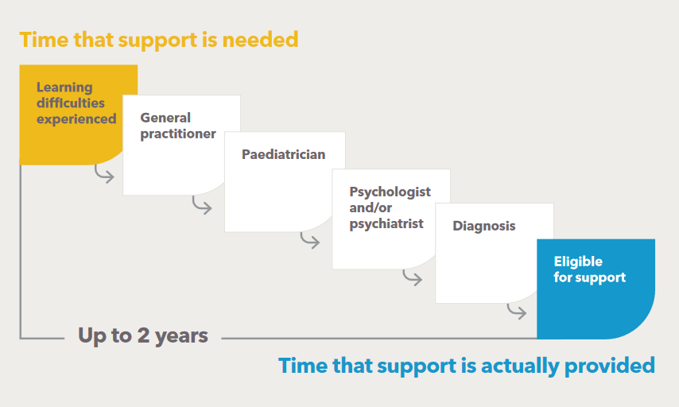

‘If parents are unable to get assessment done early, often one parent ends up having reduced working capacity’

– Child and Family Worker, Glenorchy

The delay in providing in-classroom support to children who need it can prevent them from fully engaging in education, with lasting effects on life outcomes.

# Conclusion and recommendations

Governments at all levels are working to ease the cost of living pressures. A number of positive initiatives have been announced in recent budgets and these are acknowledged.

Anglicare’s research highlights the sustained impact that cost of living pressure is having on Tasmanian families. Anglicare is seeing the makings of newly disadvantaged cohorts, with dual-income households struggling to make ends meet. Simultaneously, already vulnerable cohorts are experiencing deeper disadvantage. Families are working under extreme pressure to provide the essentials their children need to grow up healthy and well as their incomes fail to keep up with the costs of necessities. This has a toll on parents, caregivers and children.

A range of actions are needed to minimise the long-term impacts of financial hardship on Tasmanian children and to ensure they can grow up healthy and well.

**Anglicare Tasmania recommends that:**

*To ensure all families receive enough income to cover the basic cost of living*

1. The Australian Government raises the rate of social support payments above the Henderson Poverty Line, and establishes an independent Income Support Payment Commission to set and maintain payment rates.
2. The Australian Government, in partnership with the Child Support Expert Panel, undertakes a review and reform of the child support system in Australia with a focus on embedding dedicated domestic and family violence protections.

*To ensure all families have suitable and secure housing*

1. The Tasmanian Government increases the supply of social and affordable housing for Tasmanian families to fully meet demand based on current and projected need, including the needs of families escaping domestic and family violence.
2. The Tasmanian Government amends the Residential Tenancy Act to provide for minor modifications, rent stability and greater security of tenure, including amendments to ban no-cause evictions and limit the frequency and amount by which rents can be increased.
3. The Australian Government works with the Australian Banking Association to offer expanded hardship options for families experiencing mortgage stress.
4. The Australian Government reviews the Rental Assistance Scheme in association with other income support payments, to ensure that households on low incomes pay no more than 30% of their household income on rent.

*To ensure access to affordable and nutritious food*

1. The Australian Government continues to strengthen regulations of the grocery sector to ensure fair prices for consumers, and takes targeted steps to ensure an affordable supply of fresh produce.
2. The Tasmanian Government delivers on the commitment to evaluate the *Food relief to food resilience: Action Plan 2023-25.* The evaluation should focus on understanding how successfully the plan has moved Tasmanian communities from emergency food relief towards a food resilient system. The learnings from the evaluation should be incorporated into the 2025 whole-of-government food resilience strategy.
3. The Tasmanian Government develops a safe credit product incorporating fintech to provide a convenient, cost-neutral alternative to Buy Now Pay Later that can be used for essentials such as groceries and fuel. This could be through the existing No Interest Loan Scheme (NILS) or a similar product.
4. The Australian Government undertakes a six-month review of Buy Now Pay Later regulations, including considering a ban on in-store advertisement for retailers of essential items, including petrol stations and grocery stores.

*To provide access to affordable and timely medical care for families*

1. The Australian Government reviews and reforms Medicare, with the aim of

* aligning the indexation of the Medicare rebate to the operational cost of providing medical care to reduce out-of-pocket costs paid by patients
* amending the payment process for medical appointments to eliminate the need for people to cover the full fee upfront before they can claim the Medicare benefit.

1. The Tasmanian Government increases access to bulk-billing GP services, including expanding the Mobile GP Practice to rural and regional town centres and embedding bulk-billing incentives into the GP Partnerships Grants Program.

# References

ABA (Australian Banking Association) (2020) *Submission 45 to Inquiry into family domestic and sexual violence*, accessed October 2024, <https://www.aph.gov.au/Parliamentary_Business/Committees/House/Social_Policy_and_Legal_Affairs/Familyviolence/Submissions>.

ABS (Australian Bureau of Statistics) (2017) *Household Expenditure Survey, Australia*, accessed October 2024, <https://www.abs.gov.au/statistics/economy/finance/household-expenditure-survey-australia-summary-results/latest-release>.

--- (2021a) *Residential property price indexes: Eight capital cities*, accessed October 2024, <https://www.abs.gov.au/statistics/economy/price-indexes-and-inflation/residential-property-price-indexes-eight-capital-cities/latest-release>.

--- (2021b) *Search Census Data*, accessed September 2024, <https://www.abs.gov.au/census/find-census-data/search-by-area>.

--- (2024a) *Average Weekly Earnings, Australia*, accessed September 2024, <https://www.abs.gov.au/statistics/labour/earnings-and-working-conditions/average-weekly-earnings-australia/latest-release>.

--- (28 August 2024b) 'Monthly CPI indicator rose 3.5% in the year to July 2024' [media release], ABS, accessed October 2024, <https://www.abs.gov.au/media-centre/media-releases/monthly-cpi-indicator-rose-35-year-july-2024>.

--- (Jun-quarter-2024) *Consumer Price Index, Australia*, accessed October 2024, <https://www.abs.gov.au/statistics/economy/price-indexes-and-inflation/consumer-price-index-australia/latest-release>.

AFSA (Australian Financial Security Authority) (2022) *Vulnerability framework*, accessed October 2024, <https://www.afsa.gov.au/about-us/corporate-information/key-documents/vulnerability-framework>.

AHURI (Australian Housing and Urban Research Institute) (2014) *What impact does a child’s housing have on their development and wellbeing?*, AHURI Research and Policy Bulletin, Issue 171, accessed October 2024, <https://www.ahuri.edu.au/sites/default/files/migration/documents/AHURI_RAP_Issue_171_What-impact-does-a-childs-housing-have-on-their-development-and-wellbeing.pdf>.

AIHW (Australian Institute of Health and Welfare) (2021) *Australia's youth: Homelessness and overcrowding*, accessed October 2024, <https://www.aihw.gov.au/reports/children-youth/homelessness-and-overcrowding>.

--- (2022a) *Australia's children: Family economic situation*, accessed October 2024, <https://www.aihw.gov.au/reports/children-youth/australias-children/contents/income-finance-employment/family-economic-situation>.

--- (2022b) *Australia's children: Housing stress*, accessed October 2024, <https://www.aihw.gov.au/reports/children-youth/australias-children/contents/housing/housing-stress>.

--- (2023) *Housing assistance in Australia: Suitability of dwellings*, accessed October 2024, <https://www.aihw.gov.au/reports/housing-assistance/housing-assistance-in-australia-2023/contents-2023/suitability-of-dwelling-size>.

--- (2024) *Specialist homelessness services 2022–23: Tasmania*, accessed September 2024, <https://www.aihw.gov.au/reports/homelessness-services/specialist-homelessness-services-annual-report/contents/state-and-territory-summary-data-and-fact-sheets>.

AMA (Australian Medical Association) (2022) *Why Medicare indexation matters*, AMA, accessed October 2024, <https://www.ama.com.au/articles/why-medicare-indexation-matters>.

--- (2023) *Health is the best investment: Shifting from a sick care system to a healthcare system*, AMA, accessed October 2024, <https://www.ama.com.au/health-is-the-best-investment>.

Anglicare Australia (2024) *Rental Affordability Snapshot: National Report*, Fifteenth Edition, accessed September 2024, <https://www.anglicare.asn.au/publications/2024-rental-affordability-snapshot>.

ANROWS (Australia's National Research Organisation for Women's Safety) (2020) *Submission 132 to Inquiry into family, domestic and sexual violence*, accessed October 2024, <https://www.aph.gov.au/Parliamentary_Business/Committees/House/Social_Policy_and_Legal_Affairs/Familyviolence/Submissions>.

APS (Australian Psychological Society) (2024) *APS National schedule of suggested fees 2024-2025*, APS, accessed October 2024, <https://www.oraclepsychology.com.au/uploads/4/4/8/3/44838937/24-25-aps-suggested-fee-schedule.pdf>.

ARACY (Australian Research Alliance for Children and Youth) (2024) *What's in The Nest?*, ARACY, accessed October 2024, <https://www.aracy.org.au/documents/item/700>.

Black N, Harris A, Jayawardana D and Johnston D (2024) *High inflation and implications for health: A framework to examine the potential pathways through which high inflation may impact on health*, VicHealth, accessed October 2024, <https://www.vichealth.vic.gov.au/resources/resource-download/high-inflation-and-implications-for-health>.

Budinski M and Gahan L (2023) *What is family: Australian views on what makes a family*, Australian Institute of Family Studies, Melbourne, accessed October 2024, <https://aifs.gov.au/research/research-reports/what-is-family>.

CCYP (Commissioner for Children and Young People Tasmania (2024) *Nowhere else to go: Young people's views on homelessness*, Voices of young people in the youth justice system project, State of Tasmania, accessed October 2024, <https://childcomm.tas.gov.au/resource/nowhere-else-to-go-young-peoples-views-on-homelessness>.

Coley RL, Lynch AB and Kull M (2015) 'Early exposure to environmental chaos and children's physical and mental health', *Early Childhood Research Quarterly*, 3rd quarter(32):94-104, doi: 10.1016/j.ecresq.2015.03.001.

Cook K, Byrt A, Coen A and Rogers M (2024) 'Australia's child support system can put single mothers at risk of poverty and financial abuse', *The Conversation*, accessed October 2024, <https://theconversation.com/australias-child-support-system-can-put-single-mothers-at-risk-of-poverty-and-financial-abuse-240917>.

Department of Health (2019) *National action plan for the health of children and young people 2020–2030*, accessed October 2024, <https://www.health.gov.au/resources/publications/national-action-plan-for-the-health-of-children-and-young-people-2020-2030>.

DHAC (Department of Health and Aged Care) (2024a) *July 2024 News*, accessed October 2024, <https://www.mbsonline.gov.au/internet/mbsonline/publishing.nsf/Content/news-240701>.

--- (2024b) *Medicare Benefits Schedule - Item 80110*, accessed October 2024, <https://www9.health.gov.au/mbs/fullDisplay.cfm?type=item&q=80110>.

--- (n. d.) *Medical costs finder: Standard GP consult (in rooms)*, accessed October 2024, <https://medicalcostsfinder.health.gov.au/services/G23/oh?term=GP&postcode=7000&filters%5Bcurrent%5D=2&specialty=019999>.

DSS (Department of Social Services) (2023) *Executive summary: National plan to end violence against women and children 2022–2032*, Australian Government, accessed October 2024, <https://www.dss.gov.au/the-national-plan-to-end-violence-against-women-and-children/executive-summary-of-the-national-plan>.

Edwards B, Baxter J, Smart D, Sanson A and Hayes A (2009) *Financial disadvantage and children's school readiness*, Family Matters, no. 83, AIHW, accessed September 2024, <https://aifs.gov.au/research/family-matters/no-83/financial-disadvantage-and-childrens-school-readiness>.

Foodbank (2023) *Foodbank Hunger Report*, accessed October 2024, <https://reports.foodbank.org.au/foodbank-hunger-report-2023>.

Gillespie J (2024) *Blue report: National general practitioner listings*, Cleanbill, accessed October 2024, <https://cleanbill.com.au/2024/01/cleanbill-blue-report-2024>.

Healthdirect (2023) *Financial stress and your health*, accessed October 2024, <https://www.healthdirect.gov.au/financial-stress>.

Homelessness Australia (2024) *2024 Child homelessness snapshot*, accessed September 2024, <https://homelessnessaustralia.org.au/advocacy/child-homelessness-snapshot-2024>.

Homes Tasmania (2024) *Homes Tasmania Dashboard*, accessed October 2024, <https://www.homestasmania.com.au/about-us/Publications/housing-dashboard>.

Jose K, Smith K, Sutton L, Masila N, Fraser B, Proudfoot F and Cleland V (2024) *School lunch project evaluation: Final report 2024*, Menzies Institute, University of Tasmania, accessed October 2024, <https://www.schoolfoodmatters.org.au/school-lunch-project/evaluation>.

Kent K, Seivwright A, Visentin D and Murray S (2024) *“There is no food bank I can access”: Food insecurity and use of emergency food relief in Tasmania*, Faculty of Science Medicine and Health, University of Wollongong.

KPMG (2024) *Residential property market outlook June 2024*, KPMG Australia, accessed October 2024, <https://kpmg.com/au/en/home/insights/2024/06/residential-property-market-outlook.html>.

Livingstone R (2018) '"It takes a village to raise a child": The role of community', *We hear you*, ACECQA, accessed October 2024, <https://www.acecqa.gov.au/latest-news/blog/it-takes-village-raise-child-role-community-part-2>.

MHCT (Mental Health Council of Tasmania) (2023) *Access and affordability: Mental health services in Tasmania*, Report 2: Highlighting the experience of Tasmanians, accessed October 2024, <https://mhct.org/wp-content/uploads/2023/07/MHCT-Access-and-Affordability-Report-2.pdf>.

Moloney M (2024) 'Tasmanians reveal their primary concerns in new survey', *The Examiner*, accessed October 2024, <https://www.examiner.com.au/story/8508443/one-third-of-tasmanians-forego-medical-care-due-to-costs>.

Monks H (2017) *The impact of poverty on the developing child*, CoLab Evidence Report, CoLab, accessed October 2024, <https://valuingchildreninitiative.com.au/assets/uploads/documents/colab-poverty-and-the-developing-child-research-overview-2017.pdf>.

NASEM (National Academies of Sciences Engineering and Medicine) (2016) *Parenting matters: Supporting parents of children ages 0-8*, The National Academies Press, Washington, DC, doi: 10.17226/21868.

NDH (National Debt Helpline) (n.d.) *What is financial hardship and what are your rights*, accessed October 2024, <https://ndh.org.au/debt-solutions/what-is-financial-hardship-and-what-are-your-rights>.

Neppl TK, Senia JM and Donnellan MB (2016) 'The effects of economic hardship: Testing the family stress model over time ', *Journal of Family Psychology*, 30(1):12-21, doi: 10.1037/fam0000168.

NSCDC (National Scientific Council on the Developing Child) (2020) *Connecting the brain to the rest of the body: Early childhood development and lifelong health are deeply intertwined*, Working Paper No. 15, Center on the Developing Child at Harvard University, accessed October 2024, <https://harvardcenter.wpenginepowered.com/wp-content/uploads/2020/06/wp15_health_FINALv2.pdf>.

Productivity Commission (2024) *Report on Government Services 2024: E Health*, accessed October 2024, <https://www.pc.gov.au/ongoing/report-on-government-services/2024/health>.

RACGP (Royal Australian College of General Practitioners) (2024) *1 July 2024 MBS changes*, accessed October 2024, <https://www.racgp.org.au/running-a-practice/practice-resources/medicare/medicare-benefits-schedule/indexation-and-medicare-benefits-schedule-updates>.

RBA (Reserve Bank of Australia) (3 May 2022) 'Statement by Phillip Lowe, Governor: Monetary Policy Decision' [media release], accessed October 2024, <https://www.rba.gov.au/media-releases/2022/mr-22-12.html>.

--- (2024a) *About monetary policy*, accessed October 2024, <https://www.rba.gov.au/monetary-policy/about.html>.

--- (2024b) *Lenders' interest rates*, accessed October 2024, <https://www.rba.gov.au/statistics/interest-rates>.

RCH (Royal Children's Hospital) (n. d.) *Nutrition – school-age to adolescence*, accessed October 2024, <https://www.rch.org.au/kidsinfo/fact_sheets/Nutrition_older_children>.

SGS Economics & Planning (2023) *Rental Affordability Index*, SGS Economics and Planning, National Shelter, Beyond Bank and Brotherhood of St Laurence, accessed October 2024, <https://sgsep.com.au/projects/rental-affordability-index>.

Shelter Tas (2021) *Guide to housing and homelessness terms*, Shelter Tas Fact Sheets, accessed October 2024, <https://sheltertas.org.au/fact-sheets>.

SQM Research (2024) *Research the property market*, accessed September 2024, <https://sqmresearch.com.au/index_property.php>.

Steen A and MacKenzie D (2013) 'Financial stress, financial literacy, counselling and the risk of homelessness', *Australian Accounting, Business and Financial Journal*, 7(3):31-48, doi: 10.14453/aabfj.v7i3.3.

Tasmanian Government (2023a) *Responding and reporting 2023: Achievements in the delivery of Survivors at the Centre: Tasmania's Third Family and Sexual Violence Action Plan 2022-2027*, Tasmanian Government, accessed October 2024, <https://www.safefromviolence.tas.gov.au/__data/assets/pdf_file/0030/365790/Survivors-at-the-Centre-Responding-and-Reporting-2023.pdf>.

--- (2023b) *Tasmanian Housing Strategy: Delivering more homes for a growing Tasmania and ending homelessness*, accessed September 2024, <https://www.homestasmania.com.au/__data/assets/pdf_file/0028/276931/230265_Homes_Tas_Strategy_document_wcag.pdf>.

--- (2024) *Tasmanian Budget 2024-25: Delivering the 2030 Strong Plan for Tasmania's Future Overview*, accessed September 2024, <https://www.premier.tas.gov.au/budget-2024/budget-overview>.

Tasmanian Liberals (n. d.) *Doubling our healthy school lunches program*, accessed October 2024, <https://tas.liberal.org.au/doubling-our-healthy-school-lunches-program>.

Taylor M and Edwards B (2012) *Housing and children’s wellbeing and development: Evidence from a national longitudinal study*, Family Matters, No. 19, AIHW, accessed October 2024, <https://aifs.gov.au/research/family-matters/no-91/housing-and-childrens-wellbeing-and-development>.

Tiyce M (2024) 'How the cost-of-living crisis is keeping victims of financial abuse from leaving ', *Lawyers Weekly*, accessed October 2024, <https://www.lawyersweekly.com.au/politics/39873-how-the-cost-of-living-crisis-is-keeping-victims-of-financial-abuse-from-leaving>.

Treasury (5 June 2024) 'Government introduces consumer protections for Buy Now Pay Later' [media release], accessed September 2024, <https://ministers.treasury.gov.au/ministers/stephen-jones-2022/media-releases/government-introduces-consumer-protections-buy-now-pay>.

Ung B (2024) 'Cash rate pass-through to outstanding mortgage rates', *Bulletin*, RBA, accessed October 2024, <https://www.rba.gov.au/publications/bulletin/2024/apr/cash-rate-pass-through-to-outstanding-mortgage-rates.html>.

University of Melbourne (2020) *Majority of Australians are at risk of financial vulnerability*, accessed October 2024, <https://melbourneinstitute.unimelb.edu.au/news/news/old/2021/majority-of-australians-are-at-risk-of-financial-vulnerability>.

--- (2024) *March Quarter 2024*, Poverty Lines: Australia, Melbourne Institute Applied Economic & Social Research, accessed October 2024, <https://melbourneinstitute.unimelb.edu.au/publications/poverty-lines>.

Whitten R (2024) *Mortgage repayment calculator*, Finder, accessed September 2024, <https://www.finder.com.au/home-loans/home-loan-calculators/home-loan-repayment-calculator>.

Women Against Abuse (2024) *The language we use* accessed October 2024, <https://www.womenagainstabuse.org/education-resources/the-language-we-use>.