More houses needed:

Housing Connect Front Door Service Snapshot

Mary Bennett

October 2024

# Table of contents

Table of contents 2

Housing Connect Front Door 4

Executive summary 5

Front Door Services in Housing Connect 2.0 6

Through the Front Door 8

Housing System Indicators July – September 2024 10

People connecting with Front Door services 14

The people seeking support 15

Housing circumstances of people seeking housing support 18

Reasons for seeking support 19

People struggling in private rentals 20

The private market does not supply affordable rentals 21

Why the vacancy rate matters 21

People experiencing homelessness 22

People escaping domestic and family violence 23

Why Rapid Rehousing on its own is not enough 24

Front door response 26

Housing application support 26

Private rental assistance 27

Crisis and urgent need response 28

Housing support periods 30

Lack of housing is a barrier to meeting client needs 34

Delivering on the Tasmanian Housing Strategy 36

Barriers to achieving the objectives of the Housing Strategy 38

There will not be a net increase of 10,000 homes 38

Social homes needed to meet needs of Front Door clients 38

Social housing supply gap projected to grow to 7000 by 2032 39

Recommendations 40

Glossary 41

References 43

**Acknowledgement of Country**

Anglicare Tasmania acknowledges and pays respect to the Tasmanian Aboriginal community as the traditional and original owners and continuing custodians of this land, lutruwita, on which this project has taken place. We acknowledge Elders past and present, and Aboriginal people who have participated in and are connected with this research.

**Acknowledgements**

The assistance of the staff of Anglicare Tasmania’s Housing Connect Front Door service in the preparation of this report is gratefully acknowledged. Thank you for the important work you do, and to the people you work with for their strength and resilience.

The assistance of Homes Tasmania in providing data is also acknowledged.

Thank you to other Anglicare colleagues for your expertise, support and guidance.

**About Anglicare Tasmania**

Anglicare, in response to the Christian faith, strives to achieve social justice and to provide the opportunity for people in need to reach fullness of life.

Our values:

**Hope**: Confidently reaching for fullness of life.

**Compassion**: Showing empathy and care for those in need.

**Justice**: Promoting the fair distribution of resources and opportunities.

**Respect**: Recognising the inherent value and dignity of every person.

**Anglicare Tasmania’s Social Action and Research Centre**

The Social Action and Research Centre investigates how and why Tasmanians are affected by poverty and inequality. We use what we learn to advocate for changes that improve people’s lives.

Our qualitative research centres on the lived experience of Tasmanians. It often features the voices of people who use Anglicare services and our frontline workers.

Our quantitative research uses data to demonstrate social trends.

We brief government and stakeholders on our research and create opportunities for networking and collaboration.

# Housing Connect Front Door

The Housing Connect Front Door is the entry point for people to access housing support, from emergency accommodation to a long-term home. This begins with an assessment to understand their individual circumstances and to help match them with the most suitable options available.

Anglicare Tasmania is funded by government to deliver the Housing Connect Front Door Service statewide. This arrangement began from July 1, 2024.

People can access the Housing Connect Front Door by telephone, 24 hours a day, 365 days a year on **1800 800 588.** This is a free call.

People can also access the Front Door at these Anglicare Tasmania offices between the hours of 9.00 am and 5.00 pm, Monday to Friday:

* 159 Collins Street, Hobart
* 122 Elizabeth Street, Launceston
* 31 King Street, Devonport
* 51 Wilmot Street, Burnie.

Wyndarra Centre Inc. provides a Front Door service at 43 Smith Street, Smithton.

**The Housing Connect Front Door does not provide housing**

The Front Door service links people with supports that are suited to their life stage and individual circumstances. Although the Front Door service does not provide housing, it can assist clients to apply for social housing or to secure or maintain a private rental tenancy.

For many people, the Front Door can provide the level of support they need. However, for those who require more intensive and ongoing support, the Front Door connects them with Key Development coaches in their region.

# Executive summary

Commencing 1 July 2024, Anglicare Tasmania has provided Housing Connect’s Front Door services statewide, helping Tasmanians to access the housing supports they need based on their individual circumstances and personal goals.

In the first 3 months of operation the statewide Front Door service has:

* responded to 12,613 enquiries from Tasmanians seeking housing support
* assisted people to make 1533 new social housing applications
* provided 1272 periods of support to 1230 people or families
* provided 121 people or families with emergency accommodation and 10 people or families with transitional accommodation
* provided $152,000 in financial assistance to fund emergency accommodation and assist people with private rental bonds, rental arrears and moving costs so that they can establish or maintain a tenancy.

After the first 3 months of Housing Connect 2.0, it is clear that a lack of affordable housing is the key barrier to ensuring Tasmanians can be assisted into a secure home, are safe from domestic and family violence and can thrive and achieve their goals.

To meet the objectives of the Tasmanian Housing Strategy, the Tasmanian Government is urged to increase their investment in social housing with the aim of increasing the rental vacancy rate to 3% and providing timely access to affordable, secure housing for people on the social housing register.

Anglicare Tasmania recommends that the Tasmanian Government:

1. **Commits to reducing the harmful impacts of waiting for social housing** by:
   1. Establishing a target for reducing the social housing register in the next housing action plan in consultation with stakeholders
   2. Establishing a target for reducing average waiting times for social housing applicants
   3. Developing a process for providing applicants with realistic estimates of waiting times and the progress of their application.
2. **Increases investment in long-term social housing under the Tasmanian Housing Strategy** to achieve these targets and meet the housing needs of Housing Connect Front Door clients.
3. **Refines reporting and measurement** **of progress against the Tasmanian Housing Strategy** by:
   1. Clearly reporting how many dwellings delivered by Homes Tasmania under the Action Plan are new dwellings (or otherwise not previously used for long-term housing)
   2. Clearly reporting how many dwellings delivered by Homes Tasmania under the Action Plan were affordable for people in the bottom two income quintiles as reported by the ABS (ABS 2022)
   3. Reducing the lag in reporting the stock of social housing
   4. Developing better reporting of housing outcomes for Front Door clients seeking long-term housing
   5. Expanding reporting to include:
      1. the total number of dwellings relative to the population
      2. the stock of affordable rental housing relative to the population
      3. the proportion of rental households with household income in the bottom two quintiles that spend more than 30 per cent of their income on rent.

# Front Door Service in Housing Connect 2.0

Under Housing Connect 2.0, Tasmanians will get better access to housing assistance and help to develop strong connections to family and community and build their capabilities for independent living (Homes Tasmania 2024a).

The statewide Front Door service is part of the Housing Connect 2.0 model being implemented and overseen by Homes Tasmania to deliver on the Tasmanian Housing Strategy.

The functions of the Housing Connect Front Door are:

* assessment of each person’s situation and needs to ensure a tailored response
* provision of targeted housing and homelessness information, products and services, and related coaching and support (for people who need only a limited period of support)
* connecting or referring people to service system and community supports
* crisis response, including access to flexible funds for reasonable and necessary support (urgent need response)
* housing application support (Homes Tasmania 2024a).

In delivering these functions, the Front Door staff use an Advantaged Thinking approach which identifies, develops and invests in the skills, capabilities and assets of people so that they can establish sustainable lives (Homes Tasmania 2024a). This approach also recognises that ‘policies, practices and relationships … shape people’s experiences and their ability to reach their full potential’ (Homes Tasmania 2024a). In practice, the Front Door service is person-centred, trauma-informed and evidence-based.

The blue box in Figure 1 provides an overview of the Housing Connect Front Door. Figure 1 also shows how the Front Door links to the rest of Housing Connect including Homes Tasmania, community housing providers, level 3 support providers, providers of system services and community supports and private housing providers. These partners and providers are responsible for delivering services to clients (eg. mental health services), providing longer term (level 3) support, managing the social housing register, allocating social housing, funding social housing supply, and building and leasing homes.

The Tasmanian housing system is the context in which the Front Door operates. Market conditions and the supply of affordable and social housing affect the demand for services, the capacity to deliver a ‘Housing First’ approach for people in need and the opportunities for clients to achieve their goals. Key indicators of the capacity of the system to provide housing to all Tasmanians are provided on page 11.

Figure 1. Front Door Service in Housing Connect

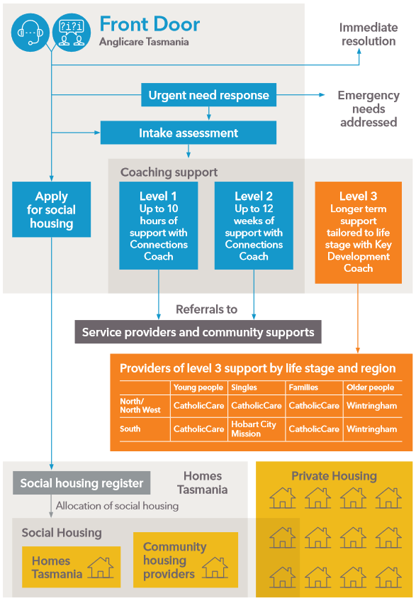

## Through the Front Door

When people contact the Housing Connect Front Door they speak to a Contact Service Officer who assesses their needs and connects them initially with either an Applications Management Officer (AMO) or a Connections Coach (coach), or resolves the enquiry straight away. Enquiries identified as urgent are prioritised so that emergency needs are addressed as soon as possible.

An AMO assists people to apply for social housing or assistance to access or maintain a private rental.

A coach assists people who need supports other than or in addition to basic information, assistance or housing applications. A coach will work with a client to build on their existing capabilities across five life domains: housing and living, education and training, employment and income, health and wellbeing, and social and community connections (see Table 1).

There are 3 levels of coaching support available and the coach matches this to the intensity of supports required by the client and the period for which they will need support.

Table 1. Life Domains

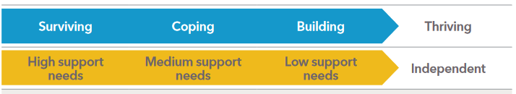

|  |  |
| --- | --- |
| Housing and living | Having a safe, stable home environment |
| Education and training | Engaging in education and/or accredited/non‑accredited training  Having literacy and numeracy skills appropriate to capacity |
| Employment and income | Having meaningful career goals and aspirations and plans to achieve them |
| Health and wellbeing | Managing own health needs  Having access to appropriate health and care services  Having a positive sense of self-identity and self-esteem |
| Social and community connections | Having positive, trusted relationships  Actively engaging with peers and community groups  Having a sense of belonging and value  Taking part in organised activities, such as sport or art  Engaging with broad social networks |

Source: Housing Connect Practice Framework (Homes Tasmania 2024a)

The coach also tailors supports for clients based their ‘life stage’: young people, families, older people or single adults. These are described in Table 2.

For clients requiring level 1 or level 2 support, Front Door Connections Coaches provide or refer clients to the services they need during a support period. Clients needing longer term support (level 3) are referred to partner organisations to work with Key Development Coaches (see Figure 1). Statewide, level 3 support for older people is provided by Wintringham and for young people and single adults by CatholicCare. Level 3 support for families is provided by Hobart City Mission in the South and by CatholicCare in the North and North West.

**Table 2. Life stages**

|  |  |
| --- | --- |
| Young people | Young people include people aged between 16‑24 except for those in families (eg. young parents). |
| Families | Families include couples, couples with children, single parents with children, blended and multi-generational family groups, and people living together due to foster and kinship care. |
| Single adults | Single adults are those aged 25-64 years. |
| Older adults | Older people are people aged 65 and over and Aboriginal and Torres Strait Islander people aged 55 and over. |

Source: Housing Connect Practice Framework (Homes Tasmania 2024a)

## Housing System Indicators July – September 2024

A sustainable vacancy rate of around 3 per cent in the private rental market will help to stabilise rents and ultimately reduce pressure on household budgets.

— Tasmanian Housing Strategy (Tasmanian Government 2023a)

Key indicators of a well-functioning housing system that provides safe, appropriate and affordable housing for all Tasmanians include:

* the residential rental vacancy rate
* median rent relative to income
* the number of rentals actually available that are affordable for people on low incomes and essential workers
* the difference between social housing supply and expressed social housing demand (the housing register)
* median and average waiting times for general and priority housing register applicants.

Changes to the Homes Tasmania dashboard in July 2024 mean that vacancy rates and average waiting time for priority applicants are no longer reported as a time series. Charts of these indicators showing trends over time are presented here.

**Figure 2. The rental vacancy rate remains very low in all regions**

Source: Homes Tasmania 2024b

In the 12 months to August 2024, vacancy rates in all regions of the state have remained between 0.4 and 1.8% (see Figure 2). This is far below the target of 3% identified in the Tasmanian Housing Strategy as the sustainable rate and recognised by industry as the rate at which supply and demand are in balance. A rate below 3% indicates that the number of people wanting rental properties is higher than the number available. See page 27 for more on the vacancy rate.

In 2024, the RBA has repeatedly stated, with supporting econometric analysis, that:

the level of housing demand relative to the stock of properties available is the key driver of rents (Hunter 2024; Twohig et al. 2024).

In other words, when the vacancy rate is above 3% rents will tend to fall, and when the vacancy rate is below 3% rents will tend to rise. Vacancy rates persistently below 2% in all regions of Tasmania are driving rents upward.

In recent years, rents have grown at double the rate of wages. Between September 2020 and June 2024, the Tasmanian median rent index grew by 26% and the Tasmanian wage price index increased by only 12.6% (see Figure 3).

**Figure 3. Rents have risen at twice the rate of wages in Tasmania**

Source: TUT 2024; ABS 2024

For people relying on income support the impact is even greater. In the 2024 Rental Affordability Snapshot, Anglicare found that statewide, there were no rental properties advertised in late March that were affordable for people whose main source of income was a Jobseeker payment or Youth Allowance (Claxton and Bennett 2024). Further analysis of the same data set found an alarming lack of affordable rental properties for essential workers (Anglicare Australia 2024). For example, there were no rentals in Hobart that were affordable for a full-time cleaner receiving the award wage (Anglicare Australia 2024).

The social housing register provides an indication of the shortfall in social housing supply relative to expressed demand. To close this gap, net growth in supply of social housing needs to be greater than the increase in demand. Between 30 June 2020 and 30 June 2023, the total demand for social housing increased by 2,018 while the number of tenanted social homes grew by 793, and so the supply shortfall increased by 1,225 to 4,598 (see Figure 4). The shortfall has continued to increase, reaching 4,792 by September 2024.

**Figure 4. The shortfall in social housing supply is growing**

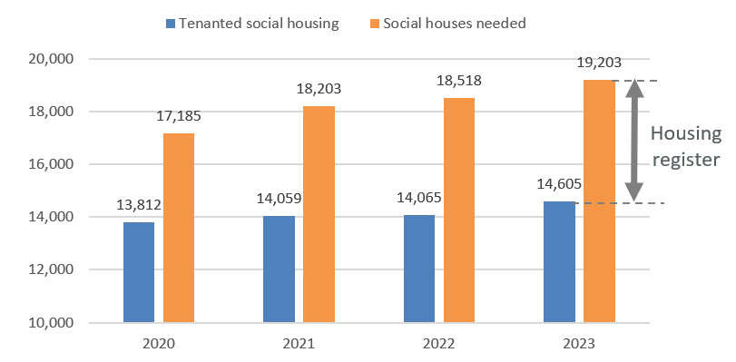

Source: Homes Tasmania 2024b

At the end of July 2024, unmet demand for social housing in the North West was 40% higher than the rest of the state, with 105 applications of the housing register per 10,000 people, compared to 77 in the northern and southern regions (see Figure 5).

**Figure 5. Unmet demand for social housing per capita is higher in North West Tasmania**

Source: Homes Tasmania 2024b

The average wait time for priority applicants increased by 10% over the 12 months to August 2024 (see Figure 6). Median wait time for priority applicants and the average and median wait time for all applicants (all of whom are eligible for social housing) are not reported by Homes Tasmania.

Figure 6. Average waiting time for social housing has increased by 10% in the past year

Source: Homes Tasmania 2024b

# The Statewide Front Door Service gets up to speed

From 1 July 2024, Anglicare Tasmania commenced delivering statewide Housing Connect Front Door as part of the new Housing Connect 2.0 service model.

This included the recruitment of additional staff by Anglicare.

Anglicare had provided Front Door services in the North and North West under the previous model. The transition to Housing Connect 2.0 saw Anglicare take on statewide delivery of the Front Door, including from its Hobart office at 159 Collins St.

In the month prior to the handover of southern operations, Anglicare staff worked closely with the previous provider to ensure continuity of client service and make the transition as seamless as possible. This mainly involved working to whittle down the number of outstanding enquiries handed over on 1 July 2024.

**Figure 7. Outstanding Housing Connect Front Door enquiries at week’s end**

When Anglicare’s southern Front Door opened on July 1, the team hit the ground running. They started with 422 enquiries from the handover and had an influx of people seeking housing support that generated a further 471 new enquiries by the end of the first week.

The staff of the southern team were handling a large number of enquiries while still getting up to speed and so the statewide team pulled together to share the load. Experienced staff from the North and North West teams pitched in and together cleared the backlog of enquiries by the end of the first week of August (see Figure 7).

By mid-August, the southern team had settled into smooth operation with a minimal number of outstanding enquiries at the end of each week. Statewide, the Front Door was providing timely responses to people contacting them for housing support.

Homes Tasmania has also announced it will launch a Housing Connect portal to give people the option of accessing housing supports online.

Alongside this option, clients will still be able to speak directly to Front Door staff by phoning or visiting in-person.

# People connecting with the Front Door

Between 1 July and 30 September, the Housing Connect Front Door responded to a total of 12,613 enquiries from over 5,000 families and individuals. 12,191 were new enquiries received statewide and 422 were enquiries transferred to Anglicare from the previous Housing Connect Front Door provider in the South.

The number of new enquiries remained fairly steady across the quarter with a small peak in August coinciding with an uplift in social housing applications (see Figure 8). Half (50%) of enquiries were in the South, 27% were in the North and 23% in the North West.

People may be referred to Front Door services by another service or can seek support by contacting Housing Connect directly. In September, Housing Connect staff participated in an outreach team with other support providers to assist people displaced by floods (see Jim’s story).

**Figure 8. Enquiries by region, July – September 2024**

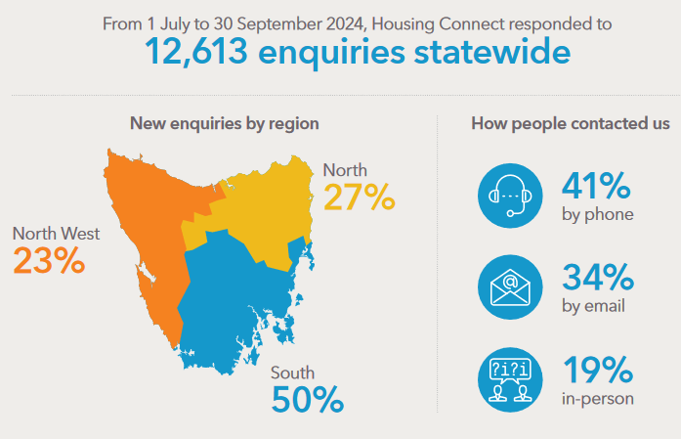

## The people seeking support

Housing Connect provides support to Tasmanians who are:

* homeless or at risk of being homeless
* living in unsafe housing or cannot stay where they normally live
* a safety risk to themselves or others or there is a third-party threat to them or their household.

Support may also be available to people who are:

* having trouble paying their rent or bond
* moving and having trouble paying the costs
* living in a place that makes it hard for them or makes their health or mobility worse
* unable to pay for their own housing.

Compared to the Tasmanian population, people needing housing support are more likely to be*[1]*:

* female
* young adults aged 18-24 years
* single parents with children
* living alone or in group/share housing

The proportion of people accessing housing supports who are Aboriginal and/or Torres Strait Islander is also higher than in the general population. Clients are virtually all on low incomes with Commonwealth Government income support payments the main source of income for over 95% of clients.

**Table 3. Selected demographic statistics**

|  |  |  |
| --- | --- | --- |
|  | Housing Connect clients | Tasmanian population |
|  | **%** | **%** |
| Women | 62% | 50% |
| Men | 37% | 50% |
| Other | 1% |  |
|  |  |  |
| Children presenting alone (<18 years) | 5% | 19% |
| Young people 16-24 years | 22% | 10% |
| Older Tasmanians (65+ years) | 12% | 21% |
|  |  |  |
| Aboriginal Tasmanians | 18% | 5% |
| Main language other than English spoken at home | 3% | 9% |

**Figure 9. Age distribution of Housing Connect clients and the Tasmanian population**

**Figure 10. Living arrangements of people accessing housing support, % distribution**

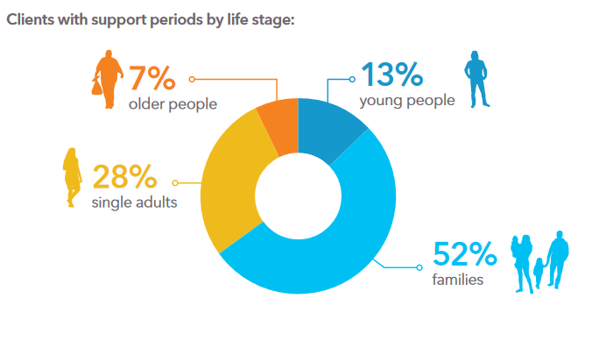

Waiting for social housing

Everyone needs the foundation of a secure and affordable home

[Waithood: The Experiences of Applying for and Waiting Social Housing](https://www.anglicare-tas.org.au/waiting-for-social-housing-report/) explored the information gathered from 75 interviews with people in Tasmania, New South Wales and Queensland who had spent time waiting for social housing (Morris et al. 2023). Anglicare Tasmania was a project partner organisation for this research which was funded by the Australian Research Council.

People described spending a considerable portion of their income to pay for a private rental, living in temporary arrangements such as a shelter, motel, boarding house or car, couch surfing with family or friends, or enduring sleeping rough. They told of being unable to afford adequate food, electricity and health care. The mental and physical impacts were marked, and those waiting for social housing were highly anxious about their financial situation, accommodation and the future. Parents were especially worried about the negative effects on their children.

## Housing circumstances of people seeking housing support

**Figure 11. Housing circumstances of people one week before support period commenced (Jul – Sep 2024)**

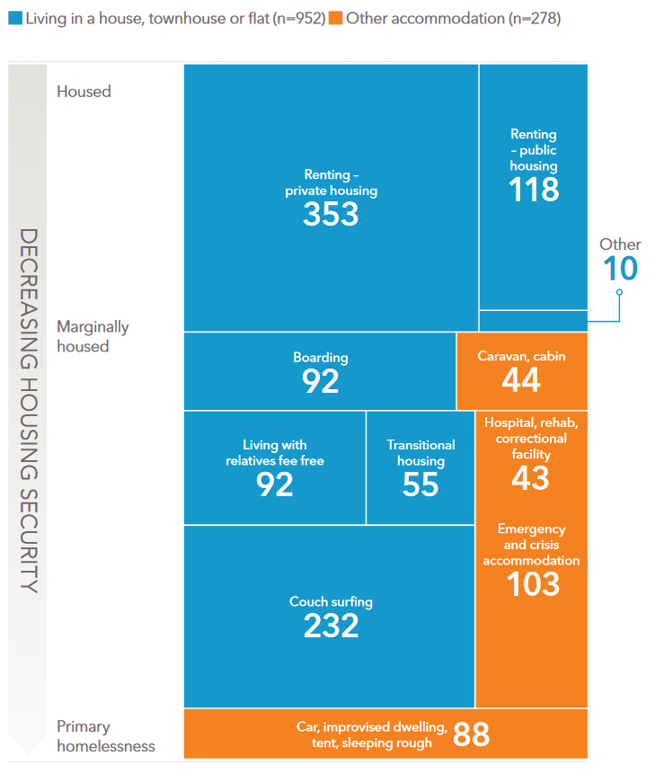

Over 90% of people seeking housing support were living in a house, apartment or flat or otherwise ‘had a roof over their head’ when they presented to Front Door services. Despite this, most were experiencing housing insecurity because their rent was unaffordable, the length of their tenure was limited (eg. transitional housing), they had no tenure and/or they were couch surfing. In addition to experiencing housing insecurity, many were also living in dwellings that did not meet appropriate living standards (Cope 2024).

Private renters were the largest group of people seeking housing support, followed by people who were couch surfing and people in emergency or crisis accommodation. Together, these groups accounted for 56% of people receiving housing support between 1 July and 30 September 2024.

People exiting adult and youth correctional facilities accounted for less than 1% of people receiving housing support and those in hospital or a psychiatric unit accounted for almost 2%.

## Reasons for seeking support

When asked to name the main reason for seeking housing support, 91% of clients cited one of eight reasons (shown in Figure 12). The most common reason, cited by more than 1 in 4 clients (27%), was a housing crisis such as being evicted, followed by inadequate or inappropriate conditions (18%), housing affordability stress (13%), domestic and family violence (12%), previous accommodation had ended (7%), financial difficulties (7%), relationship or family breakdown (6%) and non-family violence (3%).

**Figure 12. Main reasons for seeking housing support given by Front Door clients**

The majority of clients cited multiple reasons for seeking assistance and this data provides information about the range of challenges faced by people experiencing housing insecurity. 54% of clients were subject to housing affordability stress, 50% were experiencing a housing crisis and 37% had inadequate or inappropriate dwelling conditions. Many common reasons were less directly related to housing. These included financial difficulties, lack of family or community support, mental and physical health issues, domestic and family violence and relationship or family breakdown.

**Figure 13. All reasons for seeking support given by Front Door clients**

The vast majority of people seeking housing support who are not already living in social housing have applied or have an existing application for social housing. The Waithood study (page 21) identified three key groups of people waiting for social housing based on their reasons for applying – people struggling in private rentals, people who are currently homeless and people escaping domestic violence. The Front Door data indicates that these are also key reasons people sought housing support between July and September 2024.

## People struggling in private rentals

Private renters are the largest group seeking housing support. As already discussed, median rents have increased faster than both wages and income support payments. Multiple reports have demonstrated that private rental housing is unaffordable for the vast majority of people seeking assistance from the Housing Connect Front Door, who receive incomes close to or below the poverty line.

SARC’s report [*Stretched Too Far*](https://www.anglicare-tas.org.au/research/stretched-too-far-children-and-families-surviving-the-cost-of-living-crisis-in-tasmania/)explores the impact of the cost of living on Tasmanian families in 2024. The report found that rising housing costs are reducing the share of income left over for other essentials. The share remaining after housing costs buys fewer essentials, with many families unable to afford adequate food or essential medical care (Cope 2024).

AHURI research released in November 2023 recounts the precarious situation of Anglicare Tasmania client Amara, who was living in a private rental:

Amara, in Tasmania, was caring for her youngest daughter and two grandchildren. She was on Jobseeker and her rent accounted for almost all of her income. She had no idea how she was going to manage her latest rent increase:

“It was gone up $10, $10, $10, to $440. Then now, they said they put [it up by] $110. I'm paying now $550 [a week]. I'm just, I don’t know. I don’t know what to say. I don’t know what to do. And I need to move … because … this is so expensive. How I pay the house with the Jobseeker payment. How [am] I going to feed the kids, school fee, school food and the house, and everyone's clothes, everything”.

Amara was overwhelmed by her financial situation and was desperate to access social housing (Morris et al. 2023).

### The private market does not supply affordable rentals

Research released in April 2024, which included Tasmanian data, showed that less than 10% of private rental properties are affordable for the 20% of the population on the lowest incomes (up to $750 per week) (Reynolds et al. 2024). Furthermore, people in the lowest income quintile occupy less than half of the properties that they could afford (rent up to $250 per week) (Reynolds et al. 2024).

This has been the case since 2006 and is the expected outcome in a private market ‘with households understandably looking to pay as little rent as possible for a suitable dwelling in terms of household requirements and location’ (Reynolds et al. 2024) and capacity to afford the rent being an important consideration of landlords in selecting tenants. As a result, people on low incomes are often outcompeted for the most affordable rentals by people on higher incomes.

Decades of data show that the private rental market does not provide affordable and appropriate housing for all people on low incomes. People like Amara need access to housing that is reserved for those on the lowest incomes.

### Why the vacancy rate matters

There’s an industry-accepted standard that three per cent reflects a balanced rental market… If the figure sits at or below two percent, the rental market is tight, with demand in excess of the available supply of rental property. This is good news for landlords (Aspire 2021).

In addition to indicating that demand is outstripping supply, sustained vacancy rates below 2 per cent put upward pressure on rents and property values. It also keeps the balance of rental market power weighted in favour of landlords. As a result:

* there is an incentive for investors to purchase existing rental properties in preference to building new ones to keep supply limited
* tenants more often accept poor conditions and shy away from asking for reasonable repairs and maintenance due to fear of eviction or rent increases
* home owners (investors and owner-occupiers) who benefit from higher property values have little appetite for initiatives that increase the vacancy rate above a low level.

However, gains in property values without any actual change in the number of dwellings (or their quality) results in an unjust redistribution of wealth from renters to property owners that does not yield a net benefit to the economy.

A vacancy rate fluctuating around 3% reflects a rental market in which rents are stable and people have greater access to housing near employment, education and their social supports.

Client story – George and Lorraine

George, who is in his 50s, lives with his mum Lorraine, who is in her 80s. They contacted Front Door services in August, having been advised that they would be evicted from the rental property they were sub-leasing together in a rural location. They had 2 weeks to leave their accommodation, with nowhere to go.

George and Lorraine had never contacted or visited Housing Connect before. They didn’t know where to start but they knew they wanted to stay together. Front Door worker Megan helped them apply for social housing and, due to Lorraine’s age, advocated with community housing providers.

Megan knew of new units that were being built in a small rural town but George and Lorraine did not have this town listed on their housing application as an area. She discussed this with George and he and Lorraine agreed to add this town to their list of locations in which they were seeking housing.

When they were evicted 2 weeks later, George moved into a caravan park where he was paying more than he could afford. Meanwhile, Lorraine got by couch surfing and sometimes paying to stay in hotel accommodation.

During this time, George and Lorraine continued to actively apply for private rentals but experienced growing anxiety as they struggled to find something suitable and affordable.

After a few weeks, Megan was able to advise George that he and his mum had now been offered a secure, long-term tenancy in one of the new units in the rural town. George and Lorraine were relieved to move in and love their 2-bedroom unit.

## People experiencing homelessness

There are a number of recognised definitions of homelessness in use (Homelessness Australia 2023). However, all widely used definitions reflect an understanding that homelessness is more than ‘rooflessness’.

Most people seeking housing support were not ‘roofless’ at presentation. However, based on the ABS definition and categories of homelessness, around half of people seeking assistance were homeless, including the 7% living in a car, tent, improvised dwelling or sleeping rough (primary homelessness) (ABS 2021).

Many of these people do not have a contact address and so receiving and responding to correspondence in order to keep their social housing application current can be a challenge. Housing Connect provides some active outreach services to assist vulnerable groups to maintain contact.

Client story — Jim

Jim is one of nearly 20 long-term caravan park residents evacuated to the local football oval when the park was inundated by flood waters in early September.

Jeff and Kate from Housing Connect met Jim when they were part of an outreach team offering support and assistance to the park residents who had been displaced.

Jim, who is in his late 50s, was sleeping in a very basic camping trailer. He was being provided with meals as he did not have any cooking facilities. He told Jeff and Kate that he receives regular treatment for a chronic health condition and that he is waiting for social housing, having applied in 2017.

When Kate checked the social housing register, she found that Jim’s application had lapsed. From talking to Jim, Kate realised that this had probably happened because correspondence sent to Jim, who had no permanent address, did not reach him and went unanswered.

*Streets to Home* and Kate advocated successfully to have Jim’s particular circumstances taken into account and have his 2017 application reinstated on the housing register as if it had not lapsed. Jim wanted to stay in his local community and was allocated a unit managed by a community housing provider when one became available. Jim needed some money to get him settled in with the basics and he successfully applied for a loan through the No Interest Loans Scheme (NILS). Jim is now settled into his new home.

## People escaping domestic and family violence

One in five people accessing housing support say that domestic and family violence is a reason they have sought assistance. In the North West of the state, the incidence increases to one in four. Statewide, one in eight people cite escaping DFV as the main reason for seeking assistance.

A recent SARC study found that a lack of housing options is placing victim-survivors at risk with frontline domestic violence workers reporting that:

…they cannot always assist them to a place of safety because **there are insufficient short- and long-term housing options for women in the North West, especially for people on low incomes (Toombs 2024).**

Although the study highlighted the extreme situation in the North West, it is a statewide problem that is resulting in victim-survivors remaining in unsafe situations, returning to perpetrators or facing homelessness and poverty. The Rapid Rehousing Program can be a helpful short-term response if there are enough suitable properties available and there is sufficient long-term accommodation for victim-survivors to move into to prevent system bottlenecks. The commitment in the Tasmanian Housing Strategy to prioritise these applicants is also welcome. However, as the author of *Unsafe and Unhoused* succinctly observes,

prioritisation of applicants cannot address a fundamental lack of affordable housing (Toombs 2024).

Client story — Jaz

Jaz and young son Riley had been living in a Rapid Rehousing property for seven months after escaping a violent relationship. Rapid Rehousing is transitional housing that provides a safe and secure place to live for up to 12 months while finding a more permanent home.

The transitional housing was coming to an end and Jaz had not yet found long term accommodation to move into. Jaz found the task of finding a new safe place both daunting and terrifying and there was no affordable long-term housing readily available.

Jaz was referred to the Housing Connect Front Door which helped them to understand and navigate the housing system. Jaz was connected with a Private Rental Case Worker to assist with applying for a private rental and received support to develop a savings plan to cover the bond for a rental.

Jaz was in the process of receiving a settlement from the sale of the property they owned with their former partner. When this came through, the Housing Case worker assisted Jaz to complete the necessary paperwork to submit to Homes Tasmania and Centrelink to ensure that Jaz’s income support and application for housing were not suspended.

Jaz and Riley were soon discreetly moving into a Homes Tasmania property where they feel secure and safe from domestic and family violence.

### Why Rapid Rehousing on its own is not enough

Rapid Rehousing is an important response for people needing to find transitional housing quickly and is welcome. However, Rapid Rehousing is drawn from the pool of existing housing and so the program does not actually increase the supply of housing. Instead it effectively re-prioritises the allocation of existing housing to people in need. As a result the property is no longer available to other renters and does not address the shortfall in affordable housing or improve the languishing vacancy rate.

Jaz’s situation illustrates how temporary transitional housing can only be effective if there is affordable, secure long-term housing for people to move into.

Client story — Jessica

Jessica is a young mum with an 8-month-old son who applied for social housing two years ago.

Jessica was living in an overcrowded home which was often violent. It was her family home and she often experienced conflict dealing with complex family relationships. After she gave birth to her son, this became particularly distressing.

Jessica was a persistent and resourceful advocate for safe housing for her son. She contacted the Front Door and has received regular support while waiting for social housing. During that time, Jessica stayed with family on and off and had five support periods with Housing Connect.

Connection Coaches were successful in having her housing priority upgraded and accessing financial assistance to help with the cost of moving.

In September 2024, Jessica and her son moved safely into a unit.

# Front door response

## Housing application support

Between 1 July and 30 September, Anglicare’s Housing Connect Front Door assisted **1533 people** with new applications for social housing. 731 applications (48%) were in the South, 446 (29%) in the North West and 356 (23%) in the North. An uplift in applications in the North and North West resulted in a peak in August across the quarter (see Figure 14).

The Front Door also assesses new applications to ensure they fit the required criteria and subsequently assists applicants to update their circumstances and ensure that their application remains current.

**Figure 14. New Housing Applications, July – September 2024**

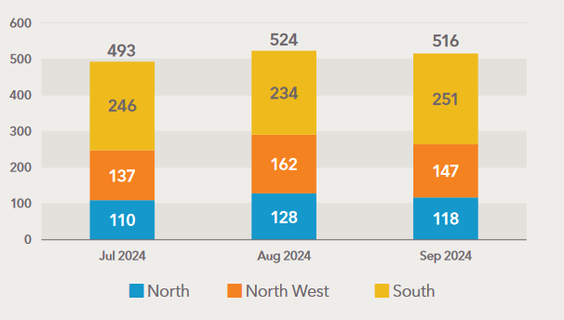

Homes Tasmania manages the Housing Register and public housing statewide, including the allocation of social housing (see Figure 1). The Housing Connect Front Door is unable to advise when applicants might be allocated housing by Homes Tasmania.

**What we do know is that most applicants will be waiting a long time for social housing, even if they are a priority applicant.**

The Waithood study (page 21) provides an insight into the impacts of waiting for social housing on applicants in Tasmania (Morris et al. 2023). It reports that ‘powerlessness, unpredictability and a lack of control are key features of this long-term waiting’ with applicants not knowing when or if they will ever access social housing (Morris et al. 2023). Adjectives used by interviewees to describe waiting include:

Horrible, exhausted, nerve-wracking, anxious, anxiety-provoking, frustrating, unfair, afraid, challenging, disempowering, tiring, continual shame, nightmare, dreadful, demeaning, disastrous, exhausting and disappointing, rough, terrifying, miserable, disheartening, horrendous, soul destroying, useless, uncertainty, absolutely f…ing frustrating, annoying, demoralising, demeaning and traumatic (Morris et al. 2023).

Researchers found that applicants in Tasmania who received assistance from professional assessment workers found the process of applying for social housing easier and more straightforward than applicants in New South Wales and Queensland (Morris et al. 2023). They suggested that this approach could be rolled out nationwide.

A major limitation with the application process is that once on the list, applicants have no way of knowing when or if they will be allocated a social housing dwelling. In NSW, if an applicant is placed on the general waiting list, they can obtain some idea of how many years they may be waiting by referring to the Department of Communities and Justice website.

Kaitlin in Tasmania has four children and is on the general waiting list. She was deeply frustrated by the housing department not giving her any idea of her chances of accessing social housing:

“I wish Housing would improve on the way that they contact people on the list. I wish that they would call them and just have a chat. … I know, there'll be 1,000 people that they [have to] call but 1,000 people would feel more listened to and they'd feel more at ease knowing that maybe Housing actually does give a shit” (Morris et al. 2023).

At least 60% of contacts with Housing Connect’s Front Door are enquiries about applications for social housing with the majority of the calls from people with existing applications. Front Door staff provide the support that they can. However, these clients need housing first and foremost and providing that housing is not within the control of the Front Door.

Addressing waiting times would improve outcomes by reducing:

* the negative impacts on people waiting for social housing
* the volume of enquiries to the Front Door
* avoidable expenditure on some functions of the Front Door service.

## Private rental assistance

Between 1 July and 30 September 2024, the Front Door service provided over $110,350 in financial assistance to help people establish or maintain a private tenancy. These payments included assistance to pay rental bonds, rental arrears or moving costs.

In the same period, 782 new applications for private rental assistance were received with a peak in August due to a 23% increase in applications in the northern and southern regions, which was balanced by a decline in applications in September.

Figure 15. Private Rental Assistance Applications

Client story – Taylah

Taylah and her children had been staying in crisis accommodation and accessing housing support after escaping family violence, but their time in the shelter was limited.

Taylah was actively looking for private rentals when she contacted the Housing Connect Front Door in September to enquire about private rental assistance. Front door staff member Jo helped her to complete and submit her application.

Taylah was offered a community housing property in the northern suburbs of Hobart but did not have enough money to cover the bond. Taylah’s application for assistance was approved and in late September she received $1276 to cover her bond and help her family move into their new safe and secure home.

## Crisis and urgent need response

Crisis and urgent responses include finding or brokering emergency accommodation and providing reasonable urgent financial assistance.

During the quarter, the Front Door organised 420 nights of short-term or emergency accommodation.

Clients were also provided with 224 nights of medium term/ transitional accommodation.

## Housing support periods

Between 1 July and 30 September 2024, 1230 clients had at least one support period. Some clients had more than one support period resulting in total of 1272 active support periods during the quarter.

**Figure 16. Length of housing support period, frequency distribution**

Support periods ranged in length from one day to 12 weeks. The average length of a support period during the quarter was 25.7 days and the frequency distribution of different support periods is shown in Figure 16.

Case management plans were in place for two-thirds of support periods. The main reason for not having a case management plan was that the support period was too short. Other reasons included that the client chose not to have one or they already had a plan with another support provider. Figure 17 shows the outcomes achieved by clients with case management plans whose support period closed within the quarter. 49% of these clients achieved all their goals and a further 20% achieved more than half. Only 6% of clients did not achieve any of their goals.

**Figure 17. Extent to which case management goals achieved by end housing support period**

The Front Door also provides support to clients with level 1 and 2 support needs. 235 clients needing long-term support (>12 weeks) were referred to a level 3 provider. 86 of these referrals were in the North, 76 in the South and 73 in the North West (see Figure 18).

**Figure 18. Referrals of clients to Housing Connect Partners for support with Key Development Coaches**

Working with a Connections Coach, clients identify their needs, which can be multiple (see Figure 19). The most common needs of people seeking housing support were advice or information (81% of clients receiving support), basic assistance (76%), long-term housing (73%), advocacy (36%), medium-term and transitional housing (31%) and short-term or emergency accommodation (31%).

100% of clients needing advice, basic assistance and/or advocacy received or were referred to the supports required.

The full list of client needs of, other than long-, medium- or short-term housing or accommodation, is listed overleaf. Housing Connect provided or referred clients to supports to meet 92% of these needs.

**Figure 19. Key client needs identified and support provided**

Client story – Maddie,

When Maddie first contacted the Housing Connect Front Door, she was living with her partner. However, their relationship became unstable and Maddie needed to move out.

After the breakup, Maddie felt socially isolated, partly due to a lack of supportive LGBTQIA+ friends. She experienced significant distress and struggled with her mental health. Without housing, she was temporarily paying to stay in a hotel which added to her anxiety due to her dwindling finances.

Maddie’s Connections Coach referred her to Headspace, where she began receiving support for her mental health. Maddie talked to her Connections Coach about relocating to another part of the state. Together, the Connections Coach and Maddie completed an application for supported accommodation, and two weeks later, she had a successful Zoom interview and secured a unit.

Maddie says that she is now well settled in her new home. She feels much more at ease in her community, thanks to the support from the LGBTIQA+ community.

**Figure 20. Supports provided to clients working with Connections Coaches**

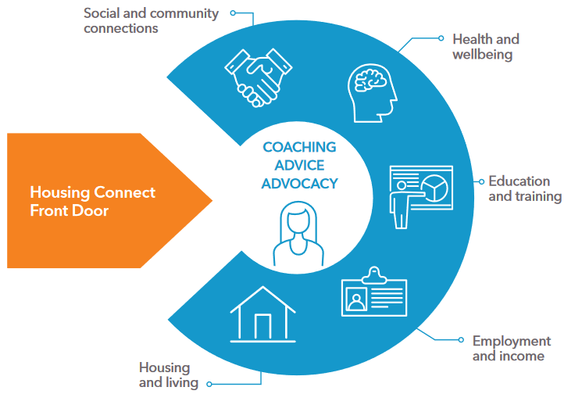

Advice/information

Other basic assistance

Advocacy/liaison on behalf of client

Material aid/brokerage

Assistance to sustain tenancy or prevent tenancy failure or eviction

Financial information

Assistance for family/domestic violence

Other specialised service

Legal information

Mental health services

Retrieval/storage/removal of personal belongings

Transport

Financial advice and counselling

Court support

Health/medical services

Child protection services

Assistance for trauma

Assistance to obtain government allowance

Employment assistance

Drug/alcohol counselling

Family/relationship assistance

Meals

Assistance with challenging social/behavioural problems

Professional legal services

Laundry/shower facilities

Educational assistance

Living skills/personal development

Parenting skills education

Intellectual disability services

Assistance to prevent foreclosures or for mortgage arrears

Assertive outreach for rough sleepers

Psychiatric services

School liaison

Specialist counselling services

Interpreter services

Training assistance

Assistance for incest/sexual assault

Child contact and residence arrangements

Psychological services

Pregnancy assistance

Physical disability services

Culturally specific services

## Lack of housing is a barrier to meeting client needs

In response to the needs identified, 90% of clients received or were referred to the support service required, except when their need was for housing or accommodation.

For people needing long-term housing, medium-term/transitional housing and/or short-term or emergency accommodation, 25% of these needs were met.

**Figure 21. Lack of housing is a barrier to meeting needs of Front Door clients**

The Housing Connect Front Door does not provide housing and so has limited capacity to assist clients to meet housing needs.

Charts in Figures 22, 23 and 24 compare the housing circumstances of clients at presentation with their circumstances at the end of a support period. Virtually all clients end their support period with their housing tenure and type of dwelling at least ‘as good’ or ‘better than’ on presentation. Significant positive change was achieved for some clients experiencing extreme housing insecurity or primary homelessness, including people sleeping rough or couch surfing.

**The primary need for long-term secure and affordable housing for most clients remained unmet.**

**Figure 22. Change in type of residence over course of support period (% change)**

**Figure 23. Change in tenure or living arrangements over course of support period**

**Figure 24. Type of dwelling at start and end of support** **period**

Research shows that the adverse impacts of waiting for social housing include:

* financial difficulties which can result in people not being able to feed themselves or their children adequately and cutting back on medication or forgoing necessary medical procedures
* people and carers of people with a disability living in inadequate and unsuitable housing
* anxiety and depression as a result of not having an affordable and stable home combined with the endless waiting
* other impacts on physical and mental health
* impacts on children (sometimes severe) as a result of having to live away from their parents or in temporary accommodation and having to constantly move
* children being removed because the parent did not have adequate and /or stable accommodation
* difficulties seeking or maintaining employment due to the lack of stable housing (Morris et al. 2023).

# Delivering on the Tasmanian Housing Strategy

The Tasmanian Housing Strategy (the Strategy) provides a statement of the Tasmanian Government’s housing commitment:

People should be at the centre of housing policy considerations because **housing is the platform for individuals, communities, and the economy to prosper**.

The Tasmanian Housing Strategy (the Strategy) seeks to end homelessness in Tasmania by **providing safe, appropriate and affordable housing for all Tasmanians**.

The Strategy builds on existing initiatives and reinforces our commitment to a target of **a net increase of 10,000 social and affordable homes by 2032**

(Tasmanian Government 2023a).

The commitment to increase an existing target to deliver 10,000 new social and affordable homes by 2032 was announced in the lead up to the 2022 state election.

The Tasmanian Housing Strategy Action Plan 2023-2027 was released along with the Tasmanian Housing Strategy (Tasmanian Government 2023b).

The Homes Tasmania Dashboard provides excellent data reporting on progress against the current action plan. Key data is summarised in the charts overleaf.

The August 2024 Housing Dashboard published by Homes Tasmania reports that:

* 3772 (38%) of 10,000 projects to be completed by 30 June 2032 have been completed
* 392 (20%) of 2,000 new social homes, including supported accommodation, to be delivered between 1 July 2023 and 30 June 2027 have been completed
* 224 (56%) of 400 affordable rental properties to be secured through the Private Rental Incentives Scheme by 30 June 2026 have been delivered
* 46 (31%) of 150 Family Violence Rapid Rehousing properties to be secured by 30 June 2026 have been delivered (Homes Tasmania 2024b).

However, the reporting is less clear about how effectively the action plan is delivering on the Tasmanian Housing Strategy’s mission and objectives. This is where Housing Connect’s Front Door data can provide useful insights.

**Figure 25. Status of Homes Tasmania action to deliver 10,000 homes, August 2024**

**Figure 26. Homes to be delivered, August 2024 to June 2032**

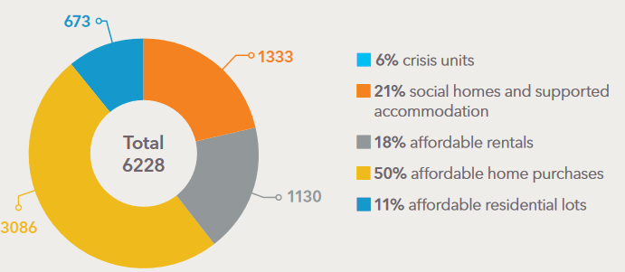

## Barriers to achieving the objectives of the Housing Strategy

### There will not be a net increase of 10,000 homes

Based on the reporting in the Homes Tasmania Dashboard, not all projects counted toward the 10,000 homes will contribute to the net increase in housing supply needed to address the housing crisis.

Clearly identifying new housing supply is critical to evaluating the progress toward the desired outcome of providing safe, appropriate and affordable housing for all Tasmanians.

A number of categories do not completely contribute to new housing supply.

**Affordable rentals**

The Private Rental Incentives and Rapid Rehousing schemes are important components of the housing system to enable flexibility and responsiveness in the supply of social and affordable housing. The expansion in these affordable rental programs is welcomed.

However, any properties added to these portfolios do not add to the stock of housing unless they were not previously part of the long-term housing stock (ie new builds, unoccupied dwellings, short stay accommodation).

To be effective, the Rapid Rehousing Program urgently needs an increase in affordable long-term housing stock for victim-survivors to move into. This will prevent victim-survivors becoming stuck in transitional housing (or facing homelessness), provide the long-term housing security they need and prevent bottlenecks that limit the transitional housing available to support people escaping domestic and family violence.

Reporting should make clear the number of properties in the affordable rental portfolio which provide new long-term housing.

**Affordable home purchases**

The MyHome Program supports the purchase of both house and land packages to build a new home and the purchase of existing homes. Only assistance to build new homes will increase housing supply.

Reporting should provide a breakdown of assisted affordable home purchases to make clear which are existing homes and which are new builds.

### Social homes required to meet needs of Front Door clients

The Housing Strategy aims to deliver a range of affordable housing for Tasmanians. Not all of this housing will be affordable for Housing Connect Front Door clients.

The Housing Strategy defines people on low incomes as the 50% of the population who receive below median income (Tasmanian Government 2023a). This differs from the ABS definition of people on low incomes. The ABS defines people on **low** incomes as people in the lowest income quintile (20% of the population) and people on **lower** incomes as people in the **two** lowest income quintiles (40% of the population) (ABS 2022).

**Figure 27. Comparison of definitions of ‘low income’**

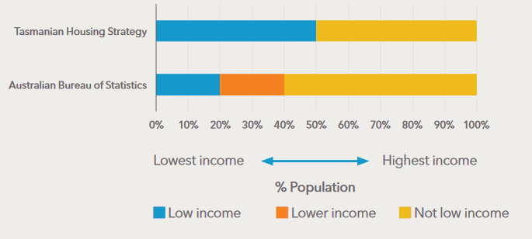

The Housing Strategy defines affordable housing as:

Housing for purchase and rental, including social housing, that is appropriate for the needs of very low-, low- and moderate-income households. This is generally understood to mean housing that costs no more than 30 per cent of a household’s gross income (Tasmanian Government 2023a).

Moderate income households are not defined in the Housing Strategy but, logically, must be people in the 50% of the population who receive above median income (otherwise they would be defined as low income) (ABS 2022).

Given that most clients of the Front Door are in the bottom 40% of the income distribution, most homes defined as affordable in the Strategy will be beyond their means. Only social housing is likely to meet their needs for long-term housing.

### Social housing supply gap projected to grow to 7000 by 2032

**Figure 28. Projected social housing supply and demand**

Social housing stock in 2023 (latest data available) was 14,065 dwellings and in June 2024 expressed demand for social housing was 18,518 dwellings. In the chart above, projected social housing supply is estimated by adding the 392 dwellings completed since June 2023, 491 in the pipeline and 848 committed to beyond that. Assuming no dwellings are removed from the stock (which is unlikely), there will be 14,948 social homes by 2027 and 15,900 social houses by 2032.

If the number of people needing social housing continues to grow at the current rate, 20,200 social homes will be needed by 2027 and 22,900 by 2032.

In the absence of improved private rental affordability or increased social housing supply, it is anticipated that by 2032 there will be at least 7,000 applicants on the housing register.

# Recommendations

Anglicare Tasmania recommends that the Tasmanian Government:

1. **Commits to reducing the harmful impacts of waiting for social housing** by:
   1. Establishing a target for reducing the social housing register in the next housing action plan in consultation with stakeholders
   2. Establishing a target for reducing average waiting times for social housing applicants
   3. Developing a process for providing applicants with realistic estimates of waiting times and the progress of their application.
2. **Increases investment in long-term social housing under the Tasmanian Housing Strategy** to achieve these targets and meet the housing needs of Housing Connect Front Door clients.
3. **Refines reporting and measurement** **of progress against the Tasmanian Housing Strategy** by:
   1. Clearly reporting how many dwellings delivered by Homes Tasmania under the Action Plan are new dwellings (or otherwise not previously used for long term housing)
   2. Clearly reporting how many dwellings delivered by Homes Tasmania under the Action Plan were affordable for people in the bottom two incomes quintiles as reported by the ABS (ABS 2022)
   3. Reducing the lag in reporting the stock of social housing
   4. Developing better reporting of housing outcomes for Front Door clients seeking long-term housing
   5. Expanding reporting to include:
      1. the total number of dwellings relative to the population
      2. the stock of affordable rental housing relative to the population
      3. the proportion of rental households with household income in the bottom two quintiles that spend more than 30 per cent of their income on rent.

# Glossary

Affordable rental housing Properties that are made available at rents that are below market rates and are affordable for low- to moderate-income households. Typically, this means rents are set at or below 80 per cent of market rates and not more than 30 per cent of a household’s gross income. This includes key worker housing and social housing.

Community housing Housing owned or managed by non-government organisations for people on low- to moderate-incomes. Community housing rent is typically set below market rate. Residents in community housing are eligible for their rent to be subsidised by Commonwealth Rent Assistance.

Crisis accommodation Shelters and transitional housing for people experiencing homelessness or domestic violence.

Essential worker An employee who provides a service that is essential to a community’s functioning, and the work role requires people being physically present at a work site rather than being able to work from home.

Homelessness The Australian Bureau of Statistics defines homelessness as when a person does not have suitable accommodation alternatives. They are considered homeless if their current living arrangement:

• is in a dwelling that is inadequate;

• has no tenure, or if their initial tenure is short and not extendable; or

• does not allow them to have control of, and access to, space for social relations (ABS 2021).

Homes Tasmania The statutory authority established in 2022 under the Homes Tasmania Act 2022 and responsible for delivering improved housing services and increasing the supply of social and affordable homes by delivering the Tasmanian Government’s 10-year housing package.

Housing affordability Housing affordability refers to the relationship between expenditure on housing (prices, mortgage payments or rents) and household incomes. The concept of housing affordability is different to the concept of ‘affordable housing’ used in the Tasmanian Housing Strategy. Households in the bottom 40 per cent of the income distribution who pay more than 30 per cent of their gross income on rent or mortgage repayments are classified as in ‘housing stress’ – see *Housing stress*.

Housing First The Housing First model is a strategic response to homelessness that prioritises permanent and stable housing as the first priority for people experiencing homelessness. The guiding principle of Housing First is that safe and secure housing should be quickly provided prior to, and not conditional upon, addressing other health and wellbeing issues first.

Housing stress Housing stress is defined as the lowest 40 per cent of income earners who pay more than 30 per cent of their gross income on housing costs. This is known as the 30/40 rule and is the benchmark measure of housing affordability in the Strategy. See also *Housing affordability*.

Overcrowding Overcrowding is defined as a situation in which one or more additional bedrooms would be required to adequately house all household members, given their number, age, sex and relationships.

Poverty Receiving income below the Henderson Poverty Line.

Public housing Housing provided by the government for people on low incomes, subsidised by government funds. The tenant contribution (rent) is set at a proportion (usually 25-30 per cent) of household income. Also referred to as social housing. See also *Social housing*.

Sleeping rough State of sleeping with no shelter on the street, in a park, in the open, or in a motor vehicle.

Social housing Social housing is affordable housing provided by the government and community sectors to assist people who are unable to afford or access suitable accommodation in the private rental market. It includes public housing, state-owned and -managed Indigenous housing and community housing. Rents are set as a proportion of household income.

Supported accommodation Housing combined with a support service. This type of housing provides higher-level care, support or supervision for vulnerable people with particular needs. Examples of this include youth or people with episodic or severe mental illness.

Tenure The legal and social arrangements that determine how individuals or households occupy and use a dwelling or piece of land. Tenure arrangements dictate the rights and responsibilities of occupants and owners and may influence the stability and security of housing. Tenure in Australia is primarily through ownership or renting, but there are many subcategories of both.

Trauma-informed An approach to care and service delivery that recognises and responds to the impact of trauma on individuals and communities.

# References

ABS (Australian Bureau of Statistics) (2021) *Estimating Homelessness: Census*, accessed October 2024, <https://www.abs.gov.au/statistics/people/housing/estimating-homelessness-census/2021>.

--- (2022) *Survey of Income and Housing, User Guide, Australia*, accessed October 2024, <https://www.abs.gov.au/statistics/detailed-methodology-information/concepts-sources-methods/survey-income-and-housing-user-guide-australia/2019-20>.

--- (2024) *Wage Price Index, Australia*, accessed October 2024, <https://www.abs.gov.au/statistics/economy/price-indexes-and-inflation/wage-price-index-australia/jun-2024>.

Anglicare Australia (2024) *Rental Affordability Snapshot: Essential Workers Report*, Second edition, accessed October 2024, <https://www.anglicare.asn.au/wp-content/uploads/2024/10/Rental-Affordability-Snapshot-Essential-Workers-Report.pdf>.

Aspire (Aspire Property Advisor Network) (2021) *How vacancy rates drive prices*, accessed October 2024, <https://www.aspirenetwork.com.au/how-vacancy-rates-drive-prices/>.

Claxton S and Bennett M (2024) *Rental Affordability Snapshot Tasmania*, Social Action and Reseach Centre, accessed October 2024, <https://www.anglicare-tas.org.au/research/rental-affordability-snapshot-tasmania-2024/>.

Cope K (2024) *Stretched Too Far: Children and families surviving the cost of living crisis in Tasmania*, Social Action and Research Centre, Anglicare Tasmania, accessed October 2024, <https://www.anglicare-tas.org.au/research/stretched-too-far-children-and-families-surviving-the-cost-of-living-crisis-in-tasmania/>.

Homelessness Australia (2023) *Definitions of homelessness fact sheet*, Homelessness Australia, accessed October 2024, <https://homelessnessaustralia.org.au/wp-content/uploads/2023/06/Homelessness-definitions.pdf>.

Homes Tasmania (2024a) *Housing Connect Practice Framework*, accessed October 2024, <https://www.homestasmania.com.au/__data/assets/pdf_file/0045/279999/Housing-Connect-Practice-Framework-MASTER2.PDF>.

--- (2024b) *Homes Tasmania Dashboard August 2024*, accessed October 2024, <https://www.homestasmania.com.au/about-us/Publications/housing-dashboard>.

Hunter S (16 May 2024) *Housing market cycles and fundamentals*, REIA Centennial Congress, Hobart, <https://www.rba.gov.au/speeches/2024/sp-ag-2024-05-16.html>.

Morris A, Idle J, Moore J and Robinson C (2023) *Waithood: The experiences of applying for and waiting for social housing*, Institute for Public Policy and Governance, University of Technology Sydney, accessed October 2024, <https://waitingforsocialhousing.com/2023/08/02/waithood-the-experiences-of-applying-for-and-waiting-for-social-housing>.

Reynolds M, Parkinson S, De Vries J and Hulse K (2024) *Affordable private rental supply and demand: Short term disruption (2016-2021) and longer-term structural change (1996-2021)*, AHURI Final Report No. 416, Australian Housing and Urban Research Institute, [10.18408/ahuri5128501](https://www.ahuri.edu.au/research/final-reports/416).

Tasmanian Government (2023a) *Tasmanian Housing Strategy 2023-2043*, accessed October 2024, <https://www.tasmanianhousingstrategy.tas.gov.au/>.

--- (2023b) *Tasmanian Housing Strategy Action Plan 2023-2027*, accessed October 2024, <https://www.tasmanianhousingstrategy.tas.gov.au/>.

Toombs G (2024) *Unsafe and Unhoused: Barriers to addressing domestic and family violence in North West Tasmania*, Social Action and Research Centre, Anglicare Tasmania, <https://www.anglicare-tas.org.au/research/unsafe-and-unhoused/>.

TUT (Tenants' Union of Tasmania) (2024) *Tasmanian Rents*, June Quarter 2024, accessed October 2024, <https://tutas.org.au/publications/tasmanian-rents/>.

Twohig D, Yadav A and Hambur J (2024) 'Do housing investors pass-through changes in their interest costs to rents?', *Bulletin,* October 2024, RBA, accessed October 2024, <https://www.rba.gov.au/publications/bulletin/2024/oct/do-housing-investors-pass-through-changes-in-their-interest-costs-to-rents.html>.

1. People needing housing support are Housing Connect clients who had an open support period between 1 July and 30 September 2024.