Putting people

at the centre

Housing Connect

Front Door Service Snapshot

December quarter 2024

March 2025

Contents

Housing Connect Front Door 4

Executive summary 5

Front Door service in Housing Connect 2.0 7

Housing system indicators October - December 2024 8

Residential vacancy rate 8

Median rent relative to income 9

Rental affordability for people on low incomes 10

The housing register 11

Wait time for social housing 12

People connecting with the Front Door 13

The people seeking support 14

What has changed over the quarter? 16

Reaching out to the regions 17

Housing circumstances of people seeking housing support 18

Reaching out to people leaving prison 19

Reasons for seeking support 20

Reaching out to hospitals and mental health hubs 22

Front door response 23

Housing application support 23

Private rental assistance 23

Crisis and urgent need response 24

Housing support periods 24

Meeting the need for housing 28

Client satisfaction 30

Putting people at the centre 31

Recommendations 32

Glossary 33

References 34

**Acknowledgement of Country**

Anglicare Tasmania acknowledges and pays respect to the Tasmanian Aboriginal community as the traditional and original owners and continuing custodians of this land, Lutruwita/Tasmania, on which this project has taken place. We acknowledge Elders past and present, and Aboriginal people who have participated in and are connected with this research.

**Acknowledgements**

The assistance of the staff of Anglicare Tasmania’s Housing Connect Front Door service in the preparation of this report is gratefully acknowledged. Thank you for the important work you do, and to the people you work with for their strength and resilience.

The assistance of Homes Tasmania in providing data is also acknowledged.

Thank you to other Anglicare colleagues for your expertise, support and guidance.

**About Anglicare Tasmania**

Anglicare, in response to the Christian faith, strives to achieve social justice and to provide the opportunity for people in need to reach fullness of life.

Our values:

**Hope**: Confidently reaching for fullness of life.

**Compassion**: Showing empathy and care for those in need.

**Justice**: Promoting the fair distribution of resources and opportunities.

**Respect**: Recognising the inherent value and dignity of every person.

**Anglicare Tasmania’s Social Action and Research Centre**

The Social Action and Research Centre investigates how and why Tasmanians are affected by poverty and inequality. We use what we learn to advocate for changes that improve people’s lives.

Our qualitative research centres on the lived experience of Tasmanians. It often features the voices of people who use Anglicare services and our frontline workers.

Our quantitative research uses data to demonstrate social trends.

We brief government and stakeholders on our research and create opportunities for networking and collaboration.

# Housing Connect Front Door

The Housing Connect Front Door is the entry point for people to access housing support, from emergency accommodation to a long-term home. This begins with an assessment to understand their individual circumstances and help match them with the most suitable options available.

Anglicare Tasmania is funded by government to deliver the Housing Connect Front Door Service statewide. This arrangement began from July 1, 2024.

People can access the Housing Connect Front Door by telephone, 24 hours a day, 365 days a year on **1800 800 588.** This is a free call.

People can also access the Front Door at these Anglicare Tasmania offices between the hours of 9.00 am and 5.00 pm, Monday to Friday:

* 159 Collins Street, Hobart
* 122 Elizabeth Street, Launceston
* 31 King Street, Devonport
* 51 Wilmot Street, Burnie.

Wyndarra Centre Inc. provides a Front Door service at 43 Smith Street, Smithton.

**The Housing Connect Front Door does not provide housing**

The Front Door service links people with supports that are suited to their life stage and individual circumstances. Although the Front Door service does not provide housing, it can assist clients to apply for social housing or to secure or maintain a private rental tenancy.

For many people, the Front Door can provide the level of support they need. However, for those who require more intensive and ongoing support, the Front Door connects them with Key Development coaches in their region.

# Executive summary

This is the second quarterly snapshot of Housing Connect Front Door services. Anglicare Tasmania delivers this service statewide, helping Tasmanians to access the housing supports they need based on their individual circumstances and personal goals.

Between 1 October and 31 December 2024 (the December quarter), the statewide Front Door service has:

* responded to 10,723 enquiries from Tasmanians seeking housing support (🡻12%)
* assisted people to make 1,248 new social housing applications (🡻19%)
* provided 1,299 periods of support to 1,252 people or families (🡹2%)
* provided short-term or emergency accommodation for 147 people or families and arranged a referral for a further 89
* arranged referrals for medium-term or transitional housing for 106 people or families
* provided over $132,000 in financial assistance to:
  + fund emergency accommodation
  + help people to establish or maintain a tenancy
  + enable people to access training, education or employment
  + help people access other specialist services.

Compared to the September quarter (1 July to 30 September 2024) there was a decrease in demand for housing support across all regions. This was in large part due to a seasonal fall in real estate market activity in the lead up to Christmas which meant that fewer people sought private rental assistance. However, there were 4,866 people on the housing register at the end of the quarter, 157 more than in June 2024.

The number of people in employment seeking housing support increased in the December quarter. This is a sobering indication that, due to a lack of affordable housing and increased cost of living, wages are not always enough to ensure housing security.

The implementation of the Housing 2.0 model continued with Connection Coaches linking people with a broad range of wrap-around supports to assist people toward meeting their own life and housing goals. The share of clients achieving all their goals increased.

A survey of clients who received face-to-face housing support achieved a 56% response rate with 97% of respondents satisfied or very satisfied with the support and service that they received.

A focus of Front Door service improvement in the December quarter was expansion of outreach services. This improved access for people in regional areas and those at higher risk of housing insecurity, including people with mental health conditions and people exiting hospital or prison.

Housing system indicators, however, reflect a sustained shortage of affordable housing supply compared to demand. There is a continued need to reduce the harmful impacts of waiting for social housing, build more social housing and improve reporting of progress toward delivering on the Tasmanian Housing Strategy.

Anglicare Tasmania recommends that the Tasmanian Government:

1. **Commits to reducing the harmful impacts of waiting for social housing** by:
   1. establishing a target for reducing the social housing register in the next housing action plan in consultation with stakeholders
   2. establishing a target for reducing average waiting times for social housing applicants
   3. developing a process for providing applicants with realistic estimates of waiting times and the progress of their application.
2. **Increases investment in long-term social housing under the Tasmanian Housing Strategy** to achieve these targets and meet the housing needs of Housing Connect Front Door clients.
3. **Refines reporting and measurement** **of progress against the Tasmanian Housing Strategy** by:
   1. clearly reporting how many dwellings delivered by Homes Tasmania under the Action Plan are new dwellings (or otherwise not previously used for long-term housing)
   2. clearly reporting how many dwellings delivered by Homes Tasmania under the Action Plan were affordable for people in the bottom two income quintiles as reported by the ABS (ABS 2022)
   3. reducing the lag in reporting the stock of social housing
   4. developing better reporting of housing outcomes for Front Door clients seeking long-term housing
   5. expanding reporting to include:
      1. the total number of dwellings relative to the population
      2. the stock of affordable rental housing relative to the population
      3. the proportion of rental households with household income in the bottom two quintiles that spend more than 30 per cent of their income on rent.

# Front Door service in Housing Connect 2.0

Under Housing Connect 2.0, Tasmanians will get better access to housing assistance and help to develop strong connections to family and community and build their capabilities for independent living.

– Housing Connect Practice Framework (Homes Tasmania 2024b)

The statewide Front Door service is part of the Housing Connect 2.0 model being implemented and overseen by Homes Tasmania to deliver on the Tasmanian Housing Strategy. The Front Door staff have been trained in Advantaged Thinking, an approach designed to deliver person-centred, trauma‑informed and evidence‑based support.

The functions of the Housing Connect Front Door are:

* assessment of each person’s situation and needs to ensure a tailored response
* provision of targeted housing and homelessness information, products and services, and related coaching and support (for people who need only a limited period of support)
* connecting or referring people to service system and community supports
* crisis response, including access to flexible funds for reasonable and necessary support (urgent need response)
* housing application support (Homes Tasmania 2024b).

The Housing Connect Front Door is just one part of the Tasmanian Housing Connect system. The Front Door links to Housing Connect partners who are responsible for delivering services to clients (e.g. mental health services), providing longer term (level 3) support, managing the social housing register, allocating social housing, funding social housing supply, and building and leasing homes.

You can read more about how the Housing Connect Front Door operates within the Housing Connect framework in [More Houses Needed](https://www.anglicare-tas.org.au/research/sarc-more-houses-needed-report-october-2024/) (Anglicare Tasmania 2024).

## Housing system indicators October - December 2024

### Residential vacancy rate

A sustainable vacancy rate of around 3 per cent in the private rental market will help to stabilise rents and ultimately reduce pressure on household budgets.

— Tasmanian Housing Strategy (Tasmanian Government 2023)

Vacancy rates in all regions of the state fell below 1% in September 2024 and stayed there throughout the December quarter (see Figure 1).[1] This is far below the target of 3%, identified in the Tasmanian Housing Strategy as the sustainable rate. A rate below 3% indicates that the number of people wanting rental properties is higher than the number available. When the vacancy rate is below 3%, rents tend to rise and upward pressure on rents increases as the vacancy rate falls further below the target.

The decrease in regional vacancy rates and enquiries to Housing Connect is partly due to a seasonal decrease in tenancy turnover in the lead-up to Christmas/New Year. However, the extremely low vacancy rates continue to place upward pressure on rents.

**Figure 1. The rental vacancy rate is at critically low levels in all regions**

Data source: (Homes Tasmania 2024a)

### Median rent relative to income

Rents surging faster than incomes has driven affordability lower.

— PropTrack Rental Affordability Report (Moore and Ryan 2024)

Rents are continuing to rise faster than incomes. Over the December 2024 quarter, the Tasmanian median rent index rose by 1.1% and the Tasmanian wage price index rose by only 0.5% (see Figure 2).

**Figure 2. Rents are rising faster than wages in Tasmania**

Data source: (ABS 2024; TUT 2024)[2]

### Rental affordability for people on low incomes

Housing… that is appropriate for the needs of very low-, low- and moderate-income households. This is generally understood to mean housing that costs no more than 30 per cent of a household’s gross income.

— Tasmanian Housing Strategy 2023-2043 (Tasmanian Government 2023)

Figure 3 shows the share of income that selected groups were likely to spend on rent in 2023 and 2024 (SGS Economics and Planning 2023, 2024). For rent to be affordable, it needs to cost no more than 30% of gross income, shown by the dotted blue line in Figure 3.

In Hobart, rents remain extremely unaffordable for people on low incomes even though rental affordability improved slightly between 2023 and 2024. For example, a single person receiving the Jobseeker payment is still likely to be spending 71% of their income on rent (see Figure 3). This is 2.3 times the rent that would be considered affordable.

Rents in the rest of Tasmania are unaffordable for people on low incomes and becoming more unaffordable. Between 2023 and 2024, the share of income spent on rent increased for most groups of people on low incomes.

**Figure 3. Proportion of income spent on rent in Greater Hobart and the rest of Tasmania**

Unaffordable

Affordable

**Greater Hobart Rest of Tasmania**

Data source: (SGS Economics and Planning 2023, 2024)

### The housing register

Goal 7 - Social and affordable housing is provided in sufficient amounts to fulfil its role as essential infrastructure to enable sustainable, productive and cohesive communities.

— State of the Housing System 2024 (National Housing Supply and Affordability Council 2024)

The large number of applications on the housing register indicates that the supply of social housing is inadequate. At the end of the December quarter the number of applications on the social housing register was 4,866 (Homes Tasmania 2024a).

This was 0.5% lower than the 4,892 applications reported for the end of September 2024. Factors contributing to this small but welcome fall include the completion of 587 new social dwellings in the 6 months to December 2024 and a reduction in new housing applications in the December quarter (see page 23). However, there was a still net increase of 3.3% between June and December 2024.

The total supply of social dwellings in June 2024 was 15,095 homes, which only met 76% of expressed demand for social housing. Analysis of housing data published by the Productivity Commission (2525) reveals that in Tasmania, the supply of social homes per capita of people experiencing extreme disadvantage is 14% lower than the national average.

**Figure 4. The social housing register indicates rising unmet demand for social housing**

Data source: (Homes Tasmania 2024a)

### Wait time for social housing

The impacts of waiting are profound. Waitees told of their financial struggles, not being able to feed themselves or their children adequately and cutting back on medication or forgoing necessary medical procedures… not having an affordable and stable home combined with the endless waiting were fundamental contributors to their poor physical and mental health… Sadly, the children of waitees were often hard-hit by their situation… Waitees felt that their lack of stability made it difficult for them to seek or maintain employment.

— Waithood: The experiences of applying for and waiting for social housing (Morris et al. 2023)

In December 2024, the average wait time for priority applicants was over 1 year and 7 months (84.6 weeks) (Homes Tasmania 2024a). Although the average wait time fell by 4% over the quarter and is 6 weeks less than the peak of 90.5 weeks in July 2024, it has still increased by 3% over the 12 months to December 2024 (see Figure 5).

Median wait time for priority applicants and the average and median wait time for all applicants (all of whom have been assessed as eligible for social housing) are not reported by Homes Tasmania.

Figure 5. The average waiting time for social housing is falling but still higher than 12 months ago

Data source: (Homes Tasmania 2024a)

# People connecting with the Front Door

Between 1 October and 31 December, the Housing Connect Front Door responded to a total of 10,723 enquiries from over 5,400 families and individuals.

The number of new enquiries fell across the quarter as real estate activity eased off in the lead up to the Christmas and New Year break (see Figure 6). The distribution of enquiries across the state remained steady with half (50%) in the South, 27% in the North and 23% in the North West.

People may be referred to Front Door services by another service or can seek support by contacting Housing Connect directly.

**Figure 6. Enquiries by region, October‑December 2024**

Infographic showing enquiries received as in text. Also shows How people contacted us, 43% by phone, 33% by email, 19% in person.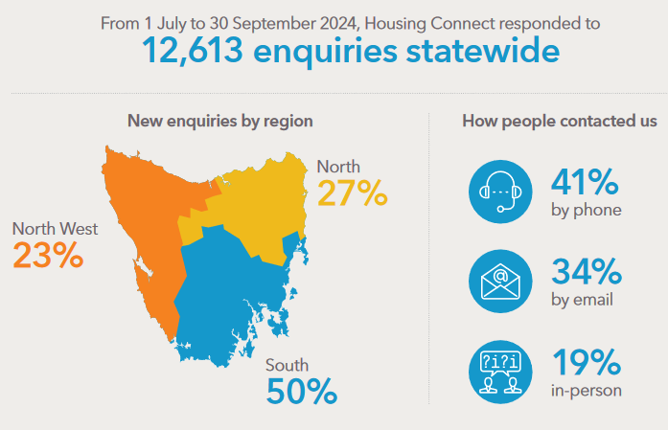

33%

1 October to 31 December

**10,723**

43%

Since September 2024, the Housing Connect team has worked to make the Front Door service even easier to access. Most people contact Housing Connect by phone, email or by visiting one of our offices. However, some people who are most at risk of housing insecurity and homelessness face barriers to accessing Housing Connect services through these channels.

To overcome these barriers, Housing Connect has worked to establish outreach services. This includes outreach to:

* regional areas (see page 20)
* hospitals and mental health care facilities (see page 26)
* prisons (see page 23).

## The people seeking support

Housing Connect provides support to Tasmanians who are:

* homeless or at risk of being homeless
* living in unsafe housing or cannot stay where they normally live
* a safety risk to themselves or others or there is a third-party threat to them or their household.

Support may also be available to people who are:

* having trouble paying their rent or bond
* moving and having trouble paying the costs
* living in a place that makes it hard for them or makes their health or mobility worse
* unable to pay for their own housing.

Table 1 provides a summary of some demographic information about people seeking housing support.

**Table 1. Selected demographic statistics**

|  |  |  |
| --- | --- | --- |
|  | Housing Connect clients | Tasmanian population |
| Women | **60%** | **50%** |
| Men | 40% | 50% |
| Other | 1% |  |
|  |  |  |
| Children presenting alone (<18 years) | 3% | 19% |
| Young people 16-24 years | **22%** | **10%** |
| Older Tasmanians (65+ years) | 12% | 21% |
|  |  |  |
| Aboriginal and/or Torres Strait Islander | **19%** | **5%** |
| Main language other than English spoken at home | 7% | 9% |

Compared to the Tasmanian population, people needing housing support are more likely to be*[3]*:

* female
* young adults aged 18-24 years
* single parents with children
* living alone or in group/share housing.

The proportion of people accessing housing supports who are Aboriginal and/or Torres Strait Islander is also higher than in the general population. Almost all clients are receiving low incomes.

Figure 7 shows the distribution of Housing Connect clients by life stages. Compared to the September quarter, the share of young people seeking housing support increased from 13% to 21% and the share of single adults aged 25 to 65 years decreased from 28% to 20%.

**Figure 7. Distribution of Housing Connect clients by life stages**

## What has changed over the quarter?

Over the December quarter, housing support workers reported an increase in the number of two-parent families with children seeking housing support and families in which at least one adult had paid employment. They also noticed more households seeking support for the first time to get them over a ‘rough patch’.

Between 1 October to 31 December the number of couples with children accessing housing support rose by 67% and the number of lone parents with children seeking support fell slightly. There was also a rise in the number of men and decrease in the number of women accessing housing support. The number of employed people seeking support increased by 17%, mainly due to a 27% increase in people in part-time work.

It is unsurprising that the cost of living and housing crises have their greatest impact on people relying on income support and single-adult households. However, this quarter’s data suggests that it is increasingly affecting people who are in paid employment and couples with children. Wages from part-time employment are less likely to be enough to cover housing costs.

People accessing support who speak a language other than English at home also increased over the December quarter.

|  |  |  |  |
| --- | --- | --- | --- |
| Woman outline  747 women | 🡻 3% | Man outline  498 men | 🡹 11% |
| Man with baby outline  306 lone parents with children | 🡻 4% | Family with two children outline  75 couples with children | 🡹 67% |
| Chef male outline  169 people in employment | 🡹 17% | Daily calendar outline  151 people in part-time employment | 🡹 27% |

### Reaching out to the regions

Face to face Front Door Services are available 9am to 5pm at the Housing Connect offices in Burnie, Devonport, Launceston and Hobart. Housing Connect services are also available for 3 hours each weekday at the Wyndarra Centre, Smithton. Travelling to one of these centres for face to face services is not possible for some people experiencing housing insecurity or homelessness in regional Tasmania.

To make Front Door services more accessible to Tasmanians in regional and suburban areas and people experiencing a housing crisis, Housing Connect staff visit the following sites:

* Burnie Safe Space fortnightly
* The Rookery at Penguin Community Op Shop monthly
* Ulverstone Neighbourhood House monthly
* East Devonport Child and Family Learning Centre monthly
* Deloraine Neighbourhood House monthly
* George Town Neighbourhood House weekly
* St Helens Anglicare Office monthly
* Hobart Safe Space weekly

Staff also visit Anglicare offices at Zeehan, Sorell and Glenorchy depending on demand for services.

To find out about what services are available near you, contact Housing Connect.

## Housing circumstances of people seeking housing support

Private renters were the largest group of people seeking housing support, followed by people who were couch-surfing and people in emergency or crisis accommodation (see Figure 8). Together, these groups accounted for 48% of people receiving housing support between 1 October and 31 December 2024.

People exiting adult and youth correctional facilities receiving housing support increased to 2% (from 1% the previous quarter) and those exiting a hospital or a psychiatric unit remained steady at 2%. This slight increase coincides with the increase in outreach services, particularly in the south.

**Figure 8. Housing circumstances of people one week before support period commenced,**

**October – December 2024**

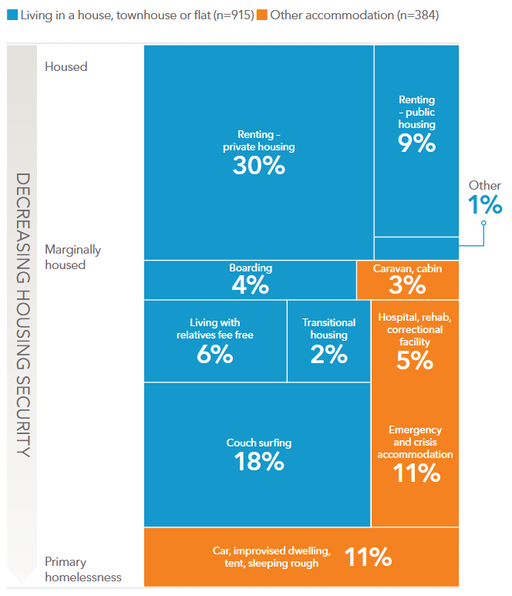

384

### Reaching out to people leaving prison

33% of people in prisons were homeless before prison, and 54% expect to be homeless when released. And if former prisoners exit into homelessness, they are twice as likely to return to prison within the first 9 months of release.

— Closing the Revolving Door Prison Project (Justice Connect 2021a)

Housing is critical for people exiting prison and lack of access to housing can be a barrier to securing parole. For people released from prison, housing instability and homelessness can result in a range of other negative outcomes ‘including breach of parole conditions, loss of possessions, a reduction in the ability to address other issues such as drug use, education and employment, the inability to obtain custody of children and a general inability to reintegrate and rehabilitate’ (Justice Connect 2021b). It also has a ‘well-established link with recidivism’ (Justice Connect 2021b).

Housing Connect works with the prison release planning team to help secure appropriate housing for people applying for parole. Planning starts 6 months ahead of an individual’s release to provide them with the opportunity to integrate back into the community successfully and start working toward their life goals.

Ted’s story: Ready for the next stage

Risdon Prison inmate Ted had engaged positively with services within the prison system and set himself goals that he wanted to achieve on his return to the community.

When an opportunity came up to apply for parole, he was determined to do all he could to secure his release. Ted knew that having a home to go to would be viewed very favourably by the Parole Board. He applied for private rentals and was successful in securing a property.

The prison release planning team reached out to Housing Connect on Ted’s behalf to see what additional support may be available. Housing Connect offered Ted bond and rent in advance. The Parole Board could see that Ted was in a good position to start this next phase of his life and granted him parole.

## Reasons for seeking support

When asked to name the main reason for seeking housing support, 91% of clients cited one of nine reasons (shown in Figure 9). The top seven reasons were the same as in the September quarter with the most common reason, cited by more than 1 in 4 clients (26%), being a housing crisis, followed by inadequate or inappropriate conditions (18%), housing affordability stress (12%), domestic and family violence (10%), previous accommodation had ended (7%), financial difficulties (7%) and relationship or family breakdown (5%).

Transition from custodial arrangements (3%) and mental health conditions (3%), which rounded out the top nine, were not among the top reasons for seeking support in the September quarter. It is likely that this change reflects the impact of ramping up Housing Connect’s outreach services, including services to people exiting psychiatric care or prison.

People seeking housing support mainly due to violence (domestic and family violence or non-family violence) decreased, accounting for 12% of clients in the December quarter, compared to 15% in the September quarter.

**Figure 9. Main reasons for seeking housing support given by Front Door clients**

Most clients cited multiple reasons for seeking assistance and this data provides information about the range of challenges faced by people experiencing housing insecurity. The ten most common reasons shown in Figure 10 remained unchanged from the previous quarter. However, a slightly smaller proportion of clients reported housing affordability stress, housing crisis, financial difficulties, lack of family or community support, previous accommodation ended and/or domestic and family violence.

**Figure 10. All reasons for seeking support given by Front Door clients**

### Reaching out to hospitals and mental health hubs

People living with mental health conditions can be more at risk of housing insecurity and homelessness. Their mental health may also make reaching out for housing support more daunting and overwhelming.

Inpatients of hospitals and psychiatric units can also face challenges seeking housing support prior to being discharged.

To help people to connect with housing support, even when they are facing mental and physical health challenges, Housing Connect staff visit hospitals and mental health centres, including:

* The Royal Hobart Hospital fortnightly
* The Peacock Centre, North Hobart weekly
* The Launceston Adult Mental Health Centre fortnightly
* The Launceston General Hospital as needed
* The North West Regional Hospital as needed

Support in the right place at the right time

Nick, his wife Lisa, and their children were issued with an eviction notice just before Christmas last year. They'd been in their private rental for over 15 years and had benefitted from a relaxed landlord and affordable rent. Suddenly they had only 4 weeks over the holiday period to find a rental they could afford.

With the stress of their situation, Nick experienced a relapse in his mental health and was admitted to the Peacock Centre. Lisa didn't know which way to turn – she wanted to support Nick, but she also had children to care for, all of whom have high needs, including mental illness, intellectual disability and learning disorders.

It was a long time since Lisa had engaged with the rental market and she wasn't familiar with the processes, or with what help was available. She was hoping to make a start before offices shut down for the Christmas break. Then Nick rang her to say Anglicare's Housing Connect team was visiting the Peacock Centre for outreach. Nick and Lisa were able to tell their story to the Housing Connect team.

Housing Connect got in touch with a real estate agent and advocated for the family. With a week to go before the eviction date, Lisa and Nick were accepted for a rental within their budget, and Housing Connect was able to assist them with their bond.

The cost of moving was expensive, but Anglicare ensured the family was able to celebrate Christmas by providing a donated food hamper and toys for the children.

# Front door response

## Housing application support

Between 1 October and 31 December, Anglicare’s Housing Connect Front Door assisted **1,248 people** with new applications for social housing. 563 applications (45%) were in the South, 380 (30%) in the North West and 305 (24%) in the North. New applications declined across the quarter mainly in the South and North (see Figure 11). In comparison to other regions, applications in the North West remained fairly steady.

The Front Door also assesses new applications to ensure they fit the required criteria and subsequently assists applicants to update their circumstances and ensure that their application remains current.

The Front Door service does not allocate housing and is unable to provide clients with advice about how long they may wait to be allocated housing.

**Figure 11. New housing applications**

## Private rental assistance

Between 1 October and 31 December 2024, the Front Door service provided over $83,400 in financial assistance to help people establish or maintain a private tenancy. These payments included assistance to pay rental bonds, rental arrears or moving costs. Total private rental assistance was 24% lower than was paid in the September due to a decline in applications for assistance.

In the same period, there were 521 new applications for private rental assistance, a 33% fall from the preceding quarter (see Figure 12). Although applications fell, the funds paid per application increased.

Figure 12. Private rental assistance applications

## Crisis and urgent need response

Crisis and urgent responses include finding or brokering emergency accommodation and providing reasonable urgent financial assistance.

During the quarter, the Front Door organised 405 nights of short-term or emergency accommodation, a decrease of 4% on the previous quarter.

## Housing support periods

Between 1 October and 31 December 2024, 1,252 clients had at least one support period. Some clients had more than one support period resulting in total of 1,299 active support periods during the quarter.

**Figure 13. Length of housing support period, frequency distribution**

Almost half of support periods (48%) were between 2 and 14 weeks in length. The average length of a support period during the quarter was 33.9 days and the frequency distribution of different support periods is shown in Figure 13.

The proportion of support periods with case management plans in place increased to 72% in the December quarter, up from 66% the preceding quarter. The main reason for not having a case management plan was that the support period was too short. Other reasons included that the client chose not to have one or they already had a plan with another support provider.

Figure 14 shows the outcomes achieved by clients with case management plans whose support period closed within the quarter. The share of clients achieving all their goals increased to 58% in the December quarter, up from 49% in the September quarter. A further 16% achieved more than half. Only 8% of clients did not achieve any of their goals.

**Figure 14. Extent to which case management goals achieved by end housing support period**

The Front Door also provides support to clients with level 1 and 2 support needs. The number of clients referred to a Housing Connect partner for level 3 support remained steady state-wide. However, referrals fell by 27% in the South, and increased by 21% and 27% in the North and the North West respectively (see Figure 15).

**Figure 15. Referrals of clients to Key Development Coaches with Housing Connect Partners[4]**

Working with a Connection Coach, clients identify their needs, which can be multiple (see Figure 16). The most common needs of people seeking housing support were advice or information (78% of clients receiving support), basic assistance (78%), long-term housing (63%), medium-term and transitional housing (31%), advocacy (27%), and short-term or emergency accommodation (26%). While the ten most common needs of clients were unchanged from the September quarter, the share of people needing long-, medium- and short-term housing fell.

100% of clients needing advice, basic assistance and/or advocacy received or were referred to the supports they needed.

The full list of client needs is provided in *More Houses Needed* (Anglicare Tasmania 2024). These needs include services to enable or support social and community connectedness, health and wellbeing, education and employment, and living skills (see Figure 17). Housing Connect provided or referred clients to supports to meet 90% of these needs.

**Figure 16. Key client needs identified, and support provided, October-December 2024**

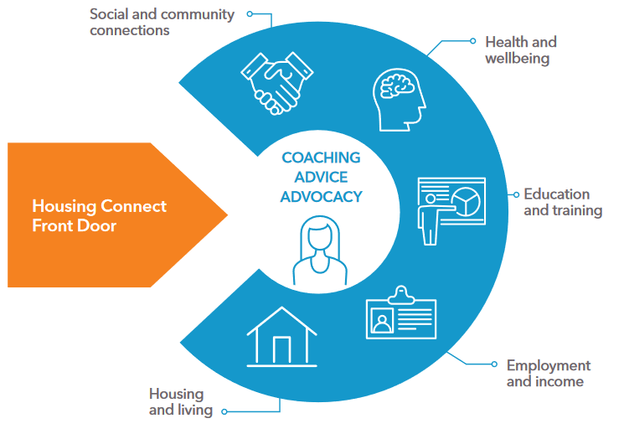**Figure 17. Supports provided to clients working with Connection Coaches**

Joy is determined to give her baby a secure home

Antoinette, a teacher at a regional college, arranged for a Connection Coach to come for an outreach appointment with Joy, who was studying for certificates in Community Services and Hospitality. Joy, who is 18 years old, recently discovered she is three months pregnant.

Joy is currently commuting over an hour to college from where she's staying with her aunt. Joy’s aunt has her own health challenges and would like Joy to move out. On top of that, sometimes when the nausea is bad Joy can't manage the long bus ride. Despite being unwell at times, Antoinette noted that she consistently reaches out via email to request assignments to complete at home.

Proactively, Joy has been managing her finances, saving enough to cover a rental bond and researching the amount needed for a future home deposit. During a meeting with the Connection Coach, the College social worker, and Antoinette, all were impressed by her dedication to her studies and her determination to provide a safe, stable home for her child.

Joy’s Connection Coach advocated on her behalf with housing providers, leading to an offer of a property through Housing Choices Tas. Joy told Antoinette that she has saved enough for the bond and has begun buying items for her new home. She has secured a second-hand fridge, a bed, and a few other essentials but still needs a washing machine.

To assist Joy, her Connection Coach successfully applied for donation funds to help purchase a washing machine, as Joy is using her saved money for the bond.

## Meeting the need for housing

Figure 18 shows the share of clients’ needs that were met either by providing support or a referral. Needs are separated into housing needs and needs other than housing.

In response to the needs identified, 90% of clients received or were referred to the support service required, except when their need was for housing or accommodation.

For people needing long-, medium- or short-term housing, 30% of these needs were met, up from 25% in the September quarter.

**Figure 18. Lack of housing remains a barrier to meeting needs of Front Door clients, October – December 2024**

The Housing Connect Front Door does not provide housing and so has limited capacity to assist clients to meet housing needs.

**Although the number of clients seeking housing fell in the December quarter, long-term housing remains the primary need of most Front Door clients and in 76% of cases this need remained unmet.**

Charts in Figures 19, 20 and 21 compare the housing circumstances of clients at presentation with their circumstances at the end of a support period. Compared to the September quarter, housing outcomes improved with a 4.9% drop in the number of people experiencing primary homelessness (sleeping rough) and a 2.9% drop in couch surfing. The number of people securing leased tenure during their support period increased by 6.8%.

Virtually all clients ended their support period with their housing tenure and type of dwelling at least ‘as good’ or ‘better than’ on presentation. Significant positive change was achieved for some clients experiencing extreme housing insecurity or primary homelessness, including people sleeping rough or couch surfing.

**Figure 19. Change in type of residence over course of support period, % change October – December 2024**

**Figure 20. Change in tenure or living arrangements over course of support period, % change October – December 2024**

**Figure 21. Type of dwelling at start and end of support** **period, % of clients by residence type October – December 2024**

## Client satisfaction

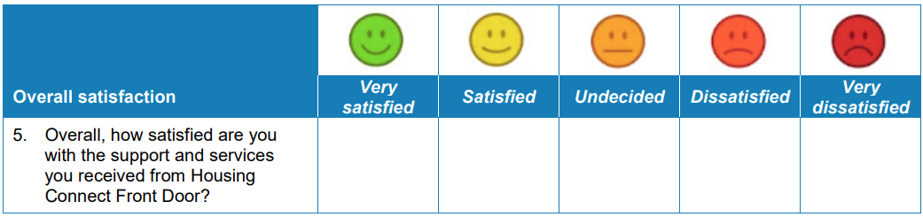Clients who receive face to face support from a Connection Coach or an Applications Management Officer are invited to complete the following client satisfaction survey:

Statewide, 431 of the 763 people surveyed completed the survey (56% response rate). Of the people who completed the survey, 97% responded that they were very satisfied (85%) or satisfied (12%) as shown in the first bar of Figure 22. 3% of respondents were undecided and 0.5% were very dissatisfied.

The highest regional response rate was 82% in the North (154 out of 188), followed by 60% in the North West (163 out of 271) and 38% in the South (114 out of 304).

The satisfaction responses for each region are also shown in Figure 22. The share of clients who responded that they were satisfied or very satisfied was 100% in the North West, 98% in the South and 94% in the North.

**Figure 22. Client satisfaction with Housing Connect Front Door support and services by region**

# Putting people at the centre

The Tasmanian Housing Strategy (the Strategy) provides a statement of the Tasmanian Government’s housing commitment:

People should be at the centre of housing policy considerations because housing is the platform for individuals, communities, and the economy to prosper

— Tasmanian Housing Strategy 2023-2043 (Tasmanian Government 2023)

Housing Connect’s Front Door service is working to put people at the centre by:

* providing and expanding outreach services to people in regional areas
* proactively reaching out to people who are known to be at greater risk of housing insecurity and homelessness, including people with mental health conditions and people exiting hospital or prison
* working to identify how we can better provide services to people who are at risk of housing insecurity and homelessness
* providing trauma-informed services
* engaging with Tasmanians seeking housing support with justice, hope, compassion and respect.

Growing in confidence

Sadie and her four children had been renting a property for the past two years under a four-year lease. The owner decided to sell the property and offered Sadie incentives, including covering moving costs and her bond for a new place, if she could vacate early. Sadie had an excellent rental history and a solid income to cover her rent so, on paper, securing a new rental should be straight forward.

However, it wasn't that easy for Sadie. She had been diagnosed with multiple mental health conditions as a result of past trauma. She could manage well enough in her daily routine, but new places, new people and new processes were terrifying for her. On her first visit to Housing Connect she was so nervous that her voice was shaky, she found it hard to make eye contact and asked for the office door to be kept slightly open.

Sadie’s Connection Coach allowed her to guide the pace of their meetings to help her feel more at ease and build rapport. After one face-to-face appointment, along with several emails and phone calls, the Connection Coach assisted her to set up her online rental applications.

Sadie found the process a bit overwhelming, and her first few applications were rejected due to missing or incorrect information. With Sadie's consent, the Connection Coach contacted the property managers to discuss her applications, allowing them to resubmit with the correct documents, which resulted in Sadie being approved to view a property.

Sadie had faced many barriers, but thanks to the Housing Connect team taking a flexible, person-centred, trauma-informed approach, she was able to achieve a good outcome.

# Recommendations

Anglicare Tasmania recommends that the Tasmanian Government:

1. **Commits to reducing the harmful impacts of waiting for social housing** by:
   1. establishing a target for reducing the social housing register in the next housing action plan in consultation with stakeholders
   2. establishing a target for reducing average waiting times for social housing applicants
   3. developing a process for providing applicants with realistic estimates of waiting times and the progress of their application.
2. **Increases investment in long-term social housing under the Tasmanian Housing Strategy** to achieve these targets and meet the housing needs of Housing Connect Front Door clients.
3. **Refines reporting and measurement** **of progress against the Tasmanian Housing Strategy** by:
   1. clearly reporting how many dwellings delivered by Homes Tasmania under the Action Plan are new dwellings (or otherwise not previously used for long term housing)
   2. clearly reporting how many dwellings delivered by Homes Tasmania under the Action Plan were affordable for people in the bottom two incomes quintiles as reported by the ABS (ABS 2022)
   3. reducing the lag in reporting the stock of social housing
   4. developing better reporting of housing outcomes for Front Door clients seeking long-term housing
   5. expanding reporting to include:
      1. the total number of dwellings relative to the population
      2. the stock of affordable rental housing relative to the population
      3. the proportion of rental households with household income in the bottom two quintiles that spend more than 30 per cent of their income on rent.

# Glossary

Community housing Housing owned or managed by non-government organisations for people on low to moderate incomes. Community housing rent is typically set below market rate. Residents in community housing are eligible for their rent to be subsidised by Commonwealth Rent Assistance.

Homelessness The Australian Bureau of Statistics defines homelessness as when a person does not have suitable accommodation alternatives. They are considered homeless if their current living arrangement:

• is in a dwelling that is inadequate

• has no tenure, or if their initial tenure is short and not extendable

• does not allow them to have control of, and access to, space for social relations (ABS 2021).

Homes Tasmania The statutory authority established in 2022 under the Homes Tasmania Act 2022 and responsible for delivering improved housing services and increasing the supply of social and affordable homes by delivering the Tasmanian Government’s 10-year housing package.

Housing affordability Housing affordability refers to the relationship between expenditure on housing (prices, mortgage payments or rents) and household incomes. The concept of housing affordability is different to the concept of ‘affordable housing’ used in the Tasmanian Housing Strategy. Households in the bottom 40 per cent of the income distribution who pay more than 30 per cent of their gross income on rent or mortgage repayments are classified as in ‘housing stress’ – see *Housing stress*.

Public housing Housing provided by the government for people on low incomes, subsidised by government funds. The tenant contribution (rent) is set at a proportion (usually 25-30 per cent) of household income. Also referred to as social housing. See also *Social housing*.

Sleeping rough State of sleeping with no shelter on the street, in a park, in the open, or in a motor vehicle.

Social housing Social housing is affordable housing provided by the government and community sectors to assist people who are unable to afford or access suitable accommodation in the private rental market. It includes public housing, state-owned and -managed Indigenous housing and community housing. Rents are set as a proportion of household income.

Tenure The legal and social arrangements that determine how individuals or households occupy and use a dwelling or piece of land. Tenure arrangements dictate the rights and responsibilities of occupants and owners and may influence the stability and security of housing. Tenure in Australia is primarily through ownership or renting, but there are many subcategories of both.

Trauma-informed An approach to care and service delivery that recognises and responds to the impact of trauma on individuals and communities.

# References

ABS (Australian Bureau of Statistics) (2021) *Estimating Homelessness: Census methodology*, accessed October 2024, <https://www.abs.gov.au/methodologies/estimating-homelessness-census-methodology/2021>.

--- (2022) *Survey of Income and Housing, User Guide, Australia*, accessed October 2024, <https://www.abs.gov.au/statistics/detailed-methodology-information/concepts-sources-methods/survey-income-and-housing-user-guide-australia/2019-20>.

--- (2024) *Wage Price Index, Australia*, accessed October 2024, <https://www.abs.gov.au/statistics/economy/price-indexes-and-inflation/wage-price-index-australia/jun-2024>.

Anglicare Tasmania (2024) *More houses needed*, Social Action and Research Centre, Anglicare Tasmania, Hobart.

Homes Tasmania (2024a) *Homes Tasmania Dashboard*, December 2024, accessed March 2025, <https://www.homestasmania.com.au/about-us/Publications/housing-dashboard>.

--- (2024b) *Housing Connect Practice Framework*, accessed October 2024, <https://www.homestasmania.com.au/__data/assets/pdf_file/0045/279999/Housing-Connect-Practice-Framework-MASTER2.PDF>.

Justice Connect (2021a) *Closing the Revolving Door Prison Project*, accessed March 2025, <https://justiceconnect.org.au/our-services/homeless-law/tenancy-legal-help-for-prisoners/>.

--- (2021b) *Closing the Revolving Door: Scoping holistic legal needs of Victorians exiting prison*, Justice Connect, Victoria.

Moore A and Ryan P (2024) *PropTrack Rental Affordability Report*, PropTrack.

Morris A, Idle J, Moore J and Robinson C (2023) *Waithood: The experiences of applying for and waiting for social housing*, Institute for Public Policy and Governance, University of Technology Sydney.

National Housing Supply and Affordability Council (2024) *State of the Housing System 2024*, Commonwealth of Australia, Canberra.

Productivity Commission (2025) *Report on Government Services 2025*, accessed 1 February 2025, <https://www.pc.gov.au/ongoing/report-on-government-services/2025/housing-and-homelessness>.

SGS Economics and Planning (2023) *Rental Affordability Index*, Canberra.

--- (2024) *Rental Affordability Index*, Canberra.

Tasmanian Government (2023) *Tasmanian Housing Strategy 2023-2043*, Hobart.

TUT (Tenants' Union of Tasmania) (2024) *Tasmanian Rents: December Quarter*, accessed February 2025, <https://tutas.org.au/publications/tasmanian-rents/>.

1. From September 2024, Homes Tasmania has published time series data for the vacancy rate in its Housing Dashboard.
2. The weighted median rent index is compiled by the Tenants' Union of Tasmania from data collected by the Rental Bond Authority.
3. People needing housing support are Housing Connect clients who had an open support period between 1 October and 31 December 2024.
4. Note that the values for the September 2024 quarter have been revised to correct some inconsistencies in data reporting that occurred during the transition to Housing Connect 2.0.