Secure foundations: how housing shapes childhood in Tasmania

Rebecca Forbes

April 2026

Acknowledgement of country
Anglicare Tasmania acknowledges and pays respect to the Tasmanian Aboriginal community as the traditional and original owners and continuing custodians of this land, lutruwita, on which this project has taken place. We acknowledge Elders past and present, and Aboriginal people who have participated in and are connected with this research.

Acknowledgements
Anglicare acknowledges the many people and organisations who contributed to this project. Thank you to the Interim Commissioner for Children and Young People, and to staff at the Centre for Excellence in Child and Family Welfare for their involvement in the project reference group.
A particular thank you to the Anglicare staff in the Burnie, Devonport, Glenorchy, Hobart, Launceston and Sorell offices who shared their insights into how children and families experience housing insecurity, and what could be done to reduce the impact.
We would also like to express our appreciation to Professor Sharon Bessell of the Children’s Policy Centre at ANU for her support and encouragement to use the More for Children Framework and project findings in this report.

About Anglicare Tasmania
Anglicare, in response to the Christian faith, strives to achieve social justice and to provide the opportunity for people in need to reach fullness of life. Our values:
- Hope – Confidently reaching for fullness of life.
- Compassion – Showing empathy and care for those in need.
- Justice – Promoting the fair distribution of resources and opportunities.
- Respect – Recognising the inherent value and dignity of every person.

Anglicare Tasmania’s Social Action and Research Centre
The Social Action and Research Centre (SARC) investigates how and why Tasmanians are affected by poverty and inequality. We use what we learn to advocate for changes that improve people’s lives.
Our qualitative research centres on the lived experience of Tasmanians. It often features the voices of people who use Anglicare services and our frontline workers.
Our quantitative research uses data to demonstrate social trends.
We brief government and stakeholders on our research and create opportunities for networking and collaboration.

Content warning
This report discusses domestic and family violence. If the content raises any issues for
you and you would like to speak to someone for support, the below services can be contacted 24/7:

1800RESPECT
phone 1800 737 732, text 0458 737 732,
online www.1800respect.org.au
Lifeline
phone 13 11 14,
online www.lifeline.org.au
13YARN
For Aboriginal and Torres Strait Islander people: phone 13 92 76

How we did this research
This report draws on a range of sources, including publicly available housing and homelessness data, established research on the impacts of poverty and housing insecurity on children, and Tasmanian Government policy statements, frameworks and other planning documents.
In addition, SARC analysed Housing Connect Front Door data for January to December 2025, and carried out group interviews with Anglicare staff working in Child, Youth and Family Services, the Housing Connect Front Door and Financial Counselling across Tasmania.
All stories used in this report have had names and details changed to protect client privacy.

Limitations of this research
This research did not engage directly with children in families experiencing housing insecurity. The quotes from children are drawn from the More for Children research project. This project worked in communities across four states between 2022 and 2024. Of the 162 children who participated, 70 were from Tasmania. As a result, the experiences of children living in Tasmania were well represented in the research (Professor Sharon Bessell, personal communication, 19 February 2026). These quotes have been reproduced with permission from the More for Children project, as they powerfully and accurately give voice to the experiences of children in Tasmania.
This research did not focus on the experiences of unaccompanied young people experiencing housing insecurity. Although children experiencing homelessness have common experiences regardless of their family situation, children experiencing homelessness away from their families (“unaccompanied children”) are a distinctive group. This project focused on the experiences of children in families, and can be considered a complement to research on unaccompanied child homelessness in Tasmania (e.g. Robinson 2020).

Definitions
Family violence, or domestic and family violence, refers to physical and non-physical violence between family members, typically where the perpetrator exercises power and control over another person. We have used the term domestic and family violence (DFV) throughout this report.
Homelessness is defined as when a person does not have a home or suitable accommodation that meets their needs. People are considered to be experiencing homelessness if their current living arrangement is in a dwelling that is inadequate; or has no tenure, or if their initial tenure is short and not extendable; or does not allow them to have control of and access to space for social relations (ABS 2012). This definition includes:
- “primary homelessness” (people without accommodation, for example sleeping rough, or in improvised dwellings)
- “secondary homelessness” (people moving between temporary accommodation, for example couch-surfing or staying in shelters)
- “tertiary homelessness” (people living long term in accommodation like boarding houses where they do not have their own bathroom, kitchen or security of tenure).
Affordability/housing stress
Housing is considered “affordable” for people on low incomes if no more than 30% of income is spent on rent (Claxton et al. 2025). When housing costs more than 30% of disposable income and that household’s income is in the bottom 40% of Australian income distribution (known as the 30:40 indicator), the household is deemed to be in “housing stress” (AHURI 2019).
Housing Connect Front Door
The Housing Connect Front Door is the entry point for people to access housing support, from emergency accommodation to a long-term home. This begins with an assessment to understand their individual circumstances and help match them with the most suitable options available.
Anglicare Tasmania is funded by the Tasmanian Government, through Homes Tasmania, to deliver the Housing Connect Front Door Service statewide. This arrangement began from 1 July 2024.
The Housing Connect Front Door does not provide housing. The Front Door service links people with supports that are suited to their life stage and individual circumstances. Although the Front Door service does not provide housing, it can assist clients to apply for social housing or to secure or maintain a private rental tenancy.

Contents
Acknowledgement of country 2
Acknowledgements 2
About Anglicare Tasmania 3
Anglicare Tasmania’s Social Action and Research Centre 3
Content warning 3
How we did this research 4
Limitations of this research 4
Definitions 4
Executive summary 9
Recommendations 10
Immediate changes 10
Longer term changes 11
Who we spoke to and what we learned 12
Introduction 13
Findings 14
Housing circumstances of Housing Connect Front Door clients 14
Children under 18 years in families receiving housing support 15
Identifying clients with dependent children 16
Main reason for seeking assistance 17
Type of residence or dwelling at presentation 18
Many “housed” families are experiencing homelessness 20
Housing circumstances of families without a permanent address 21
Housing circumstances and main reason for seeking assistance 21
Clients experiencing a housing crisis or domestic and family violence 22
Clients experiencing inadequate or inappropriate dwelling conditions 23
Clients experiencing financial difficulties or housing affordability stress 23
Family size and overcrowding 24
Common reasons families are in insecure or inappropriate housing 24
Lack of affordable housing 24
Domestic and family violence 26
Poor quality rental stock 27
What is it like for children living with their families in inadequate housing? 28
Material impacts 29
Impacts on opportunity 33
Relational impacts 36
What can be done? 39
Where could we take immediate action? 39
Prioritisation of families for access to housing 39
Continuity of support services when families move region because of housing insecurity 40
School-based supports to identify and mitigate the impacts of housing insecurity on affected children 41
Opportunities for children to have fun and make connections outside school and home 41
Transport 42
What needs to happen over the longer term? 42
Social and affordable housing 42
Access to safe housing for victim-survivors of DFV 43
Income support and cost of living 43
References 45

Table of Figures
Figure 1: Key findings 14
Figure 2: The number of children in families seeking housing support is growing, especially in the North West and the South 15
Figure 3: Children in families accessing housing support by age group 16
Figure 4: Clients with and without dependent children 17
Figure 5: Main reason for seeking assistance 18
Figure 6: Type of residence or dwelling at presentation 19
Figure 7: Housing circumstances of 307 unhoused families 20
Figure 8: Conditions of occupancy for people with dependent children residing in a house at the time they sought support through Housing Connect Front Door 21
Figure 9: Housing circumstances of clients with dependent children seeking assistance mainly due to (a) housing crisis; (b) domestic and family violence 22
Figure 10: Housing circumstances of clients with children seeking assistance mainly due to inadequate or inappropriate dwelling conditions 23
Figure 11: Housing circumstances of clients with dependent children seeking assistance mainly due to (a) financial difficulty; (b) housing affordability stress 24
Figure 12: The More for Children Framework of multidimensional poverty (Bessell et al. 2021) 28
Figure 13: What happens if we can prevent or address the material impacts of housing insecurity on children? 32
Figure 14: What happens if we can prevent or address the impacts of housing insecurity on children’s opportunities? 36
Figure 15: What happens if we can prevent or address the relational effects of housing insecurity on children? 38

Executive summary
‘Children have the right to food, clothing and a safe place to live so they can develop in the best possible way. The government should help families and children who cannot afford this’ (UNICEF 2019).
The Tasmanian Government recognises that housing is a fundamental human right (2022), and has committed to ‘ensuring all Tasmanians can find a place to call home’ (Tasmanian Government 2023a). This includes ensuring that Tasmanian children ‘have access to suitable, secure stable housing’ (Tasmanian Government 2021).
However, the housing crisis in Tasmania has led to an increase in the number of families living in insecure, unsafe or unaffordable housing. In some cases, families have nowhere to live at all. These circumstances impact every part of life, and have ongoing effects on the children involved, even once their housing situation is resolved.
In 2025, more than 3 in 10 people who presented to the statewide Housing Connect Front Door service were part of a family with dependent children. These families included 4,237 children.
Families most often required help with housing because of
- a housing crisis, e.g. eviction (27%)
- domestic and family violence (19% ‒ more than three times more likely than clients without dependent children)
- inappropriate dwelling conditions (13%)
- housing affordability stress (12%)
- financial difficulties (11% ‒ nearly twice as likely as clients without dependent children).
Many of these families are not living in shelters or other crisis accommodation, making them less visible than other groups. Instead, they are staying with family or friends (often in overcrowded conditions), paying for rental accommodation they cannot afford, or, in some cases, living in cars, cabins and tents.
The impact of housing insecurity on children is profound. It affects their health, development, opportunities and relationships. This report summarises how so many Tasmanian families have come to be in insecure housing. It then draws on existing evidence and the experiences of Anglicare staff to describe how children are being affected by their housing situations. In particular, it breaks down the impacts on children in three categories:
- material impacts
- impacts on opportunity
- relational impacts.
In response to these findings, this report identifies a number of areas where changes could be made. In some cases, these are changes to existing policy. In others, they require Governments to deliver on commitments already made.

Recommendations

Immediate changes

Prioritisation of families for access to housing
Recommendation One: In line with the commitments made in the Tasmanian Housing Strategy 2023-43 and Tasmania’s Third Family and Sexual Violence Action Plan 2022-2027, the Tasmanian Government ensure that families escaping domestic and family violence are appropriately prioritised for rapid access to housing, even if they are not living in a shelter.

Continuity of support services when families move region because of housing insecurity
Recommendation Two: The Tasmanian Government (through Strong Families Safe Kids) create a process for warm handover of at risk families who move regions due to housing insecurity.

School-based supports to identify and mitigate the impacts of housing insecurity on affected children
Recommendation Three: The Tasmanian Government identify and expand opportunities for extending school-based support for children affected by housing insecurity.

Opportunities for children to have fun and make connections outside school and home
Recommendation Four: The Tasmanian Government extend the “Ticket to play” initiative to include creative activities for eligible children.

Transport
Recommendation Five: The Tasmanian Government continue to make public transport free for Tasmanian children beyond 30 June 2026.

Longer term changes

Social and affordable housing
Recommendation Six: The Tasmanian Government increase the state’s stock of social housing by building new homes that will provide appropriate shelter for low income Tasmanians, including families.

Access to safe housing for victim-survivors of DFV
Recommendation Seven: In line with the commitments made in the Tasmanian Housing Strategy 2023-43 and Tasmania’s Third Family and Sexual Violence Action Plan 2022-2027, the Tasmanian Government increase the supply of crisis, transitional and long-term housing for victim-survivors of DFV, including accommodation designed for families.

Income support and cost of living
Recommendation Eight: The Australian Government increase income support payments above the poverty line.

Who we spoke to and what we learned
The Social Action and Research Centre (SARC) spoke with frontline staff from Anglicare services that support children and families experiencing homelessness or housing insecurity. SARC also conducted an analysis of de-identified data from the Housing Connect Front Door from 1 January to 31 December 2025. We analysed how many of the people contacting the Housing Connect Front Door were part of families with dependent children, the main reasons they required support, and where they were living at the time they presented to the service.
Both the data and our conversations with Anglicare staff painted a picture of families facing impossible choices. We heard about the decisions parents make daily, trying to keep their families together, safe and well.
Frontline staff also talked about what that is like for children – how hard it is to concentrate at school or get your homework done if you’re couch-surfing and don’t know where you will be sleeping tomorrow. About children sleeping in cars or remaining in dangerous situations because of a lack of other options, and the difference it makes when a child and their family find stable accommodation and can begin to rebuild.

Introduction
What does it feel like if you are a Tasmanian child whose family is struggling with housing? What are your days and nights like? What are you seeing at home, and what are you thinking about when you are at school?
In Tasmania, the number of children in families experiencing housing insecurity is growing year on year. Anglicare’s Housing Connect Front Door Service Snapshot series chronicles ongoing housing shortages and a rising number of Tasmanians living in circumstances ‘more commonly seen in developing countries’ (SARC 2025).
These statistics include a growing number of children whose families are unable to access or remain in safe, secure, appropriate housing. From 1 October to 31 December 2025, Anglicare’s Housing Connect Front Door services provided housing support to 423 lone parents with children and 108 couples with children. The number of families with children accessing housing support increased by 42% compared to the same period the year before (SARC 2026).
Tasmanians are well aware of the pressures created by the rising cost of living. For children in families already experiencing disadvantage, the impact is compounded by housing stress, and can compromise their education, wellbeing and development (O'Connell et al. 2025, AIHW 2025).
Anglicare staff are seeing the growing effects of inadequate housing on children and their families across the state. They are supporting families sleeping in cars, couch-surfing for months at a time, living in tents or making the difficult decision to remain with perpetrators of domestic and family violence (DFV) in order to keep a roof over their heads.
When children do not have a safe, stable home, the impact is felt across every aspect of their life. They experience material deprivation, relational effects and shrinking opportunities. As a result, their social, emotional and physical development (including neurological development) is adversely affected.
When families move frequently to access housing, children are dislocated from school, friends, communities and other key support networks (Murran and Brady 2023). Parents who are struggling to find and maintain housing may decide that their only option is to accept living conditions that many Tasmanians would consider unacceptable.
For as long as housing in Tasmania remains unaffordable for a wide range of Tasmanians, families will remain in this position. The research shows that early intervention can prevent homelessness and its impacts on children (Teager et al. 2019). However, when it is not prevented, children are at greater risk of experiencing homelessness again, particularly in adulthood (Flatau et al. 2013). This is a cycle that needs to be prevented, or broken, before it continues.

Findings

Housing circumstances of Housing Connect Front Door clients
Quantitative analysis of children in families experiencing housing insecurity was undertaken using de-identified data from the Housing Connect Front Door service from 1 January to 31 December 2025.
The Housing Connect Front Door is the entry point for people to access housing support in Tasmania, from emergency accommodation to a long-term home. Anglicare Tasmania is funded by government to deliver the Housing Connect Front Door Service statewide.
Clients eligible for housing support through the Front Door service are generally experiencing some degree of housing insecurity. This data therefore provides valuable insights to the experiences of a large sample of Tasmanian families experiencing housing insecurity.
In 2025, the Housing Connect Front Door handled 51,383 enquiries statewide and provided support to 4,584 unique clients. The service provided 5,574 periods of support, with some clients receiving more than one period of support.
Figure 1: Key findings
About families with dependent children who accessed housing support in 2025:
- 1,431 clients caring for 4,237 dependent children
- 1,724 support periods
- Families experiencing homelessness were more than 3 times more likely to be couch-surfing than in emergency accommodation
Compared to clients without dependent children:
- 3.4 times more likely to be escaping DFV
- 1.7 times more likely to seek assistance due to financial difficulty
- The experience of homelessness looks different
3 key groups identified:
- Families housed for now but in financial stress
- Families experiencing homelessness who are staying at someone else’s place
- Families who were not housed

Children under 18 years in families receiving housing support
Data from 1 January to 31 December 2025 (12 months to December 2025) was compared with the data from 1 July 2024 to 30 June 2025 (12 months to June 2025).
In the 12 months to December 2025, there were 4,237 children under the age of 18 identified in the families that received housing support, with 1,107 (26%) in the North, 1,920 (45%) in the South and 1,210 (29%) in the North West (see Figure 2). Statewide, this was an increase of 19% from 3,567 in the 12 months to June 2025. Almost all of this increase occurred in the North West and the South.
When regional population is taken into account, the North West has the greatest number of people with dependent children accessing housing support ‒ 31 per 10,000 people, followed by the North with 28 per 10,000 and the South with 21 per 10,000.
Figure 2: The number of children in families seeking housing support is growing, especially in the North West and the South
Number of children in families accessing housing support through the Housing Connect Front Door Service in Tasmania (and by region) in the 12 months to 30 June 2025 and the 12 months to 31 December 2025.
12 months to 30 Jun 25

12 months to 31 Dec 25
3,567 total
4,237 total
Figure 3 shows that by age, 118 (3%) of the 4,237 children were babies under 1 year of age, 894 (21%) were aged 1 to 4 years (pre-school), 947 (22%) were aged 5 to 8 years (lower primary), 1005 (24%) were aged 9 to 12 years (upper primary) and 1,273 (30%) were aged 13 to 17 years (high school). The two age brackets that recorded the greatest percentage increase from 2024-25 to 2025 were preschoolers aged 1 to 4 years (up 23%) and high school children aged 13-17 years (up 24%).
Figure 3: Children in families accessing housing support by age group
Children in families accessing housing support through the Housing Connect Front Door service in Tasmania between 1 January and 31 December 2025.
22% of children were identified as Aboriginal and/or Torres Strait Islander. The indigenous status of a further 9% was not stated. The prevalence of children identified as indigenous in Housing Connect Front Door data is more than twice the 10.2% prevalence of indigenous people among the general Tasmanian population under 18 years of age (ABS 2022).

Identifying clients with dependent children
The experiences and circumstances of the households in which these children live was further explored by identifying the Housing Connect Front Door clients who received housing support and who were parents or guardians of children under 18 years. This group will be referred to as having ‘dependent children’ and clients not in this group (all other clients) will be referred to as having ‘no dependent children’.
Housing support clients were identified as having dependent children if they met one or more of the following criteria:
- Their living arrangement was recorded as ‘couple with child(ren)’.
- Their living arrangement was recorded as ‘lone parent with child(ren)’.
- Their main source of income was recorded as ‘Parenting Payment’.
1,431 (31%) out of 4,584 clients were identified as having dependent children, accounting for more than three in ten clients accessing housing support.
Figure 4: Clients with and without dependent children
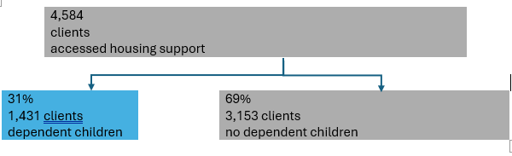
Of the clients identified as having dependent children, 75% were single parents with children, 17% were living as a couple with children, and 8% had some other living arrangement (for example, grandparents or other family caring for children).
86% of lone parents with child(ren) were female and 14% were male.
Clients with dependent children were less likely to be born overseas than the broader Tasmanian community, but they had similar levels of English proficiency. However, members of culturally and linguistically diverse communities were more likely to have accessed housing support if they had dependent children than if they did not.

Main reason for seeking assistance
When we looked at the main reasons for seeking assistance, clients with dependent children presented a different picture to clients without dependent children.
Firstly, they had a more limited range of main reasons for seeking assistance, with 90% of clients citing one of 7 reasons (see Figure 5). A housing crisis (27%) and domestic and family violence (19%) were the top two reasons that clients with dependent children sought assistance, followed by inadequate or inappropriate dwelling conditions (13%), housing affordability stress (12%), financial difficulties (11%), previous accommodation ended (4%) and relationship/family breakdown (4%).
Only 10% of clients with dependent children cited something else as their main reason for seeking assistance, compared to 20% of clients without dependent children. For example, they were far less likely to seek housing support due to mental health conditions, substance use disorders or because they were exiting hospital, rehabilitation or a correctional facility.
Compared to people without dependent children, they were 3 times more likely to cite domestic and family violence as their main reason for seeking housing support.
They were 1.7 times more likely to seek help mainly due to financial difficulties. This may be related to parents prioritising keeping their family housed, even when the accommodation is not affordable. In contrast, clients without dependent children were more likely to seek assistance due to inadequate or inappropriate dwelling conditions.
Figure 5: Main reason for seeking assistance
Percentage of clients receiving housing support through the Housing Connect Front Door, 1 January to 31 December 2025.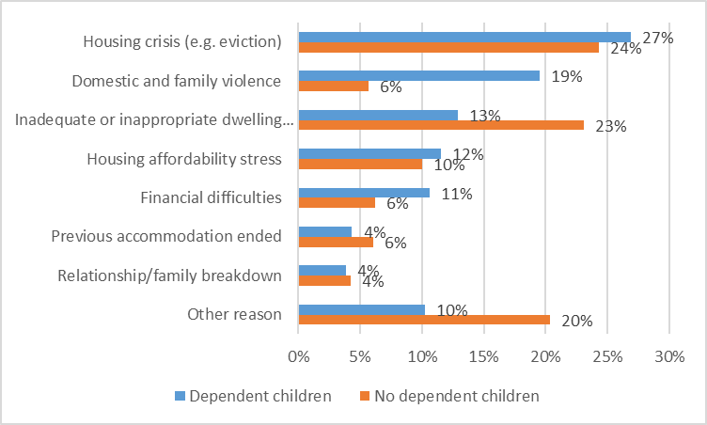

Type of residence or dwelling at presentation
At the time they sought assistance (at presentation), people with dependent children were more likely to be residing in a house, townhouse or flat compared to people without dependent children.
Figure 6 shows that 82% of clients with children were housed and 18% were living in some other type of residence or dwelling. In comparison, only 61% of people with no dependent children were housed at presentation and 39% were in some other type of residence or dwelling.
Clients without dependent children resided in a greater range of accommodation, including aged care facilities, youth residential institutions, correctional facilities, hospital, psychiatric units and rehabilitation services.
Figure 6: Type of residence or dwelling at presentation
Percentage of clients with and without dependent children who received housing support through Housing Connect Front Door, 1 January to 31 December 2025.
Housing circumstances of unhoused families
At the time they sought assistance from Housing Connect Front Door, 307 families with children were not living in a house, townhouse or flat.
Alarmingly, a total of 87 unhoused families with dependent children (28%) were experiencing primary homelessness (sleeping rough, in an improvised dwelling, car or tent) when they sought assistance.
77 (25%) were living in emergency accommodation, 69 (22%) were in a hotel/motel/bed and breakfast, 40 (13%) were in a caravan, 11 (4%) in a cabin and 7 (2%) were in a boarding or rooming house.
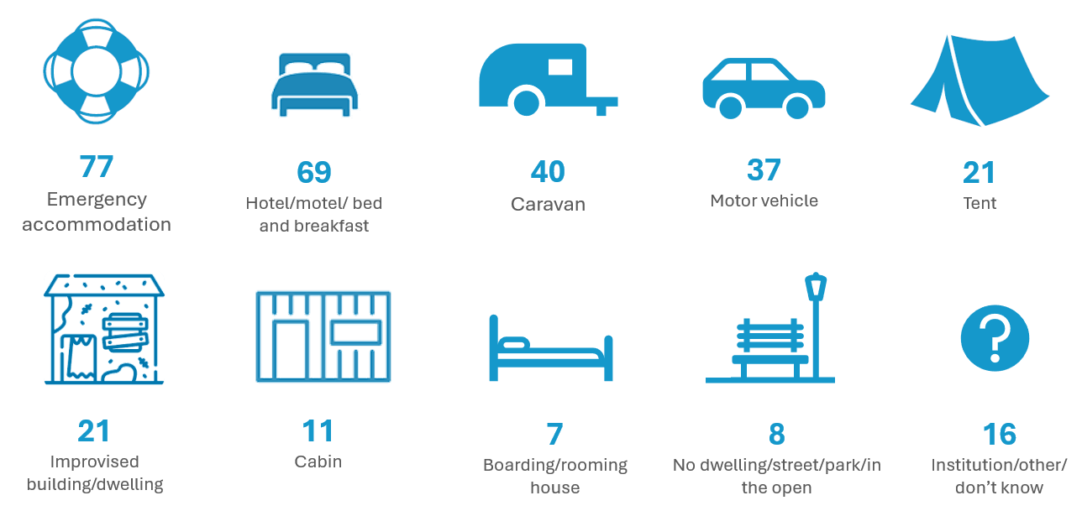
Figure 7: Housing circumstances of 307 unhoused families

Many “housed” families are experiencing homelessness
Although 82% (1417) of clients with dependent children were housed when they sought housing support, their housing was not necessarily secure. Figure 8 shows the conditions of occupancy for families with dependent children living in a house, townhouse or flat.
Fewer than two thirds of families (59% or 834) who were housed at presentation had leased tenure and were nominated on the lease. Most of the remaining 41% had minimal housing security or were experiencing homelessness, including:
- 260 who were couch surfing
- 72 who were boarding, including those living with relatives and paying board
- 78 living with relatives fee free.

Figure 8: Conditions of occupancy for people with dependent children residing in a house at the time they sought support through Housing Connect Front Door
1 January to 31 December 2025
Conditions of occupancy at presentation | Number of clients
Leased tenure – nominated on lease | 834
Couch surfing | 260
Lease in place – not nominated on lease | 83
Boarding | 72
Living with relative fee free | 78
Other/don’t know/not applicable | 90

Housing circumstances of families without a permanent address
The housing circumstances of families experiencing homelessness varied depending on how long they had been without a permanent address.
However, by far the most common housing circumstance of families who were without a permanent address at presentation is that they were couch surfing. Fewer than 1 in 6 families without a permanent address were in emergency accommodation when they presented to Housing Connect Front Door.

Housing circumstances and main reason for seeking assistance
For the top 5 main reasons for seeking housing support, Figures 9 to 11 (see below) show the share of clients with families in each of 7 broad housing circumstances:
- housed and either had leased tenure and were nominated on the lease or who own or were purchasing the house they were living in (dark blue)
- housed and either couch surfing or living fee free with a relative (orange)
- housed under some other arrangement such as boarding or renting without being nominated on a lease (yellow)
- in emergency accommodation (light blue)
- in a hotel, motel or bed and breakfast (light grey)
- experiencing primary homelessness and were staying in a tent, an improvised dwelling, a motor vehicle or in the open (green)
- in a housing circumstance other than those listed above (charcoal).
Clients with dependent children fall into three broad categories of housing circumstances depending on their main reason for seeking housing assistance:

Clients experiencing a housing crisis or domestic and family violence
Eight in ten people seeking assistance mainly due to a housing crisis or domestic and family violence were housed but not necessarily securely.
Figure 9: Housing circumstances of clients with dependent children seeking assistance mainly due to (a) housing crisis; (b) domestic and family violence
Clients accessing housing support through Housing Connect Front Door, 1 January to 31 December 2025.

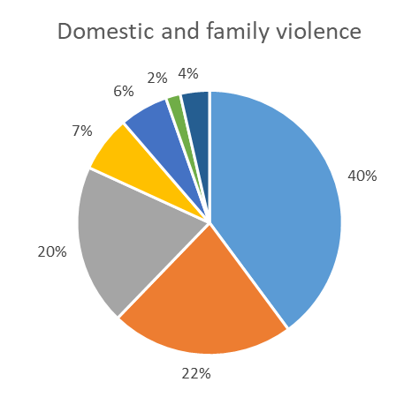
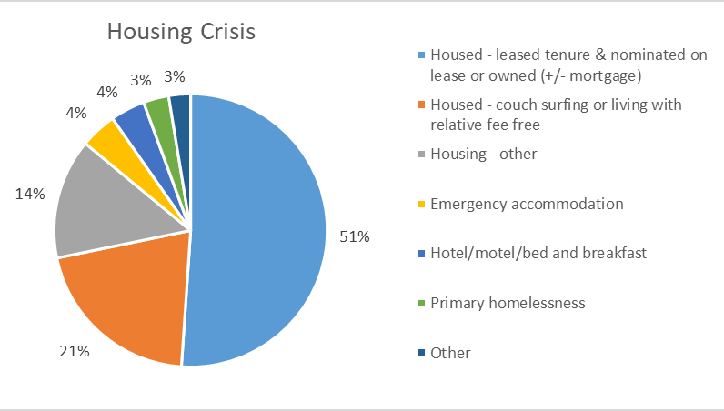
Less than half were housed with secure tenure. Many were couch-surfing or living with relatives fee free, including 21% of those experiencing a housing crisis and 22% of those escaping domestic and family violence.
7% of those escaping DFV and 4% of those experiencing a housing crisis were in emergency accommodation, with similar proportions staying in a hotel, motel or bed and breakfast.
This data suggests that when people with dependent children experience a crisis, they seek shelter with friends or family who are willing to accommodate them. This is more frequently the case for people escaping domestic and family violence, who may seek shelter with another household because it feels safer and/or provides other supports.

Clients experiencing inadequate or inappropriate dwelling conditions
The greatest share of people in this category were couch-surfing or living with relatives fee free (28%) and fewer than 1 in 4 were in housing with security of tenure (22%). One in five families in this group were experiencing primary homelessness (20%). Alarmingly, only 5% were in emergency accommodation and 10% were in a housing circumstance other than being housed, in emergency accommodation, in a hotel/motel or primary homelessness.
Figure 10: Housing circumstances of clients with children seeking assistance mainly due to inadequate or inappropriate dwelling conditions
Clients accessing housing support through Housing Connect Front Door, 1 January to 31 December 2025.

Clients experiencing financial difficulties or housing affordability stress
Clients seeking assistance due to financial difficulties or housing affordability stress were most likely to be housed (96% and 88% respectively). They were also most likely to have secure tenure in that they were nominated on the lease, owned or were buying their residence (88% and 65% respectively).

Figure 11: Housing circumstances of clients with dependent children seeking assistance mainly due to (a) financial difficulty; (b) housing affordability stress
Clients accessing housing support through Housing Connect Front Door, 1 January to 31 December 2025.
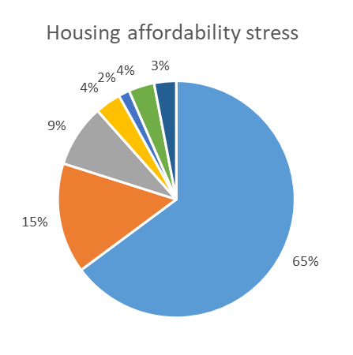
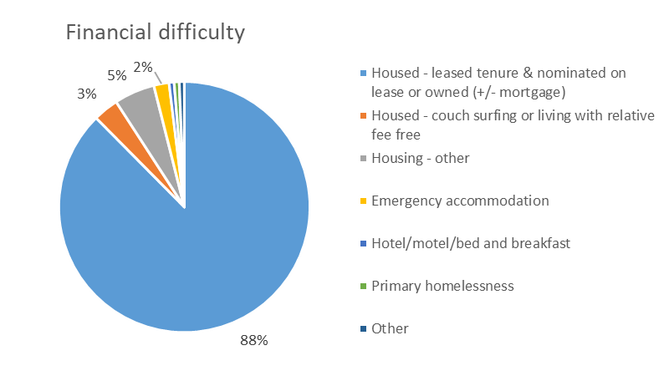
This suggests families often had secure tenure, but it was at a cost beyond their means, and they were experiencing ongoing financial and/or housing affordability stress.

Family size and overcrowding
Many children in these families seeking housing support were recorded as living in large family groups. Housing Connect Front Door data shows that over 1,300 children live in families with more than 6 members and over 600 were in family groups of 10 or more.
This data does not necessarily capture all families who were couch-surfing or living with relatives fee free, only those families who contacted Housing Connect Front Door for support. The number of children living in overcrowded circumstances is likely to be much larger.

Common reasons families are in insecure or inappropriate housing

Lack of affordable housing
“I had a client recently that's in a 2 bedroom and there's seven of them… They're just waiting. They're in a private rental, it's the best that they could get. It's not really affordable, but it's a roof over their head and they're waiting on the housing list. But that's just the only option that they had. You take what you can get really.”
‒ Financial counsellor

Housing in Tasmania is becoming less affordable for more people. The 2025 Rental Affordability Snapshot (Claxton et al. 2025) found that there were almost no affordable and appropriate properties for Tasmanian families receiving Single Parenting Payment or Jobseeker as their main source of income. Only 7% of rentals were affordable for a single parent earning the minimum wage, or for couples where one partner was earning the minimum wage and the other received Parenting Payment.
As described in the previous section, 12% of the families who contacted the Housing Connect Front Door in 2025 gave “housing affordability stress” as the main reason for seeking assistance, while another 11% gave “financial difficulties.”
When affordable housing is not available, many parents cut back on other necessities (Leishman et al. 2025) or go into debt in order to keep a roof over their family’s heads.
“Well, most of the rentals on the North West are over $400 [a week], so you know, that doesn't leave much out of Parenting Payment at the end of the fortnight.”
‒ Housing Connect Front Door staff member.
“They can't afford it. It's too expensive. That's probably the main thing. They’re falling behind in everything else just to maintain their rental.” Financial Counsellor
Client story – Dan
“…housing insecurity is really filtering right up to people who earn reasonable money as well. It's really affecting them too.”
‒ Families, Children and Young People practitioner
When Dan's mum died, he and his sister went to live with a family friend, Jonno.
Jonno has two other kids Dan's age, and they all lived together with Jonno's mum, who everyone just called Nan. Six months after Dan's mum died, Nan died too. Now Jonno can't afford to rent the house, and money is really tight, even for things like petrol to get them all to school.
Dan can tell that Jonno is stressed about it and would like to get a part time job to help with rent, but he doesn't have his license yet and they live out of town. They are all missing Nan, and Dan and his sister really miss their mum. They want to stay with Jonno, even though the house is crowded and they live a long way from anything, but if he can't find a place big enough, they don't know if they will be allowed to.

Domestic and family violence
“You have told us that housing is one of the major barriers for women and children escaping family violence. I am committed to ensuring that Tasmanians in crisis are able to access safe and affordable housing.”
‒ Hon Guy Barnett MP, Minister for State Development, Construction and Housing in Survivors at the Centre: Tasmania’s Third Family and Sexual Violence Action Plan 2022-2027 (Tasmanian Government 2022).
Domestic and family violence (DFV) is the main reason for women and children in Australia to leave their homes (AIHW 2024).
Families accessing support from the Housing Connect Front Door are 3.4 times more likely to name “domestic and family violence” as their main reason for seeking assistance, compared to people without dependent children.
This aligns with other statistics about DFV in Tasmania. For example, in 2023, Impact Economics and Policy estimated approximately 604 women a year in Tasmania experience homelessness after leaving a violent partner, and of these, around half return to that partner as they have ‘nowhere else to go and no financial support’ (Impact Economics and Policy 2023).
“And I'm just saying, like, the bulk of my clients are displaced because of family violence.”
‒ Families, Children and Young People practitioner
When families leave a dangerous situation, they often find themselves in accommodation that makes it hard for children to begin recovering from what has happened.
“…the housing situation makes it, or can make it worse. You stay because you've got nowhere else to go. It's super common.”
‒ Families, Children and Young People practitioner

Client story – Evie and Mason
When their mum needed to leave their dad because of safety concerns, Evie (9) and Mason (7) went to stay with their aunt. They missed their mum badly, and were confused and upset by what had happened. Mum didn’t have anywhere to live and was sleeping in their car, and they knew she didn’t want them doing that too. They knew Mum was working hard to find them somewhere to all live together, but it felt like forever until they found a place.
Client story ‒ Jess
Evie and Mason’s mum, Jess, came to the Housing Connect Front Door experiencing significant safety concerns and homelessness following family violence. Because Jess was sleeping in her car, she had had to ask her sister to take her two primary-aged children to live with her indefinitely. This was distressing to Jess, as well as disruptive to the family as a whole.
Jess worked with a Connections Coach who advocated to the Family Violence Rapid Rehousing program for Jess, Ella and Mason to be allocated a home where they could be together and safe. It took nine weeks, but finally, they moved into their new home. Jess’s Connections Coach says that being reunited has restored the family’s stability, strengthened Jess’s sense of security, and enabled her to continue rebuilding her life with her children by her side.

Poor quality rental stock
When families do have housing, it can be too small, in poor condition, or expensive to heat and cool. Because securing a rental property is so difficult, many parents choose to remain in housing that many Tasmanians would consider substandard, rather than risk leaving and not finding something else, or offending the landlord by requesting changes.
“Everything needs repairing. Nothing happens. You know, it costs so much to heat it because the property is in this state. But they're too scared to take those concerns because they're worried they'll get kicked out.”
‒ Financial counsellor

“And they often take these properties for fear of losing their children if they don't have a roof over their head. That's always in the back of their mind.”
‒ Families, Children and Young People practitioner

What is it like for children living with their families in inadequate housing?
Children living with their families in precarious housing situations are impacted in a range of ways. It is helpful to think of housing insecurity as being not just a question of physical or “material” impact, but as something that also affects children’s opportunities and relationships (Bessell et al. 2021).

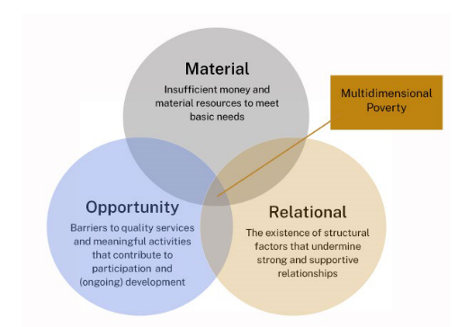
Figure 12: The More for Children Framework of multidimensional poverty (Bessell et al. 2021)
The More for Children project interviewed Australian children (including children in Tasmania) about their experiences of housing and home, and quotes from these interviews are included in this report alongside quotes from Anglicare Tasmania staff.

Material impacts
‘Tasmania is a place where everyone has a safe, warm home, one that protects health and gives stability to build a great life. No one is harmed or held back by housing, because secure, healthy homes are the foundation for all of us.’ The Health Revolution: 20-Year Preventive Health Strategy exposure draft (Tasmanian Centre for Mental Health Service Innovation and Tasmanian Government Department of Health 2025).
“Yeah, I always think of like Maslow's hierarchy of needs.
“Housing is the bottom foundation of that hierarchy. Nothing else works if the housing is ‒ and safety and security – if that is not achieved, you can't help the parent develop their parenting capacity.
“You can't build in routines and structure and boundaries and things for the kids. You can't get them to education sufficiently and you can't work properly, so you can't earn enough, like it affects every single thing.
“Then, of course, Mum and Dad are beside themselves because of the stress, and they don't parent well, there's the warmth and the love is gone too, because they're stressed.”
‒Families, Children & Young People Practitioner

Overcrowding
Anglicare staff across the state described children living in overcrowded conditions. Families might only be able to afford a small property, it might be all that is available in the area, or they may be staying with friends or family whose home was already at full capacity.
For children, this may mean sharing a bedroom with several other children of different ages, who may not be from their own family, or sleeping in a living area. People living in severe overcrowding fall within the definition of homelessness ‘because they do not have control of, or access to space for social relations’ (ABS 2012)
For children, this can mean constant pressure to “behave” so that the family can stay, and not having access to toys, clothes and other belongings because these have been left behind, put into storage, or need to be packed and unpacked each day.
“[My brother] sleeps on the couch, and I sleep on the ground on a mattress. She [younger sister] sleeps next to me.”
‒ Suii, 12 years (Bessell et al. 2024)

Physical health
Client story – Erin, Ethan and Madison
Erin and her two teenagers, Ethan and Madison, have been living in their car for several months, after their lease was not extended. They are on the waiting list for all the shelters in their area and Erin has applied for dozens of other rental properties.
While they wait, normal life is not possible. There is nowhere to cook and nowhere to wash. Ethan and Madison have to go to school in the same clothes day after day and other kids at school have noticed. Not surprisingly, their mental and physical health is suffering. Madison feels embarrassed and it’s getting harder to go to school at all.
Before this happened, the family had no history of homelessness.
“And yeah, I do see a lot of families like in, you know, units with two bedrooms, but they've got four kids and it's not so bad when they're little. But as they get older, you know, it poses more problems.”
‒ Families, Children and Young People Practitioner
Living in unstable housing is well-known to have negative impacts for children’s health and development. For example, children under 5 who have lived in temporary accommodation are more likely to have lower IQ, reduced muscle and body mass and weakened immune systems compared to other children (Rosenthal et al. 2021).
Children who live in poor quality housing (for example where there is persistent overcrowding, mould, damp or extreme temperatures) are at greater risk of chronic disease throughout their lives (Duncan and Twomey 2025).
When families are struggling, there is less money for good quality food (even when the family has a kitchen to prepare it in) and children are more likely to miss routine health checkups (Bell et al. 2025). Children living in tents, cars or cabins may not be able to wash regularly, brush their teeth or change into clean clothes, which affects their physical and mental health. Lack of routine (due to frequent moves, uncertainty and being in “crisis mode”) can also interrupt or delay childhood developments like toilet training. These children are less likely to have a regular GP who can assist with preventative health or specialist referrals, and so they are more likely to be treated in Emergency departments (Bell et al. 2025).
I've got one family in a cabin. There's no proper cooking facilities, so you can imagine what they eat all the time in this tiny little one bedroom cabin… And that can be going on for years…
‒ Families, Children and Young People practitioner

The costs of housing insecurity
Homelessness is expensive (valentine et al. 2020). Families in insecure housing incur costs related to moving house, needing to store possessions, changing schools and living in poor quality accommodation.
“[In emergency housing] we only had a stove that didn’t work so we couldn’t really cook anything. We only had a microwave, so I would just usually just have a cup of noodles. We were there for 4 months. Our beds were like really uncomfortable, so it was hard to sleep. I didn’t really sleep much, and I was too tired to even go to school and catch the bus.”
‒ Warren, 11 years (Bessell et al. 2024)
As in Ella’s story (below), parents may have to use expensive workarounds like staying in motels or hiring taxis to get children to school. Families couch-surfing or staying with families and friends may try to compensate for their stay by paying bills or buying additional groceries (sometimes in addition to contributing to rent).
Families living in crowded accommodation, or in cabins, tents and cars with nowhere to store food or cook, rely on expensive pre-prepared food. All of these issues are examples of “the poverty premium” (McKail 2023) paid by people who are already under financial stress, because cost-saving options (e.g. buying in bulk, shopping around, investing in high quality goods with lower running costs) are not available to them. This exacerbates the financial stress of parents and reduces the options available to them to meet their children’s needs.
Transport difficulties are a good example. Many families try to maintain normality for their kids when they move house, keeping children at the same school even when this means more travel. This may mean spending more money on petrol or, when families don’t have a car, using taxis or borrowing friends’ cars. Changing address or changing schools changes the bus routes children use (where there are school buses). Areas that are more affordable to rent are often less serviced by public transport, ‘resulting in increased travel times and a greater reliance on cars’ and increasing costs (Liu et al. 2023).
When public transport is limited, or families don’t have a car, or can’t afford petrol, it’s more difficult for children to attend school regularly, be part of other activities, or, in the case of older children (see Dan’s story) to get a part time job.

A lack of affordable housing can mean that families have to choose between homelessness and remaining in situations where there is physical violence, criminal activity or people using alcohol and other drugs.
“Pretty much, I would say three out of four clients that you meet with when you're doing a budget and you, you know, talk about all the bills and everything like that, when you ask about groceries, so this could be, you know, families with children, they will always just say whatever's left over.”
‒ Financial counsellor
“So we’re actually at the point now where you accept that sleeping in a car is the outcome that’s achievable for the now... we’ve even been paying people’s registration to ensure that they’re not getting any additional penalties while they’re sleeping in the vehicle and that's their everything... the strain on every option that we have or the ineligibility for every option that is usually in front of us has pushed us to accept something that is unacceptable.”
‒ Housing Connect Front Door staff member
Figure 13: What happens if we can prevent or address the material impacts of housing insecurity on children?
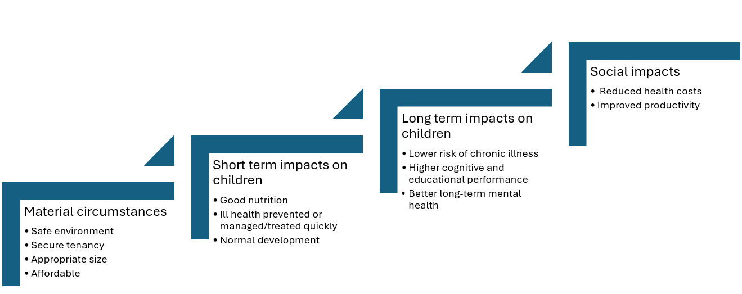
Drawing on concepts from Rosenthal et al. (2021), Bell et al. (2025), Hock et al. (2024) and Monks et al. (2022).

“Having material basics means that children and young people:
- have access to suitable, secure stable housing with adequate heating and cooling
- have access to appropriate clothing and footwear
- have access to nutritious food and clean water
- have access to transport, required local services and materials to support participation in activities
- have access to education and training materials
- have access to the outdoors and green space”. 'It Takes a Tasmanian Village' - Tasmania's first Child and Youth Wellbeing Strategy (Tasmanian Government 2021).

Impacts on opportunity
Living in inadequate housing, moving frequently, or not knowing where you will be living from day to day affects how children engage with the world, and their opportunities to grow and flourish. Children are adaptable, but adapting to living in substandard conditions or constant moves can lead to resignation, desperation and a narrowing of expectations and hopes (Bessell et al. 2024).

Education
One of the biggest impacts is on education. Moving between schools, not being able to attend regularly (for example, because of transport issues), being exhausted, hungry or stressed and not having the necessary clothes or equipment all reduce a child’s ability to engage at school, which leads to poorer educational outcomes (Bell et al. 2025).
Client story – Ella (Part 1)
“And the young people don't wanna go back to school because they've missed so much. They feel so behind. They feel socially isolated.”
‒ Families, Children and Young People practitioner
Ella (8) and her mum have been living with her mum’s friend Nat and her three kids for six months now. They needed to leave home when things got very bad with Ella’s dad. Ella’s big sister is living with her grandmother until Mum can get her own place.
It is not easy living at Nat’s. The other kids are noisy, especially at night. There’s nowhere to do her homework or just chill out. Ella knows that she needs to behave so that Nat will be happy to keep having them. But she and her mum sleep in the loungeroom and have to pack away their stuff every morning. Recently Nat’s toddler tore up a photo that is precious to Ella and it was hard not to get angry. Sometimes Mum takes Ella and her big sister to a motel for a few days, to give everyone a break from each other, but that’s really expensive.
Ella hasn’t been getting to school all the time because Nat’s place isn’t on the bus route and her mum doesn’t like borrowing Nat’s car too often. That’s okay – Ella would rather be with Mum than at school. She feels safe with Mum and she also likes knowing that Mum is safe. Also, she feels like she’s always in trouble at school ‒ for not paying attention in class or dozing off, and also for getting angry with other kids when they touch her stuff or make stupid jokes. School just seems too hard, and she doesn’t feel like she has any friends anymore. Even if she did, she couldn’t invite them over.
Note: This story is a composite of two very similar stories from two different regions of Tasmania. Details have been changed to protect the identities of the families involved.

“Just being a kid”
Kids in these situations also have fewer opportunities to take part in activities outside of school, and to behave in ways that are part of an ordinary childhood. Their housing situation may mean that they lose a beloved pet, or that they aren’t able to relax and be silly, noisy, active or creative. The uncertainty and instability that comes with insecure housing can lead to anxiety, poor sleep and ‘being chronically unsettled’ (Morris et al. 2023).
“We've had young people that have gone to the school office and been like, I need to call, every break. Yeah, they'll be like, I need to call mum to, make sure my mum's safe.”
‒ Families, Children and Young People practitioner
Play is vital for children’s development (Dall'Omo et al. 2023). However, when their living situation is precarious, finances are tight and the adults around them are stressed, children are not free to “just be kids”.
Tasmanian young people themselves have identified the importance of ‘more things to do and places to do them (CCYPT 2021). Activities outside of school are important opportunities for kids to have a routine, make friends and do something they are good at, or enjoy.
“[It was] kinda sad ‘cause we had to send our cats to the RSPCA ‘cause they wouldn’t allow them, in the emergency unit. We gave them to our auntie and she wasn’t taking good care of them and then we took them back. But we hid them when we had house inspection.
It was kinda sad ‘cause I wanted to spend time with them before we sent to them to the RSPCA.”
‒ Warren, 11 years (Bessell et al. 2024)
When children have stable housing, there is more opportunity for them to settle into routines and activities, make friends and explore new opportunities and interests.
“…I hear that more often, actually. Parents saying we used to do swimming or we used to do gymnastics or… but we don't do it anymore, it's just too expensive.”
‒ Financial counsellor
In contrast, when children and young people don’t have safe places to be and good things to do, they are at greater risk of exposure to adults and environments that are unsafe, and ultimately to engagement with the justice system (CCYPT 2024).
“…most of my mates, they got no home, or they’re broken and just they don’t know what to do in their life so that’s what they do. Get in trouble.”
‒ James, 15. Taken from Nowhere else to go: Young people’s views on homelessness (CCYPT 2024)
Client story – Ella (Part 2)
When Ella’s mum found a flat to rent, the three of them could be together again. Ella and her sister have put up photos and posters in their room, and they hang out there together. Ella is finding it easier to concentrate in class now that she is sleeping better and life feels more stable. The best thing is that they have bought a cockatiel called Cheeky and Ella is training him. Last week she asked a girl in her class to come over after school to meet Cheeky and have afternoon tea.

Figure 14: What happens if we can prevent or address the impacts of housing insecurity on children’s opportunities?

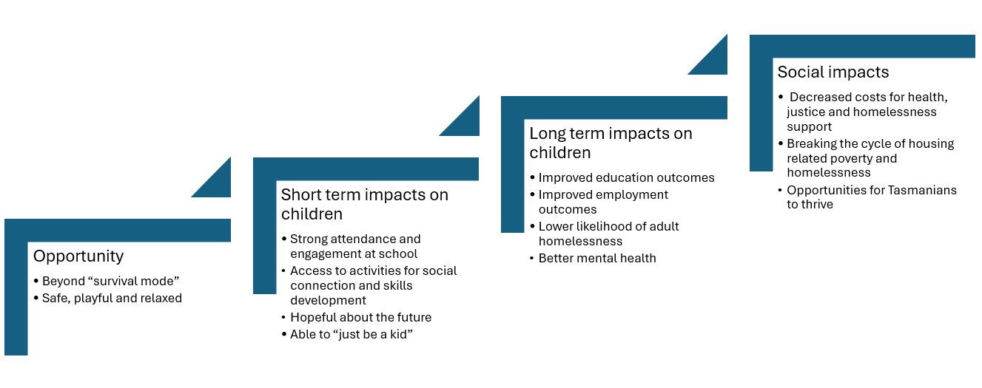
Drawing on concepts from Flatau et al. (2013), Hock et al. (2024), Murran and Brady (2023), Bessell and O’Sullivan (2024), and Kolar (2019).
‘By providing every Tasmanian with a safe and stable home, we empower individuals to pursue education and employment, and contribute to the community.’
‒ Tasmanian Housing Strategy 2023-2043 (Tasmanian Government 2023a)

Relational impacts
The strain of housing insecurity affects families in multiple ways. Moving house repeatedly dislocates children from friends, extended family and other supportive adults in their lives. Within the family itself, there are additional stresses. Even when families stay together, the stress of being in insecure housing impacts on parent-child relationships (Murran and Brady 2023).
“I mean they're not bad rules [in emergency housing]. Like you can’t make a lot of noise but that’s perfectly understandable and you can’t have people over…That's why we can’t easily hangout.”
‒ B, 13 years (Bessell et al. 2024)
Anglicare staff spoke repeatedly about families making decisions about whether they would separate in order to ensure that children were safely housed (as in Jess’s and Erin’s stories) or stay together in circumstances that might also cause harm.
Staying with family and friends can be a vital stop-gap for families. However, when families have nowhere else to move on to, overcrowding and stress can lead to strained relationships with their hosts. This can result in families “using up” relationships, networks and support. As a family becomes more isolated, children have fewer supportive adults in their lives.
“…you might have Uncle Someone you can go with two weeks. He's not gonna have you for longer than two weeks, but then you can go to Aunt Mary, she's not gonna have you for longer than a week. But you know, they're not going to do that consistently. So after Aunt Mary’s, if the family’s not going to take you back in, so you’ve used up that option.”
‒ Families, Children and Young People practitioner

One issue is the eligibility criteria of some shelters (valentine et al. 2020) and a lack of family friendly accommodation can make it impossible for families to stay together. Homelessness systems were not built with families and children in mind. While some crisis accommodation includes offsite units that can accommodate families, this is not available everywhere. Most notably, some women’s shelters cannot accommodate teenage boys as part of a family group (Toombs 2024; Donnelly 2020).
It is also well documented (Fidler 2018) that lack of appropriate housing with enough bedrooms often delays reunification of families after a child has been removed by child safety services.
“No parent’s going to choose to willingly leave a 13, 14 year old boy on the street. Imagine how dire it must be to make that decision.”
‒ Families, Children and Young People practitioner
“Yeah. So they're sitting in out of home care, foster care, kinship care. And they're just waiting on getting a home so they can, yeah, be restored to their families.”
‒ Families, Children and Young People practitioner
Strong parent-child relationships are vital for children’s healthy development. When parents are “survival parenting” (‘exerting constant and often extraordinary efforts to attend to their children’s basic needs’ (Hilton and Trella 2014)) they become exhausted.
“OK, so when life is tough at home, it’s anger, heartbroken, feels like pain is in the air, devastation is everywhere. You can see it through peoples' eyes. It’s so frustrating but it happens sometimes in life. It just hurts. It hits you in a way you don’t want it to. It normally causes people to argue, and you get hurt, or no one helps you. It hurts you inside.
‒ Max , 12 years (Bessell et al. 2025)

This can impact on parents’ ability to build their relationships with their children as they would if daily life were less challenging. As Professor Sharon Bessell, from the More for Children project states, ‘This is not an issue of personal or family choices, but a reflection of the pressure and stress that poverty causes’ (personal communication, 19 February 2026).
Figure 15: What happens if we can prevent or address the relational effects of housing insecurity on children?
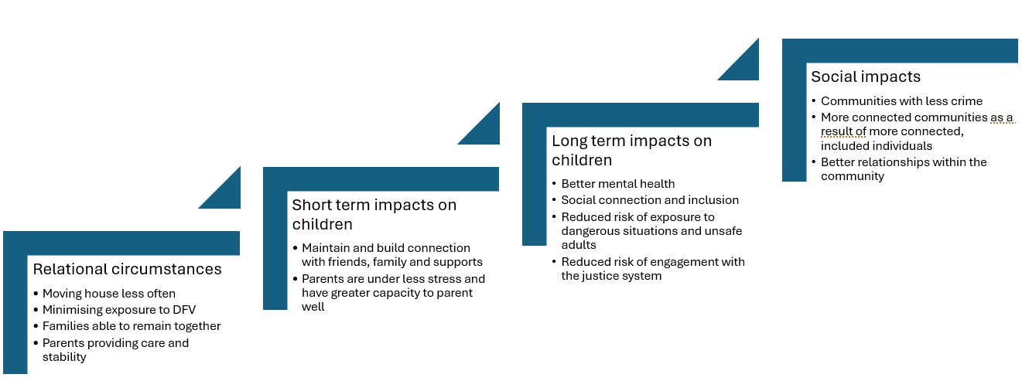
Drawing on concepts from Bessell and O’Sullivan (2024), Hock et al. (2024) and Murran and Brady (2023).

“Tasmanians are socially connected, included, and have a strong sense of belonging. Tasmanians have fulfilling relationships and feel connected to others” ‒ The Wellbeing Framework (Tasmanian Department of Premier and Cabinet 2025)

What can be done?
The Tasmanian Government’s Child and Youth Wellbeing Strategy outlines a vision where ‘Children and young people in Tasmania have what they need to grow and thrive’ (Tasmanian Government 2021).
This includes having:
- ‘…a safe, stable and supportive home environment’
- ‘…access to suitable, secure, stable housing with adequate heating and cooling…’.
Anglicare Tasmania supports the Government’s commitment to end homelessness in Tasmania. We also recognise that this will take time.
We therefore propose a range of measures that will reduce the impacts of insecure housing on children both now and into the future.
‘In Tasmania, housing is recognised as a fundamental human right enshrined in the Homes Tasmania Act 2022. Ending homelessness in Tasmania is not just a moral imperative, it is a strategic investment in the wellbeing of our entire community. By providing every Tasmanian with a safe and stable home, we empower individuals to pursue education and employment, and contribute to the community.’ Tasmanian Housing Strategy 2023-2043 (Tasmanian Government 2023a)

Where could we take immediate action?
There are several initiatives that can be implemented quickly to reduce the impact of Tasmania’s housing crisis on children.

Prioritisation of families for access to housing
Children and young people are named in the Tasmanian Housing Strategy 2023-2043 as “Tasmanians who require additional support”. The Strategy also states that ‘Programs that provide crisis accommodation or rapid rehousing will be continued, with a focus on larger homes for vulnerable families and those escaping family violence’ (Tasmanian Government 2023a).
However, in practice, for a person to be considered a “high priority” for social housing, the applicant must either be moving from crisis or transitional homelessness accommodation or exiting from institutional care settings or a health facility into homelessness (Homes Tasmania 2024).
The circumstances described in this report (primary or secondary homelessness, domestic and family violence, affordability crisis) would place families in “standard priority” or “general need”, but not in “highest priority”. As described throughout this report, many parents use every option available to keep their family together and under a roof. Therefore, despite being in dangerous, overcrowded or unstable situations, they may fail to meet the criteria for highest priority. On average, priority applicants wait 84.4 weeks before receiving housing (Homes Tasmania 2025) and 90.3% of allocations are made to “priority” applicants.
This has particular relevance to families leaving domestic and family violence. As described earlier in this report, 22% of these families are couch surfing or living with relatives fee free, while only 7% are in crisis or transitional accommodation. Others may still be living with the perpetrator.
In the past, families leaving DFV situations had exclusive access to some transitional housing through the Family Violence Rapid Rehousing program (as occurred in Jess’s story). Rapid Rehousing for families affected by DFV was a key action in Tasmania’s Third Family and Sexual Violence Action Plan (2022-2027) (Tasmanian Government 2022).
This allocation of housing has now been combined with properties in the Private Rental Incentives Scheme under Affordable Private Rentals and is not necessarily reserved for families escaping DFV. To reduce the impact of DFV and ongoing housing insecurity on families with children, this group must be prioritised for social housing, even if they are not exiting crisis or transitional accommodation.
Recommendation One: In line with the commitments made in the Tasmanian Housing Strategy 2023-43 and Tasmania’s Third Family and Sexual Violence Action Plan 2022-2027, the Tasmanian Government ensure that families escaping domestic and family violence are appropriately prioritised for rapid access to housing, even if they are not living in a shelter.

Continuity of support services when families move region because of housing insecurity
Many support services for families under pressure are allocated via the Strong Families Safe Kids Advice and Referral Line (ARL) and provided locally. When families move between regions, those supports are often closed off and a new referral must be created to begin services again in the new location. This creates a gap at a time when families are in greatest need of support, advice and connection.
A process to ensure a “warm handover” between regions would mean that vulnerable families do not lose support just at the point when they need it most.
Recommendation Two: The Tasmanian Government (through Strong Families Safe Kids) create a process for warm handover of at-risk families who move regions due to housing insecurity.

School-based supports to identify and mitigate the impacts of housing insecurity on affected children
The positive response to school-based programs like breakfast clubs and school lunches (Jose et al. 2020; Jose et al. 2024) is an indication of how effective schools can be as a hub for holistic support. Many Anglicare staff spoke about the positive impact these programs have on children whose families are struggling with housing. As the number of children living in insecure housing grows, the Tasmanian government should review existing school-based initiatives that identify and support such children.
A review of what already exists in Tasmania, what is working well, and other evidence-based models (e.g. full-service schools (Molina et al. 2025) and the Education Pathways Program (Kolar 2019)) would provide a good basis for introducing and/or extending supports in Tasmanian schools. This would be in line with the Multi-Tiered System of Supports model recommended in the 2024 Independent Review of Education in Tasmania, and with the review’s finding that wellbeing initiatives ‘played a key role in supporting student resilience and emotional health’ (Baylis 2024).
Recommendation Three: The Tasmanian Government identify and expand opportunities for extending school-based support for children affected by housing insecurity

Opportunities for children to have fun and make connections outside school and home
Children in housing insecurity often have fewer opportunities to “just be a kid” due to financial constraints, repeated moves and the constraints of their home environments (e.g. overcrowding). While the Ticket to Play program provides opportunities for eligible children to take part in sport and active recreation (Tasmanian Government 2026b), it is restricted to sporting and “active” activities (e.g. orienteering, Scouts, Guides and Cadets).
Extending the scope of the program to include activities like choirs, art groups, community theatre or chess clubs would give more options to include children with diverse interests and needs. Like sport, these activities support social connection, skills development and provide a place for children (outside school or home) to be safe and encouraged.
Recommendation Four: The Tasmanian Government extend the “Ticket to play” initiative to include creative activities for eligible children.

Transport
Currently, some children are eligible for free travel to and from school. Other children pay a flat fare, and some are eligible for discounts (Tasmanian Government 2026a). When families’ circumstances change or they move house, eligibility changes and the child may require a replacement pass. Making public transport free for children would simplify this system and lessen the administrative burden of beginning at a new school when a family must move. Not all families live in areas where there is public transport, but for those who do, free public transport would reduce barriers to school attendance.
It would also make it more achievable for children to attend other activities and for young people to hold part time jobs.
On 29 March 2026, the Tasmanian Government announced free public transport across the state, in response to the increased cost of fuel (Rockliff and Vincent 2026). This policy could be extended beyond its current end date, targeted specifically to children under 18.
Recommendation Five: The Tasmanian Government continue to make public transport free for Tasmanian children beyond 30 June 2026.

What needs to happen over the longer term?
Without significant change, more Tasmanian children will continue to grow up in the circumstances described in this report. This is unacceptable.

Social and affordable housing
As outlined in the Tasmanian Housing Strategy 2023-2043 (Tasmanian Government 2023a), ‘Increasing the supply of housing is an important factor in responding to need and reducing housing prices.’
The Tasmanian government must increase investment in new social housing. This goes beyond meeting the commitment to deliver 10,000 social and affordable homes by 2032 (Tasmanian Government 2023a) – it requires that these are new social housing dwellings that will provide secure housing for low-income Tasmanians. These must include homes suitable for families, including larger families, in locations close to schools and support services.
In addition, as Anglicare Tasmania has previously recommended (Anglicare Tasmania 2026), the Tasmanian Government’s proposed short-stay levy should better address the negative spillover impacts of the short-stay rental market on rental affordability, and avoid further escalating house prices by:
- directing 100% of revenue from the levy to fund the construction of social housing and homelessness services
- imposing a levy of 7.5%
- ensuring that revenue from the levy does not assist the purchase of existing homes.
Recommendation Six: The Tasmanian Government increase the state’s stock of social housing by building new homes that will provide appropriate shelter for low-income Tasmanians, including families.

Access to safe housing for victim-survivors of DFV
The Tasmanian government has committed to ‘targeting supply and support initiatives to assist women and children escaping family violence’ (Tasmanian Government 2023b) and ‘recognises children and young people as victim-survivors in their own right’ (Tasmanian Government 2022).
The need for more housing for people leaving DFV is well documented (e.g. Impact Economics and Policy 2023; Toombs 2024).
In the case of families leaving DFV, there is a need for a range of accommodation options that are designed to be safe and child friendly (e.g. Donnelly 2020). These should include stand-alone housing with three or four bedrooms (Shelter Tas 2025), close to schools and support services, with access to safe areas for play.
Recommendation Seven: In line with the commitments made in the Tasmanian Housing Strategy 2023-43 and Tasmania’s Third Family and Sexual Violence Action Plan 2022-2027, the Tasmanian Government increase the supply of crisis, transitional and long-term housing for victim-survivors of DFV, including accommodation designed for families.

Income support and cost of living
People whose main source of income is government payments are largely unable to afford private rental housing in Tasmania. The Australian government must raise payments above the poverty line. Anglicare Australia estimated in 2025 that raising Parenting Payment and Carer Payment (along with Jobseeker) would lift 840,000 children out of poverty (Anglicare Australia 2025).
Improving income support for families would reduce strain on parents and improve their capacity to provide food, transport, clothing and activities for their children.
Recommendation Eight: The Australian Government increase income support payments above the poverty line.

References
ABS (Australian Bureau of Statistics) (2012) Information paper: a statistical definition of homelessness, ABS, Canberra.

--- (2022) Tasmania: Aboriginal and Torres Strait Islander population summary, accessed March 2026.

AHURI (Australian Housing and Urban Research Institute) (2019) Understanding the 30:40 indicator of housing affordability stress, Australian Housing and Urban Research Institure (AHURI), accessed March 2026.

AIHW (Australian Institute of Health and Welfare) (2013) National housing and homelessness data dictionary: version 1, 2013, Australian Government, Canberra.

--- (2023) Specialist Homelessness Services collection manual, accessed February 2026.

--- (2024) Specialist homelessness services clients experiencing family and domestic violence: interactions with out-of-home care and income support, accessed February 2026.

--- (2025) Homelessness services: children and young clients, accessed February 2026.

Anglicare Australia (2025) Investing in people: Anglicare Australia’s plan for the 2025-26 Federal Budget, Anglicare Australia, Canberra.

Anglicare Tasmania (2026) Submission No. 44 to Tasmanian Department of Treasury and Finance, Short Stay Levy Bill 2025 consultation, accessed March 2026.

Baylis V (2024) Independent review of education in Tasmania: final report to the Tasmanian government, accessed January 2026.

Bell A, Parry YK, Ankers M, Sivertsen N, Willis E, Kendall S and Yin H (2025) 'An innovative nurse practitioner-led service for children from families living in housing instability', Primary Health Care Research & Development, 26(e22), doi: 10.1017/S1463423625000118.

Bessell S, Bexley A and Vuckovic C (2021) The MOR for Children Framework, Children's Policy Centre, Australian National University, Canberra.

Bessell S and O'Sullivan C (2024) More for children: children’s experiences of poverty in Australia, Children's Policy Centre, Australian National University, Canberra, doi:10.13140/RG.2.2.12416.24321.

Bessell S, O'Sullivan C and Lang M (2024) More for Children issues paper: Housing, More for Children, Australian National University, Canberra.

Bessell S, O'Sullivan C, Rose T, Lang M and Avrahamzon T (2025) 'Measuring multidimensional child poverty in Australia', Australian Economic Review, 58(S1), doi: 10.1111/1467-8462.70016.

CCYPT (Commissioner for Children and Young People Tasmania) (2021) We call it happy...: CCYP wellbeing consultations with 0 to 18 year old Tasmanians, Wellbeing Report, State of Tasmania, Hobart.

--- (2024) Nowhere else to go: young people’s views on homelessness, State of Tasmania, Hobart.

Claxton S, Bennett M and Toombs G (2025) Rental Affordability Snapshot Tasmania 2025, Social Action and Research Centre, Hobart.

Dall'Omo L, Johnson AP, Yaseen S, Lakhanpaul M and Lewis C (2023) A place to play: children’s play needs in England’s temporary housing, Reach Alliance.

Donnelly S (2020) Design guide for refuge accommodation for women and children, University of Technology, Sydney, doi:10.57956/68ZE-Z882.

Duncan A and Twomey C (2025) Child poverty in Australia 2025, Bankwest Curtin Economics Centre.

Fidler L (2018) In Limbo: exploring income and housing barriers for reunifying Tasmanian families, Anglicare Tasmania, Hobart.

Flatau P, Conroy E, Spooner C, Edwards R, Eardley T and Forbes C (2013) Lifetime and intergenerational experiences of homelessness in Australia, AHURI Final Report No. 200, AHURI, Melbourne.

Government of Tasmania (2022) Homes Tasmania Act 2022, accessed March 2026.

Hilton TP and Trella DL (2014) '“You just gotta do it, 'cause those are your kids”: survival parenting and rural homelessness', World Medical & Health Policy, 6(4):446-482, doi: 10.1002/wmh3.115.

Hock ES, Blank L, Fairbrother H, Clowes M, Cuevas DC, Booth A, Clair A and Goyder E (2024) 'Exploring the impact of housing insecurity on the health and wellbeing of children and young people in the United Kingdom: a qualitative systematic review', BMC Public Health, 24(1):2453, doi: 10.1186/s12889-024-19735-9.

Homes Tasmania (2024) Social housing policy, accessed February 2026.

--- (2025) Homes Tasmania Dashboard December 2025, accessed February 2026.

Impact Economics and Policy (2023) Somewhere to go: meeting the housing needs of women and children in Tasmania, Hobart.

Jose K, MacDonald F, Vandenberg M, Williams J, Abbott-Chapman J, Venn A and Smith KJ (2020) 'School breakfast club programs in Australian primary schools, not just addressing food insecurity: a qualitative study', Health Education & Behavior, 47(4):619-630, doi: 10.1177/1090198120920193.

Jose K, Smith KJ, Sutton L, Masila N, Fraser B, Proudfoot F and Cleyland V (2024) School lunch project evaluation: final report 2024, Menzies Institute for Medical Research, University of Tasmania, Hobart.

Kolar V (2019) ‘No child misses out’: Education Pathways Program, Launch Housing, Melbourne.

Leishman C, Hewton J, Ong ViforJ R, Washington L, Zhang R and Liang W (2025) The impact of Commonwealth Rent Assistance on low income privately renting parents and children, AHURI Final Report No. 446, Melbourne, doi:10.18408/ahuri3234501.

Liu E, valentine k, Batterham D, Stone W, Martin C, Parkinson S and Hynes D (2023) Poverty and Australian housing: findings from an investigative panel, AHURI Final Report No. 410, 410, AHURI, Melbourne, doi:10.18408/ahuri7130501.

McKail B (2023) The poverty premium: the high cost of poverty in Australia, Anglicare Australia, Canberra.

Molina A, Doeke E and Hildebrandt M (2025) Achieving better and fairer schools: the case for full-service school models in Australia, Mitchell Institute, Victoria University, Melbourne.

Monks H, Mandzufas J and Cross D (2022) The impact of poverty on the developing child: a narrative review, Life Course Centre Working Paper Series, Australian Research Council Centre of Excellence for Children and Families over the Life Course.

Morris A, Idle J, Moore J and Robinson C (2023) Waithood: the experiences of applying for and waiting for social housing, Institute for Public Policy and Governance, University of Technology Sydney.

Murran S and Brady E (2023) 'How does family homelessness impact on children's development? A critical review of the literature', Child & Family Social Work, 28(2):360-371, doi: 10.1111/cfs.12968.

O'Connell M, Jayasinghe D, Supramaniam T, O'Dell A, Bennett T, Smith R and Breeze N (2025) The state of Australia’s children 2025, UNICEF Australia & ARACY.

Robinson C (2020) A public health approach to ending unaccompanied child homelessness in Tasmania, accessed March 2026.

Rockliff J and Vincent K (29 March 2026) Travel Free Tasmania [media release], Tasmanian Government, accessed March 2026.

Rosenthal DM, Lewis C, Heys M, Schoenthaler AM, Ucci M, Hayward A and Lakhanpaul M (2021) 'Barriers to optimal health for under 5s experiencing homelessness and living in temporary accommodation in high-income countries: a scoping review', Annals of Public Health and Research, 8(1)(1103):18.

SARC (Social Action and Research Centre) (2025) Housing Connect Front Door Service Quarterly Snapshot September 2025, Housing Connect Front Door Service Quarterly Snapshot, Anglicare Tasmania, Hobart.

--- (2026) Housing Connect Front Door Service Quarterly Snapshot December 2025, Anglicare Tasmania, Hobart.

Shelter Tas (2025) Shelter Tas Budget Submission 2026-27, accessed December 2025.

Tasmanian Centre for Mental Health Service Innovation and Tasmanian Government Department of Health (2025) 20-Year Preventive Health Strategy round 1 consultation summary report, accessed December 2025.

Tasmanian Department of Premier and Cabinet (2025) The Wellbeing Framework, version 1, accessed March 2026.

Tasmanian Government (2021) 'It Takes a Tasmanian Village' - Tasmania's first Child and Youth Wellbeing Strategy for 0-25 year olds, Wellbeing Tasmania, Hobart.

--- (2022) Survivors at the Centre: Tasmania’s Third Family and Sexual Violence Action Plan 2022-2027, accessed January 2026.

--- (2023a) Tasmanian Housing Strategy 2023-2043, accessed March 2026.

--- (2023b) Tasmanian Housing Strategy: Action Plan 2023-2027, accessed March 2026.

--- (2026a) Student bus pass for free travel, accessed February 2026.

--- (2026b) Ticket to Play, accessed February 2026.

Teager W, Fox S and Stafford N (2019) How Australia can invest early and return more: A new look at the $15b cost and opportunity, Early Intervention Foundation, The Front Project and CoLab at the Telethon Kids Institute.

Toombs G (2024) Unsafe and Unhoused: Barriers to addressing domestic and family violence in North West Tasmania, Anglicare Tasmania, Hobart.

UNICEF (2019) Convention on the Rights of the Child: Children's version, accessed March 2026.

valentine k, Blunden H, Zufferey C, Spinney A and Zirakbash F (2020) 'Supporting families effectively through the homelessness services system', AHURI Final Report, (330), doi: 10.18408/ahuri-7119201.

A “warm handover” refers to a direct transfer of a client from one practitioner to another, with discussion of their history and support needs. This is in contrast to a referral being made to an intake line or service with no direct conversation between practitioners (e.g. by submission of an online form). A warm handover provides greater support to the client, enabling the practitioner to provide relevant information and minimise the client re-telling their story.
“Couch surfing” refers to ‘moving from household to household intermittently’ and captures situations where the person is not considered a member of the household. This is distinct from “living with relatives fee free” where the client is a relative of a household member and “boarding” where the client is ‘supplied with meals and/or lodging in return for payment’ (AIHW 2023).
Anglicare Tasmania holds statewide Housing Connect Front Door Service data from 1 July 2024. Two 12-month periods were compared to eliminate the impact of seasonal variation on the data.
1 January to 31 December 2025 inclusive.
Note that a very small number of households (<1%) with children in the care of a guardian may have been omitted from the dependent children group.
These reasons for seeking assistance are defined by the Australian Institute of Health and Welfare (AIHW 2013). “Financial difficulties” relate to the person seeking assistance because they ‘had insufficient money to pay for accommodation, food, bills or other essentials’. In contrast, ‘Housing affordability stress is selected if the person sought assistance as a result of the current rent on the leased property being too high, or they are having difficulty meeting mortgage repayments, creating stress with general living expenses’.
Families without a permanent address are a larger group than unhoused families, as they include families who are not “unhoused” but are in accommodation with no security (e.g. staying with friends or family).
Families boarding or staying fee free with relatives were not included in this data.
For example, Intensive Family Engagement Service (IFES), Integrated Family Support Services (IFSS), Targeted Youth Support Service (TYSS), Community Kinship Program.
A “warm handover” refers to a direct transfer of a client from one practitioner to another, with discussion of their history and support needs. This is in contrast to a referral being made to an intake line or service with no direct conversation between practitioners (e.g. by submission of an online form). A warm handover provides greater support to the client, enabling the practitioner to provide relevant information and minimise the client re-telling their story.
Children who hold or are listed on a concession card and children under a Care and Protection Order are eligible for a school bus pass for free travel, as are children living in rural areas who fall within the “home area school” classification.

