

2025-26 ANNUAL REPORT
Real impact


Messages

Board Chair, James McKee
As a Board, we are entrusted with stewarding Anglicare Tasmania not only for today, but for future generations.
Throughout the year, we remained focused on ensuring the organisation continues to deliver compassionate, high-quality services while responding confidently to a changing social, economic and policy environment.
We undertook a strategic exercise that explored what the next 20 years may hold for Tasmania, the communities we serve, and Anglicare. We considered the demographic, technological, environmental, workforce and social changes likely to shape our future. This work will continue to guide our long-term decision-making and help ensure Anglicare remains innovative and true to its mission.
We thank Chief Executive Officer Chris Jones and the Executive Management Team for their commitment to supporting our staff to deliver services that make a meaningful difference in people’s lives.
This year marks the conclusion of Mike Blake’s service as Chair of the Board. Mike provided wise and principled leadership during a challenging period, and we thank him for the lasting contribution he has made.
Finally, I thank our Board Members for the generosity with which they contribute their time and expertise. Together, we remain committed to ensuring that Anglicare continues to be a trusted organisation in the Tasmanian community.
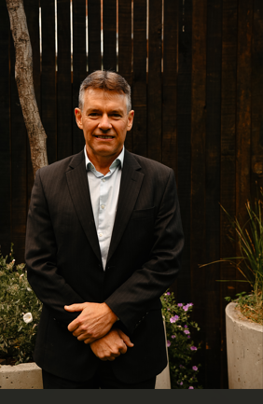
Board Chair, James McKee
CEO, Chris Jones

The work we do at Anglicare is difficult, but it’s work that is important and meaningful.
I use the word ‘difficult’ only because often the people we support don’t have access to essentials like affordable housing and healthcare, and their needs are complex.
We believe an organisation like ours has the power to make a difference in people’s lives, and we are guided by our organisational values of respect, compassion, hope and justice towards this end.
We encourage team member to ask questions, think deeply, and consider diverse perspectives during their work. This willingness to listen closely to the Tasmanians we support, and to walk alongside them, continues to strengthen our services.
This year we were presented with new opportunities to reach people in need, particularly young people. We responded quickly and effectively to these challenges, and I am proud of the progress we’ve made in this area.
Despite system constraints and limited resources, we are reminded each day that even the smallest acts of care can have a real and positive impact. Thank you to everyone who shares our vision, in particular the Anglicare team, for bringing our values to life.

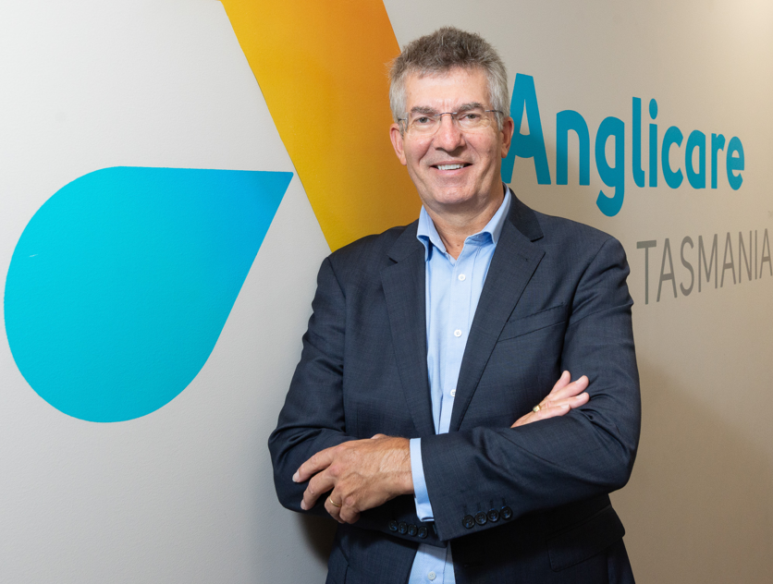
CEO, Chris Jones

With thanks
In 2025-26, Anglicare received funding and support from:
- ABC Giving Tree
- Allport Bequest
- Attorney-General’s Department (Commonwealth)
- Brotherhood of St Laurence
- Colin Bisdee Trust
- CatholicCare Tasmania
- Department for Education, Children and Young People
- Department of Health, Disability and Ageing (Commonwealth)
- Department of Health (Tasmania)
- Department of Premier and Cabinet (Tasmania)
- Department of Social Services (Commonwealth)
- Department of Veterans’ Affairs (Commonwealth)
- Farrell Foundation
- Financial Counselling Industry Fund
- GIO
- Homes Tasmania
- Icare
- Launch Housing
- Motor Accidents Insurance Board
- National Disability Insurance Agency
- National Injury Insurance Scheme Queensland
- Primary Health Tasmania
- Queensland University of Technology.
At a glance
Anglicare Tasmania is a not-for-profit organisation that has served the Tasmanian community since 1983.
We provide aged care, acquired injury, housing and community support services across the state, and advocate for people experiencing disadvantage.
Our values:
Hope: Confidently reaching for fullness of life.
Compassion: Showing empathy and care for those in need.
Respect: Recognising the inherent value and dignity of every person.
Justice: Promoting the fair distribution of resources and opportunities.

Here for all Tasmanians
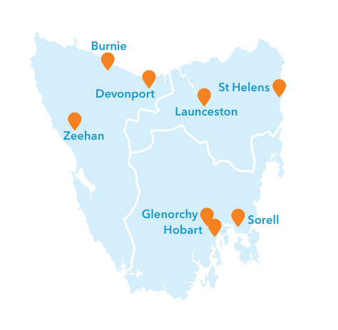
Anglicare team members work across eight office locations and community settings throughout Tasmania.

Real impact
Across Tasmania
805 team members spread around the state
51,973 people came through our office doors, including clients, contractors and visitors
800+ Tasmanian businesses supplied us with goods and services

Financial performance

Anglicare delivered more than $82.3 million in services to Tasmanians during 2025-26, up from $77.7 million in the previous year.
We invested in our workforce, systems, advocacy efforts and service delivery to achieve positive outcomes for the people we serve.
We are proud of our contribution to Tasmania's economy. We spent $59.2 million on wages and salaries during the year. Anglicare Tasmania continues to be one of the state’s largest employers.
A surplus of $3.0 million will strengthen our capacity to invest in and sustain services that will continue to support Tasmanians into the future.
Buying local
Anglicare is committed to supporting local communities, including those in rural and remote areas. We prioritised the procurement of Tasmanian goods and services wherever possible, spending more than $23 million with Tasmanian businesses.
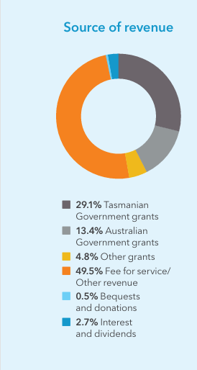
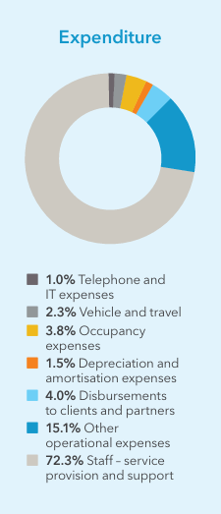
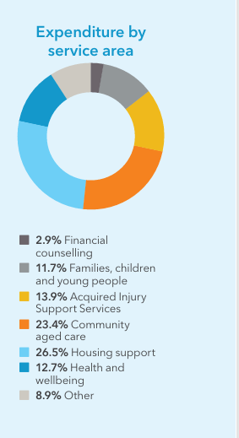

Read Anglicare’s full financial statements.

Collaborating with care
Our work is strengthened by the generosity of Anglican parishes, schools, community organisations and donors across Tasmania.
Parish support
Twenty-seven Anglican parishes supported our work this year through donations, practical assistance and personal connection. This included:
- regular donations of food, toiletries and other essentials
- fresh vegetables from a church-led community garden
- companionship for people living in supported accommodation
- pastoral care for clients receiving aged care services.
Three parishes received Anglicare grants to strengthen connections in their local communities:
- All Saints Network, Launceston – a multicultural café and English language learning resources
- Huon Anglican – hot breakfasts and frozen meals for community members; and
- Midlands Anglican – Christmas hampers for people in need.

Real impact:
Using donations
Donated funds are used to meet people’s individual needs. In 2025-26 this included:
34 pairs of sports shoes for children returning to school
1 boxing bag, to help someone improve their fitness
2 bassinettes and bottles for premature, newborn twins
a bath chair and continence aids for an older person
19 psychological assessments for children.

Schools giving back
Anglican Church schools supported our work while learning more about poverty and disadvantage. Hutchins School Year 12 students donated more than $27,000 following a year-long fundraising drive.
Community generosity
Almost $26,000 raised through the ABC Giving Tree helped us provide Christmas hampers and meals at our accommodation facilities, as well as back-to-school essentials for families.
Donations through our two Winter Appeals also helped us respond to cost-of-living pressures, including assistance with rental arrears, bond payments and fuel costs.
Practical help when it’s needed
In September 2025, the Goodnight Tasmania campaign donated emergency backpack beds to community service organisations, including Anglicare. We distributed around 30 beds during the year to people in need.
The ongoing demand for this kind of emergency assistance highlights the need for greater investment in social and affordable housing across Tasmania.

Real impact:
Christmas Appeal
In the lead-up to Christmas 2025 we distributed:
700 family-sized food hampers
300 cleaning and laundry packs
150 packs of personal hygiene products.

Join us in supporting Tasmanians in need
When you donate to Anglicare, you are helping us to enrich someone’s life. 100% of your donation will go directly to Tasmanians in need. We do not apply an administrative fee.
More than a meal
More than 500 Quality of Life surveys were completed this year by clients across our housing, aged care and acquired injury services. Two things people living in supported accommodation told us were particularly important to them were food and social connection.
More choice around food
People living in Lodge accommodation told us they couldn’t always afford healthy snacks between meals and wanted more choice about what and when they ate. Young people in our Youth2Independence (Y2I) program could access affordable meat and vegetables but not always the condiments needed to turn them into a meal.
In August 2025, staff looked at how donated funds could give residents more choice and independence. Y2I students received spice and oil packs, while adult residents trialled access to snacks. Cooking equipment, a shared freezer and communal pantries were also introduced at several facilities to give residents more options.
Changes to Lodge catering complemented this work. With Loaves and Fishes now managing kitchen operations, residents have access to 120 extra ready-to-heat meals each week at no additional cost.
“I'm so much happier eating the healthier food, and if there is something I don't like there is another option.”
- a Lodge resident
More opportunities to connect
Quality of Life feedback also led to a greater focus on activities and community outings. Donated funds supported new monthly barbecues at Grove House in Ulverstone and Campbell Street in Hobart, a coffee club at Goulburn Street, and a bus trip to Hastings Caves for southern residents over Easter.

Real impact:
Supported accommodation
This year 591 people lived in supported accommodation managed by Anglicare. They enjoyed:
127,000 meals
73 excursions to places such as Tasmazia and Hobart Zoo
206 on-site activities such as cooking, gardening, craft and celebrations.

Our people

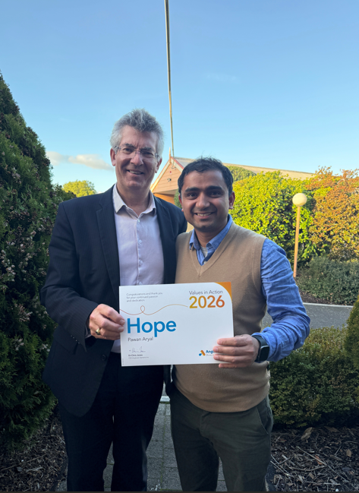
Pawan Aryal (pictured on the right with CEO Chris Jones) is a Launceston-based Workforce Scheduling Planner in the Acquired Injury Support Services team. In April 2026 he was named the winner of the Values in Action Award for ‘hope’. These peer-nominated awards are the highest accolade for people who work at Anglicare.
The 2025 staff engagement survey results showed a strong sense of pride and purpose amongst people who work here.
Respondents described feeling a clear connection between their work and the values and mission of Anglicare.
Benchmarking against similar organisations across Australia shows that we are performing within the top quartile.
Team members said:
“Meaningful, impactful work. I am trusted to do the right thing and backed in to make important decisions. I feel like I'm appreciated.”
“I really value the supportive and inclusive team environment, where staff are encouraged to learn, grow, and bring their strengths to the role."
This year’s focus on recruitment, retention and boosting support to managers resulted in improvements to processes and systems. Next year the focus will be on strengthening leadership capabilities and improving workforce support through better resources, training and collaboration.

Using AI at Anglicare
At Anglicare Tasmania, we see artificial intelligence (AI) and emerging technologies as tools that can help us do our work. We explored how AI could support our work, talked with our team about their experiences and views, and strengthened our policies and procedures to support safe, responsible and human-centred use.
We use AI where it adds value and aligns with our mission, values and responsibilities, with a strong focus on privacy and protecting information.
People remain at the heart of everything we do. AI can support our work, but people make the decisions and provide the care, judgement and connection that technology cannot replace.

Real impact:
Our team
86% of staff engagement survey respondents said they were proud to work at Anglicare
78% said they would recommend Anglicare as an employer to family and friends
265 people joined our organisation
25 languages other than English are spoken by our team members, including Nepali, Cantonese, Arabic and Spanish
7 employees were promoted into managerial positions.

We are hopeful
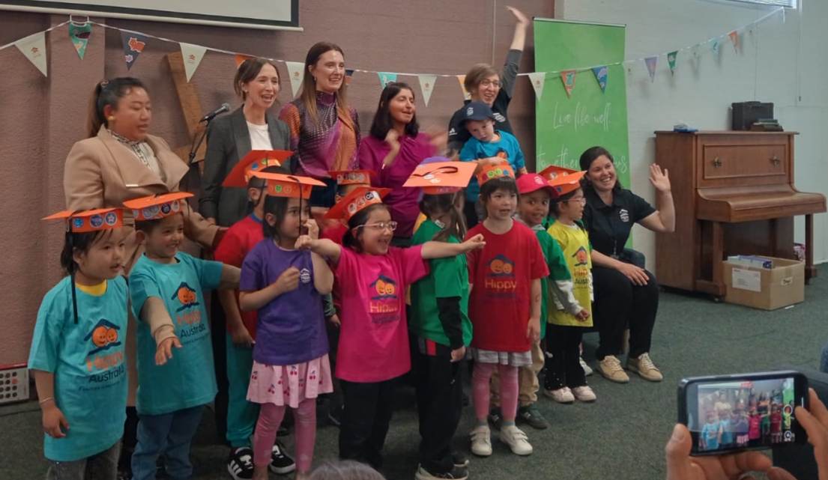
We were delighted that Jess Teesdale MP (second from the left) joined us at the HIPPY program graduation in November 2025 as our special guest.
Our housing and community programs support children and young people to reach their full potential.
More Tasmanians seeking help
Anglicare has provided the statewide Housing Connect Front Door Service on behalf of Homes Tasmania since 1 July 2024.
This year we saw a concerning increase in the number of Tasmanians seeking housing support. Families with school-aged children were living in cars. Some Tasmanians were living in conditions more commonly seen in developing countries.
The Housing Connect Front Door Snapshot for the quarter to March 2026 highlighted the urgent need for more pathways to secure and affordable housing for young Tasmanians. 90 young people aged 16-17 were supported by the Front Door during this period. Unaccompanied by a parent or guardian, 62% had been homeless in the previous 12 months.
During the full year under review, 324 young people came to the Housing Connect service alone, without a parent or guardian.
Practical support when it matters
The scarcity of affordable private rentals gave rise to 1,170 applications for private rental assistance. Housing Connect provided $1,942,060 to help people secure and maintain their tenancies, including payment of bonds, rent in advance and rent arrears, removal expenses, and ‘starter packs’ to settle people into their new home. Something as simple as providing people with a toilet brush and toilet cleaner from donated funds can be the difference between maintaining a tenancy and losing it.
Housing Connect team members referred people to a wide range of services (both run by Anglicare and other organisations). Donated funds were also used to provide them with urgent needs such as food.
Services are seeing a growing number of people with complex needs. This is placing pressure on staff and service capacity and highlights the need for greater investment in accommodation pathways that provide more intensive supports.

Real impact:
Housing Connect
52,273 enquiries were handled
5,306 individuals received support across 7,125 support periods
29 lots of rent arrears, 30 advance rent payments and 30 bond payments were paid, keeping people including families housed
46 bills including power, water, medical and car registrations were covered

“More than I imagined”
Young people enrolled in the Youth2Independence (Y2I) program are provided with supported accommodation for a period of up to two years. Anglicare manages two facilities in Hobart, one in Launceston and one in Devonport on behalf of Homes Tasmania. Students work with staff from Anglicare and TasTAFE to identify their unique pathway to study, employment, independent living and civic participation.
Student Sage is adding advocacy skills to his repertoire. A semi-finalist in the 2026 Young Achiever Awards, he was interviewed for television alongside the Youth Network of Tasmania for Homelessness Matters Day in April 2026. He also shared his thoughts for an Anglicare website story to mark the day:

“I’d like people to understand that there’s no one way a homeless person does or should look or act. Giving people grace is so important. Having stable and supportive housing like I have at Trinity is making a world of difference for me”.

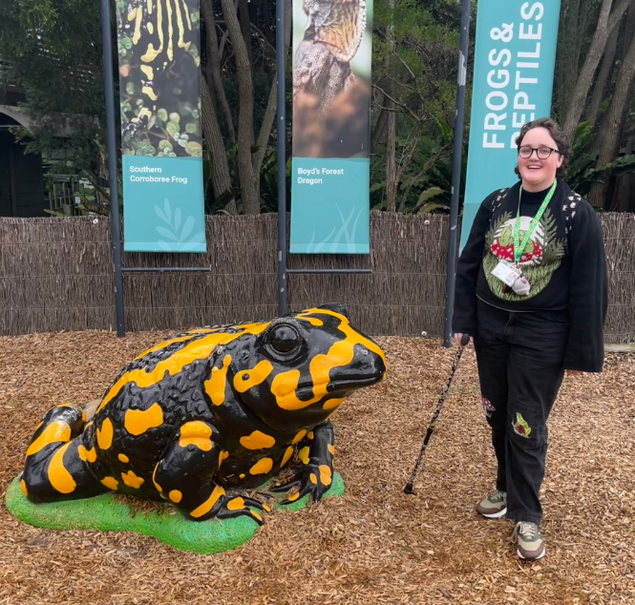
Y2I student Sage (pictured above on a trip to Melbourne zoo) lives at Trinity Hill in North Hobart.

Real impact:
Youth2Independence
235 young people were supported
117 students were supported to transition into social housing or private rental accommodation
4 bikes, 12 driving lessons, 69 activities and 3 sports memberships were provided to students from donated funds

Youth justice
Anglicare joined a coalition of community service organisations that opposes the development of a new youth detention facility at Pontville, north of Hobart. A joint statement from the coalition, From harm to healing, recommends investment in community-led alternatives.
We were asked by the Tasmanian Government to run two new pilot programs to support children and young people on the cusp of entering the youth justice system.
The Youth After-hours Diversion Support program (YADS) supported young people who had come to the attention of police in and around Hobart outside business hours. In conjunction with CatholicCare Tasmania, we provided a youth worker to support the young person to access resources. Examples included securing accommodation for a young person so that they didn’t have to stay overnight at the police station or watch-house, and providing immediate material basics, such as food.
Police described Anglicare staff as ‘easy to access, prompt and supportive’. The program has been expanded to include an outreach element focused on preventative support.
Anglicare also provided tailored and trauma-informed care to children and young people across the North/North West who were on bail in the community. On average, we spent 49 days with each young person to help them establish a more positive path.
Early learning and support
Anglicare has delivered the home-based school readiness program known as HIPPY in Launceston and the Tamar Valley since 2009. The program has benefits for the entire family. Younger siblings and grandparents are brought along on the learning journey and families that may have experienced cultural isolation have opportunities to come together. Parents who go through the program gain self-confidence and experience that can lead to paid work.
Taz Kids is a free program designed for children living in families where a parent experiences mental ill health. We promoted the program to educators ahead of the start of the school year in January 2026.
Anglicare’s West Coast Support Service offers play-based and counselling programs from its Zeehan office and via outreach to surrounding communities. It caters for families with children and young people experiencing challenges with their mental health. The service hosts regular meetings with other local service providers to promote the sharing of information and resources.

Real impact:
Community Services
20 young people were supported in the South through YADS
160 young people participated in 14 Taz Kids adventure days
33 families graduated from the HIPPY program in November 2025
32 families engaged with the West Coast Support Service and on average, received 111 days of support

We are respectful
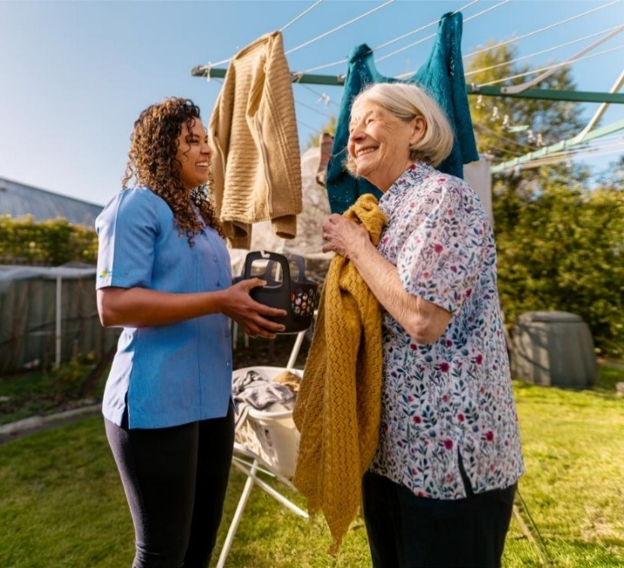
We support older Tasmanians to maintain their independence and live safely and comfortably at home. This image was part of the ‘It’s good to be home’ advertising campaign that went to air in September 2025.
Respect starts with listening to the people we support and valuing their experiences and perspectives.
Participant Advisory Council
We value the unique insights of members of our Participant Advisory Council. Current and former clients and their relatives meet with the CEO each quarter. A wide range of topics were discussed this year, including combating isolation and loneliness, communicating about changes in the aged care sector and how to make the transition into and out of an accommodation service more seamless.
Yarnin up
Our Aboriginal advisory group, yarnin up, meets regularly with the CEO (including on Country) to review our progress against an annual action plan. Its guidance assists us to deliver services that are culturally safe and effective for members of the Tasmanian Aboriginal community.
It’s good to be home
During the year, our Aged Care team supported clients through major changes to how aged care at home is funded and delivered. As the new Support at Home program began on 1 November 2025, we focused on helping clients understand what the changes meant for them.
This work required patience, flexibility and care. The team’s perseverance was recognised with the ‘Team Spirit’ award in Anglicare’s Values in Action Awards.
We listened to clients, answered questions and supported them to share their experiences with government, so they felt informed, respected and able to keep living safely at home.
We are grateful when clients take the time to share feedback about the care and kindness they receive from our team members. Examples this year included:
“Crystal is a beautiful soul … warm and compassionate.”
“Rimelly’s kind personality shines through.”
“Paula … is always willing to go the extra mile.”
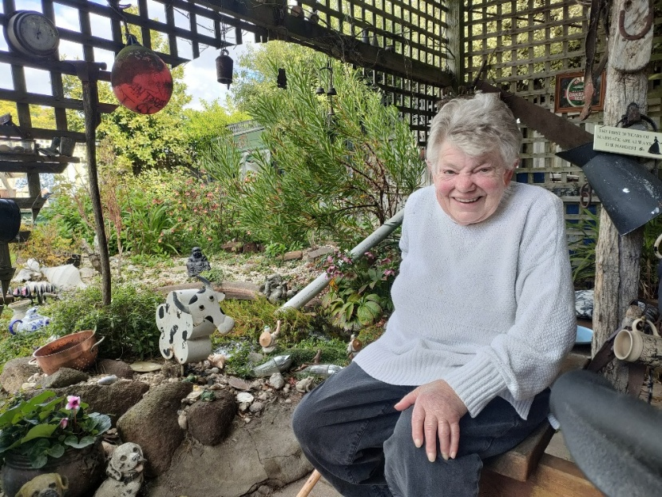
For many clients, support at home is about staying connected to the people, places and routines that matter most. A service from Anglicare supports Jane Hall to stay in the home and community she loves. “Keeping my brain active and staying connected with people is very important to me,” she says.

Real impact:
Aged Care Services
1,457 clients were supported in their own homes
210,960 hours of support were delivered, including more than 45,000 showers and around 43,000 shopping trips
504 compliments were lodged by clients

Information is power
In March 2026 we shared information about Advance Care Planning Week with clients and the broader community. We also began a project to help team members feel more confident supporting people who are nearing the end of life, using resources from End-of-Life Directions for Aged Care. Where people wish to die at home, we work closely with specialist palliative care services to help make this possible.
We also regularly share practical information about elder abuse, home safety, physical activity, social connection, making a complaint and seeking legal advice.


“Everyone belongs”
The Aged Care team is proudly multicultural, and our diversity strengthens the way we support clients. During Harmony Week in March 2026, we shared photos and reflections from team members through social media and client communications.
Home Care Worker Hema shared the spiritual meaning of Onam, an annual festival celebrated in the Indian state of Kerala: “The festival promotes unity, peace, compassion, generosity and a sense of connection among people,” she said.

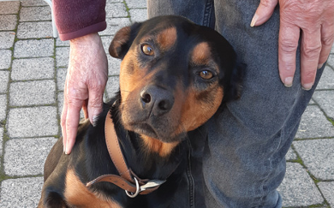
Pet Passports have been flying out the door this year. In total, 255 pets (including Ben) have been assessed as safe to stay alongside their owners while services are delivered.

A shared framework for safety
Community Services has introduced a new Domestic and Family Violence Practice Framework to strengthen how Anglicare identifies and responds to domestic and family violence across its services. Every member of the Community Services team has been briefed on how to incorporate the new framework into their daily work.
The framework establishes a consistent, organisation-wide approach grounded in safety, dignity and accountability. It centres the voices and experiences of victim-survivors, recognises children as victim-survivors in their own right, and keeps responsibility for violence with the person using it. It also helps practitioners identify patterns of coercive control, avoid collusion and challenge the social and systemic conditions that enable violence.
The framework supports practitioners to respond safely and respectfully while working collaboratively with specialist services and other supports. It was initially informed by the knowledge and experience of practitioners from Anglicare’s Relationship Abuse of an Intimate Nature (RAIN) program. RAIN supports women and children across Tasmania’s North West and West Coast through counselling, safety planning and specialist family violence supports.
Real impact:
Domestic and family violence
73 women experiencing domestic and family violence were supported by RAIN to strengthen their safety, wellbeing and choices
4 families received donated funds to cover the cost of children’s ADHD assessments
40 Community Service team members completed training with the Safe & Together Institute about how to work with families where DFV is present.


New artworks created by residents bring colour and personality to the newly refurbished communal spaces at Indigo Lodge, Prospect.

Welcome back
Residents at Indigo Lodge at Prospect were required to move into hotel accommodation for several months while Homes Tasmania replaced the building’s roof and refreshed rooms and communal spaces.
The priority for our team was to ensure people felt safe, supported and respected throughout what was a complex and unsettling process.
Everyone was very pleased to return home in February 2026:
“It is nice to be back … and to see my friends after tea. I love seeing lighter paint, it’s much brighter:”
“It has motivated us all to want to keep everything clean and tidy, we want it to feel like home and want to be responsible for our place”.
We are compassionate
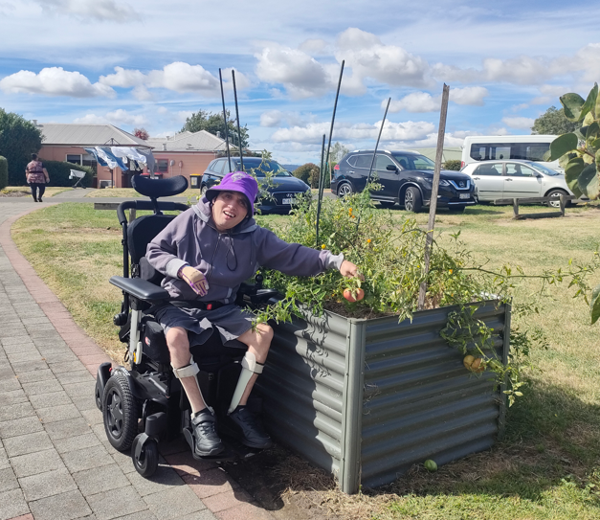
Keen gardener Verdun lives at Neena, an MAIB facility in the state’s North. In the new year he will move into a temporary home while Neena is renovated. Ensuring he has a space to grow the vegetables he loves during this period will be a key focus for our AISS team.

We provide Tasmanians with safe spaces in which to receive support.
Anglicare Tasmania is the state’s largest and most experienced provider of acquired injury support services (AISS). People with complex, short- and long-term needs are supported in residential accommodation, while others receive services in their own homes.
We sponsored the free public screening of a film about four Tasmanians with disabilities as they tackle the Larapinta Trail in the Northern Territory, More than 20 people attended the event in Burnie as part of Brain Injury Awareness Week in August 2025.
Film maker and participant Paul Pritchard spoke about the need for everyone to be able to make their own decisions and challenge themselves.
“It’s an approach that resonates with us,” said General Manager AISS Liz Leslie. “That’s why we ask people what activities they would like to do and then do everything in our power to make them happen.”
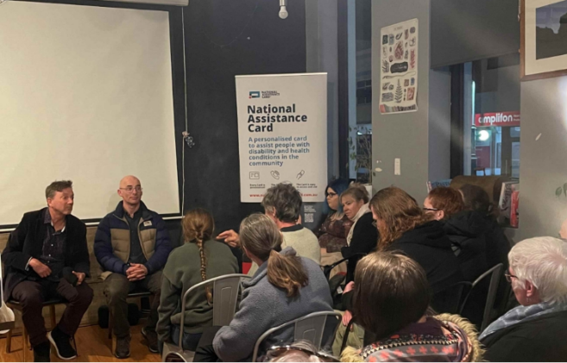
Paul Pritchard (front, left) and Paul Allen take questions from the audience in Burnie about their Larapinta Trail experience.
Person-centred care
Learning and development was a focus this year in AISS. Team members completed over 1,800 training modules. Many courses were directly shaped by our clients’ feedback, experiences and priorities.
In July 2025 we launched the MyAnglicareTas app to help clients stay informed about their supports. The app offers real-time roster access, direct contact with our team, important updates, and the option for a trusted family member to view their schedule. Again, clients had direct input into the design.
Best practice recognition
This year the service achieved its strongest result to date in the 2025 ACIS 5.0 audit, receiving best practice ratings in four key areas. These recognised our approach to quality and continuous improvement, workforce capability and training, clinical governance, and complex physical support.
The result reflects a strong focus on safe, person-centred care, supported by skilled team members, effective training and quality systems, and the involvement of clients in decisions about their care.
Client feedback
Each month, AISS invites clients to complete a voluntary satisfaction survey. This year, 82.4% of clients were satisfied with their support overall, exceeding our target of 80%.
Clients also told us:
- 88% felt safe
- 87% felt they were treated with respect and dignity
- 85% felt comfortable raising concerns
- 82% felt they were achieving their goals.

Real impact:
Acquired Injury Support Services
95 Tasmanians with an acquired injury were supported, ranging in age from 14-90
132,125 hours of care were delivered
26 holidays were planned and scheduled, supporting people to enjoy new experiences and connect with family and friends


NSP worker Jamie explains how to use naloxone at our International Overdose Awareness Day event in August 2025.
When support saves lives
Anglicare managed Needle and Syringe Program (NSP) outlets at offices in Hobart, Glenorchy and Burnie during the year. The Hobart NSP ceased operating in January 2026 when our office closed for renovations. We will take over operation of the Launceston outlet from The Salvation Army in July 2026.
NSPs play a critical role in protecting public health. This year outlets started stocking a new form of the free opioid reversal drug naloxone, called Prenoxad. It contains multiple doses in one kit which makes it a more effective tool at a time when strong synthetic opioids are circulating in the community.
International Overdose Awareness Day
More than 30 people came together at Anglicare’s Glenorchy office to mark International Overdose Awareness Day on 31 August 2025.They included NSP clients and their friends and family members. It was an opportunity to pay respect to people who had lost their lives to overdose and share stories of recovery. Twelve people took naloxone kits away with them. .
Real impact:
Needle and Syringe Program
189 life-saving naloxone kits were handed out by Anglicare’s NSP team this year
834 conversations about harm reduction were held in the Glenorchy NSP
85 people were tested at Hepatitis C clinics hosted by the Burnie NSP
ADATS program expanded
Anglicare’s Alcohol and Drug Treatment program (ADATS) expanded this year to include a new program designed to be culturally safe and effective for Aboriginal clients, called ADATS Uplift. It had immediate impact and has created a model that has the potential to be expanded across other community service programs.
Real impact:
New alcohol and drug treatment program
86 referrals from other Anglicare programs and external services
133 drop-in engagements and enquiries
371 individual service periods were provided, including assessments, a yarn, a referral and brief interventions
6 people who arrived as drop-in contacts to progress into an AOD treatment service
14 clients successfully completed treatment and exited the program.

A more welcoming place to connect
This year we upgraded a client meeting room in our Launceston office to make it a more inviting and culturally respectful space. We added soft furnishings, artwork by a local Aboriginal artist and an Aboriginal flag.
ADATS Uplift program practitioners Amanda and Gannon (below) enjoy supporting people in the new space. We’ve received very positive feedback from our staff and clients and are looking at expanding this approach at other offices.
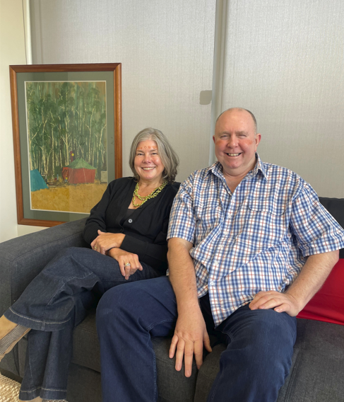

A powerful personal story
In April 2026, Anglicare hosted three regional community sessions designed to educate young people and their parents on the harms caused by online gambling, including sports betting.
The sessions featured conversations with Tasmanian advocate Mark Kempster about his personal journey from addiction to recovery. Free to attend, they provided a safe space for exploring this complex topic.
The audiences were small, but participants engaged actively during and after the sessions. The Gamblers Help team identified a need for more resources that are designed for young people and will progress this in the new year.
“I know the warning signs that families often miss. I also know that with early intervention and support, recovery is possible.”
- Gambling reform advocate, Mark Kempster




Anglicare is committed to supporting the next generation of social workers. One avenue is through the Anglicare Tasmania Scholarship for Social Work at the University of Tasmania. We congratulated Bridie Denman (above) when she was awarded the 2026 scholarship.

Back on track
Anglicare secured funding from the Australian Government deliver vital financial counselling services for the next five years. This includes operating the National Debt Helpline in Tasmania.
Issues of concern to Tasmanian callers remained the same as in previous years: mortgage payments, rent, utility and insurance costs, and Buy Now Pay Later loan repayments.
Real impact:
Financial Counselling
3,772 calls and online chats came into Anglicare via the National Debt Helpline
1,176 Tasmanians were supported to take back charge of their finances. On average, their engagement with us lasted for 16 days
39% required support to set up a budget, while 43% required assistance with negotiating finance and debt
27% reported they felt empowered to take control of their own decision-making.

Room to flourish
Many of the young people joining our Youth2Independence program have come from homelessness or precarious housing situations. We were very pleased to achieve an increase in the number of students who rated ‘safety’ highly in Quality of Life surveys this year. Results for ‘social connections’ have also improved.
Some examples of feedback included:
“The security, I feel pretty safe. There is a sense of community. The location is amazing”!
“Having a stable place to sleep without having to think about where I’m going to stay next”.
“Being able to have my own space and decorate how I want has helped my mental health”.

We work for justice
Our advocacy brings important issues to light, influences public policy debate and drives change.
Anglicare Tasmania’s Social Action and Research Centre (SARC) partners with frontline staff to identify systemic disadvantage in the community and advocate to decision-makers for practical solutions.
From evidence to action
The 2024 Unsafe and Unhoused report remains influential, continuing to highlight the intersection between domestic and family violence and housing insecurity. The report contributed to the announcement in June 2026 to increase the size of a shelter under construction in Ulverstone for women and children. It also helped fast-track the opening of the North West ARCH Centre in March 2026, providing coordinated support for people affected by sexual violence.
We drew on this work in our submission to the State Government’s Family Violence Discussion Paper (April 2026) and in presentations at the TasCOSS and Anglicare Australia conferences in 2025.
Keeping housing on the agenda
Quarterly snapshots from the Housing Connect Front Door Service demonstrated the growing need for more crisis, transitional and supported accommodation as well as long-term homes. Anglicare continues to call on the Tasmanian Government to strengthen its response to the housing crisis.
The close relationship between homelessness and mental ill health was highlighted during Homelessness Week in August 2025 through the release of a snapshot of the first 12 months of Housing Connect data. It showed that 45 per cent of people seeking housing support had a mental health issue.
The Mind the gap report, released during Mental Health Week in October 2025, revealed that the mental health system in Northern Tasmania is fragmented, under-resourced and failing people with multiple and complex needs. The report was provided to decision-makers in state and federal governments.
This work provided the foundation for a subsequent project, Strengthening support (March 2026) that urged government to introduce integrated treatment models for people experiencing both mental ill health and alcohol and other drug issues. It also informed our submission to the Tasmanian Mental Health Strategy Discussion Paper.
Bringing family homelessness into focus
A new report exploring the impacts on children in families experiencing homelessness was released in April 2026. Secure foundations described how families often fly under the radar while living for extended periods in cars, unpowered cabins and tents, or couch-surfing in overcrowded conditions.
Twenty years of tracking rental affordability
The annual Rental Affordability Snapshot (April 2026) marked 20 years since Anglicare first started capturing data on the private rental market. It revealed a housing crisis so entrenched that a person earning the minimum wage could not afford a room in an average-priced share house anywhere in the state. Politicians referred to the analysis during debate in state Parliament on the Short-stay Levy Bill 2026 in May 2026.
Minimising gambling harm
Tasmanians lost a record $208.7 million on poker machines this year, which is a 6.9% increase on the previous year.
We continued to advocate for a mandatory, universal poker machine card as the gold standard of meaningful policy reform. We asserted that the package of alternative harm-minimisation measures announced by the Tasmanian Government in June 2026 would be ineffective.
Real impact:
Social Action and Research Centre
28 mentions of Anglicare services and research in Parliament
21 briefings with parliamentarians and senior bureaucrats
17 media interviews
6 written submissions to government consultations

“Being homeless or in a precarious housing situation affects children’s health, development, opportunities and relationships. It makes a huge difference when a child and their family find stable accommodation and can start to rebuild their lives.”
- Anglicare Policy and Advocacy Officer Rebecca Forbes, in the Secure foundations report.

“It’s essential that more Tasmanians have better access to psychosocial supports so that they stay out of crisis.”
– Dan Vautin, CEO Mental Health Council of Tasmania, endorsing the Mind the gap report.

Read more about how Anglicare’s work improves the lives of Tasmanians by subscribing to Snapshot, our monthly newsletter that arrives by email.

