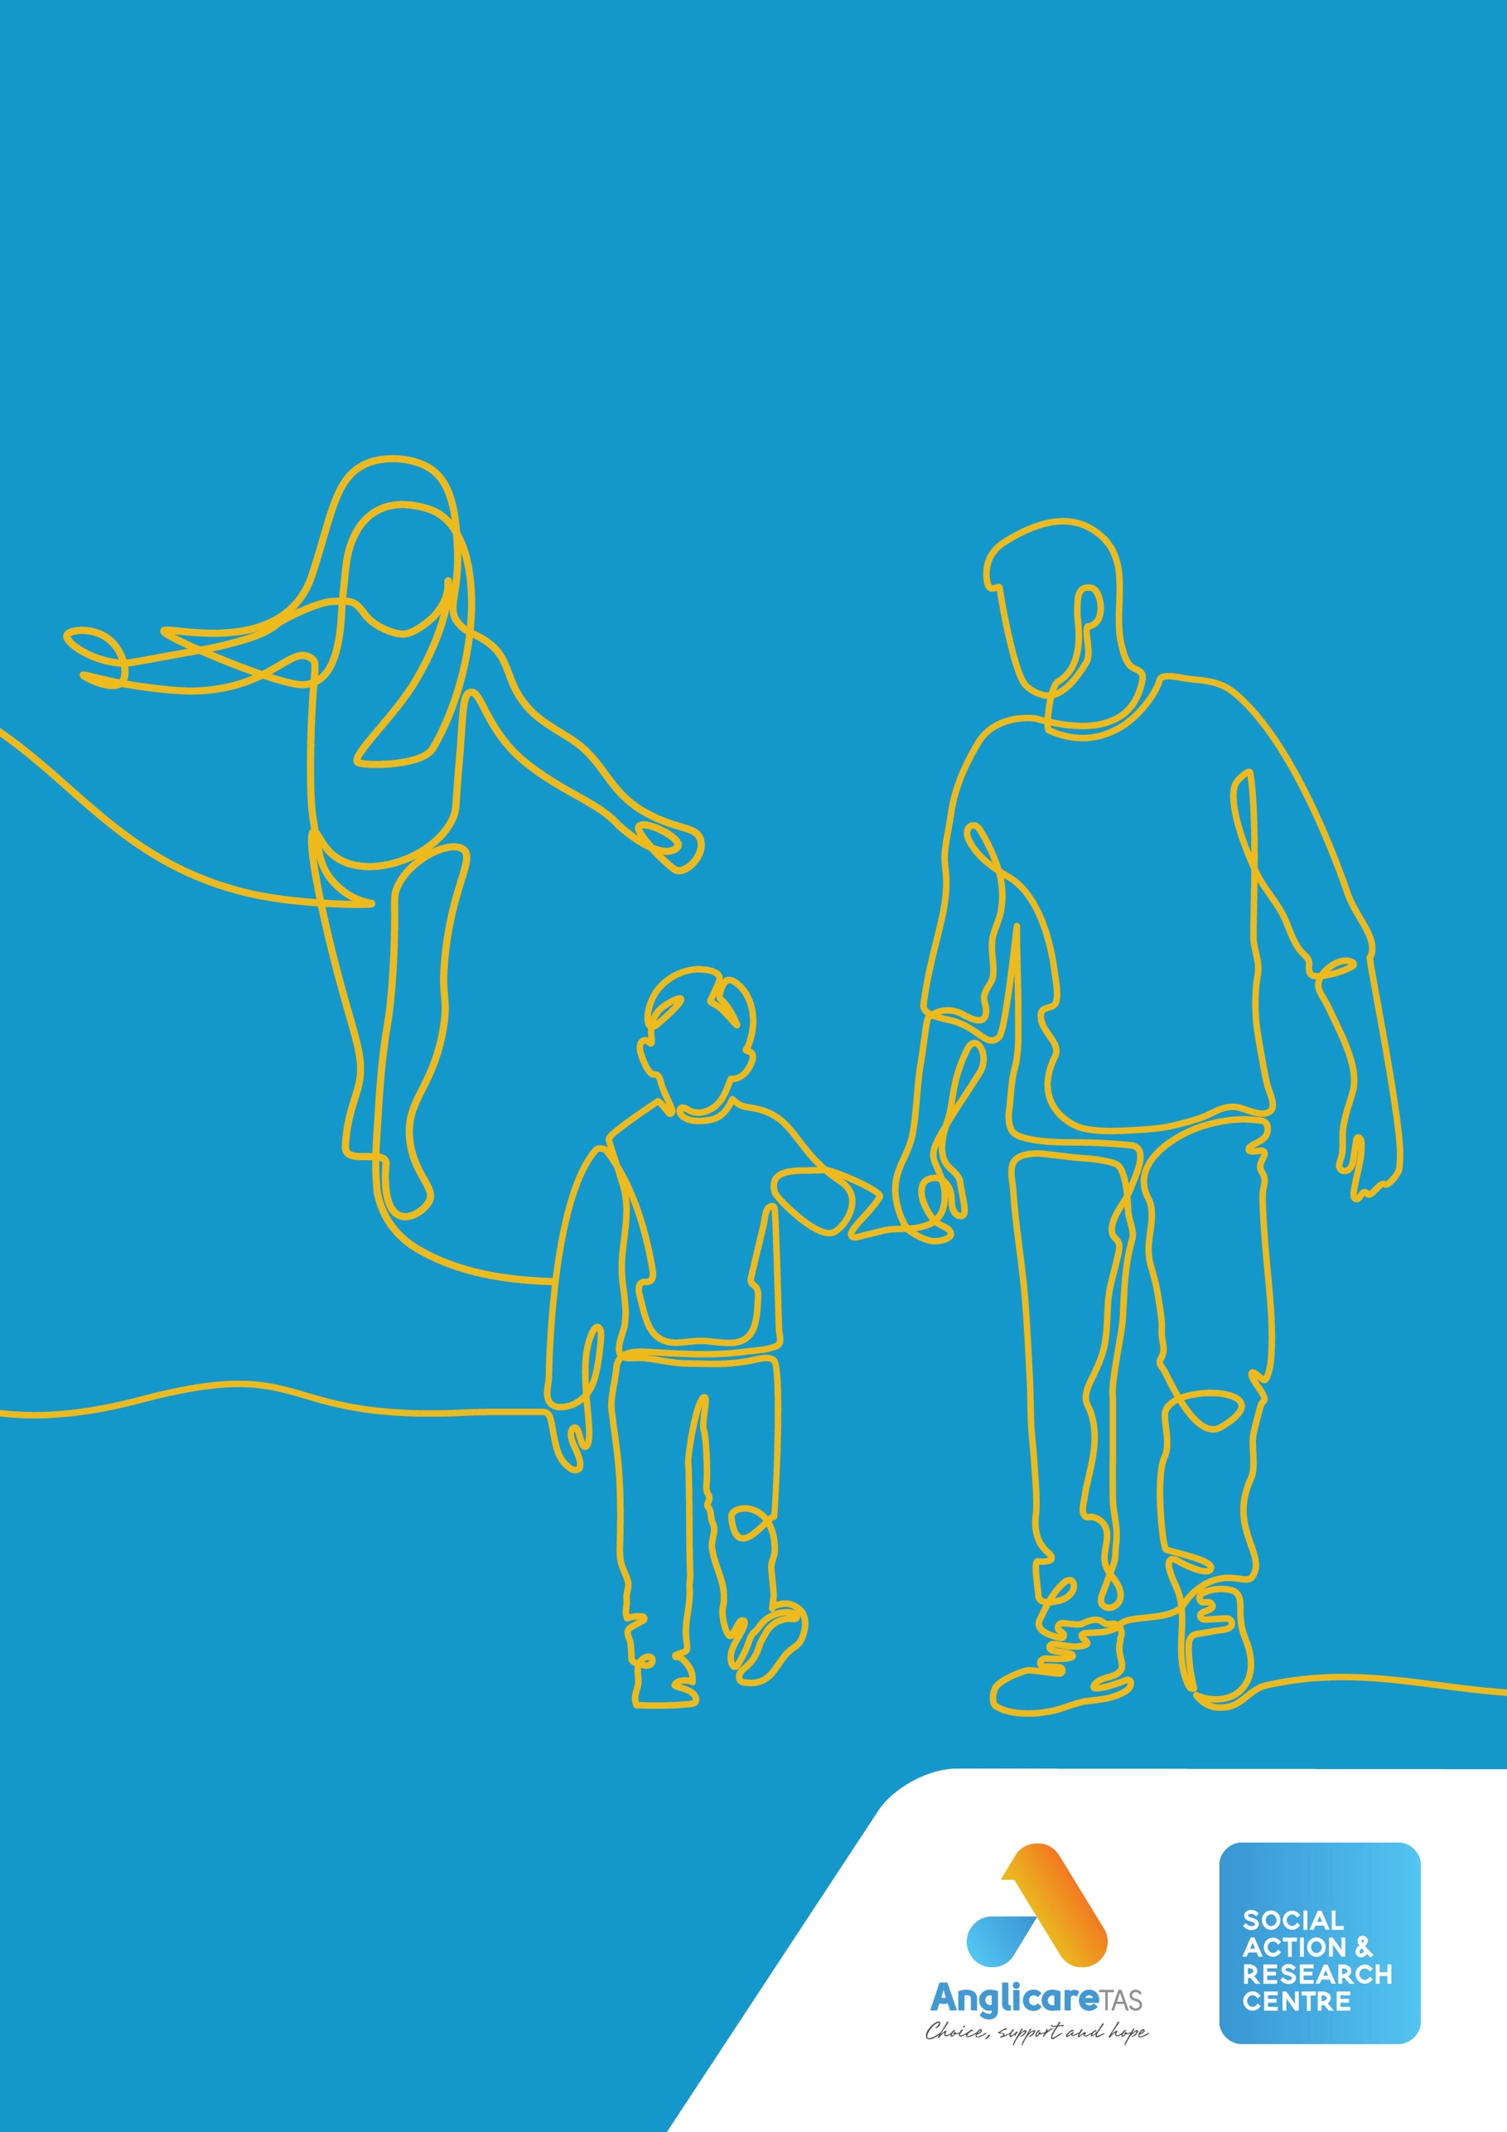
Action for a healthier community: an effective response to illicit drugs

2023
WORKING FOR
A JUST TASMANIA

Contents
Hope for a healthier community 4
Recommendations 5
The current approach 6
Harms from drug use 7
The current approach is not meeting Tasmanians' needs 8
Treatment and supports are under pressure 8
… and they don’t always feel safe 8
Criminal convictions are not preventing future crime 9
Drug arrests and seizures rise, but use is unaffected 9
Problematic drug use is a marker of inequality 10
The ripples from a criminal conviction and inequitable penalties spread widely 12
A more effective approach to drug use 13
The harm cycle can be interrupted and redirected to flourishing 13
Prevention is the first step 15
Our recommended approach addresses harms 15
The evidence for this approach 17
Decriminalisation is associated with less harmful drug use 17
Decriminalisation reduces the prevalence of drug use disorders 17
Decriminalisation reduces deaths due to drug use disorders 18
Decriminalisation is saving lives 19
Decriminalisation is a matter of justice 20
Decriminalisation delivers net economic benefits 21
Conclusions 22
Recommendations 23
Glossary 24
References 26

Anglicare Tasmania acknowledges the Tasmanian Aboriginal community as the traditional and original owners and continuing custodians of this land lutruwita. We pay respect to Elders past and present.

Social Action and Research Centre
At the Social Action and Research Centre (SARC), we contribute to building a more just Tasmania.
This means we listen, collaborate, research, advocate and educate. We carry out research and work for changes that will reduce poverty and disadvantage. We listen to the views and experiences of people in local communities. We also hear from frontline workers. We share what we learn with others—including decision-makers in government.

Some words in the text are highlighted. These terms are defined in the Glossary.

There comes a point where we need to stop just pulling people out of the river. We need to go upstream and find out why they’re falling in.
―Archbishop Desmond Tutu

Hope for a healthier community
“I was in child protection from really early, and never really learned how to care for my own kids. I wasn’t the parent I wanted to be. The kids were taken away, ’cause I’d neglected them, and it hit me so hard. Drugs numbed the pain. Now, if I don’t get myself sorted out, I’m facing prison”
Safeguarding and improving the health and wellbeing of all Tasmanians is a priority. The State’s Healthy Tasmania Five-Year Strategic Plan 2022–2026 identifies the need for a healthier population, greater equity of health outcomes, liveable, vibrant and healthy places, and greater social connectedness.
To deliver a healthy Tasmania, we need evidence-based, effective action on drugs.
We are already delivering services to reduce the harm to Tasmanians from drug use. But our current response to the possession and use of illicit drugs criminalises people, pushing them to the margins of society and perpetuating trauma by cutting them off from family and friends, from secure housing, from paid employment and volunteering, and from seeking the preventive help or treatment that might enable them to be part of flourishing communities.
We have the opportunity to disrupt this cycle of harm by increasing equity, fairness and inclusion, and empowering people and communities to shape their health and wellbeing.
This position paper builds on Anglicare’s work to reduce the harms from drug use, to enable the development of natural social supports for members of our community who have drug use disorders, and to work for a more just approach.
Restorative justice and therapeutic jurisprudence are at the heart of this work.

Recommendations
Anglicare Tasmania recommends implementing an evidence-based public health approach to illicit drug use that is effective in reducing harms to individuals, families and communities and less costly than the current approach by:
- Acting to address the upstream factors that predispose people to drug use disorders and recognising that access to the social determinants of health (including housing, education, social supports, health care, income, employment, connected communities and nurturing childhood experiences) are critical to the success of any strategy to minimise harm from drugs.
- Increasing access to treatment by building on existing evidence-based initiatives to significantly boost the availability of non-discriminatory, adequate, accessible and non-stigmatising treatments and support services for those living with drug use, including:
  - making the needle and syringe program available in more locations
  - providing safe injecting rooms
  - addressing the lack of access to health care through general practitioners
  - providing bulk-billed access to mental health programs for people at increased risk of drug use disorders.
- Removing criminal sanctions for possession and personal use of illicit drugs and replacing them with administrative and civil sanctions as well as expunging historical convictions.
- Introducing more equitable penalties such as means-tested penalties (“day fines”) and Work and Development Orders as well as making greater use of cautions, deflection and diversion, and treatment orders.
This position paper sets out the evidence for the harms perpetuated by our present approach, and for an alternative that is compassionate, respectful, and just.

The current approach
The current approach does not adequately minimise harms to individuals, families and communities, and is costly.
The aim of Tasmania’s present strategy is to prevent and reduce the health, economic and social costs and harmful effects of drug use in Tasmania [2]. This harm-minimisation approach considers the systems that may be involved in problematic drug use and the need for cross-agency responses [3].
While many aspects (e.g., Court Mandated Diversion, Diversion Treatment Orders) of Tasmania’s approach are de facto decriminalisation, the criminalisation of possession and personal use of illicit drugs undermines efforts at harm minimisation [4].
Criminalisation of possession and use is costly [5]. It underpins stigma and marginalisation, increasing the harms from drug use, damaging the lives of individuals and their families, and creating barriers to a healthier Tasmania.
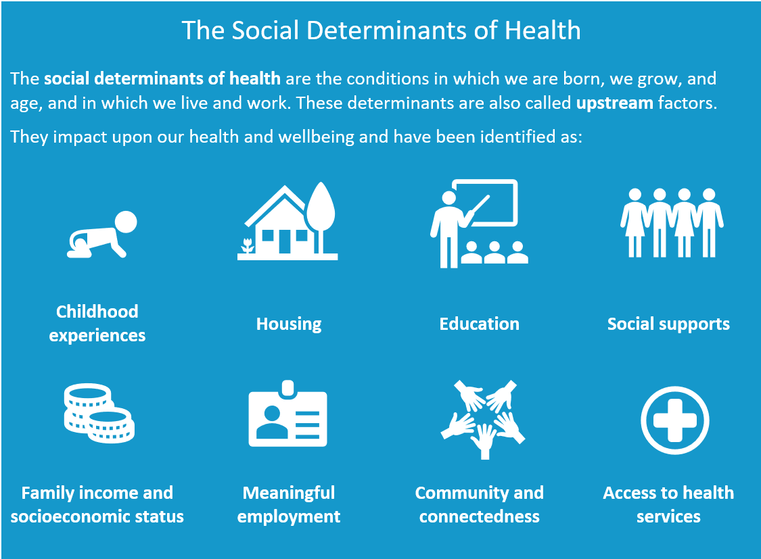
Criminalisation also compounds rather than improves the upstream factors, including the social determinants of health, that play a major role in perpetuating the harms from drug use.

Harms from drug use
Harms are physical, psychological and social, and the ripples touch everyone. They are summarised in Table 1.
Table 1: A categorisation of harms from drug use
Harms | Individuals | Families and friends | The community
Physical | Drug overdose (fatal or non-fatal)  Drug-related comorbidities impacting health, including:  - HIV, Hep C  - liver damage, cancer  - IV site infections/damage  - accidents and injuries  - impaired cognitive function | Elevated risk of family violence  Infection | Unsafe environments due to:  - discarded sharps  - risky or aggressive drug-related behaviours  Personal and property damage due to drug-related crime, including road trauma
Psychological | Drug dependence  Impaired cognitive function  Anxiety and depression associated with:  - drug use  - interactions with the criminal justice system  Stigma and taking on a stigmatised identity  Moral injury from perpetrating acts that transgress deeply held moral beliefs and expectations | Anxiety about the welfare of the drug user  Anxiety about interaction with the criminal justice system  Vicarious stigma  Moral injury from failing to prevent, bearing witness to, or learning about acts that transgress deeply held moral beliefs and expectations | Moral injury from failing to prevent, bearing witness to, or learning about acts that transgress deeply held moral beliefs and expectations
Social | Loss of primary relationships (e.g., partner, children, parent)  Criminal convictions, and incarceration  Increased likelihood of future criminal behaviour  Loss of work and economic resources  Insecure housing or homelessness  Stigma and marginalisation from:  - services (e.g., health)  - community [6, 7] | Time lost to and emotional load of attending to drug user’s health  Disrupted or lost primary relationships  Impacts on family cohesion, household income and child development  Insecure housing or homelessness  Vicarious stigma and marginalisation from services (e.g., health and education)  Vicarious stigma and marginalisation from community | Economic costs due to:  - disability and death of persons using drugs  - reduced engagement in workforce  - welfare and health care costs  - criminal justice system costs (enforcements, courts, incarceration)  Intergenerational trauma  Intergenerational perpetuation of marginalisation and disadvantage
Adapted from Bonnet et al. [8].
Australia’s National Drug Strategy [9] categorises a similar set of harms as health, social and economic harms (see Table 2).

The current approach is not meeting Tasmanians' needs
“You can get treatment, and maybe control your use, but the conviction you get at 17 stays with you forever”
Tasmania has several harm-minimisation measures in place, including Alcohol and Other Drug services, the Needle and Syringe Program and naloxone kits. These measures help to reduce co-morbidities among injecting drug users, and better manage overdoses [10]. However, they do not address upstream risk factors for drug use disorders (DUD) or enable people to access preventive treatment. Where stigma or poverty are present, a court-mandated order for drug treatment may be the only opportunity to access help.

Treatment and supports are under pressure
In a healthy Tasmania, all those seeking assistance to prevent or treat a drug use disorder would have safe access to appropriate services: mental health services, general practitioners and drug treatment programs. Mental health, general practice and drug treatment services are at or near capacity, bulk-billed options are rare, and people who use drugs (especially intravenous drugs) are often excluded [11, 12]. In addition, while Aboriginal health services provide culturally appropriate care and support, this is not necessarily the case in the mainstream. Even where services and supports are available, there is evidence of stigmatising interactions and discrimination [e.g., 13, 14, 15] creating “additional barriers to accessing social and medical support, financial stability, housing, and employment and thereby compound the risk factors for progression” [16].
“This is a small town—everyone knows that you’ve been getting methadone, or been to the clinic”

… and they don’t always feel safe
The stigma attached to drug use and fear of the consequences of a drug conviction means that people who might have sought help do not do so [7]. As a result, we are not effectively preventing the development of drug use disorders. Stigma is increased by drug convictions.
“[We’ve] seen the look on people’s faces. When we took B [to health services] for example … she looks like a drug addict. … And the doctors and the nurses [have] an involuntary look of ‘Oh my God’… And I understand where that’s coming from, but if I see it, do they see it? — Absolutely. They see that they’re being judged immediately. And that’s why so many [of our community] have trust issues around … entering buildings where they need to try and access health … ” [1]
People with a drug conviction are often unable to find work, with many organisations and employers using police checks that can result in (illegal) discrimination against potential paid employees and volunteer [16-18]. Similarly, drug convictions result in discrimination in the housing market. This is especially damaging where custody of children might be affected by a lack of secure and appropriate housing. The present policy exacerbates these factors.
Julie
Julie started injecting heroin at the age of 14 and soon became dependent on opioids. She started opioid agonist therapy (OAT) when she was 17. Julie’s OAT use has been intermittent, but she’s currently on methadone.
After injecting for 30 years, Julie has few veins that she can access and she’s begun injecting in her neck. Now, though, she’s developed a lump in her throat where she has tried to inject and worries that she’s accidently ‘blown’ the vein. The throat is a high-risk site for injecting, since the carotid artery is right next to the jugular vein and a major nerve, close to the heart and the brain. Repetitive injecting may lead to deep vein thrombosis (DVT).
The service staff discovered Julie was injecting in the wrong direction and urged her to seek medical attention. Like many illicit drug users, she was very hesitant to seek medical assistance for an injecting injury. She had experienced stigma in the healthcare system before and feared being “kicked off” methadone and “forced onto” buprenorphine, which comes with multiple side effects like anxiety and dizziness, headache and constipation or diarrhoea and vomiting.

Criminal convictions are not preventing future crime
Drug use disorders, homelessness, poor access to health and psychological care, unemployment and mental illness [19] are elements in “a cycle of poverty, criminality, incarceration, and recidivism” [20]. Incarceration does not reduce reoffending or recidivism [21, 22]. Indeed, incarceration can increase criminal behaviour [23]. Nationally, up to 84 per cent of convicted intravenous drug users return to prison within two years [24], and in Tasmania, around 60 per cent of all young offenders return to prison within a year of release.

Drug arrests and seizures rise, but use is unaffected
I remember when I first started [using drugs], when I was 19, I used to look at some of my older friends and think ‘‘I wonder at what age you grow out of it?’’ [25]
The Alcohol, Tobacco and Other Drugs Council [14] reports that despite a 91.7 per cent increase in drug seizures over the past decade and an increase in drug arrests [5], illicit drugs continue to be cheap and easy to access in Tasmania [26]. Long delays in the court processes [in Tasmania in 2021–2, the mean delay was 22 weeks; 27] and the disruption to work and family caused by multiple appearances add to disadvantage.
A much larger proportion of Australians has used illicit drugs [28] than might consider themselves law-breakers.
Generally, people take drugs socially rather than living the life of a heroin addict or ‘spice zombie’ as presented in the media … a large majority of persons who have used drugs do not proceed to develop [problematic drug use] PDU, regardless of the particular substance used. Rather, most people’s drug use is episodic and transient. [29]
For most people, drugs—including alcohol—are used for social reasons [30]. Those who remain safe from interaction with the criminal justice system are protected by the absence of upstream factors that predispose people to developing a drug use disorder. They remain free to participate in and contribute to the healthy life of the community. If a drug use disorder develops, they are also more likely to be able to afford private treatment.

Problematic drug use is a marker of inequality
Drug use, the development of drug use disorders, and deaths from drug use disorders are not evenly spread across society. Deaths in particular are much more prevalent among people who have poorer access to the social determinants of health.
Being an Aboriginal person reduces access to the social determinants of health, and adds the burden of discrimination [31-33]. Tasmanian Aboriginal people are over-represented in Tasmania’s corrections system [34, 35], and the Tasmanian Aboriginal Legal Service reports that more than three-quarters of Indigenous prisoners have a substance use problem. This is associated with a high rate of mental illness among Aboriginal prisoners (at least 22%) [34]. Aboriginal people are also over-represented in Tasmanian Alcohol and Other Drug services (e.g., Anglicare service data).

Jas
Jas’s life has been shaped by trauma. Her parents used drugs, and had several convictions, resulting in Jas being taken into the Child Safety System. Jas had her first child at 14, while she was under a Child Safety Services Care and Protection Order; the child was taken into permanent care.
A few years ago, Jas was convicted for crimes related to drug use. The prison term did not act as a deterrent. She was facing similar charges when she came into Anglicare’s Kids in Focus program.
Jas has a long-term relationship with Tim and they have three children. Jas and Tim have their ups and downs, but they wanted to be deemed capable of looking after their kids. That meant managing their illicit drug use and gaining some parenting skills, so they worked with Kids in Focus for about 18 months. Their goal was realistic: reduce drug use to enable them to be good enough parents and keep the family together.
Jas and Tim have sometimes found it hard to get the kids to school; eventually Child Safety got involved. Finding that Tim and Jas were using illicit drugs and that the house was not in a safe state for children, Child Safety took the kids into care. At the same time, Jas was also waiting for possession, theft and drug-driving charges to come up in the court system. When they were eventually heard, Jas was jailed, although she maintained access visits to her children. Tim, who had been relying on sharing rental costs of their home with Jas, was unable to cover the rent and became homeless.

A study reported in The Lancet found that three-quarters of all premature deaths in England caused by illicit drug use were attributable to socioeconomic inequality [36]. Childhood or adolescent trauma—such as that caused by poverty, being removed from parents or having children removed [24], experience of family or other violence, and housing insecurity or unsuitability—increase the likelihood of problematic drug use [16, 37-39] and of incarceration [24], while also being frequent products of untreated drug use disorders. Access to health care is a social determinant and so where mental health and services are stretched or expensive, children and young people in need of diagnosis or preventive care miss out.
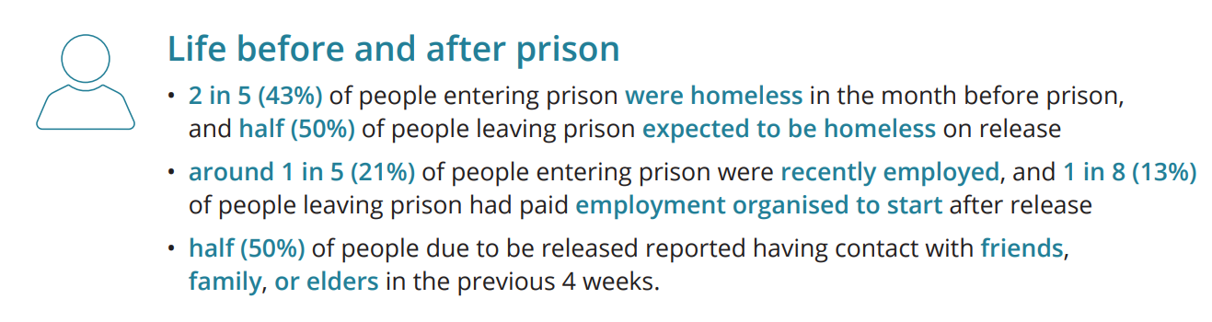
The following 2018 snapshot of life before and after prison in Tasmania shows how imprisonment leads from disadvantage to even greater disadvantage [40]:
People with a range of mental health conditions are between two (social phobia) and more than five times as likely (ADHD or bi-polar disorder) to develop a drug use disorder [41].
Problematic drug use, then, is a risk marker [42]. It indicates, and may be a response to, the presence of upstream problems [43]. Criminalisation unjustly affects those already living with some forms of disadvantage [21]. Criminalisation of drug possession and use exacerbates existing disadvantage and creates additional trauma.
Toby
“If you can get into CAMHS. If they’ll accept you … Child Adolescent Mental Health Service. If you can get in, you can get a counsellor. But they don’t have to accept you. So, you’ve got to go to your GP to get a referral to a paediatrician who’ll refer you to a counsellor, who’ll refer to a service.
And in the meantime, you have a child that has anxiety, depression, expresses the desire to commit suicide, expresses a desire to harm others, gets violent, has explosive uncontrollable rage, and … you’ve got to deal with all of that and social issues and the schooling issues and the mental downturn of that child because they feel worthless. And you’ve got this whole process that you’ve got go through. And in the meantime, it’s just getting worse. And the process takes as long as it takes.
It’s time, expense, and process of referral to a referral to a referral, that each process takes as long as it takes. It could be months for each process to be done. And in the meantime, the school outcomes are—‘I’m so far behind and I’m not worth anything because I can’t read as well as my younger two siblings can read. And I’ve got this older brother that’s got—you know, is off the charts brainy-wise and I just feel so worthless. So, I’ll just break something, pull something apart—‘.
And at the end of the day, you end up with someone, not to put too fine a point on it, like my child. Drug addicted. Disenfranchised. Disassociated from family. Only associates with other drug users. Unemployed. Unemployable. Violent. Uncontrollable rage. And then it just goes from there.” [1]

The ripples from a criminal conviction and inequitable penalties spread widely
A criminal conviction can mean incarceration, the involvement of Child Safety, significantly reduced employment opportunities and the loss of secure housing.
Even the apparently mild sentence of a fine can result in a cascade of difficulties. In Tasmania, about half of all drug offenders are fined, with the maximum penalty being $7050; at present, the median amount is $500 [27]. For an unemployed person, with few or no assets, any fine can be unaffordable. People who are unable to pay a fine receive enforcement sanctions, including suspension of driver’s license and vehicle registration, yet they may take the risk of driving to take children to school or to go to work, thus resulting in the commission of other crimes and in many cases a prison sentence.
Criminalisation perpetuates intergenerational trauma. It exacerbates upstream structural failures. It is costly, ineffective and harmful. We are, to quote Archbishop Tutu, simply “pulling people out of the river”. We need to find ways to stop people from falling in.

Dave
A likely mental health disability and cognitive impairments have shaped Dave’s life. His disability sits alongside a very traumatic childhood, loss of attachment to his mother, early departure from education, very long-term homelessness, and the use of alcohol and other drugs to ease the effects of his anti-social personality disorder and his anxiety-provoking circumstances. He reacted to some of his difficult encounters with aggression and violence, drank too much and took illicit drugs, and it’s got him into trouble. Criminal charges were hanging over him.
With support, Dave was able to find a stable job and a unit, but he lost the unit when he was finally sentenced for possession of illicit substances and went to jail for four months. That process—with long delays, multiple court appearances and disruption to his work, and uncertainty about the adjournments and possible outcomes—added significantly to his distress and, with his criminal record, secure housing is now out of reach.

A more effective approach to drug use
Criminalisation of the possession and personal use of drugs compounds a cycle of intergenerational disadvantage. This is illustrated in the left-hand panel of Figure 1.
People’s lives are shaped by access to the upstream social determinants of health.
Where there is a failure upstream, people face greater risk of developing drug use disorders (including as self-medication) and more barriers to prevention and treatment.
Criminalisation of possession and personal use perpetuates trauma.
Drug convictions and incarceration cause personal, family and community harms through stigma and marginalisation and exclusion from work, services, housing and social connection. Convicted drug users may lose custody of their children, increasing trauma for themselves and their children, and undermining social cohesion.
Stigmatised and marginalised people lack access to the social determinants of health necessary for flourishing.
A criminal conviction sets people up to experience conditions that increase their own and their children’s risk of developing a drug use disorder.

The harm cycle can be interrupted and redirected to flourishing
Existing harm-minimisation measures can be complemented and improved through an evidence-based public health approach that:
- Addresses the upstream factors—for flourishing, people of all ages need access to the social determinants of health. Such access reduces the rates of intergenerational trauma, and enables protective measures such as early diagnosis and treatment of disorders.
- Increases access to treatment—existing evidence-based initiatives (e.g., the Needle and Syringe Program, take-home naloxone kits) should be complemented by non-discriminatory, adequate, accessible and non-stigmatising treatments and support services.
- Decriminalises personal drug possession and use—possession and personal use should attract civil and administrative sanctions only, and expunging historical convictions would further minimise harmful marginalisation and exclusion.
- Removes the discrimination of inequitable penalties—increased use of informal and formal cautions, deflection and diversion, treatment orders, and the introduction of means-tested (“day fine”) penalties and Work and Development Orders, to support recovery, reconnection with community and restored relationships.
The approach proposed by Anglicare supports the goal of harm minimisation, championed by successive Tasmanian governments, and the National Drug Strategy [2, 3, 9]. It does this by following a whole-of-life prevention, treatment, harm-minimisation and restorative justice model, illustrated in the right-hand panel of Figure 1. Crucially, it enables healing of the moral injuries that damage us all.
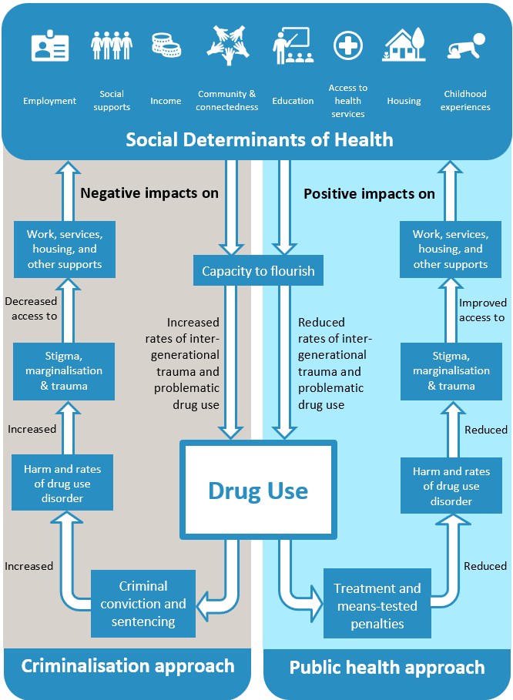

Figure 1: Comparing criminalisation and public health responses—impacts on social determinants of health and the capacity to flourish.

Prevention is the first step
“Why treat people and send them back to the conditions that made them sick?” [38]
The strength of the approach proposed by Anglicare lies in combining “prevention, demand reduction, and harm-reduction, as well as maximizing treatment resources and availability for those who seek it” [44]. This means that unless we address the upstream social determinants of health, and their role in drug use disorders, any approach will remain costly and harmful.
The risk factors for the development of drug use disorders can be mitigated by:
- safe, affordable access to good quality healthcare (including mental health care) for the diagnosis and early treatment of disorders that predispose a person to unsafe drug use
- protection from the traumas of poverty and violence
- reliable access to education, housing and employment
- social connection within families and with community.
For the public health approach to work, we need decriminalisation—but decriminalisation nested in a web of supporting measures [see 45]. The evidence for Anglicare’s proposed approach is provided in the next section.
Decriminalisation is not legalisation. Drugs that are currently illicit in Tasmania would remain so. But their possession and personal use would attract fines and treatment orders, rather than convictions and incarceration.

Our recommended approach addresses harms
The National Drug Strategy categorises the harms of drug use as health, social and economic harms. These can be mapped to the physical, psychological and social/societal harms provided in Table 1.
Table 2: Impact of recommendations on harms in the National Drug Strategy
Types of harm | Recommendations address harm by
Health  - injury and overdose  - chronic conditions and preventable diseases  - mental health conditions and psychological distress  - road trauma | - improving accessibility of medical treatment, including removing fear of conviction and stigma and discrimination as barriers to seeking help.  - decreasing stigma and discrimination overall and its impact on inclusion, mental wellbeing and help-seeking  - reducing drug overdoses (fatal and non-fatal) by enabling safer environments and practices for people using drugs  - decreasing levels of anxiety and depression associated with interactions with the criminal justice system  - decreasing drug dependence by increasing use of treatment and support services  - decreasing moral injury experienced as a result of perpetrating, failing to prevent, bearing witness to, or learning about acts that transgress deeply held moral beliefs and expectations
Social  - violence and other crime | - decreasing the total number of criminal offences by decriminalising minor offences  - minimising potential increased future engagement in other criminal activity associated with incarceration  - decreasing violence through increased effectiveness and reach of drug treatment and support programs  - preventing crime perpetrated to avoid conviction for minor drug offences
- engagement with the criminal justice system | - reducing the engagement of people using drugs with the criminal justice system  - improving compliance with penalties and reinforcement of the rule of law
- contribution to domestic and family violence | - improving engagement of drug users with treatment and supports  - increasing the likelihood of perpetrators and victim survivors seeking help, and the likelihood of victim survivors escaping from a violent situation, by removing the fear of conviction
- unhealthy childhood development & trauma  - intergenerational trauma  - child protection issues  - child/family wellbeing | - avoiding impacts of conviction or incarceration of parents on family cohesion  - improved treatment and supports for parents using drugs  - consequential improvements in social determinants of health  - preventing problematic drug use by children through improved social determinants of health and reduced experience of trauma  - increasing opportunities for restoration of beneficial community relationships
Economic  - healthcare and law enforcement costs | - reducing health care costs mainly due to prevention, earlier intervention and treatment  - increasing cost effectiveness of support programs through increased engagement  - reducing criminal justice system costs, including enforcement, courts and incarceration
- decreased productivity | - reducing death and disability as a result of drug use  - decreasing lost productivity due to incarceration and drug-related disability or illness  - preventing the impacts of convictions on future employability
- associated criminal activity | - decreasing the total number of criminal offences by decriminalising minor offences  - reducing the increased future engagement in other criminal activity associated with incarceration  - preventing crime perpetrated to avoid conviction for minor drug offences  - reducing the consequential personal and property costs of crime
- reinforcement of marginalisation and disadvantage | - preventing the amplification of disadvantage resulting from criminal conviction and incarceration of a parent  - reducing stigma and marginalisation of drug users  - reducing intergenerational harm by improving the social determinants of health—childhood experiences, housing, education, social supports, family income, meaningful employment, communities and access to health services

The evidence for this approach
Portugal is the most-cited example of the benefits to society of decriminalising the possession and personal use of drugs [15, 44, 46-49]. Bartl [5] provides a clear description of the Portuguese public health and social model. Portuguese responses to drug use are multi-factorial, and include prevention, demand reduction, harm minimisation via decriminalisation of possession and consumption, citation for possession or use to a “Dissuasion Committee” rather than arrest, application of administrative responses, increasing information and education, and expanding investment in therapy and other rehabilitative measures and in social reintegration [44, 47]. Since decriminalisation came into force in 2001, Portugal has recorded declines in:
- drug use by young people (the most at-risk group for the development of drug use disorders)
- drug use disorders and drug-related deaths overall
- imprisonment for drug offences and recidivism
- HIV and hepatitis infections
- social costs (health and criminal justice system costs): 12% after 5 years and 18% after 11 years [45, 48, 50]
- stigma associated with drug use (leading to more people accessing and undertaking treatment)
- effective restoration of people to their communities and work.
As well, younger police officers are now more likely to intervene in drug usage, viewing the administrative processes as “the best hope for containing addiction” [44].

Decriminalisation is associated with less harmful drug use
There are now more than 30 nations with decriminalisation [51]. They share many of the beneficial changes seen in Portugal. Changes include reduced HIV infection rates among intravenous drug users [52] and, with fewer minor offences to process, overcrowding in the criminal justice system is reduced, freeing up additional resources for targeting drug trafficking [47] and supporting people with complex needs [53].
Importantly, decriminalisation is associated with reductions in the prevalence of drug use disorders and deaths caused by drugs.
Despite multiple versions of decriminalisation operating internationally, there are better health and social cost outcomes associated with drug use in countries with decriminalisation than in those without.

Decriminalisation reduces the prevalence of drug use disorders
The Global Burden of Disease study [54] provides prevalence data for drug use disorders and drug use deaths in countries broadly comparable with Australia (OECD nations).

Between 1990 and 2019, the prevalence of drug use disorders (DUD) declined in OECD countries with decriminalisation (Figure 2) and rose in countries without.

Figure 2: Comparison of mean prevalence rate of DUDs per 100,000 population, OECD
The reduction in prevalence of drug use disorders in countries with decriminalisation is small, but markedly different from the increase experienced in countries without decriminalisation (Figure 3).

Figure 3: OECD change in prevalence of DUDs, 1990–2019

Decriminalisation reduces deaths due to drug use disorders
Between 1990 and 2019 there has been an overall increase in the proportion of all OECD deaths caused by drug use disorders. The OECD average for this period is very low, at 0.24% of all deaths, and countries where drug use is criminalised account for most of the increase in the death rate since 1994. Between 1994 and 2019, in countries where drug use is criminalised the death rate increased by 110% (green line, Figure 4), compared to a 17% increase where decriminalisation is in place (red line).

Figure 4: Comparison of mean death rate from DUDs per 100,000 population, OECD

Figure 5: Comparison in deaths due to drug use disorders, 2019, OECD nations with and without decriminalisation
The gap has widened and by 2019, the proportion of all deaths related to drug use disorders was 2.3 times higher in countries where drug use is criminalised (Figure 5) than where it is decriminalised.

Decriminalisation is saving lives
Internationally, the United States is a clear outlier. It continues to experience striking increases in the prevalence of drug use disorders and in deaths due to drug use disorders (2.23% of the nation’s total deaths in 2019). This reflects a battle with illicit use of prescription opioids, as well as a very complex policing environment, some failings in healthcare provision, and high levels of stigma attached to drug use [16, 55], especially among disadvantaged people.
In 2019, Australia had the fourth highest percentage of deaths caused by drug use disorders in the OECD (0.66%) and this death rate has been trending up (Figure 6).

Figure 6: Deaths due to drug use disorders as a proportion of all deaths in Australia, 1990–2019

Decriminalisation is a matter of justice
The rule of law is an essential part of a functioning society. It can be summed up as “(1) that the people (including, one should add, the government) should be ruled by the law and obey it and (2) that the law should be such that people will be able (and, one should add, willing) to be guided by it” [56]. The rule of law is under threat in those places where poorer people have reduced access to prevention and treatment (and so are more likely to commit offences), and where some groups are more likely to be arrested and imprisoned. This is true for disadvantaged people in Tasmania, and for Aboriginal Tasmanians in particular [33, 34, 57]. States and nations where decriminalisation has been less effective are characterised by discriminatory policing [e.g., 55].
Drugs which are presently illegal would remain so with decriminalisation. The important change is that in the approach proposed by Anglicare, a person found in possession of or using illicit substances would—assuming they were not involved in trafficking or dealing—receive an administrative or civil penalty rather than a criminal conviction. That is, when police encounter a person using or in possession of a non-trafficable quantity of an illicit drug, they could choose to:
- issue an informal or formal caution
- deflect the person (e.g., calling a case worker to assesses the person’s needs and find a suitable treatment program)
- issue a citation to a specialist drug court that applies therapeutic principles.
These elements build on Tasmania’s existing court processes [58]. Importantly, criminal justice responses need to impact all equally. Adding day fines and a ‘work and development order’ option to existing strategies would support a restorative justice approach [17], and enhance opportunities for social reintegration.
Stigma and hardship can be reduced through fairer penalties, which reinforce the rule of law, the foundational principle that laws are applied equally and fairly to all in a society.

Decriminalisation delivers net economic benefits
Christina
Christina is in home detention, living in a caravan on a relative’s property near a rural town. This is the third place she’s tried to ‘park’ the caravan as she needed to find somewhere legal and long-term in order for home detention option to be allowed. She lives in the caravan with her long-term partner, and is very happy to not be in prison. She was convicted of drug possession after spending 18 months on bail. The home detention sentence is a bright spot; she’s managed to stay out of jail.
How did she get here? She had a violent and abusive childhood and adolescence characterised by poverty, crime and sex work. She managed to escape this traumatic life, and to form and maintain a long relationship with the father of her children, despite patches of violence. He doesn’t use drugs, but for Christina, using may have been a form of self-medication.
Christina has lost custody of her children, each of whom has suffered the impacts of traumatic beginnings. The kids have significant physical and mental health conditions—all of which are beyond her capacity to support or manage. She wants to maintain their relationship and visits them when she can, relying on public transport. Christina’s very long-term drug use means that she has impairments of her own that require treatment. But the services she needs are a long way from where she lives, transport is expensive and infrequent, and appointments are on a first come first served basis.
She can feel hopeless at times but has not used drugs since before the home detention order was put in place. Now, she’s taking things one day at a time. The opportunity of home detention rather than a prison term gives her hope of staying away from drug use.

Blacklow [5] estimated the annual cost of drug use (in 2021–22 dollars) under the current Tasmanian legal framework and compared it to the annual cost of illicit drug use under decriminalisation. Basing his assumptions on data from countries that have decriminalised drug use and drawing on available quantifiable Tasmanian data, Blacklow estimated that decriminalisation of illicit drug use in Tasmania in 2021-22 would save $61.8 million or 10.4% of the 2021–22 cost annually [5].
Blacklow’s estimates of quantifiable costs are summarised in Table 3.
Table 3: Quantifiable costs of illicit drug use 2021–22 under current law and decriminalisation
 | Current law | Decriminalisation | Difference
 | ($m) | ($m) | ($m) | (%)
Total crime | $160.2 | $156.2 | -$4.0 | -2.5%
Total death and disease | $367.0 | $302.6 | -$64.3 | -17.5%
Total health | $54.8 | $60.3 | $5.6 | 10.2%
Total road crashes | $10.0 | $11.0 | $1.0 | 10.0%
Total quantifiable cost | $591.9 | $530.1 | -$61.8 | -10.4%
Source: Blacklow in [5].
With an estimated cost of $367.0 million, death and disease accounts for almost two thirds (62%) of the $591.9 million cost of illicit drug use under current law. This includes the contribution of illicit drug use to liver disease, liver cancer and suicide as well as direct impacts of illicit drug use.
Tasmania—and Tasmanian families—are losing people to drug-induced deaths (39 people in 2020 [59]) and to illness and long-term disability. Evidence indicates that decriminalisation would reduce that loss as a result of drug users seeking earlier treatment which is more effective. The resultant $64.3 million (17.5%) reduction in the cost of death and disease is over ten times greater than the $5.6 million (10.2%) increase in health costs.
Total crime costs include costs of policing, costs to victims of crime and prison costs. Prison costs alone are $122,144 per inmate per year (the second highest in Australia) [21]. People are going to prison for a wide range of drug offences, yet “serious” drug offences make up a small proportion of all convictions. Estimated at $160 million, crime costs contribute 27% of the quantified cost of illicit drug use under current law. Decriminalisation was estimated [5] to reduce crime costs by $4.0 million (2.5%), mainly due to reduced prison costs with the decline in incarceration rates.
Evidence indicates that drug use is likely to increase by around 10% and the costs of road accidents due to illicit drug use is also likely to rise by $1 million (10%) annually. This is a very small increase in comparison to the quantified value of harm reduction through improved health, productive life years and reducing the costs of incarceration.
Applying a social discount rate of 7% to the estimated annual net benefit of decriminalisation yields a total net present value of decriminalisation of $883 million.
Blacklow’s [5] estimate does not include unquantifiable impacts such as the personal cost to illicit drug users of physical and psychological pain (see Table 1), of waiting to learn their fate in the criminal justice system, of damaging conditions that go undetected or untreated because of stigmatising experiences with services [e.g., see 7] or mandatory reporting requirements, and the psychological pain of exclusion. Similarly, families and friends experience not only the pain of problematic drug use by a loved one, but also the disruptions to relationships, schooling and work, and the taint associated with addiction and the costs of supporting the drug user. The costs to Tasmanians of intergenerational trauma and child removals are also not quantified and are likely to be large. Finally, there are the costs to all Tasmanians of the moral injury of “perpetrating, failing to prevent, bearing witness to, or learning about acts that transgress deeply held moral beliefs and expectations” [60].

Conclusions
The evidence supporting decriminalisation is strong and it is strongest in countries where decriminalisation has been introduced as part of a response focused on health and therapeutic justice. Models of decriminalisation that include targeted diversion to health and social services show the greatest promise:
drug-related health harms decrease
burden on the criminal justice system is decreased
access to treatment and harm-reduction services increases
social integration [47] increases
Such comprehensive approaches have high start-up requirements. However, Tasmania already has many of the elements of an effective and beneficial decriminalisation model in place (diversion, NSP, etc.). Further, Blacklow’s [5] estimate of a net reduction in the annual cost of illicit drug use in Tasmania, as well as the unquantified benefits of reducing harm, supports greater investment in a public health approach. This would include the development and implementation over time of upstream measures to reduce the risk factors for problematic drug use, bolstering treatment provision, continuing to build service capacity to deliver trauma-informed support, and building on restorative models of justice that enhance social integration.
The recommendations in this paper address the harms we currently experience from drug use, and can reduce the moral injuries we sustain as a community from witnessing and failing to prevent acts that transgress our deeply held moral beliefs and expectations.

Recommendations
Anglicare Tasmania recommends implementing an evidence-based public health approach to illicit drug use that is effective in reducing harms to individuals, families and communities and less costly than the current approach by:
- Acting to address the upstream factors that predispose people to drug use disorders and recognising that access to the social determinants of health (including housing, education, social supports, health care, income, employment, connected communities and nurturing childhood experiences) are critical to the success of any strategy to minimise harm from drugs.
- Increasing access to treatment by building on existing evidence-based initiatives to provide non-discriminatory, adequate, accessible and non-stigmatising treatments and support services for those living with drug use, including:
  - making the needle and syringe program available in more locations
  - providing safe injecting rooms
  - addressing the lack of access to health care through general practitioners
  - providing free access to mental health programs for people at increased risk of drug use disorders.
- Removing criminal sanctions for possession and personal use of illicit drugs and replacing them with administrative sanctions as well as expunging historical convictions.
- Introducing more equitable penalties such as means-tested penalties (“day fines”) and Work and Development Orders as well as making greater use of cautions, deflection and diversion, and treatment orders.

Glossary
The following terms have been highlighted in this position paper.
Administrative and civil penalties | In law, penalties may be criminal, civil or administrative. Administrative penalties include things like parking fines. They can be imposed by a regulator or agency. Civil penalties are usually monetary but can include community service or compensation orders.
Chronic conditions | Chronic conditions are health conditions or illnesses that are persistent or long-lasting. Examples include diabetes, kidney and heart disease, some cancers and lung diseases. Chronic conditions are linked with the social determinants of health and the risks of chronic illness developing are reduced when people have reliable access to economic resources, secure and good quality housing, good diet, hygiene, health services, social networks and education.
Comorbidity | Morbidities are medical (including psychological and psychiatric) conditions. Where there is more than one condition, these are called comorbidities.
Day fines | Day fines are “founded on recognition of the principle of equal treatment, that is, the impact of the sentence should be similar despite the wealth or financial disadvantage of the offender” [61]. Day fines are applied, usually by police, on the basis of (1) an assessment of the gravity of the offence to determine the applicable number of fine units, and (2) the means of the offender to pay. Thus, a wealthier offender will receive a heavier fine than a poorer offender for the same offence. Offenders would also be offered the chance to replace fine payment with undertaking approved activities through a work and development order (WDO).
DALY, YLL and YLD | DALY—disability-adjusted life years. One DALY represents the loss of the equivalent of one year of full health. DALYs for a disease or health condition are the sum of the years of life lost to due to premature mortality (YLLs) and the years lived with a disability (YLDs) due to prevalent cases of the disease or health condition in a population.  YLL—years of life lost from mortality. One YLL represents the loss of one year of life. YLLs are calculated from the number of deaths multiplied by a global standard life expectancy at the age at which death occurs.  YLD—years of health life lost to disability. One YLD represents the equivalent of one full year of healthy life lost due to disability or ill-health [62].
Decriminalisation | There are two forms of decriminalisation.  In de facto decriminalisation, the misuse of drugs remains a criminal offence, but courts and police may exercise discretion in enforcing laws. Tasmania has several de facto decriminalisation measures in place, including Court Mandated Diversion, and Tasmania Police’s Illicit Drug Diversion Initiative.  In de jure decriminalisation, legislation is changed to remove criminal penalties and replace them with civil and/or administrative penalties.  Decriminalisation is NOT legalisation. Decriminalisation does not allow for the sale and supply of illicit drugs [14].
Discrimination | While discrimination means identifying differences, in justice terms it refers to unequal and worse treatment of people based on characteristics like race, sexuality or culture.
Diversion and deflection | Deflection happens at the point of arrest, with the police officer helping the offender to access treatment (e.g., by calling a case worker who assesses the person’s needs and finds a suitable treatment program) [63].  Diversion involves the Court making an order that usually includes a custodial element, which is activated only if the offender does not meet treatment and supervision requirements (e.g., a Drug Treatment Order) [64].
Drug use disorder (DUD) | A person has a drug use disorder (also known by the terms ‘problematic drug use’ or ‘high-risk drug user’) when their drug use causes significant distress or harm to the user or those around them [65].
Intergenerational trauma | Trauma refers to physical or emotional harms, which may or may not be directly life-threatening and that have a lasting and adverse effect. Violence and abuse are forms of trauma, as is living in poverty. Intergenerational trauma is “psychological trauma transmitted within families and communities” [66].
Marginalisation | People can be pushed to the margins (or edges) of society by characteristics that they may be unable to alter, or because of a mismatch between their culture or beliefs and those of more powerful people. Marginalisation is a result of discrimination.
Moral injury | Moral injury can happen when one is “Perpetrating, failing to prevent, bearing witness to, or learning about acts that transgress deeply held moral beliefs and expectations” [60].
Naloxone | Naloxone is an “opioid antagonist”, used to reverse the effects of opioids. Its main application is in temporarily reversing overdose. This enables responders to seek urgent medical help. Naloxone is available, free of charge, in Tasmanian needle and syringe program (NSP) outlets.
Needle and syringe program (NSP) | The needle and syringe program is a Department of Health service that provides a range of information and equipment to people who inject drugs.
Recidivism | Recidivism is another word for reoffending, or returning to criminal behaviour.
Restorative justice | Restorative justice is informed by Indigenous and other approaches in which the aim is to “repair and restore the relationships and community affected by an offence” [67]. Offenders acknowledge the harms caused by their actions and work with community to be reintegrated and to restore the community to health.
Therapeutic jurisprudence | Therapeutic justice is a form of restorative justice. It is a way of using the law to “prevent conflict, promote procedural fairness, facilitate mediation, protect crime victims, and promote alternative dispute resolution” [68].
Social determinants of health | The social determinants of health are the conditions in which we are born, grow and age, and in which we live and work. They impact upon our health and wellbeing and have been identified as: childhood experiences, housing, education, social supports, family income, meaningful employment, communities and access to health services. These determinants are also called upstream factors [69-71].
Stigma and vicarious stigma | Stigma is a characteristic that sets a person apart from others, and is a source of lower status or discredit. When this taint spreads to those associated with the stigmatised person, it is called vicarious stigma.
Work and Development Order | New South Wales has piloted and introduced Work and Development Orders (WDOs). People who are assessed as eligible can replace paying a fine—in part or in full—with completion of approved activities. Approved activities include treatment programs and work in approved organisations, including government agencies, NGOs and health practitioners. WDOs can be seen as part of restoring the offender’s place in the community, and repairing damage done.

References
1. Banks, S., et al., Building on local strengths: Launceston's Northern Suburbs. Full report from the Anticipatory Care Action Learning Project. 2020, Hobart, TAS: University of Tasmania.
2. Department of Health, Tasmania Drug Strategy 2013-2018 Report on Activities. 2019, Mental Health, Alcohol and Drug Directorate, Department of Health, Government of Tasmania: Hobart, TAS.
3. Department of Health, Tasmanian Drug Strategy 2021-2027 Summary Paper. 2021, Department of Health, Government of Tasmania: Hobart, TAS.
4. Misuse of Drugs Act 2001 (TAS). Available from: https://www.legislation.tas.gov.au/view/whole/pdf/authorised/2021-07-01%202021-07-15/act-2001-094.
5. Bartl, B., The case for a health focused response to drug use in Tasmania's legal system. 2022, Community Legal Centres Tasmania: Hobart, TAS.
6. Room, R., Stigma, social inequality and alcohol and drug use. Drug and Alcohol Review, 2005. 24: p. 143-155.
7. Sutherland, R., et al., Experiences of stigma while visiting healthcare services among people who use drugs in Australia, 2022. Drug Trends Bulletin Series, 2023.
8. Bonnet, U., et al., Ranking the harm of psychoactive drugs including prescription analgesics to users and others – A perspective of German addiction medicine experts. Frontiers in Psychiatry, 2020. 11.
9. Department of Health, National Drug Strategy 2017-2026. 2017, Department of Health, Commonwealth of Australia: Canberra, ACT.
10. Bruno, R., et al., Access to naloxone in Tasmania, 2014-2022. 2022, National Drug and Alcohol Research Centre (NDARC), UNSW Sydney: Sydney, NSW.
11. Mental Health Alcohol and Drug Directorate, Reform Agenda for the Alcohol and Other Drugs Sector in Tasmania. 2020, Hobart, TAS: Mental Health, Alcohol and Drug Directorate, Department of Health, Government of Tasmania.
12. Fraser, S., et al., Exclusion and hospitality: The subtle dynamics of stigma in healthcare access for people emerging from alcohol and other drug treatment. Sociology of Health & Illness, 2020. 42(8): p. 1801-1820.
13. Parliament of Australia, Inquiry into crystal methamphetamine (ice). Final Report. 2018, Parliamentary Joint Committee on Law Enforcement, Commonwealth of Australia: Canberra, ACT.
14. Alcohol Tobacco and other Drugs Council Tasmania (ATDC), Decriminalising personal drug use. Position paper. December 2022. 2022, Alcohol, Tobacco and other Drugs Council Tasmania (ATDC): Hobart, TAS.
15. Finucane, A. and J. Moran Stritch, Connecting the person by removing the stigma: Why Ireland should follow the Portuguese model of drug decriminalisation. South Eastern European Journal of Public Health, 2022. Special Volume 6: Addiction & Dependency: p. 7.
16. Park, J.N., et al., Situating the continuum of overdose risk in the social determinants of health: A new conceptual framework. The Milbank Quarterly, 2020. 98(3): p. 700-746.
17. White, R.D., Treating offenders seriously, in University of the Third Age (U3A). 2023: Hobart, TAS.
18. Australian Human Rights Commission. Police checks. n.d. Retrieved 22nd March 2023]; Available from: https://humanrights.gov.au/quick-guide/12075.
19. Sentencing Advisory Council, Mandatory treatment for alcohol and drug affected offenders. Research Paper No. 2. 2017, Department of Justice, State of Tasmania: Hobart, TAS.
20. Pereira, M., J. Scott, and A. Beem, Imaginary drug control and the failures of contemporary Australian drug policy. Contemporary Drug Problems, 2020. 47(1): p. 29-42.
21. Justice Reform Initiative, Jailing is Failing. State of Incarceration: Tasmania's broken criminal justice system. 2021, Justice Reform Initiative: Hobart, TAS.
22. Mitchell, O., et al., The effectiveness of prison for reducing drug offender recidivism: A regression discontinuity analysis. Journal of Experimental Criminology, 2017. 13(1): p. 1-27.
23. Cid, J., Is imprisonment criminogenic? A comparative study of recidivism rates between prison and suspended prison sanctions. European Journal of Criminology, 2009. 6(6): p. 459-480.
24. Kirwan, A., et al., The Prison and Transition Health (PATH) Cohort Study: Study protocol and baseline characteristics of a cohort of men with a history of injecting drug use leaving prison in Australia. Journal of Urban Health, 2019. 96(3): p. 400-410.
25. Green, R., ‘‘I wonder what age you grow out of it?’’: Negotiation of recreational drug use and the transition to adulthood among an Australian ethnographic sample. Drugs: Education, Prevention and Policy, 2016. 23(3): p. 202-211.
26. Wilson, Y., A. Stone, and R. Bruno, Tasmanian Drug Trends 2022: Key findings from the Illicit Drug Reporting System (IDRS) interviews. 2022, Sydney, NSW: National Drug and Alcohol Research Centre, UNSW Sydney.
27. Australian Bureau of Statistics Criminal courts, Australia. 2023.
28. Australian Institute of Health and Welfare, Australian Burden of Disease Study 2018 – Key findings. 2021, Australian Institute of Health and Welfare: Canberra, ACT.
29. Schlag, A.K., Percentages of problem drug use and their implications for policy making: A review of the literature. Drug Science, Policy and Law, 2020. 6: p. 1-9.
30. Mey, A., et al., What’s the attraction? Social connectedness as a driver of recreational drug use. Journal of Substance Use, 2017. 23(3): p. 327-334.
31. Tasmanian Council of Social Services (TasCOSS), The Social Determinants of Health. Working together to address the social factors that affect the health & wellbeing of Tasmanians 2012, Tasmanian Council of Social Services (TasCOSS): Hobart, TAS.
32. Walter, M., E. Hansen, and S. Banks, How valuable is mainstream social determinants theory for explaining Indigenous health inequality? 2012, Hobart, TAS: National Aboriginal and Torres Strait Islander Health Inequality Council.
33. Australian Institute of Health and Welfare (AIHW), How are young Indigenous people in Tasmania faring? 2018, Australian Institute of Health and Welfare (AIHW): Canberra, ACT.
34. Tasmanian Aboriginal Legal Service, TALS Tasmania Aboriginal Legal Service 2022 Annual Report. 2023, Hobart, TAS: TALS.
35. Australian Bureau of Statistics Prisoners in Australia. 2023.
36. Lewer, D., et al., Premature mortality attributable to socioeconomic inequality in England between 2003 and 2018: An observational study. The Lancet Public Health, 2020. 5(1): p. e33-e41.
37. Sentencing Advisory Council, Sentencing Young Offenders. 2021, Sentencing Advisory Council: Hobart, TAS.
38. Marmot, M., The Health Gap. The challenge of an unequal world. 2015, London: Bloomsbury.
39. Stanford, S., et al., Identifying the root causes of drug overdose health inequities and related social determinants of health: A literature review. 2021, Washington, DC: National Association of County and City Health Officials (NACCHO); Center for Disease Control.
40. Australian Institute of Health and Welfare (AIHW), The health of Tasmania’s prisoners, 2018. 2018, Australian Institute of Health and Welfare (AIHW): Canberra, ACT.
41. Swendsen, J., et al., Mental disorders as risk factors for substance use, abuse and dependence: Results from the 10-year follow-up of the National Comorbidity Survey. Addiction, 2010. 105: p. 1117-1128.
42. Schempf, A.H. and D.M. Strobino, Illicit drug use and adverse birth outcomes: Is it drugs or context? Journal of Urban Health, 2008. 85(6): p. 858-873.
43. Caruso, G.D., Public Health and Safety: The Social Determinants of Health and Criminal Behavior. 2017, UK: ResesarchersLinks Books.
44. Greenwald, G., Drug decriminalization in Portugal: Lessons for creating fair and successful drug policies. 2009, Cato Institute: Washington, DC.
45. Greer, A., et al., The details of decriminalization: Designing a non-criminal response to the possession of drugs for personal use. International Journal of Drug Policy, 2022. 102.
46. Orsini, M., Effects of drug policy liberalization on public safety: A review of the literature. 2022, Drug Enforcement and Policy Center, Moritz College of Law, Ohio State University: Columbus, OH.
47. Hughes, C., et al., Models for the decriminalisation, depenalisation and diversion of illicit drug possession: An international realist review, in 2019 International Society for the Study of Drug Policy Conference. 2019: Paris.
48. Gonçalves, R., A. Lourenço, and S.N. da Silva, A social cost perspective in the wake of the Portuguese strategy for the fight against drugs. International Journal of Drug Policy, 2015. 26(2): p. 199-209.
49. Hughes, C.E. and A. Stevens, What can we learn from the Portuguese decriminalization of illicit drugs? British Journal of Criminology, 2010. 50(6): p. 999-1022.
50. Tran, A.D., D. Weatherburn, and S. Poynton, The savings associated with decriminalization of drug use in New South Wales, Australia: A comparison of four drug policies. Journal of Substance Use and Addiction Treatment, 2023.
51. Release LEADS Ltd. Drug decriminalisation across the world. Talking Drugs 2023 Retrieved 15 February 2023; Available from: https://www.talkingdrugs.org/drug-decriminalisation.
52. Fischer, B., N. Boyd, and S. Brochu, Proposals for decriminalization of illicit drug use: Considering a combination of déjà-vu, diversion and devil-with-many-details for health-oriented policy reform. The Canadian Journal of Psychiatry, 2022. 67(1): p. 13-15.
53. Bhui, K.S., et al., Addiction care in crisis: Evidence should drive progressive policy and practice. British Journal of Psychiatry, 2019. 215(6): p. 702-703.
54. Institute for Health Metrics and Evaluation (IHME). GBD Compare. 2019 Retrieved 1st March 2023]; Available from: https://vizhub.healthdata.org/gbd-compare/.
55. Harrington, C., After fifty years of the War on Drugs, the nation looks west: Why Oregon required the Drug Addiction Treatment and Recovery Act and what we can learn from it. Seton Hall Law Review, 2023. 53: p. 1005-1033.
56. Walker, G.d.Q., The Rule of Law: Foundation of constitutional democracy. 1st ed. 1988, Carlton, VIC: Melbourne University Press.
57. Beavis, L. Number of Aboriginal Tasmanians in prison more than doubles in a decade. ABC News, 2023.
58. Tasmanian Law Reform Institute, The Establishment of a Drug Court Pilot in Tasmania. 2006, Tasmanian Law Reform Insitute: Hobart, TAS.
59. Chrzanowska, A., et al., Trends in overdose and other drug-induced deaths in Australia, 1997-2020. 2022, National Drug and Alcohol Research Centre (NDARC), UNSW Sydney: Sydney. NSW.
60. Litz, B.T., et al., Moral injury and moral repair in war veterans: A preliminary model and intervention strategy. Clinical Psychology Review, 2009. 29(8): p. 695-706.
61. Bartl, B., The 'Day Fine' - Improving equality before the law in Australian sentencing. University of Western Sydney Law Review, 2012. 16: p. 48-78.
62. World Health Organization. The Global Health Observatory. 2023 Retrieved 17th March 2023]; Available from: https://www.who.int/data/gho.
63. Levine, K.L., J.C. Hinkle, and E. Griffiths, Making deflection the new diversion for drug offenders. Ohio State Journal of Criminal Law, 2021. 19(1): p. 75-118.
64. Sentencing Advisory Council, Review under Section 2 of the Sentencing Amendment (Phasing out of Suspended Sentences) Act 2017. Final Report no. 11. 2021, Sentencing Advisory Council: Hobart, TAS.
65. Open Arms - Veterans & Families Counselling. Drug use disorders. 2019 Retrieved 24th March 2023]; Available from: https://www.openarms.gov.au/signs-symptoms/alcohol-and-substance-use/drug-use-disorders.
66. Isobel, S., et al., Preventing intergenerational trauma transmission: A critical interpretive synthesis. Journal of Clinical Nursing, 2018. 28: p. 1100-1113.
67. Weaver, H.N., Indigenous struggles for justice, in The Routledge International Handbook of Social Justice M. Reisch, Editor. 2014, Routledge: London. p. 111-122.
68. Reamer, F.G., Social justice and criminal justice, in The Routledge International Handbook of Social Justice M. Reisch, Editor. 2014, Routledge: London. p. 269-285.
69. Marmot, M. and R.G. Wilkinson, The Social Determinants of Health. 2005, Oxford: Oxford University Press.
70. Strother Ratcliffe, K., The Social Determinants of Health: Looking Upstream. 2017: Polity.
71. World Health Organization. Social determinants of health. n.d. Retrieved 20th March 2023]; Available from: https://www.who.int/health-topics/social-determinants-of-health#tab=tab_1.

All quotes in this paper are from members of the Anglicare community, unless otherwise noted.

